RP no: Century Gothic 15pt
(所有圈號用15pt)

Finish the questions and answers.
A
B
A
B
A
B
A
B
A
B
1 | 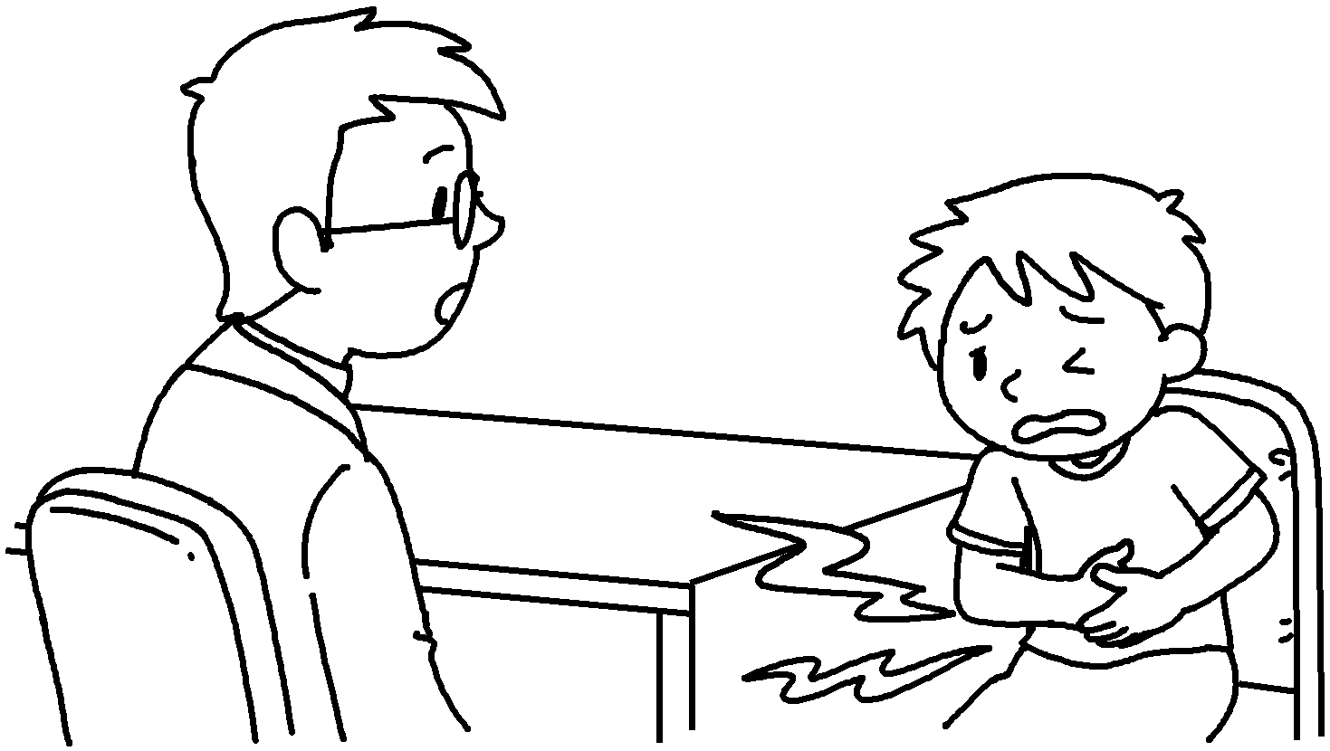 | A : What’s the matter?  B : I’ve got a s .
2 | 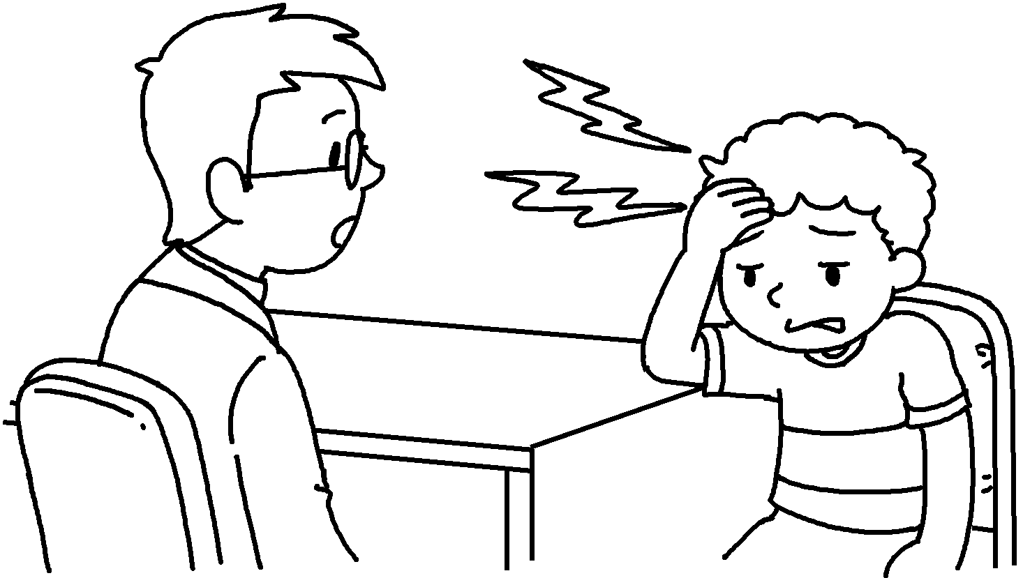 | A : What’s the matter?  B : I’ve got a h .
3 | 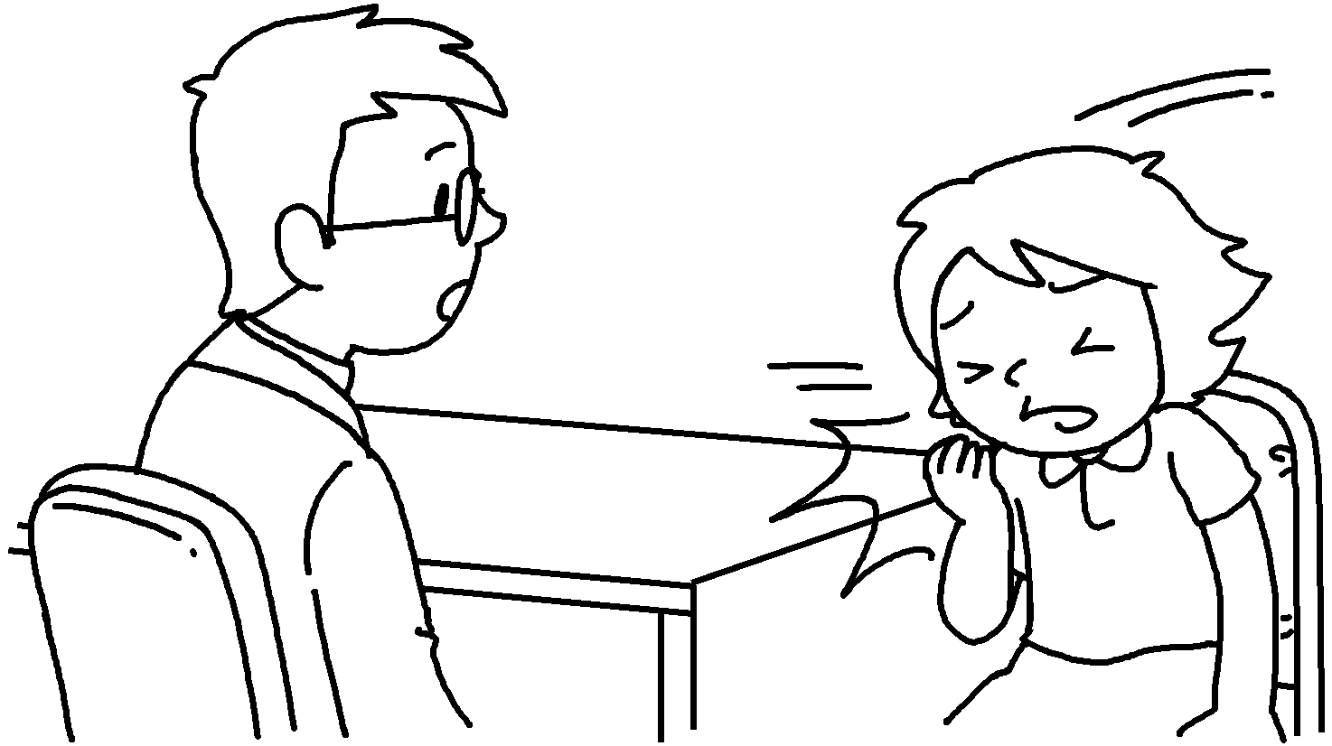 | A : __________________________________  B : I’ve got a c .
4 | 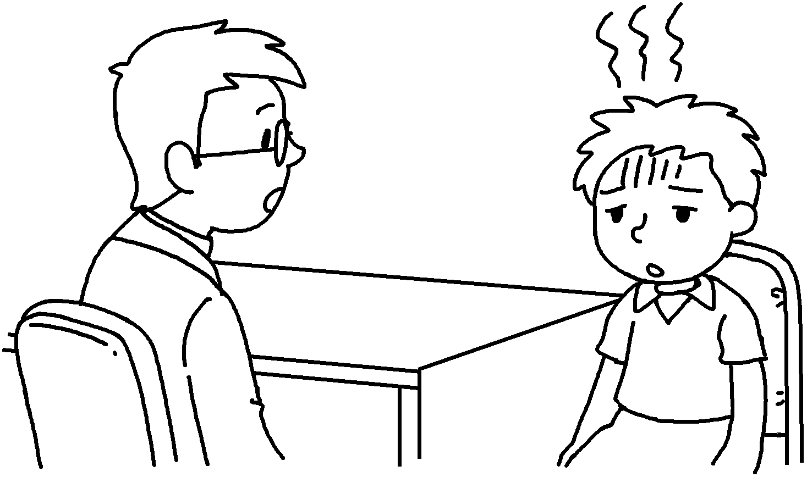 | A : __________________________________  B : _____________________ a f .
5 | 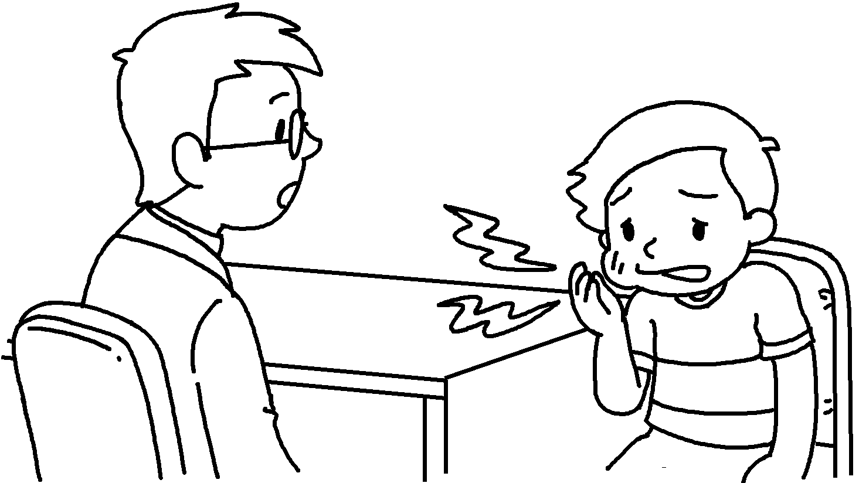 | A : __________________________________  B : _______________ a t .


Book 5B Chapter 7 Graded Worksheets
Worksheet 2⬇⬇
- stomachache
- headache
- What’s the matter?
cough
- What’s the matter?
I’ve got fever
- What’s the matter?
I’ve got toothache

