Finish the questions and answers.
A
B
A
B
A
B
A
B
A
B
1 | 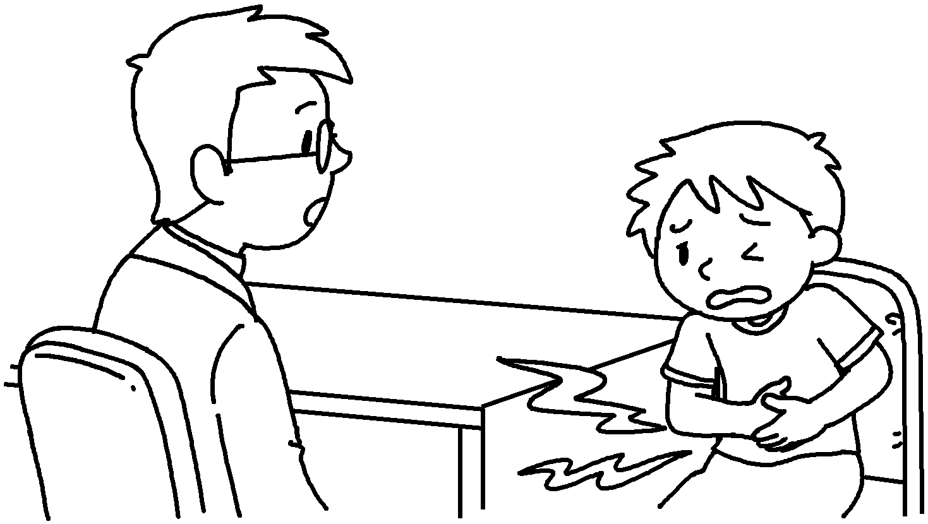 | A : What’s the matter?  B : I’ve got a .
2 | 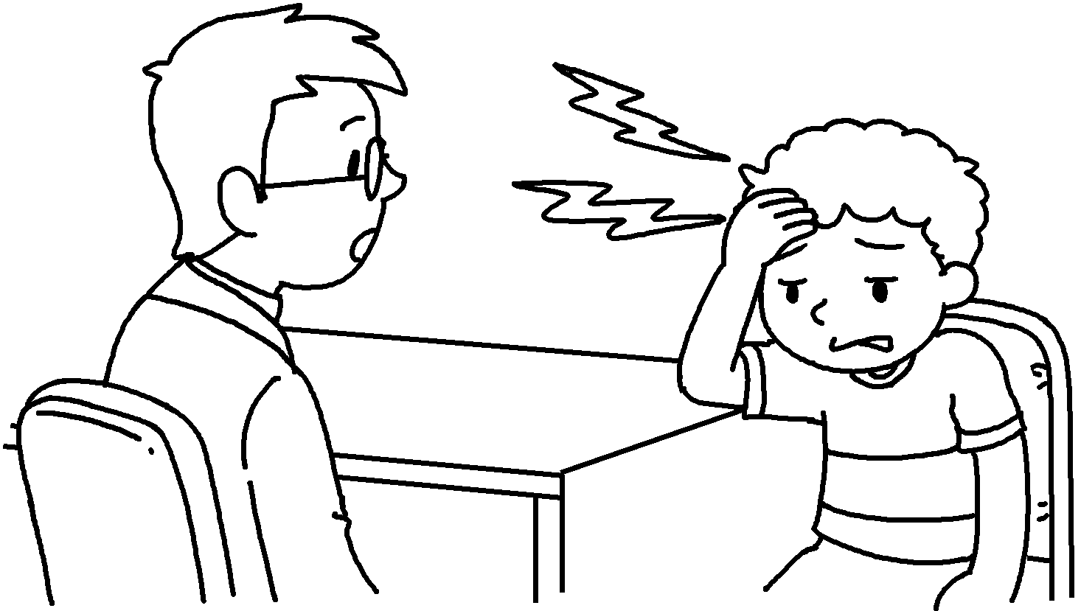 | A : What’s the matter?  B : I’ve got .
3 | 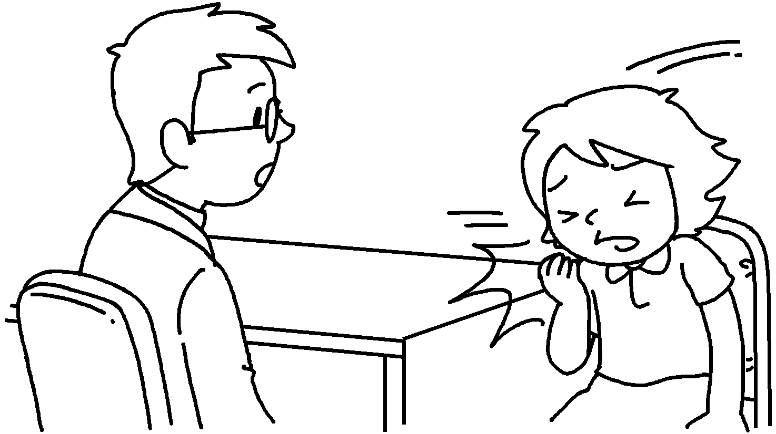 | A : ___________________________________  B : ___________________________________  ___________________________________
4 | 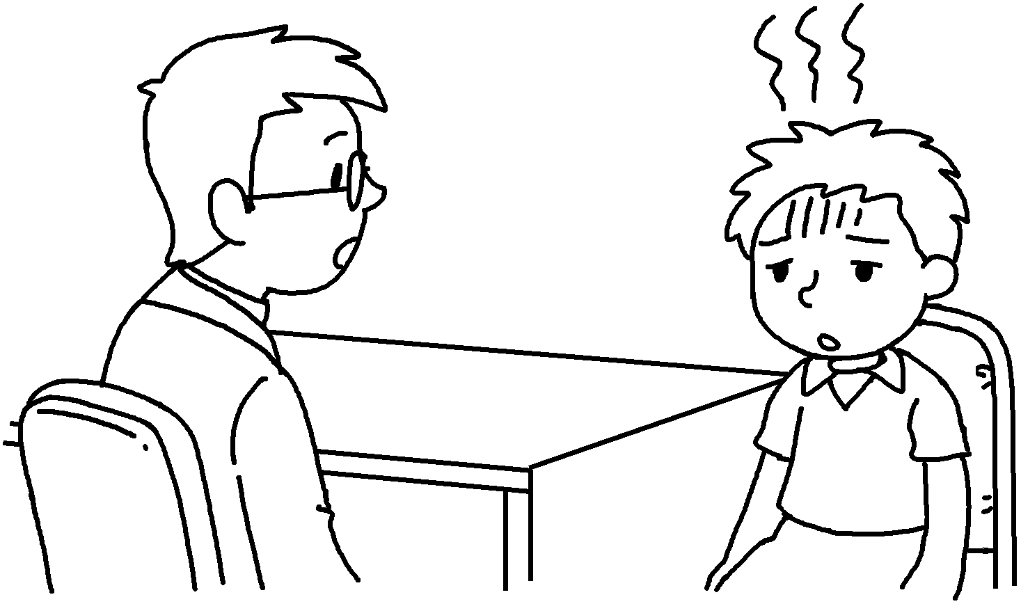 | A : ___________________________________  B : ___________________________________  ___________________________________
5 | 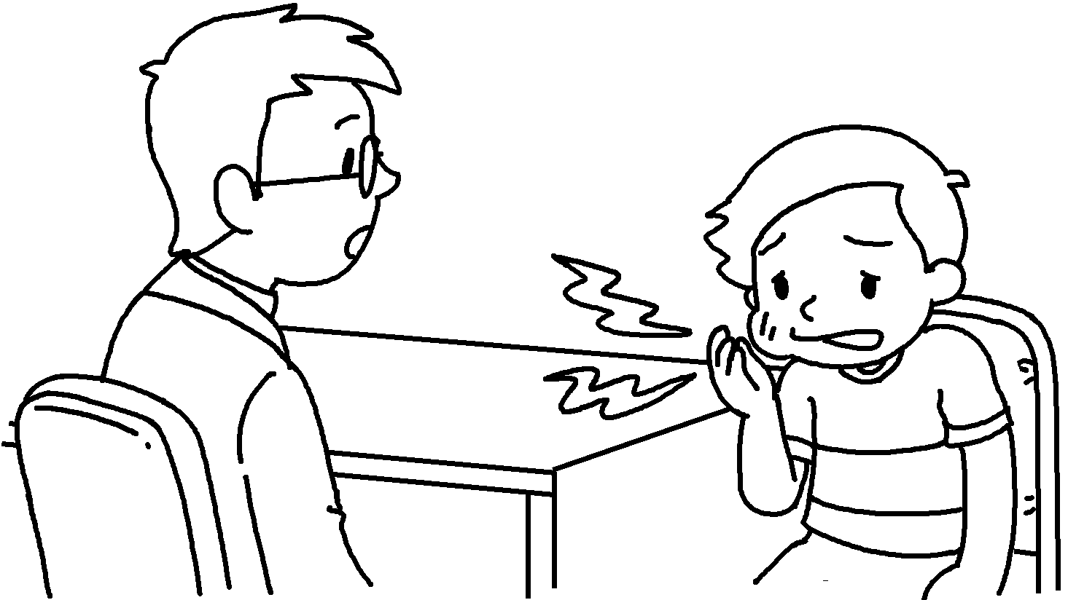 | A : ___________________________________  B : ___________________________________  ___________________________________


Book 5B Chapter 7 Graded Worksheets
Worksheet 2⬇⬇⬇
- stomachache
- a headache
- What’s the matter?
I’ve got a cough.
- What’s the matter?
I’ve got a fever.
- What’s the matter?
I’ve got a toothache.

