Choose and write.
told
himmeher
to

1 | 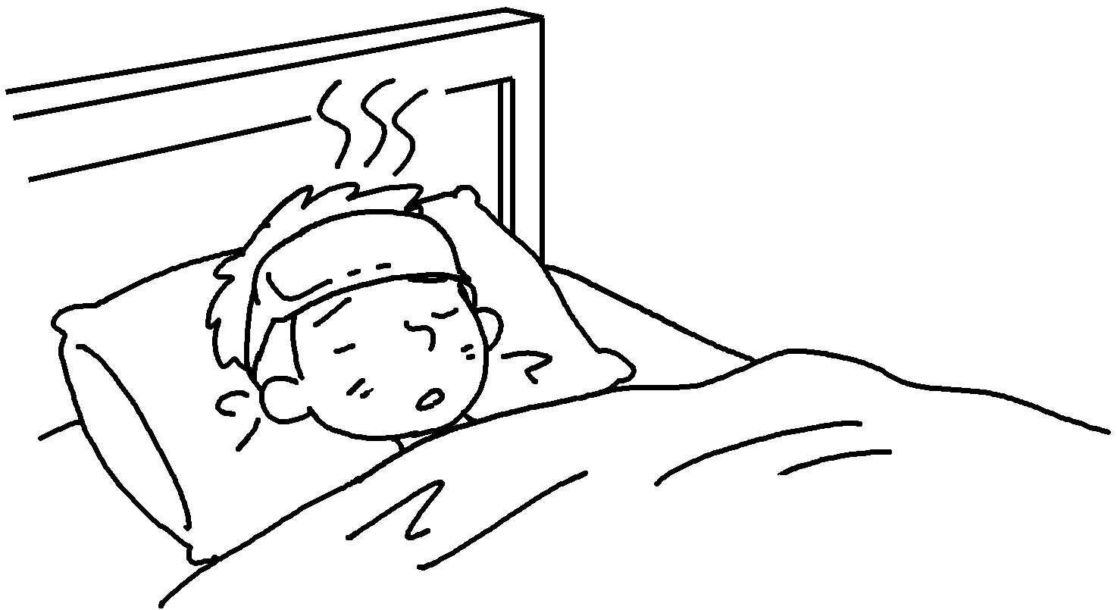 | Peter has got a fever.  The doctor told to rest in bed  for one day.
2 |  | Mary has got a sore throat.  The doctor told  drink more water.
3 |   … | I’ve got a toothache.  The dentist to eat fewer sweets.
4 | 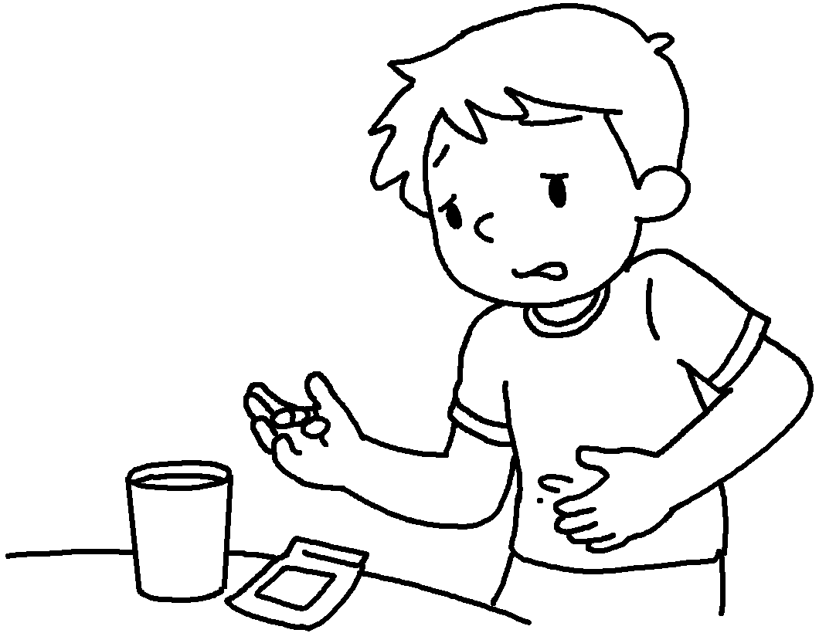 | Sam has got a stomachache.  The doctor  take some medicine.
5 | 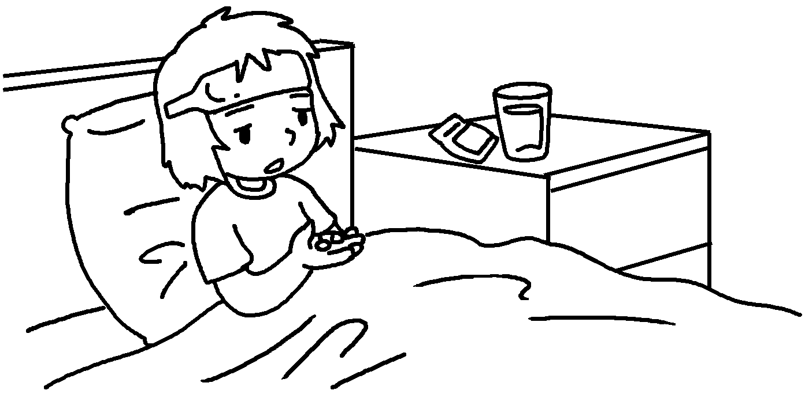 | My sister has got the flu.  The doctor  rest in bed for one day and  take some medicine.


Book 5B Chapter 7 Graded Worksheets
Worksheet 3⬇
- him
- her to
- told me
- told him to
- told her to

