Finish the sentences.
himmeher

1 | 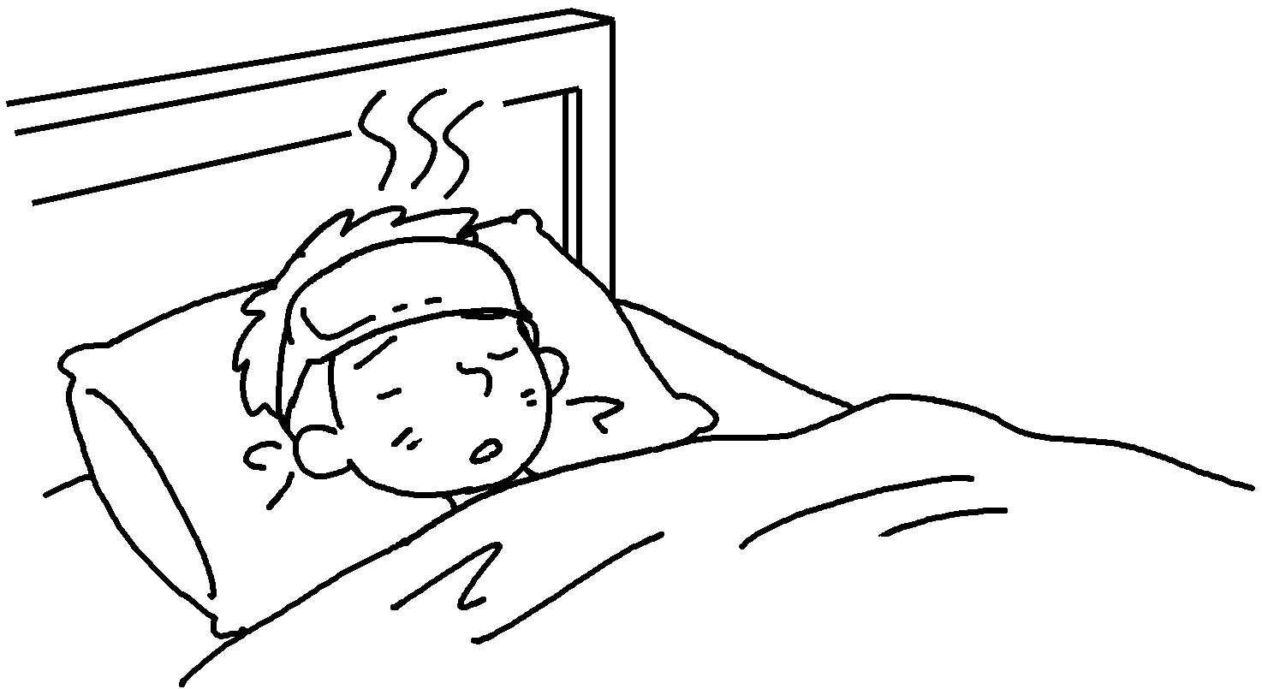 | Peter has got a fever.  The doctor told to rest in bed  for one day.
2 |   ( drink ) | Mary has got a sore throat.  The doctor told to  more water.
3 |   …  ( eat ) | I’ve got a toothache.  The dentist told fewer sweets.
4 | 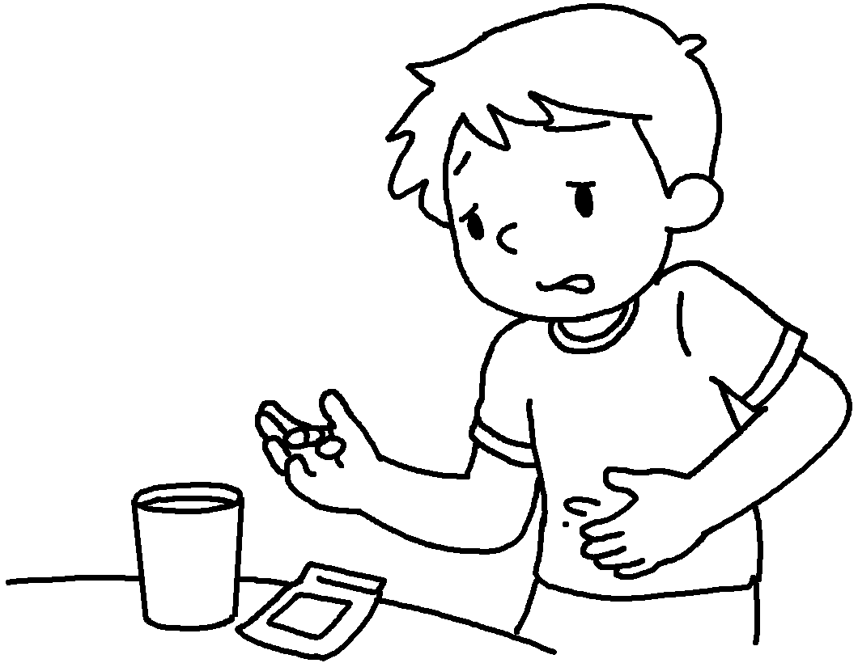  ( take some medicine ) | Sam has got a stomachache.  The doctor  .
5 | 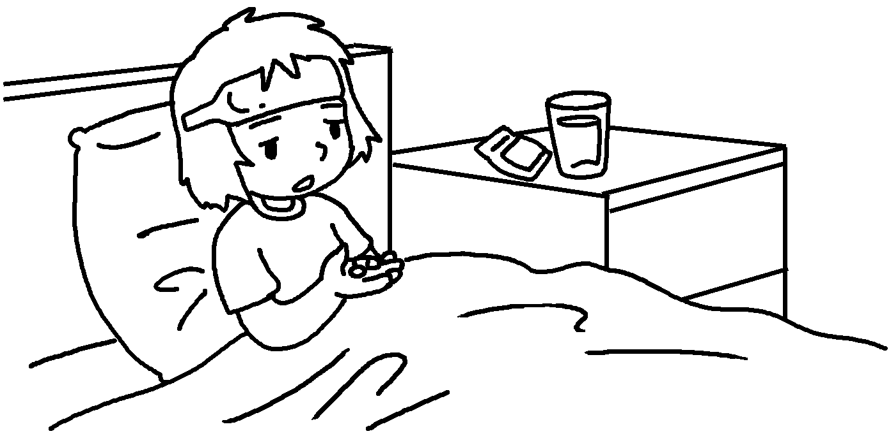  ( rest in bed +  take some medicine ) | My sister has got the flu.  The doctor  for one day and  .


Book 5B Chapter 7 Graded Worksheets
Worksheet 3⬇⬇
- him
- her drink
- me to eat
- told him to take some medicine
- told her to rest in bed take some medicine

