- At the clinic
Have you ever felt ill? What was the matter? What did you do? Last week Mike was not feeling well. Read the story and find out what happened.
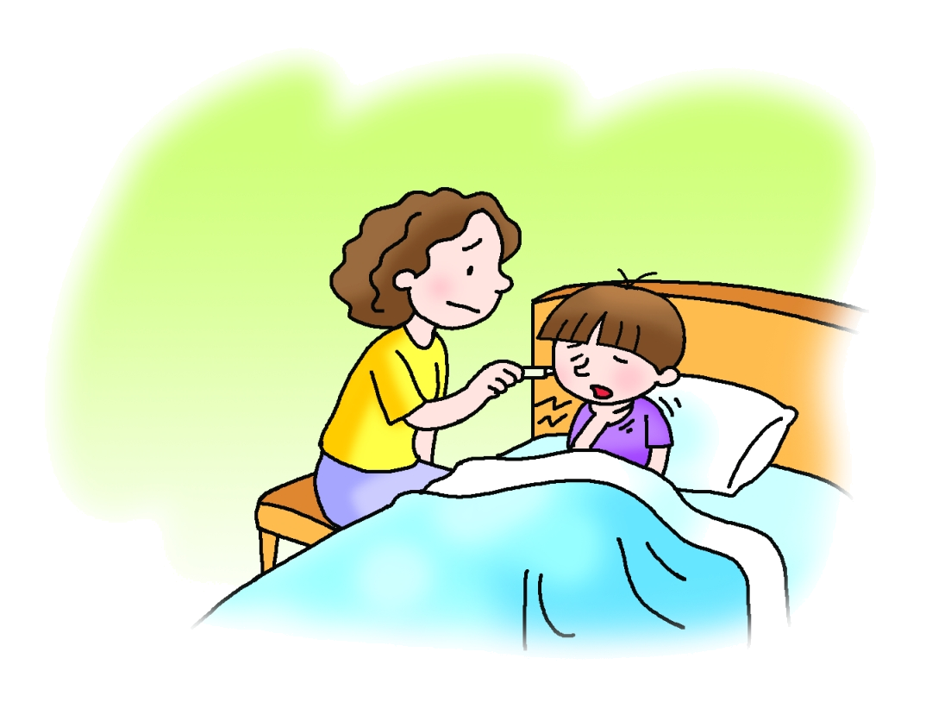

It was 7 o’clock in the morning.
‘Mum, I’m not feeling well,’ said Mike.
‘What’s the matter?’ asked Mrs Chan.
‘I’ve got a cough and a sore throat,’ said Mike.

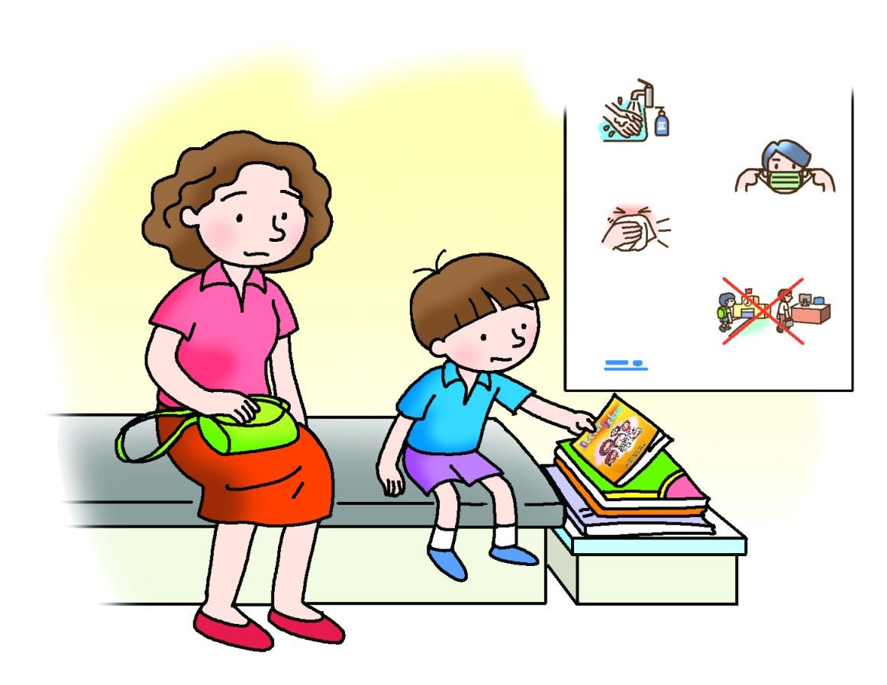
‘Oh dear!’ she said. ‘You’ve got a fever. Maybe you’ve caught a cold.’
Mrs Chan took Mike to see the doctor. Mike found a book there and started reading.

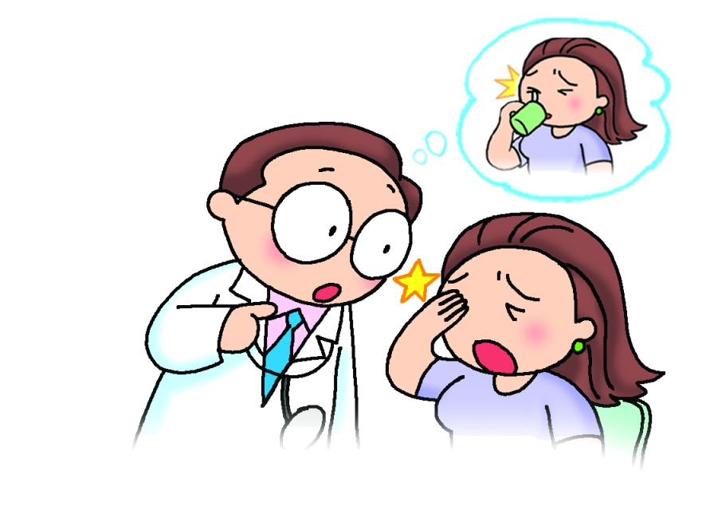
Joke 1
Patient:Doctor! Doctor! I was drinking a cup of coffee when I got a pain in my eye.
Doctor:Take the spoon out of the cup before drinking.
Doctor Jokes

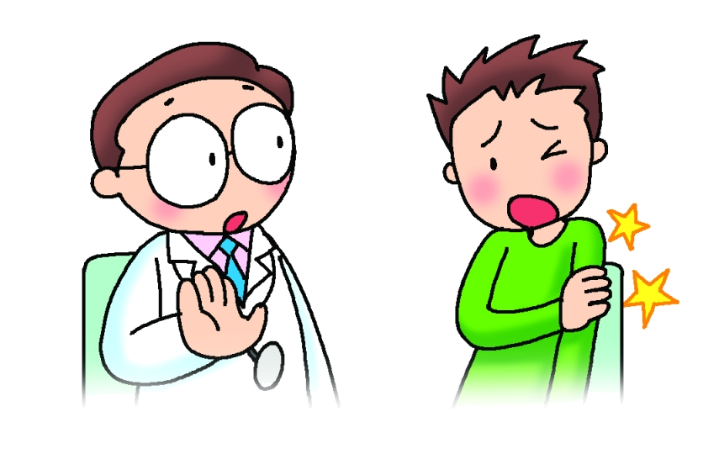
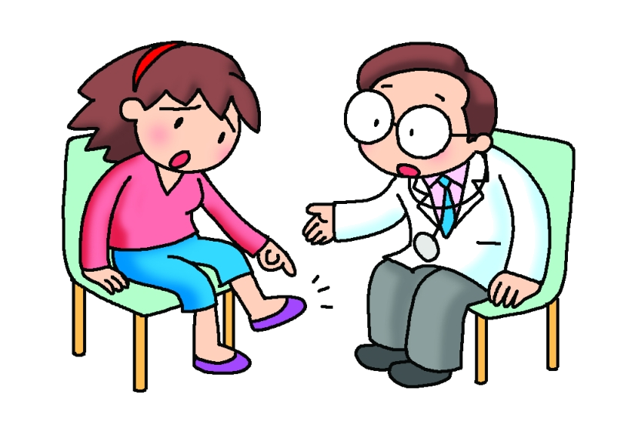
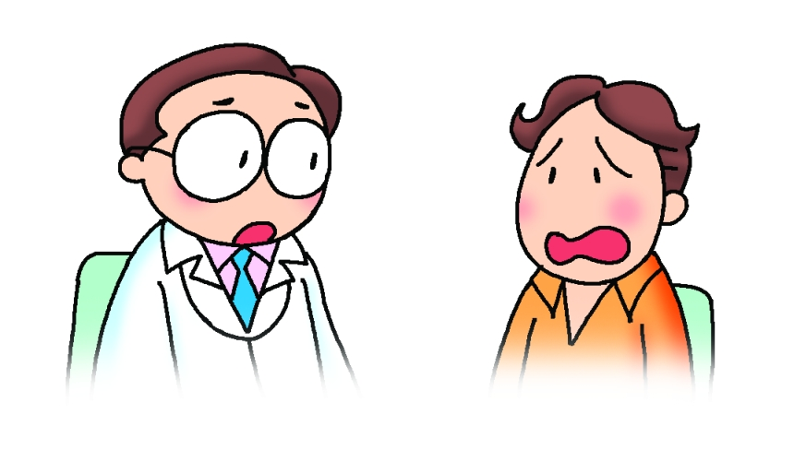
Joke 2
Patient:Doctor! Doctor! I’ve broken my arm in two places.
Doctor:Don’t go to those places again!

Joke 3
Patient: Doctor! Doctor! It’s my foot. It’s not right.
Doctor: Of course it’s not right. That’s your left foot!
Joke 4
Patient:Doctor! Doctor! When I touch my stomach with my finger, it hurts. When I touch my head, it hurts. When I touch my tooth, it hurts. I’ve got a stomachache, a headache and a toothache.
Doctor:No, you have a broken finger!

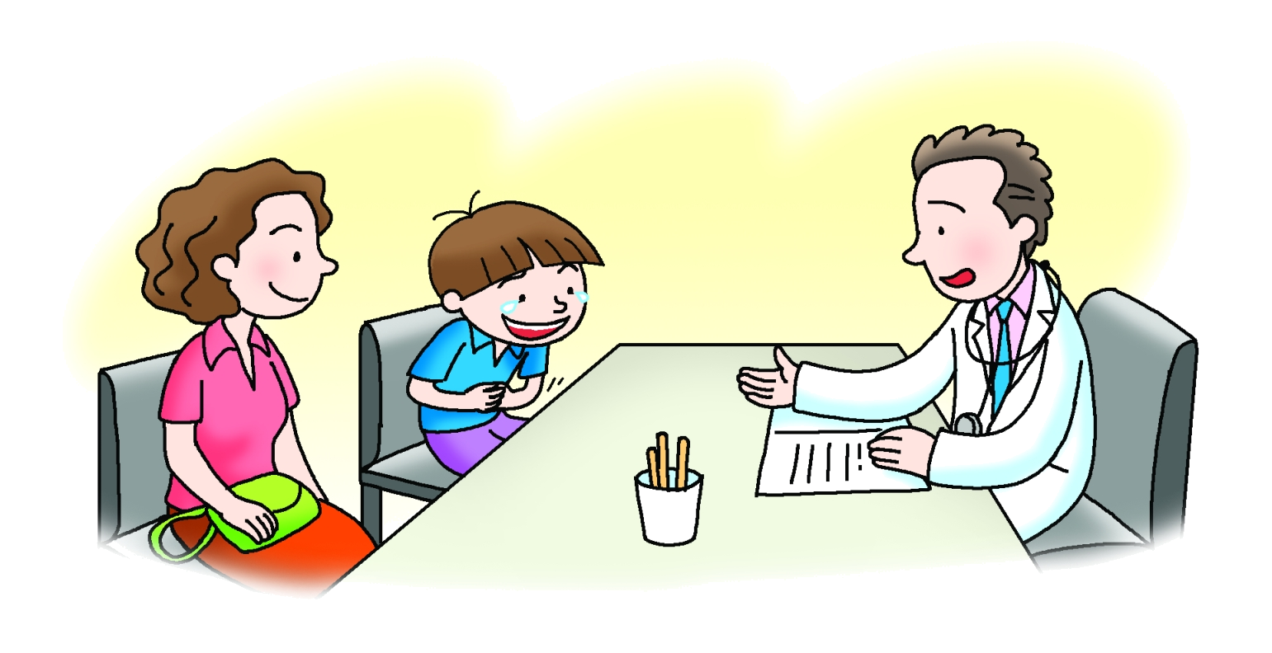
‘Mike! The doctor can see you now,’ said the nurse.
‘What’s the matter? Why are you crying? Are you very ill?’ asked the doctor.
‘Doctor Jokes was very funny. I laughed so much that I cried. I feel a bit better now.’

‘Well, laughter is the best medicine,’ smiled the doctor.

