Choose and write.
actress architect astronaut businesswoman
fashion designer flight attendant lawyer
model pilot reporter social worker vet

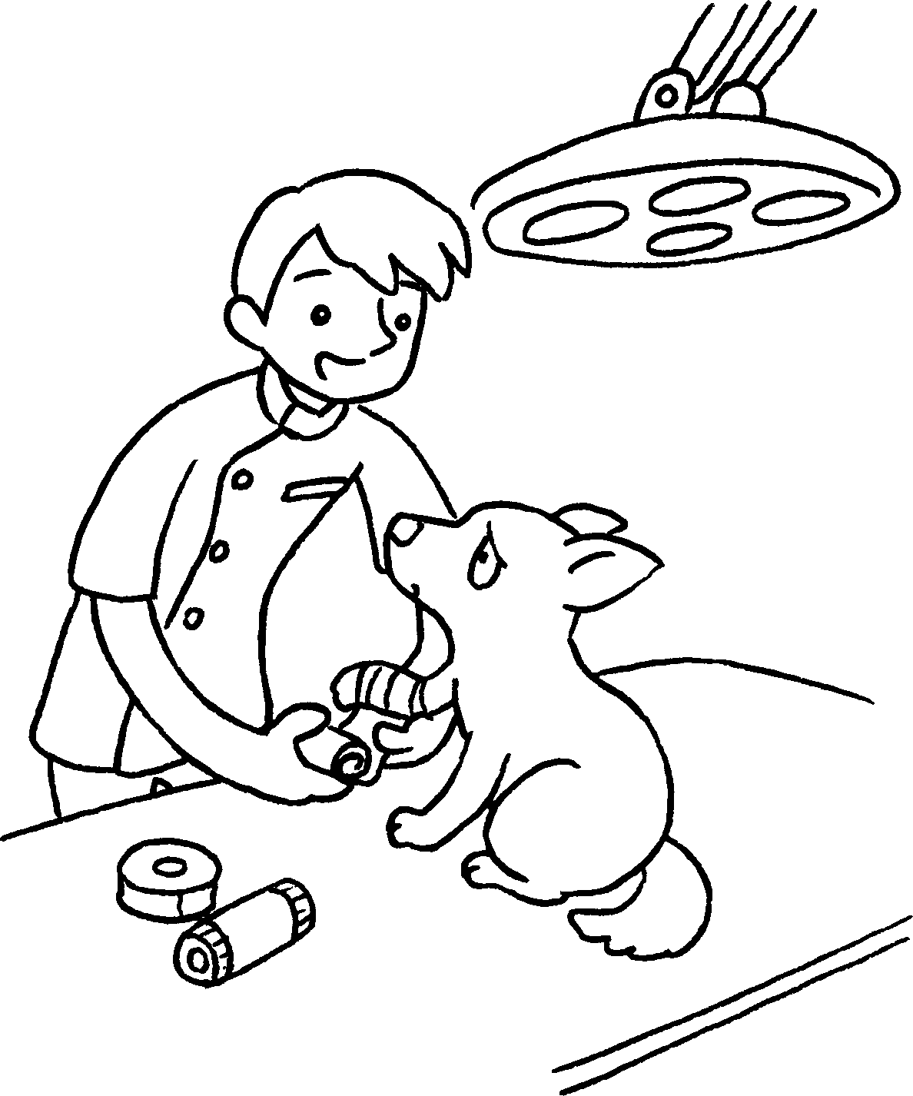  1  2 | 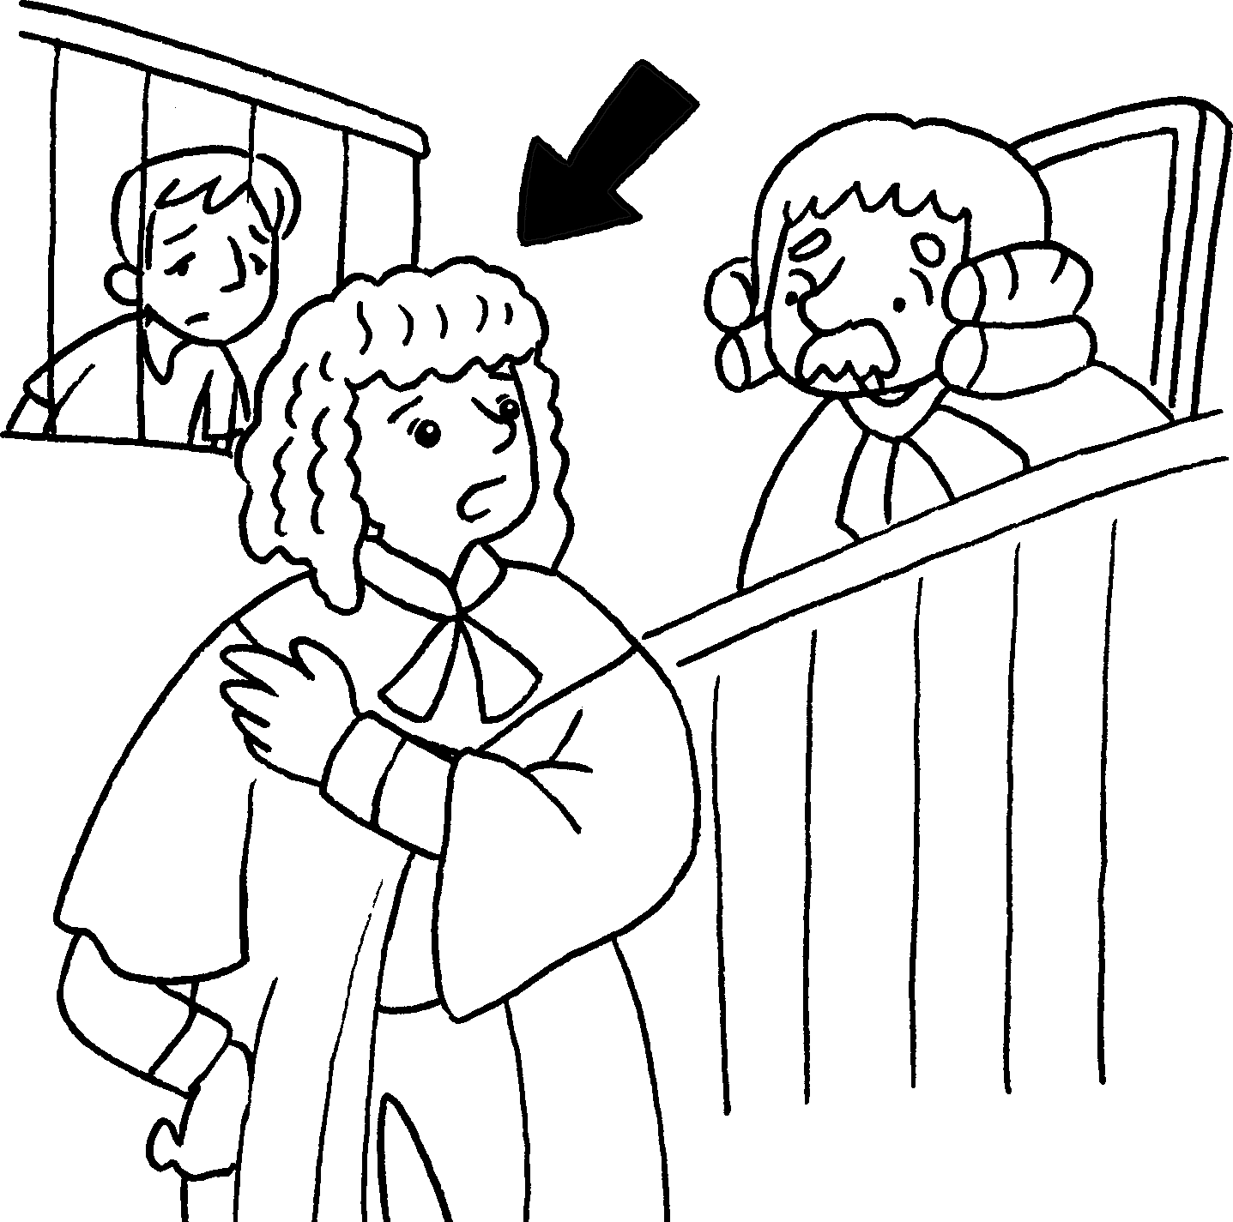 |  | 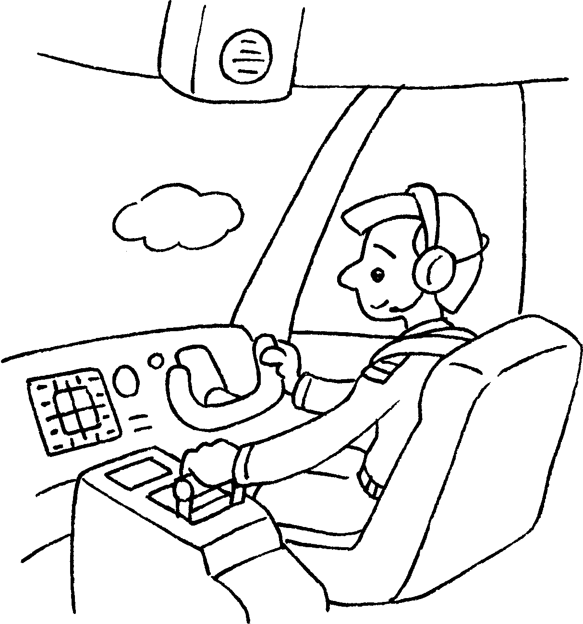  3 |  | 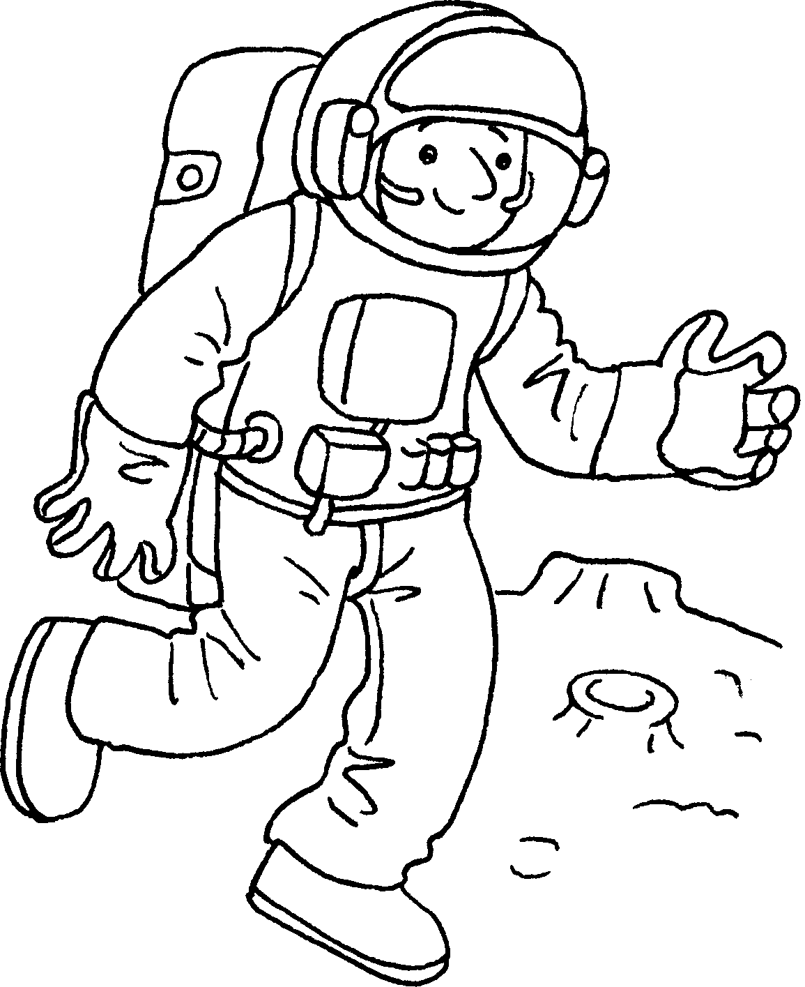  4
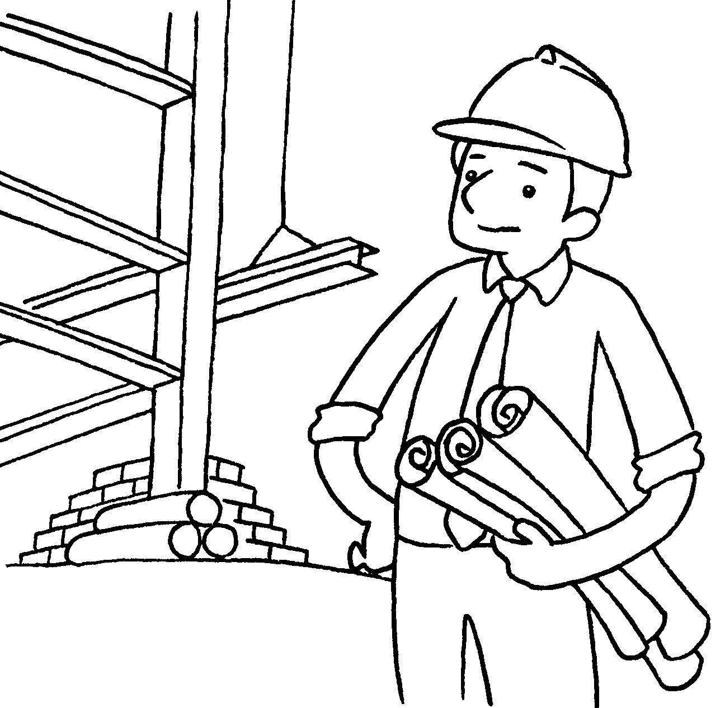  5 | 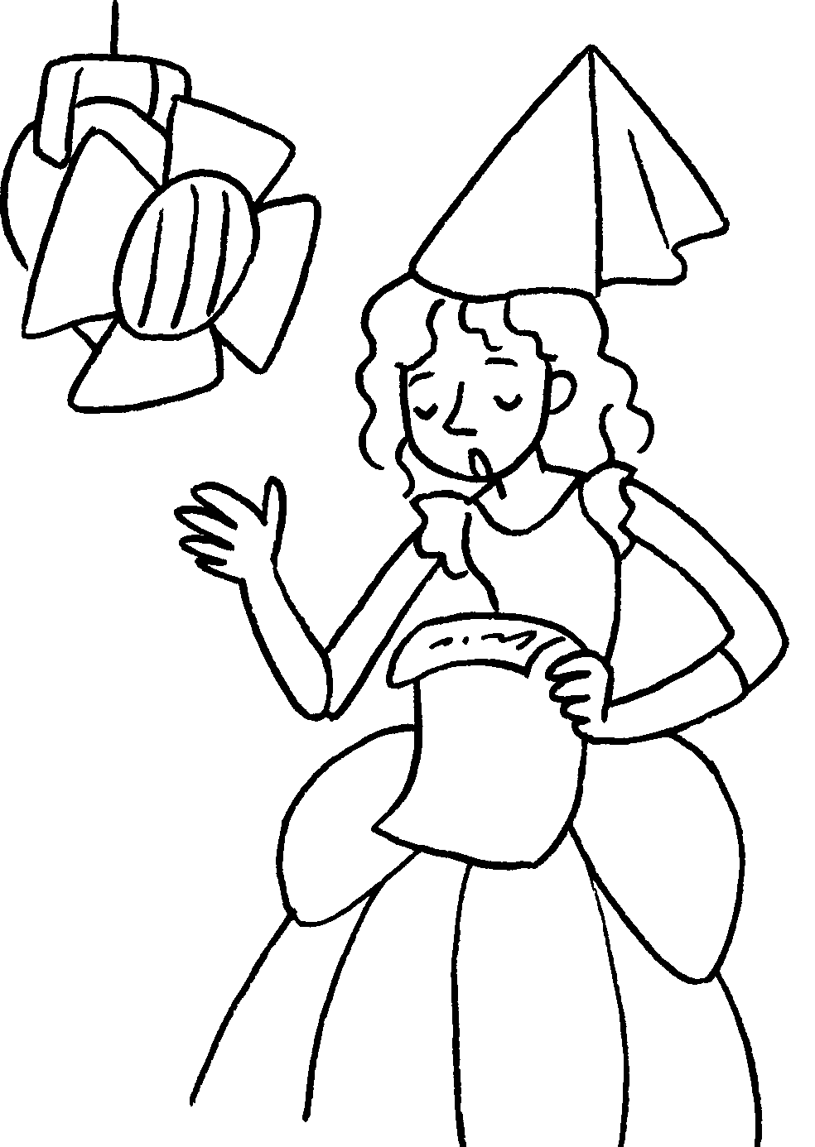  6 |  |   7 |  | 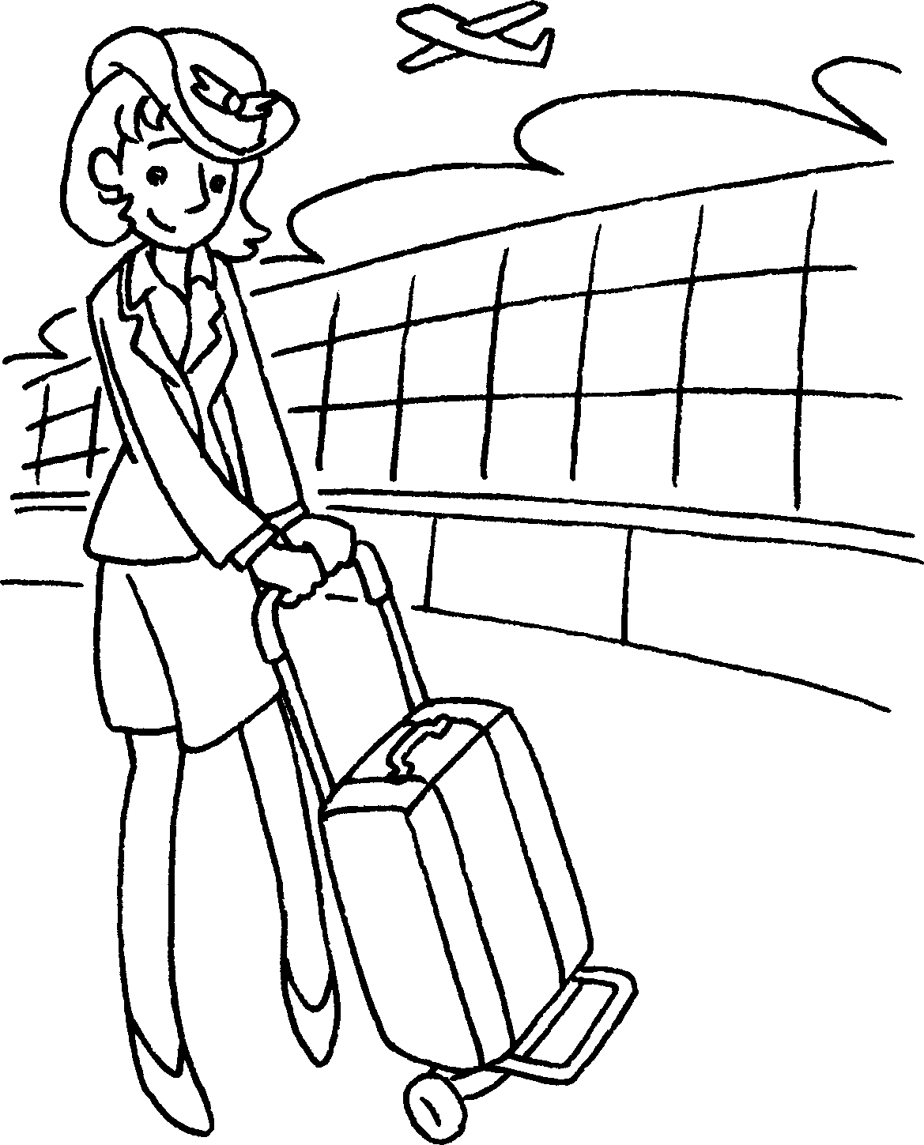  8
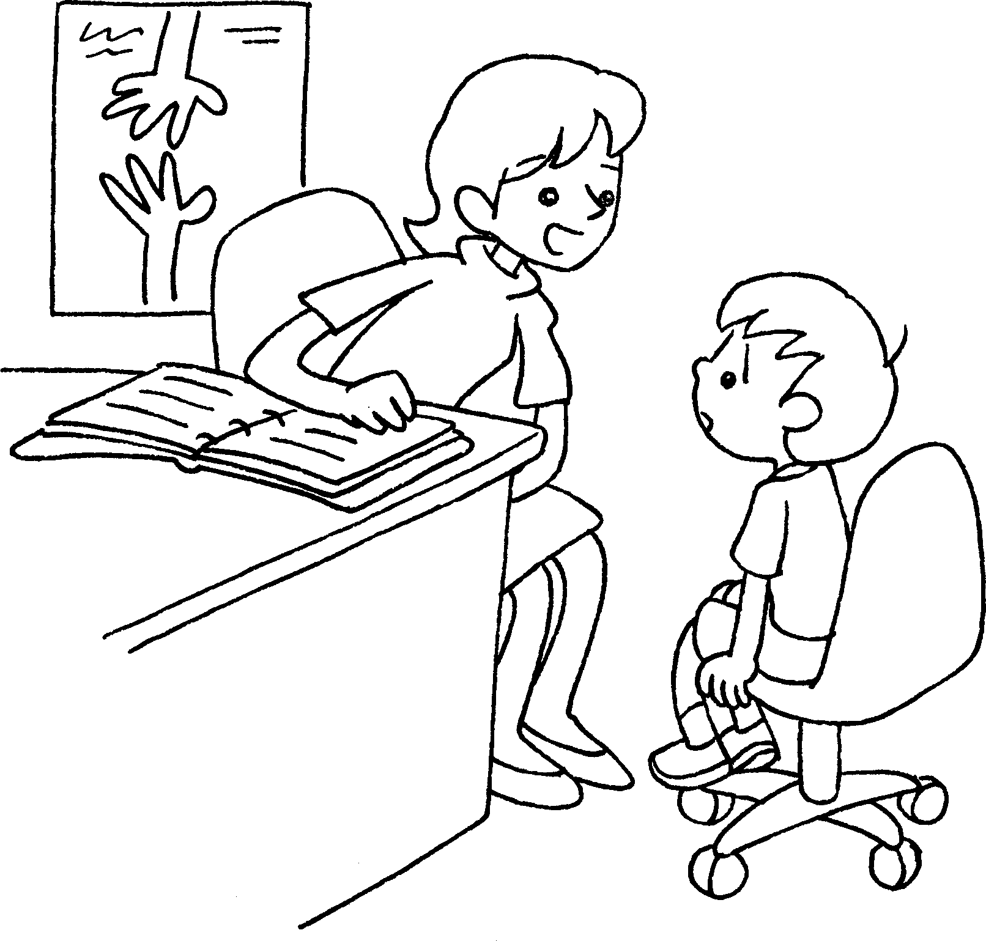  9  10  11  12 |  | 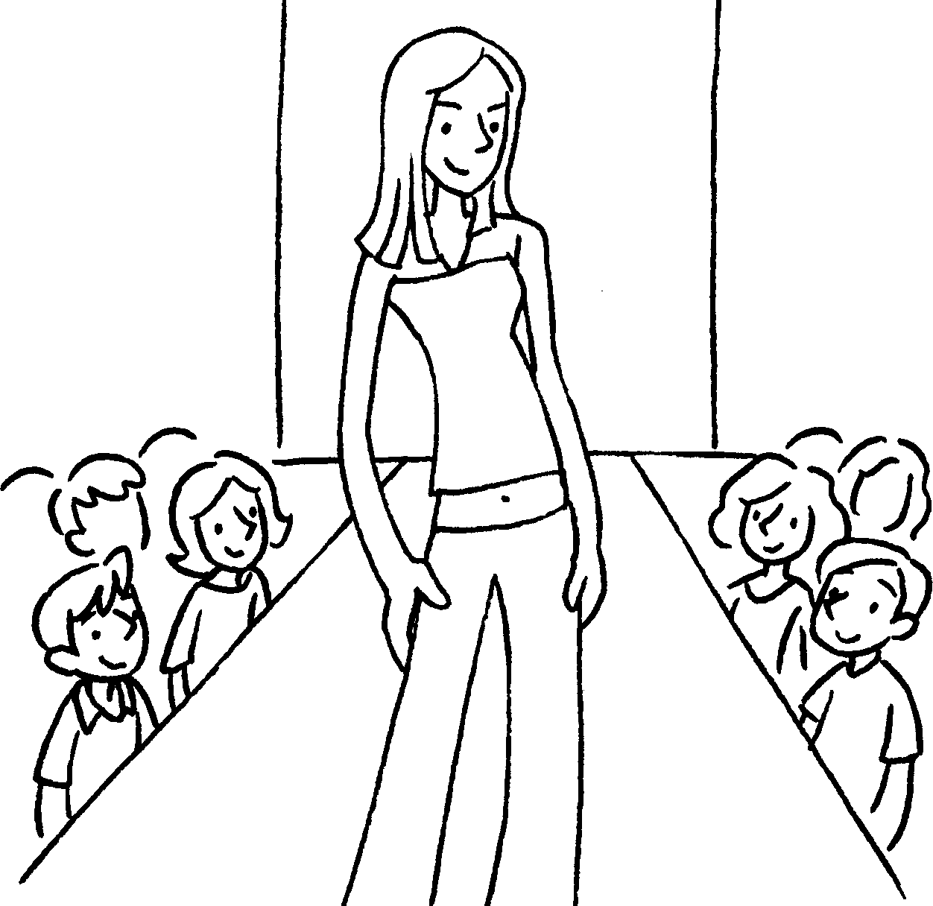 |  |  | 

1 | a | 2 | a
3 | a | 4 | an
5 | an | 6 | an
7 | a | 8 | a
9 | a | 10 | a
11 | a | 12 | a


Book 6A Chapter 1 Graded Worksheets
Worksheet 1⬇
- vet 2 lawyer
3 pilot 4 astronaut
5 architect 6 actress
7 reporter 8 flight attendant
9 social worker 10 model
11 fashion designer 12 businesswoman

