Who are they? Write.

  1  2 | 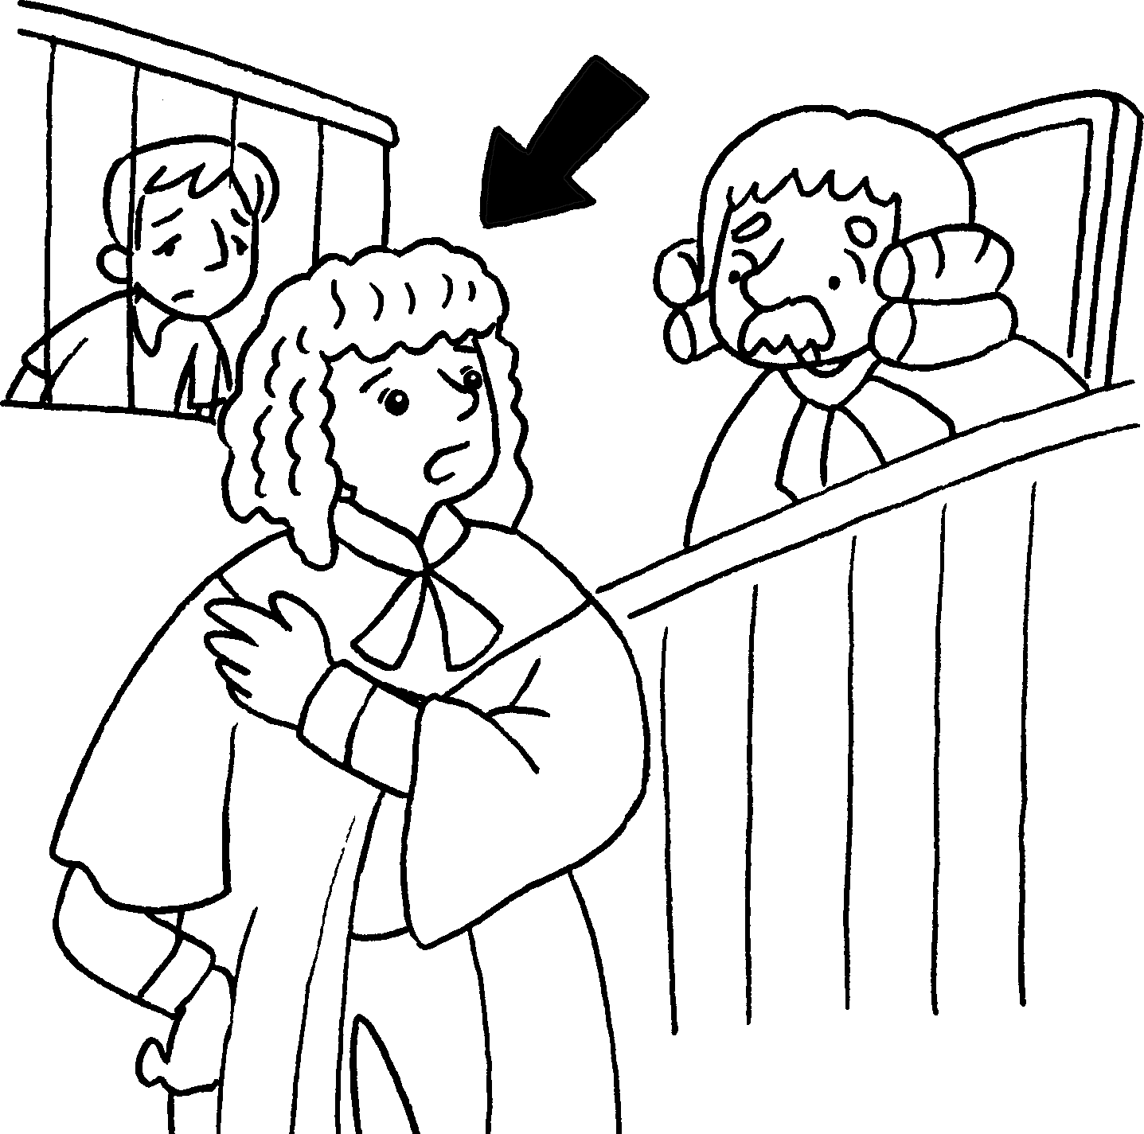 |  | 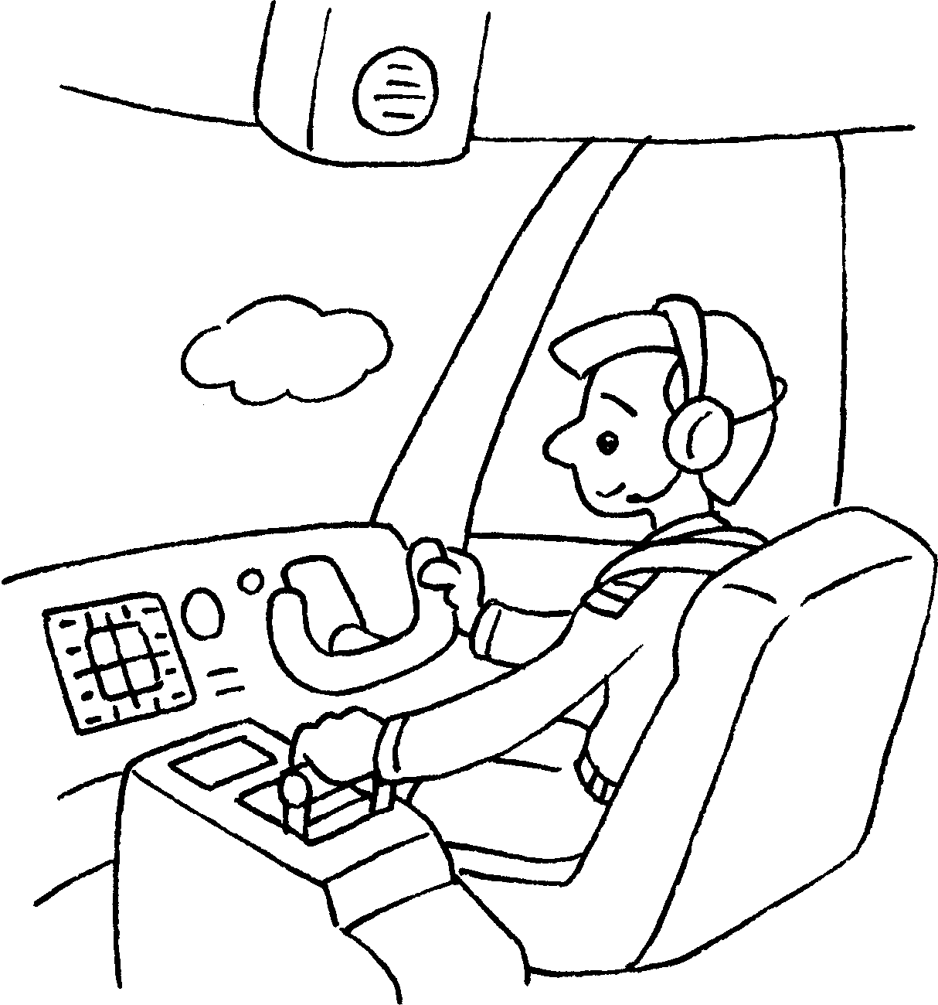  3 |  | 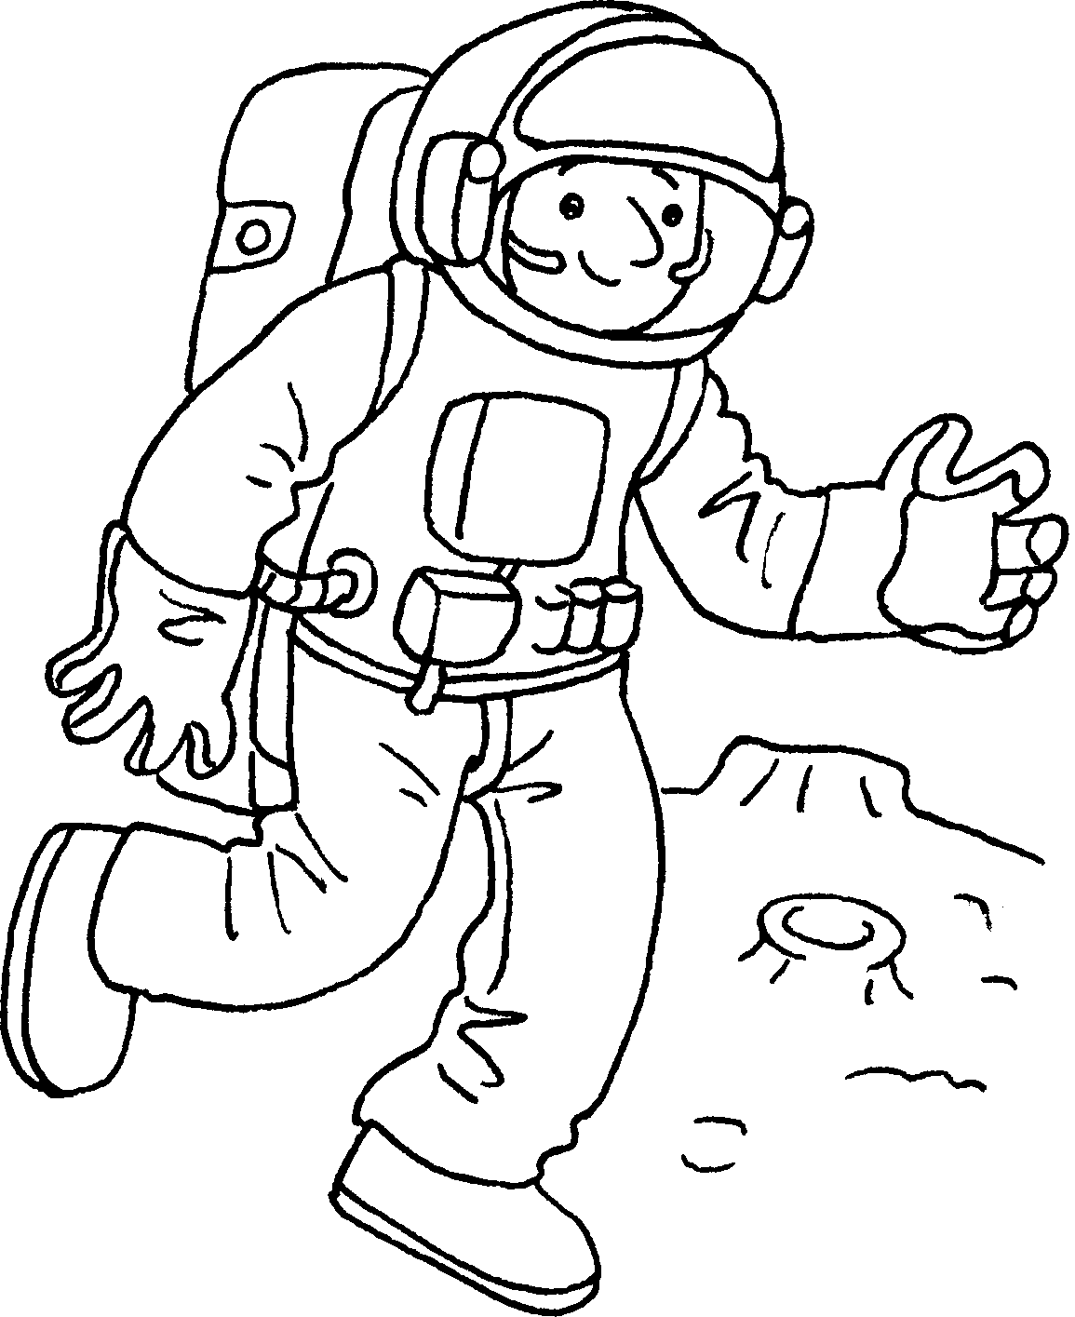  4
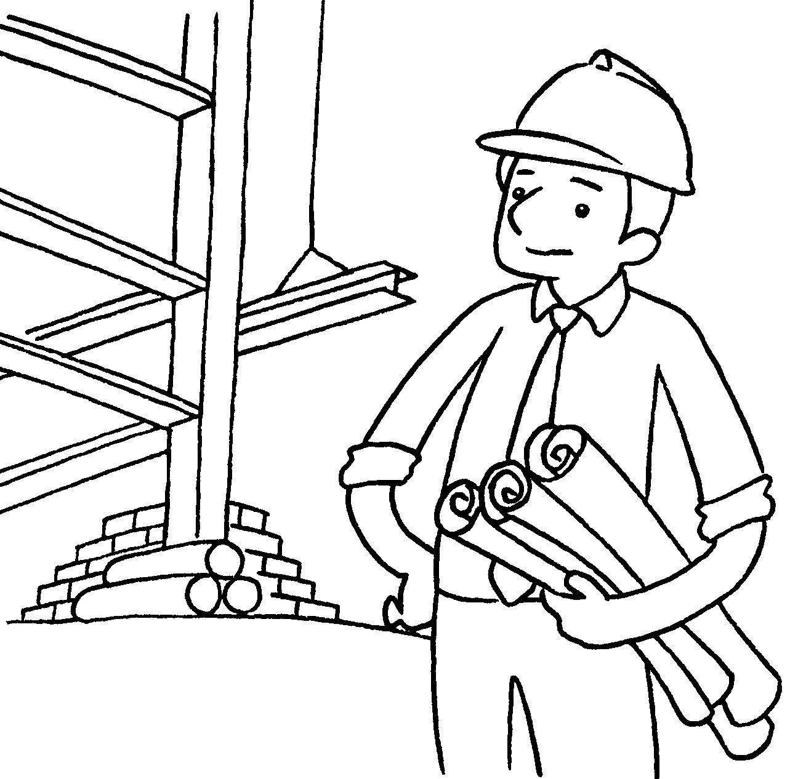  5 | 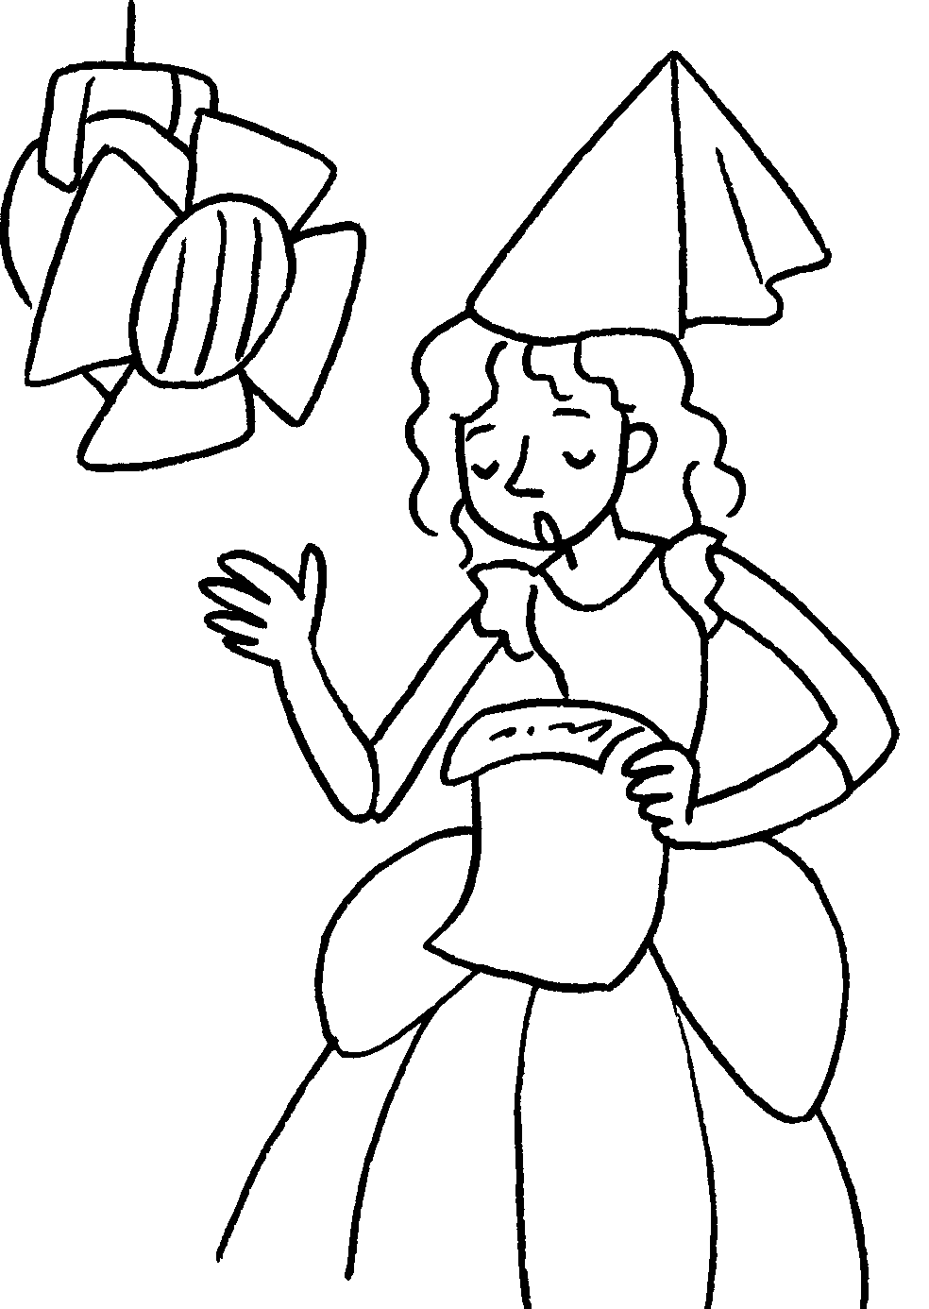  6 |  |   7 |  |   8
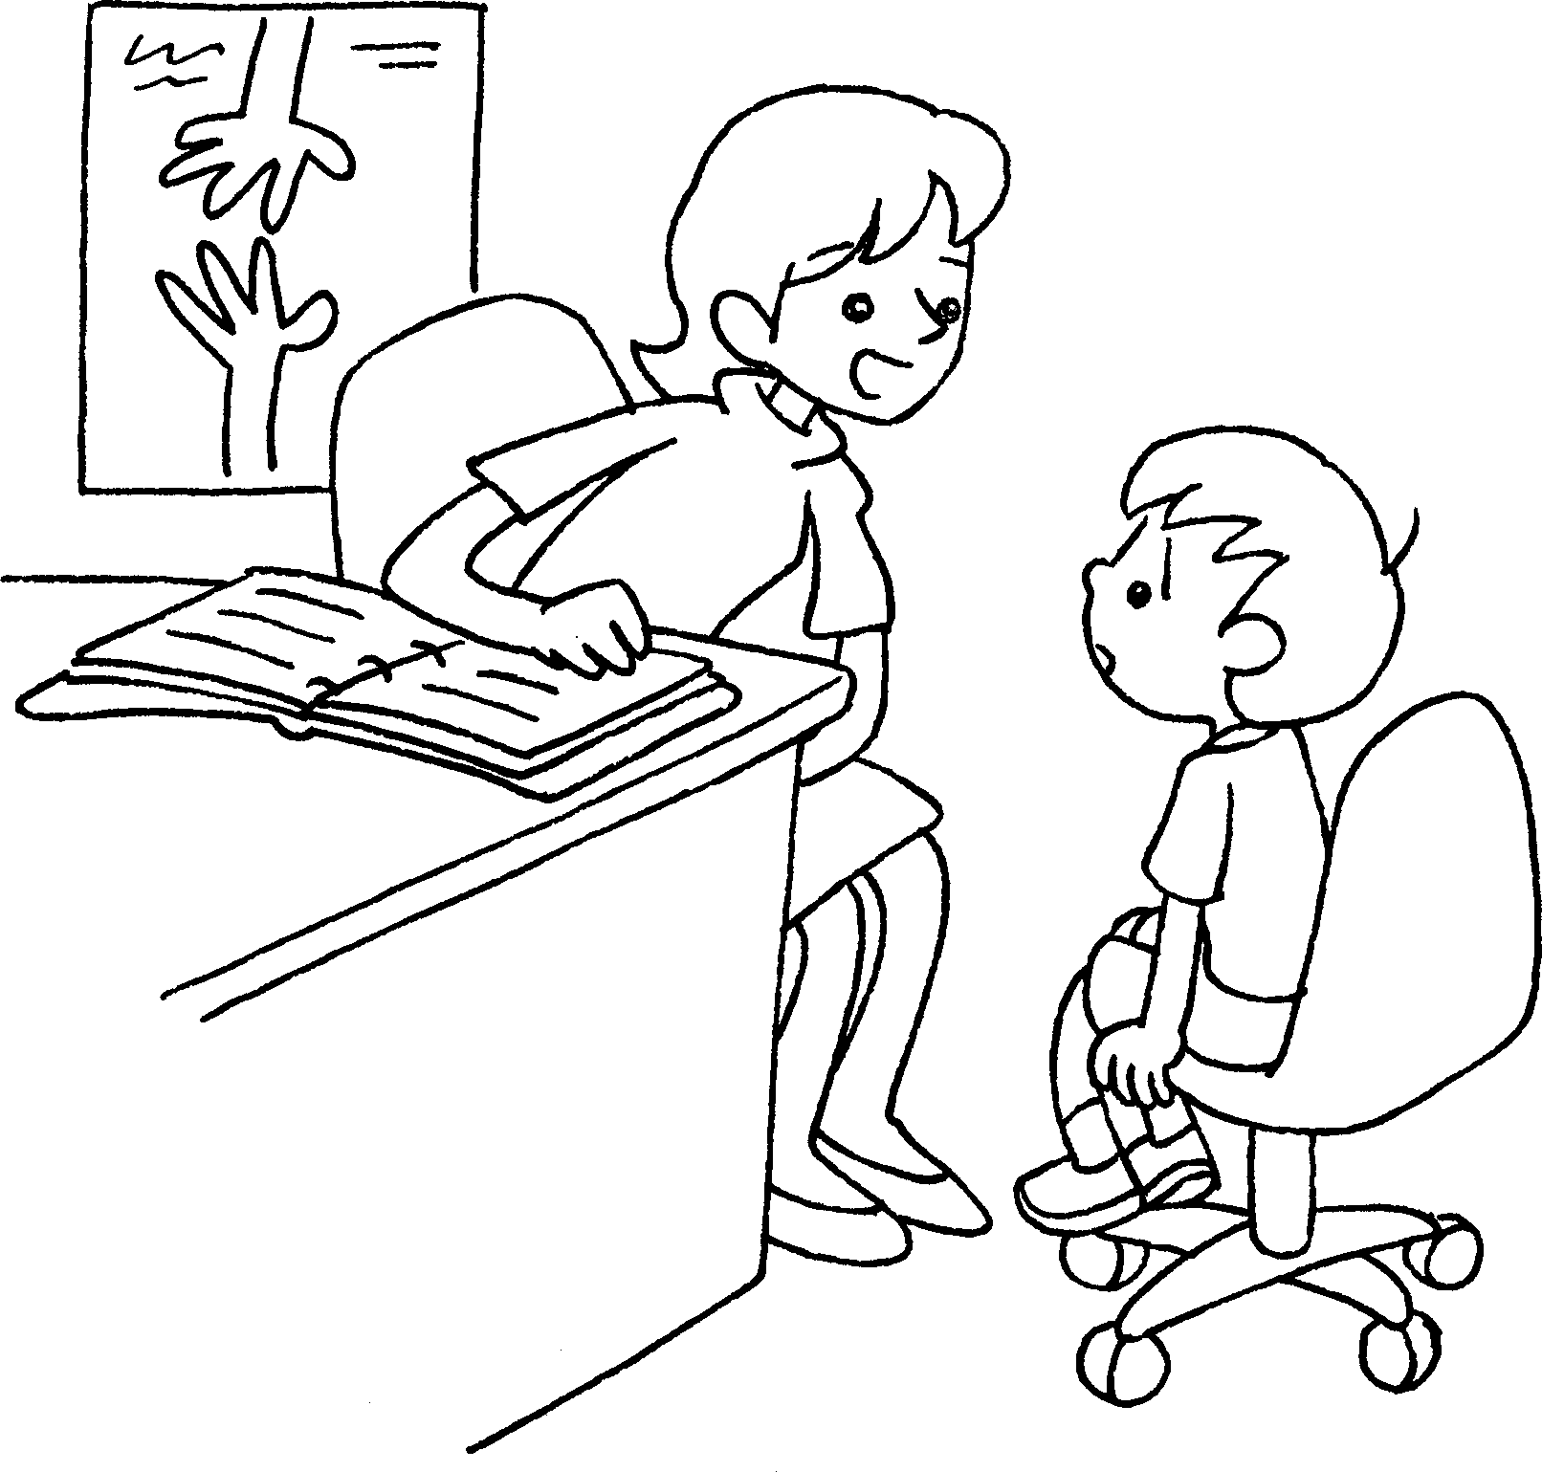  9  10  11  12 |  | 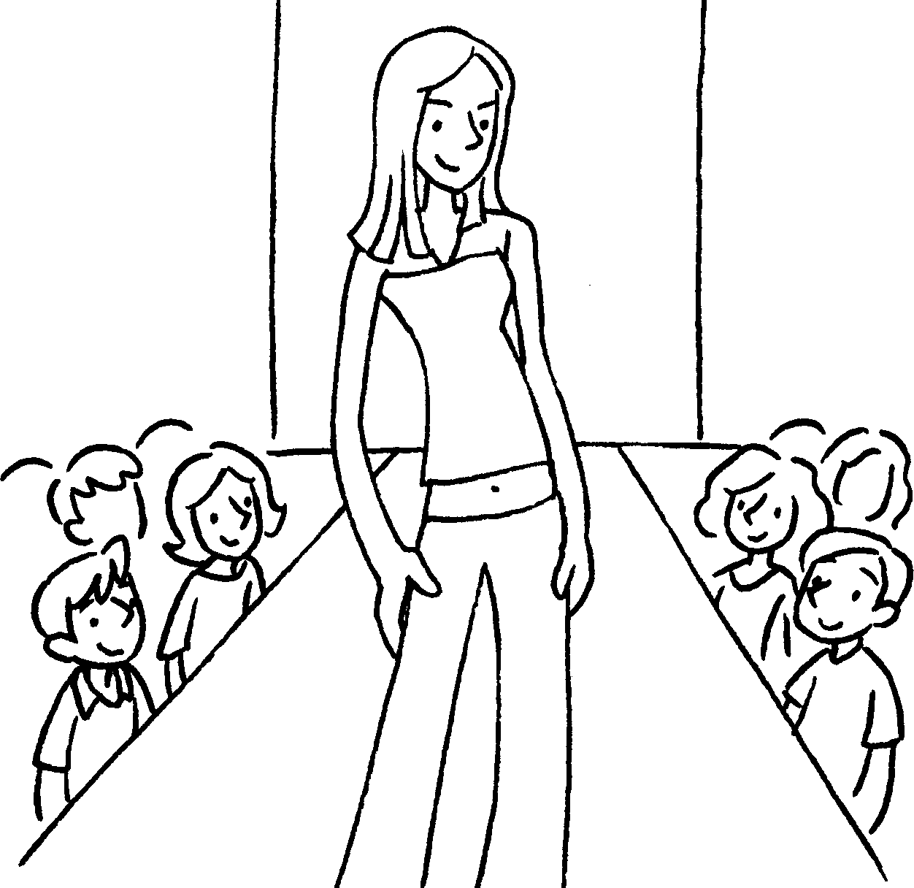 |  |  | 

1 | a v | 2 | a l
3 | a p | 4 | an a
5 | an a | 6 | an a
7 | a r | 8 | a f a
9 | a s w | 10 | a m
11 | a f d | 12 | a b


Book 6A Chapter 1 Graded Worksheets
Worksheet 1⬇⬇
- vet 2 lawyer
3 pilot 4 astronaut
5 architect 6 actress
7 reporter 8 flight attendant
9 social worker 10 model
11 fashion designer 12 businesswoman

