Who are they? Write.

  1  2 | 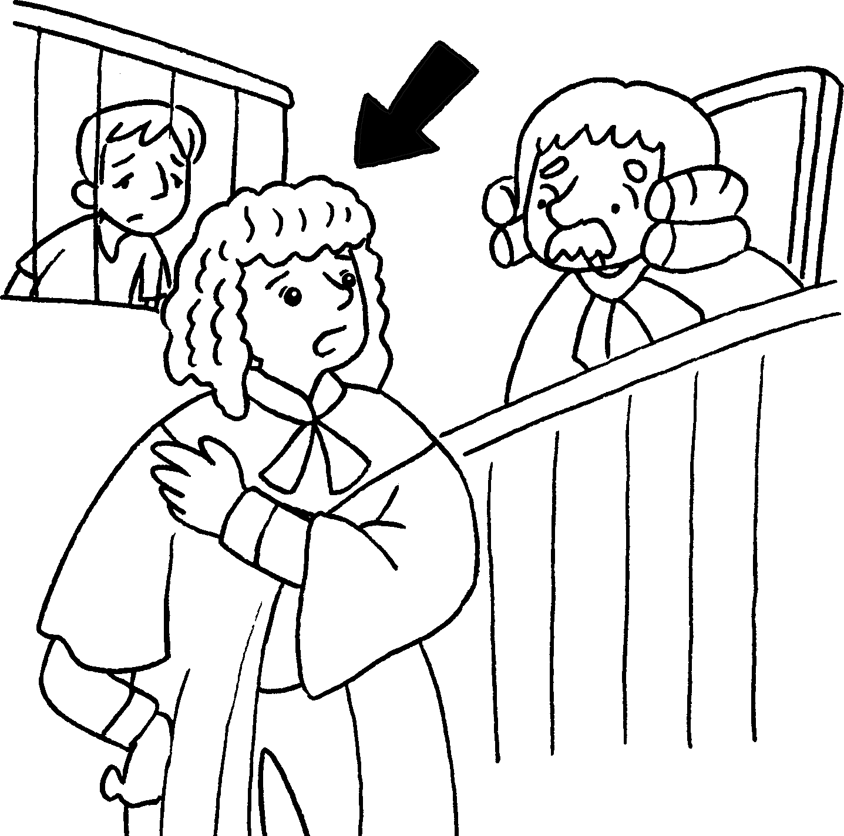 |  | 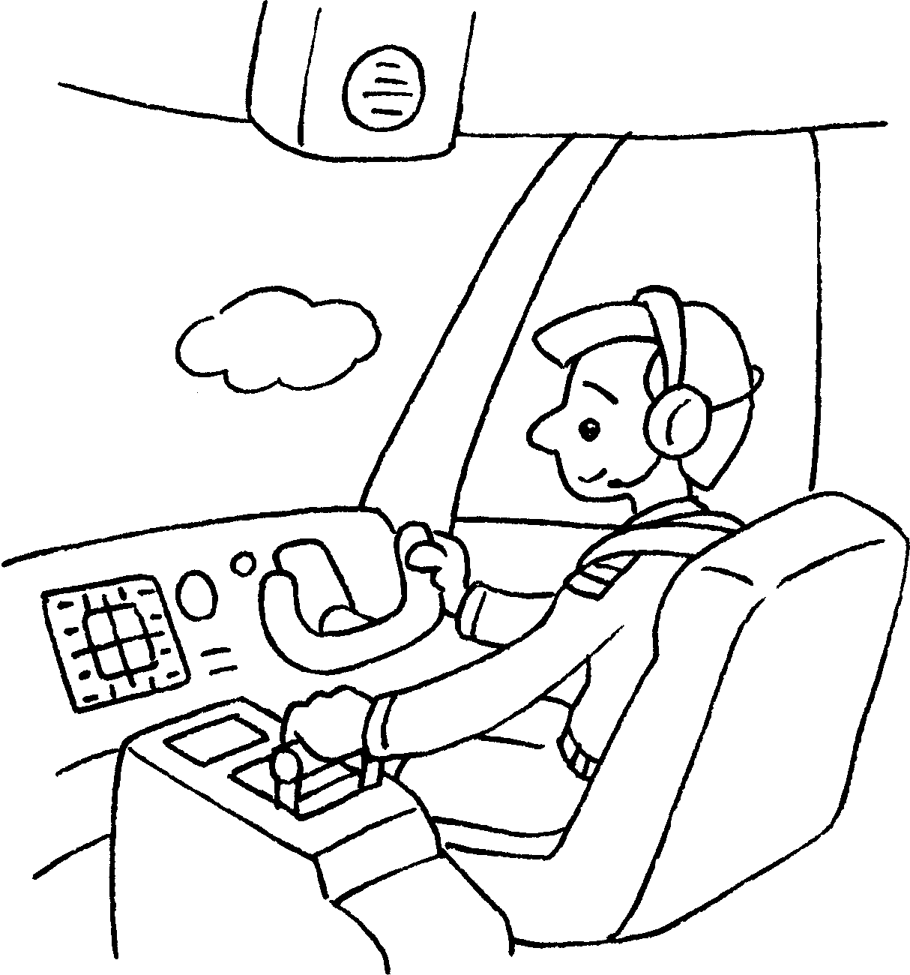  3 |  | 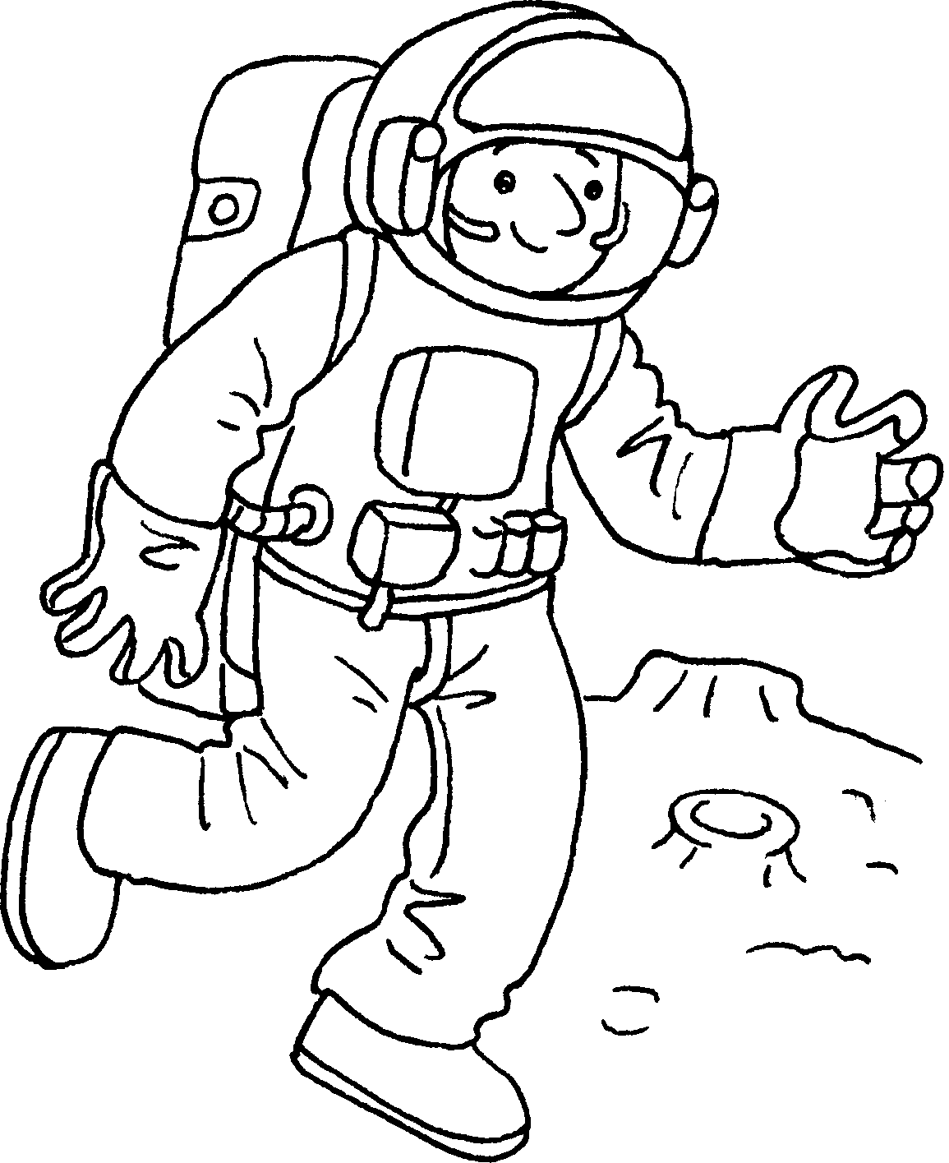  4
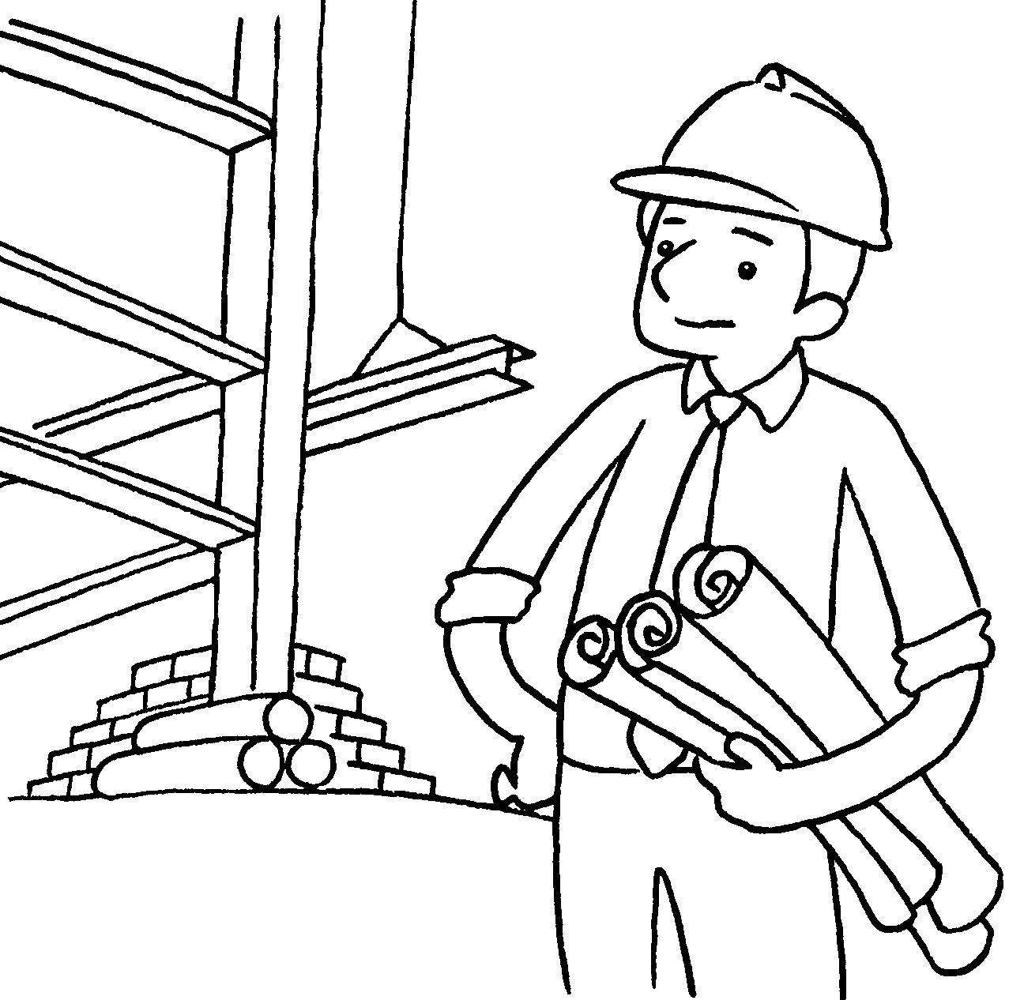  5 | 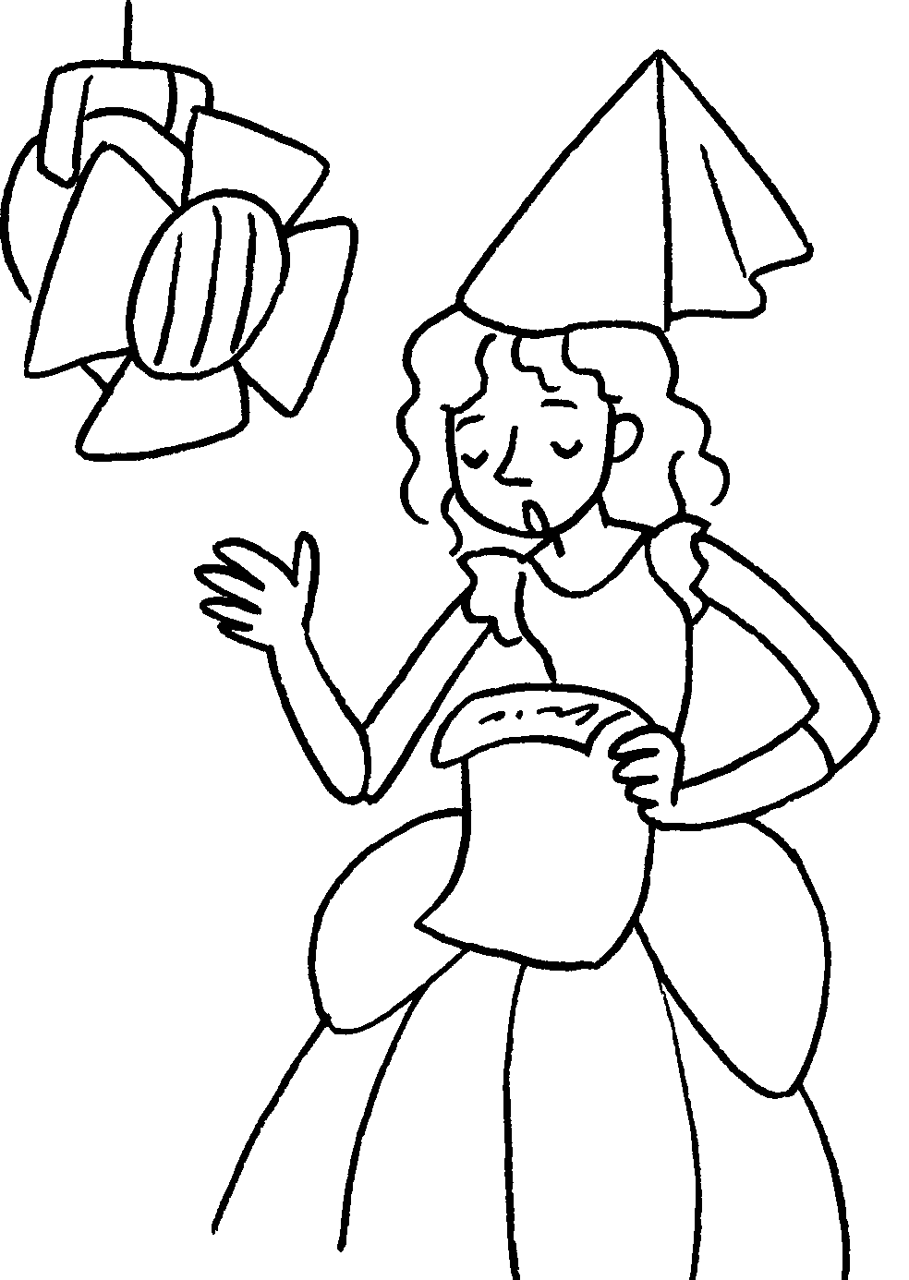  6 |  |   7 |  | 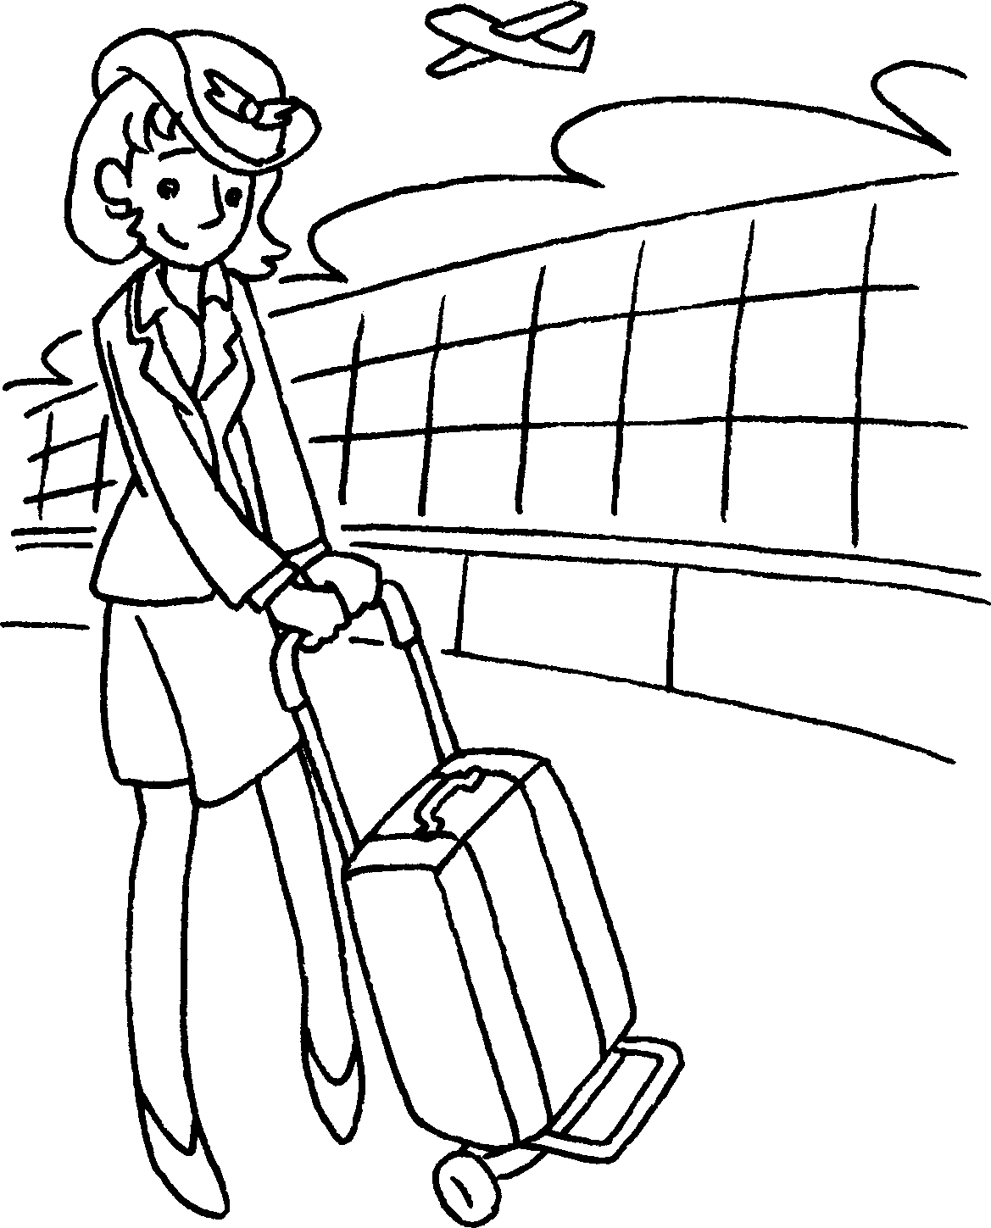  8
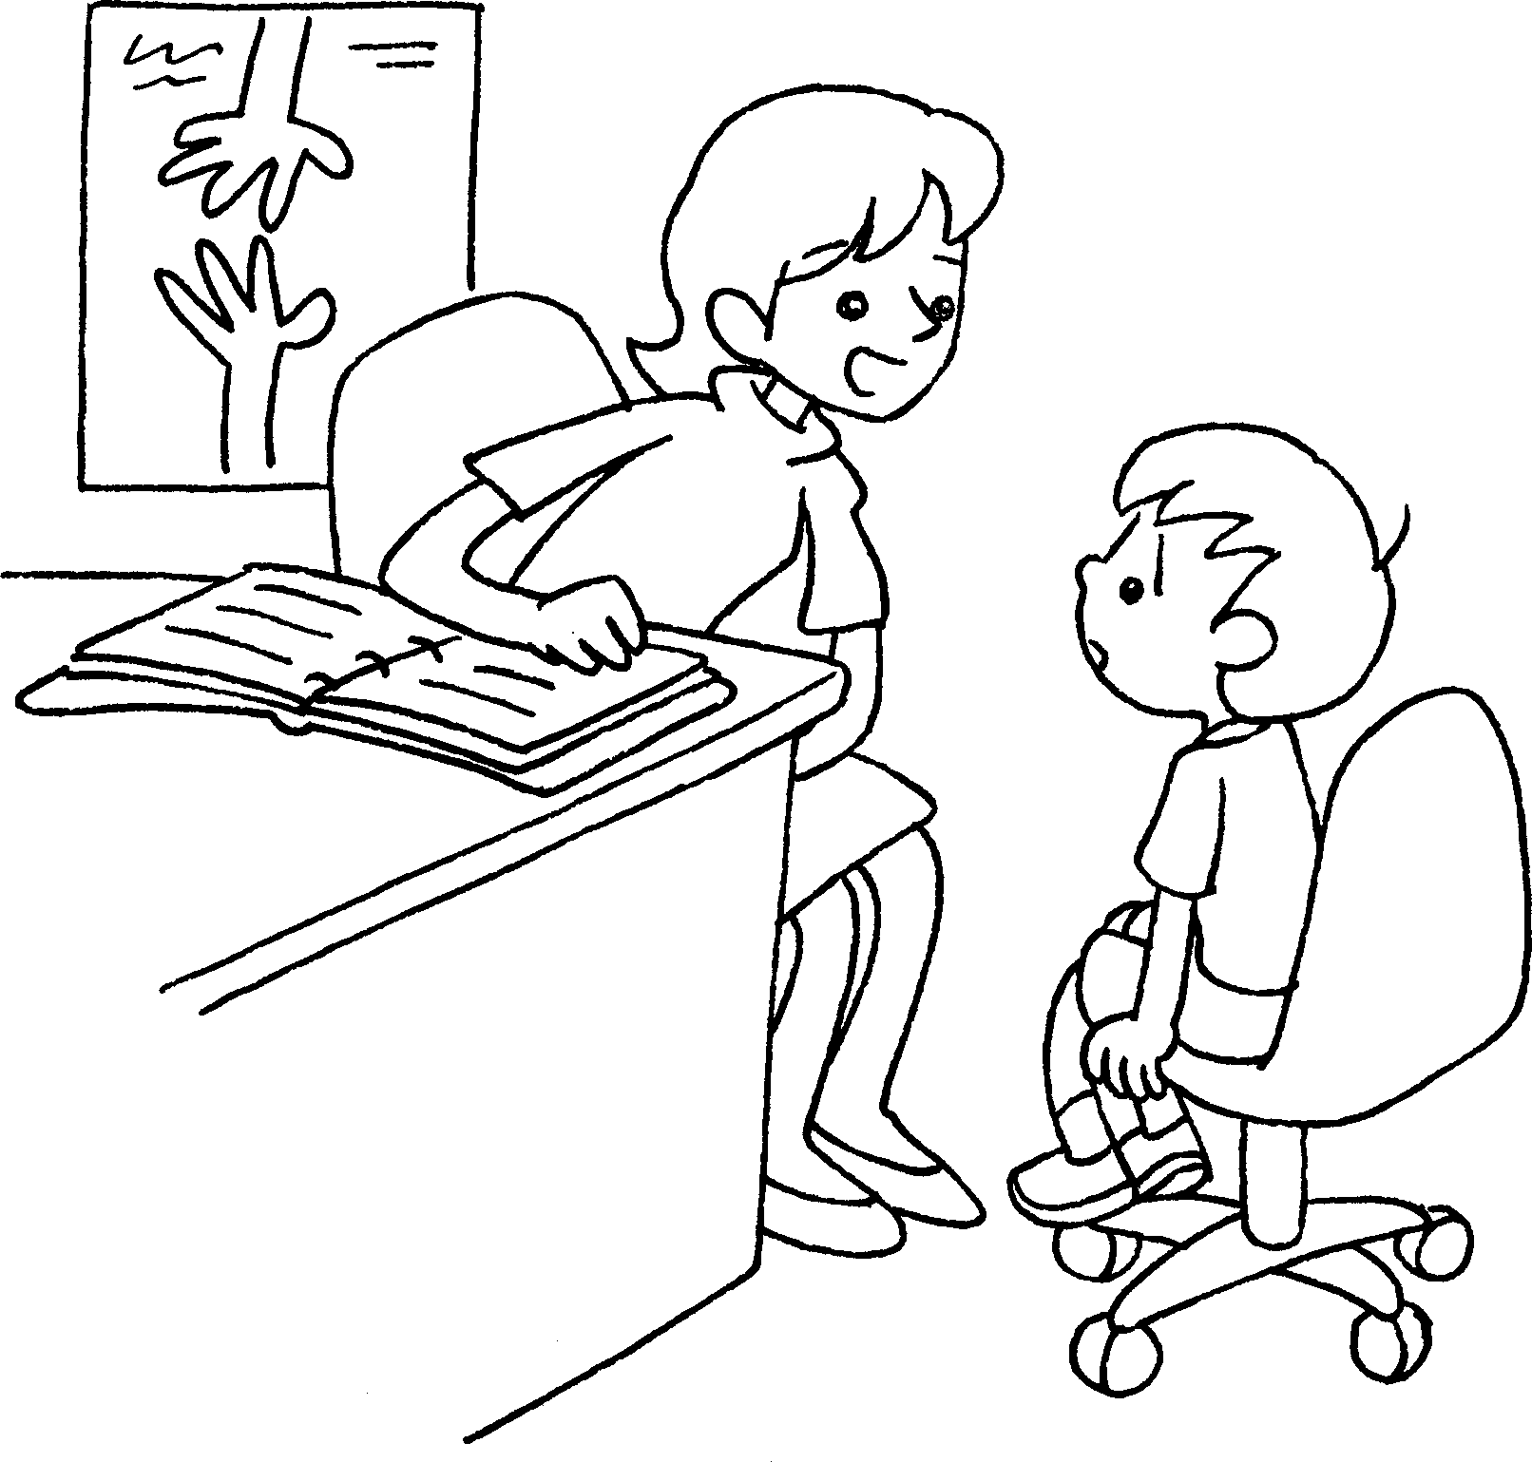  9  10  11  12 |  | 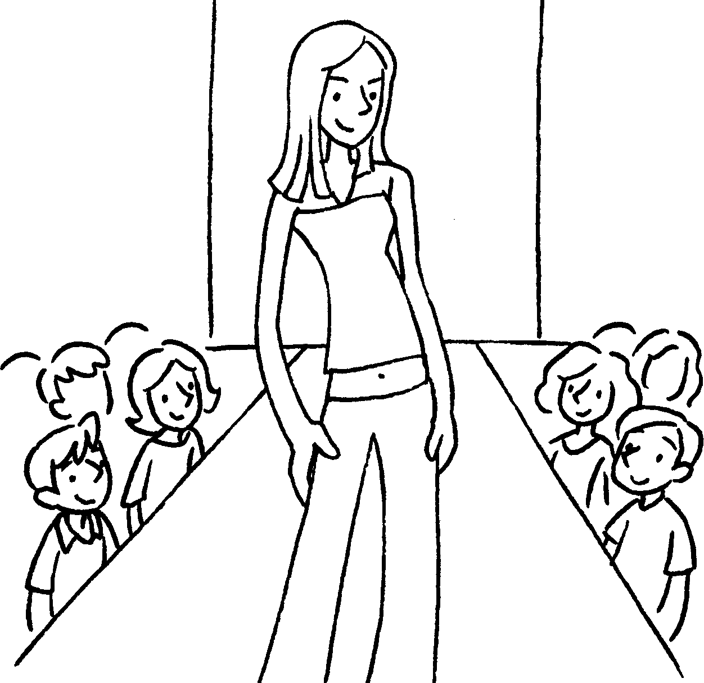 |  |  | 

1 | a | 2 | a
3 |  | 4
5 |  | 6
7 |  | 8
9 |  | 10
11 |  | 12


Book 6A Chapter 1 Graded Worksheets
Worksheet 1⬇⬇⬇
- vet 2 lawyer
3 a pilot 4 an astronaut
5 an architect 6 an actress
7 a reporter 8 a flight attendant
9 a social worker 10 a model
11 a fashion designer 12 a businesswoman

