Finish the sentences.
want to be
What
1  A  B | 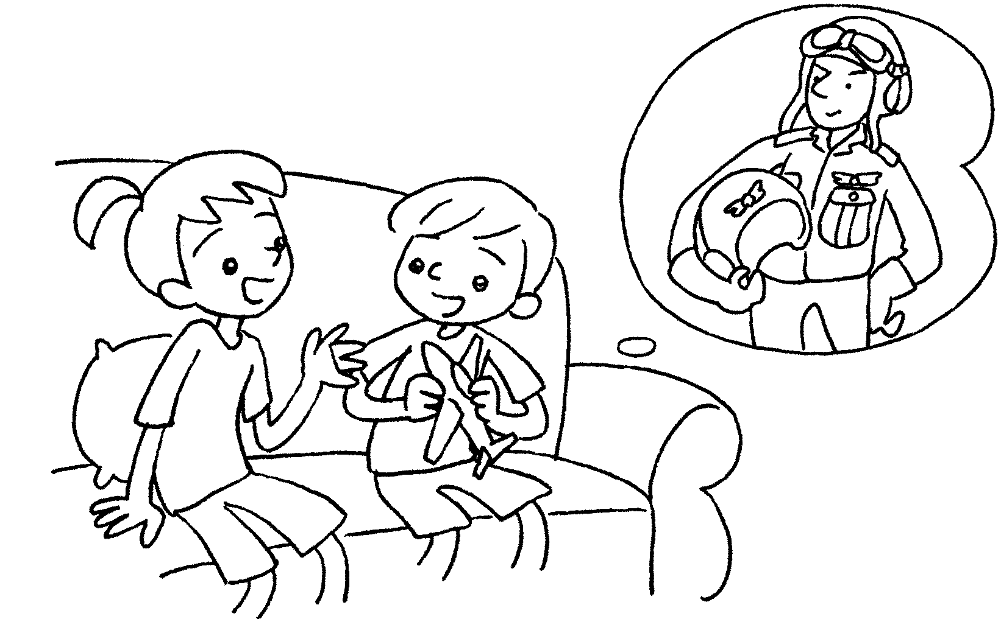 |  |  | A : do you want to be  when you grow up?  B : I want to be a pilot.
2  A  B |  | 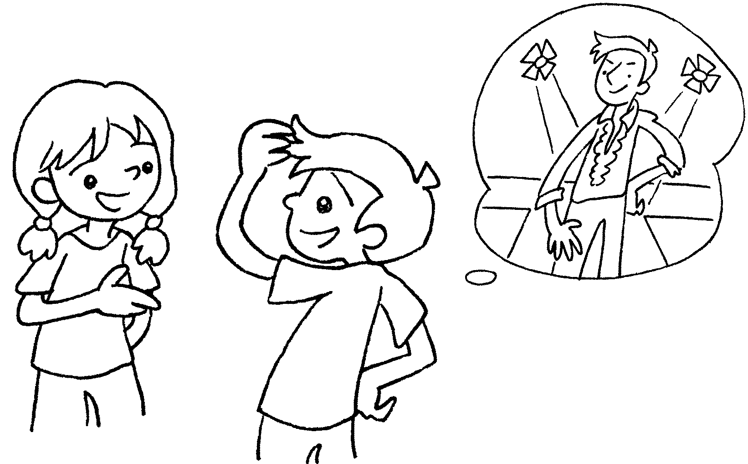 |  | A : What do you when you grow up?  B : I a model.
3  A  B |  | 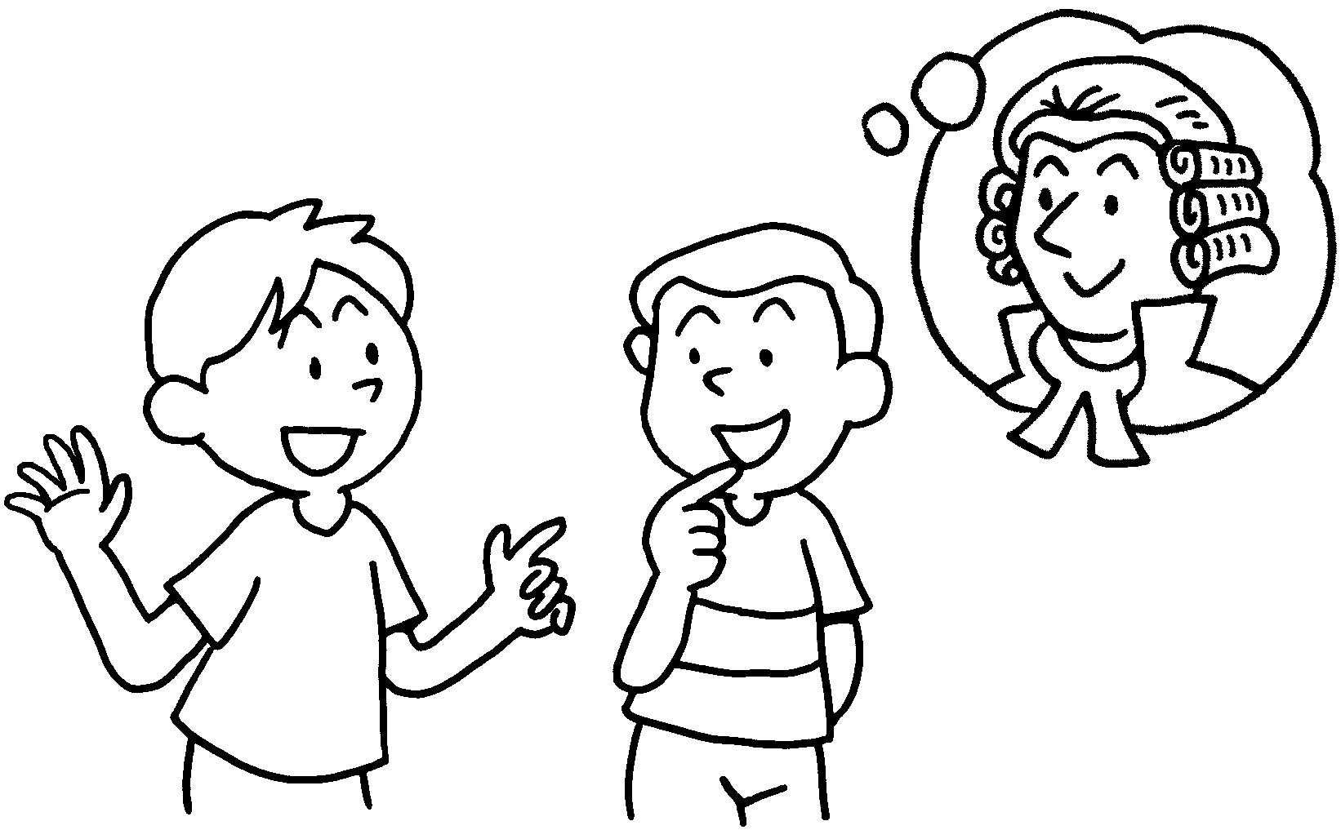 |  | A : do you  when you grow up?  B : I a lawyer.
4  an architect  A  B |  | 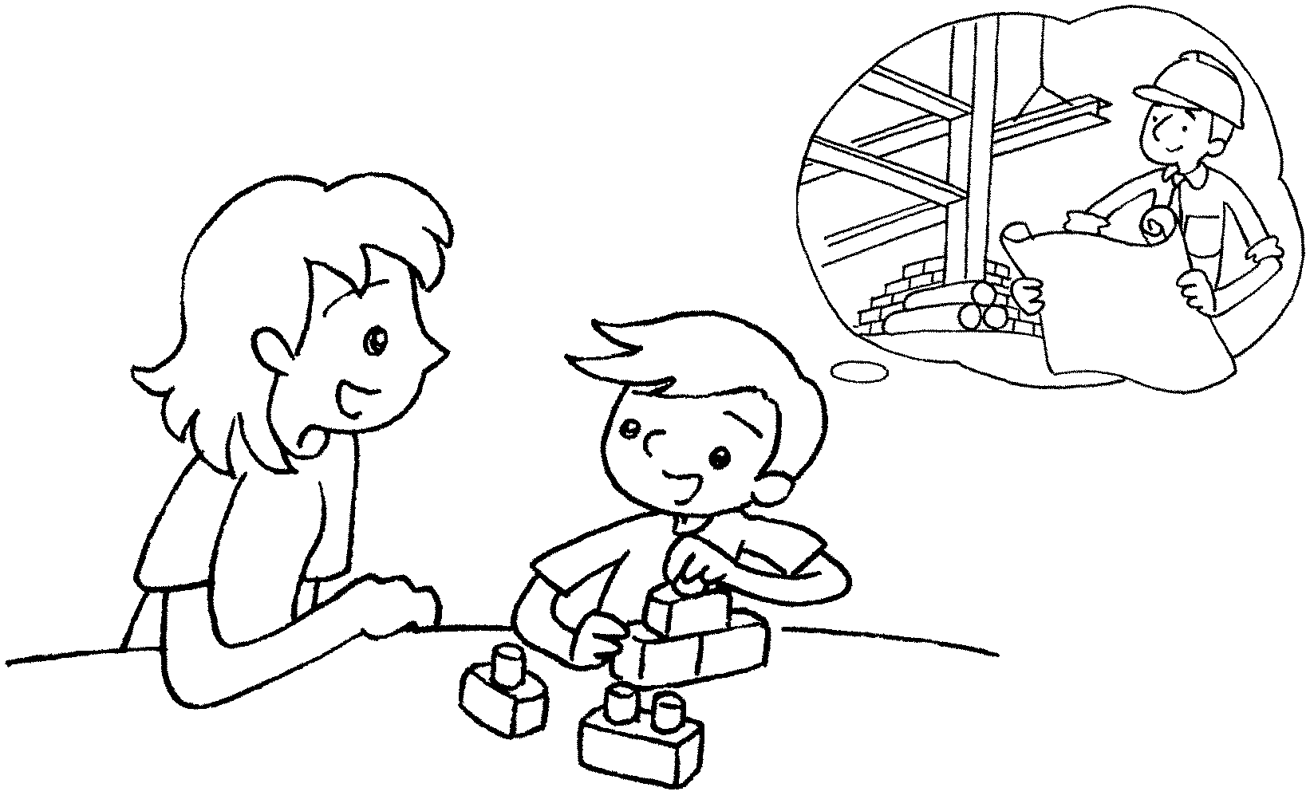 |  | A : What do you when you grow up?  B : I .
5  a policeman  A  B |  | 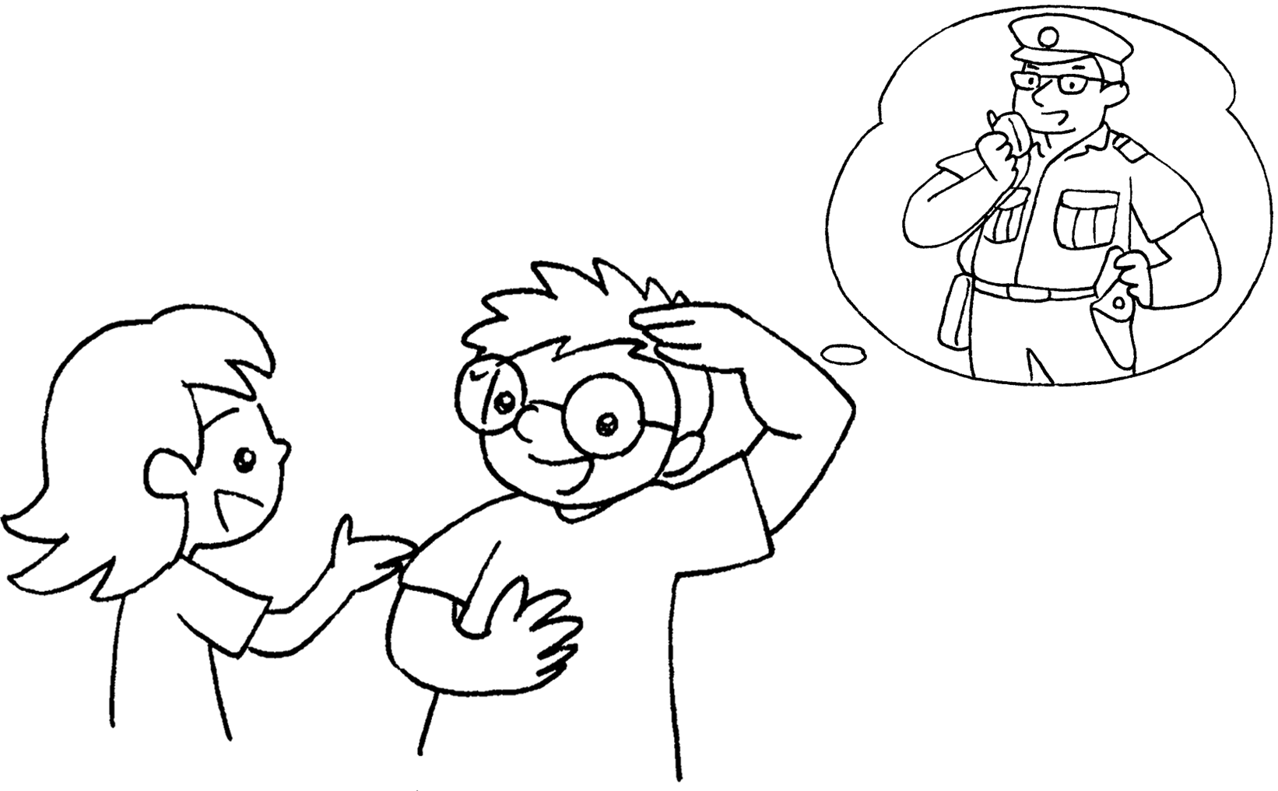 |  | A : do you  when you grow up?  B : I .
6  A  B  an astronaut |  | 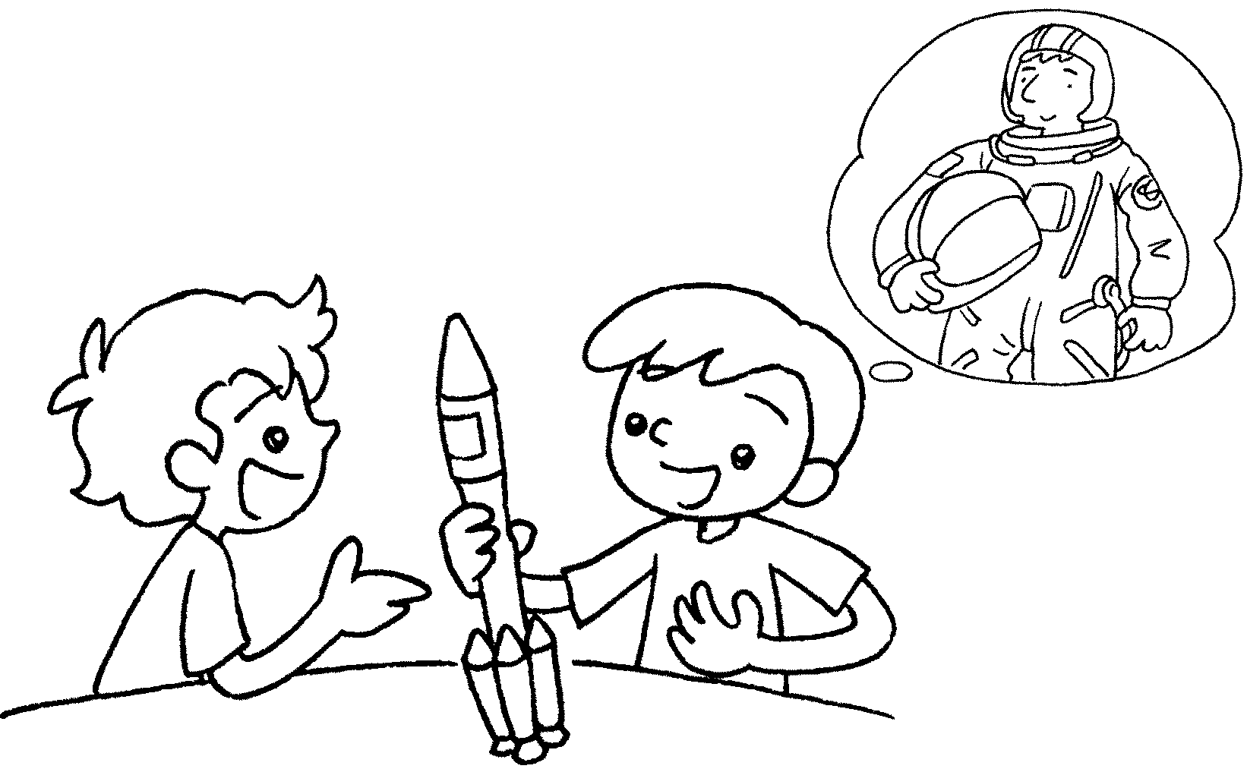 |  | A : do you  when you grow up?  B : I .


Book 6A Chapter 1 Graded Worksheets
Worksheet 2⬇
- What
- want to be
want to be
3 What want to be
want to be
4 want to be
want to be an architect
5 What want to be
want to be a policeman
6 What want to be
want to be an astronaut

