policeman
What do the children want to be when they grow up? Finish what they say.
astronaut
model
architect
lawyer
1  A  B | 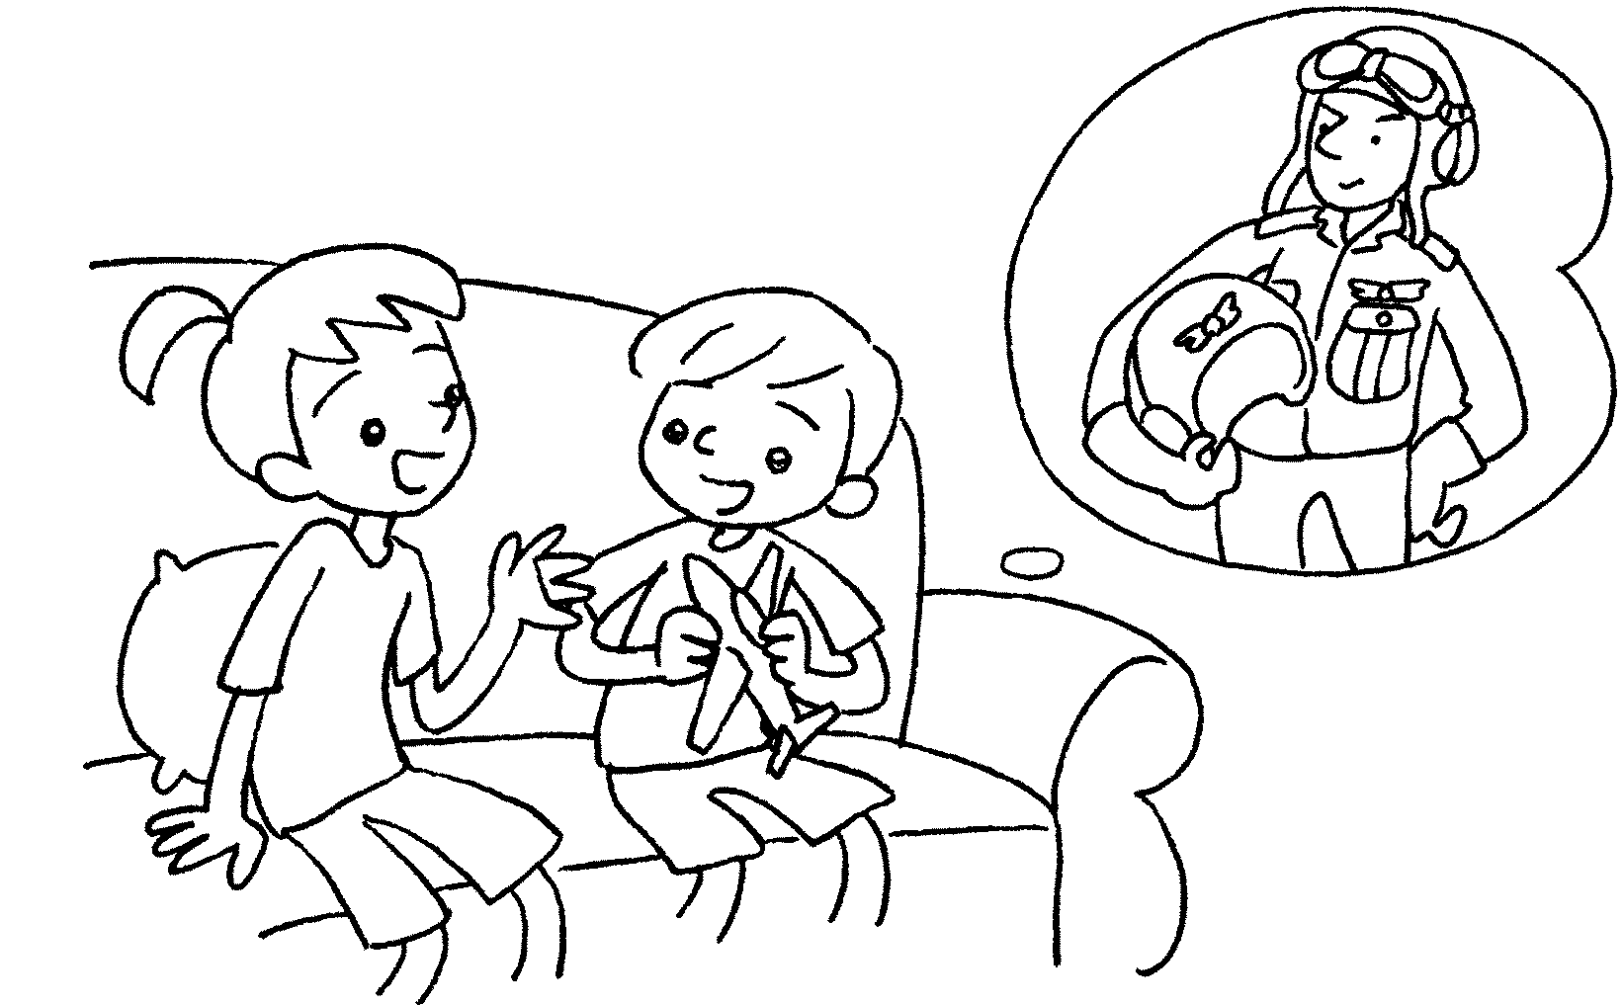 |  |  | A : What do you want to be when you grow up?  B : I want _______________ a pilot.
2  A  B |  | 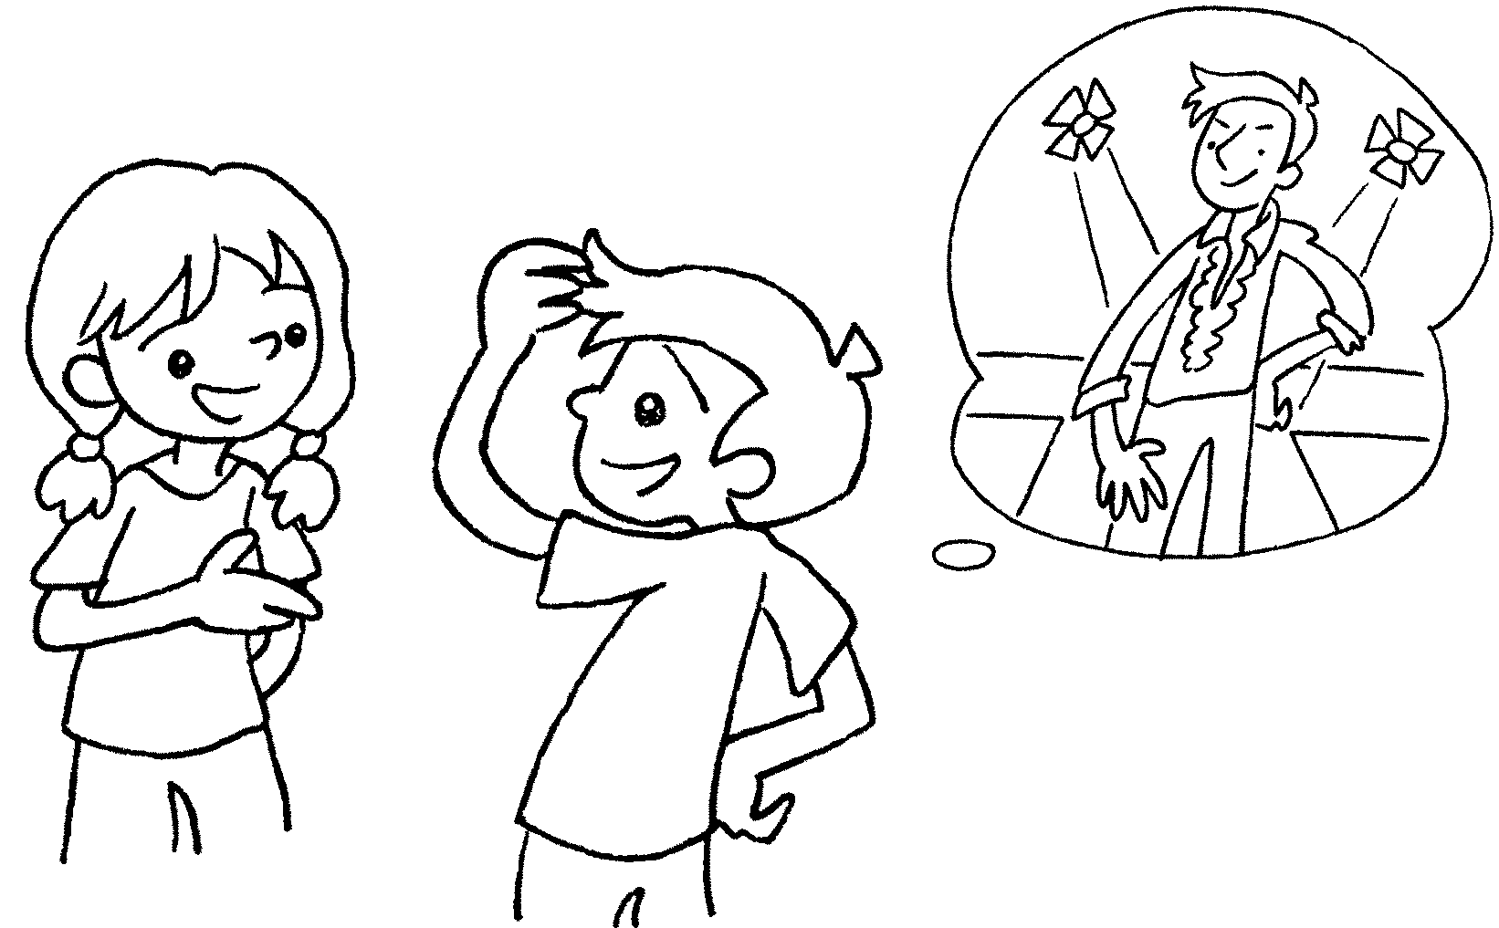 |  | A : What do you when you grow up?  B : I want .
3  A  B |  | 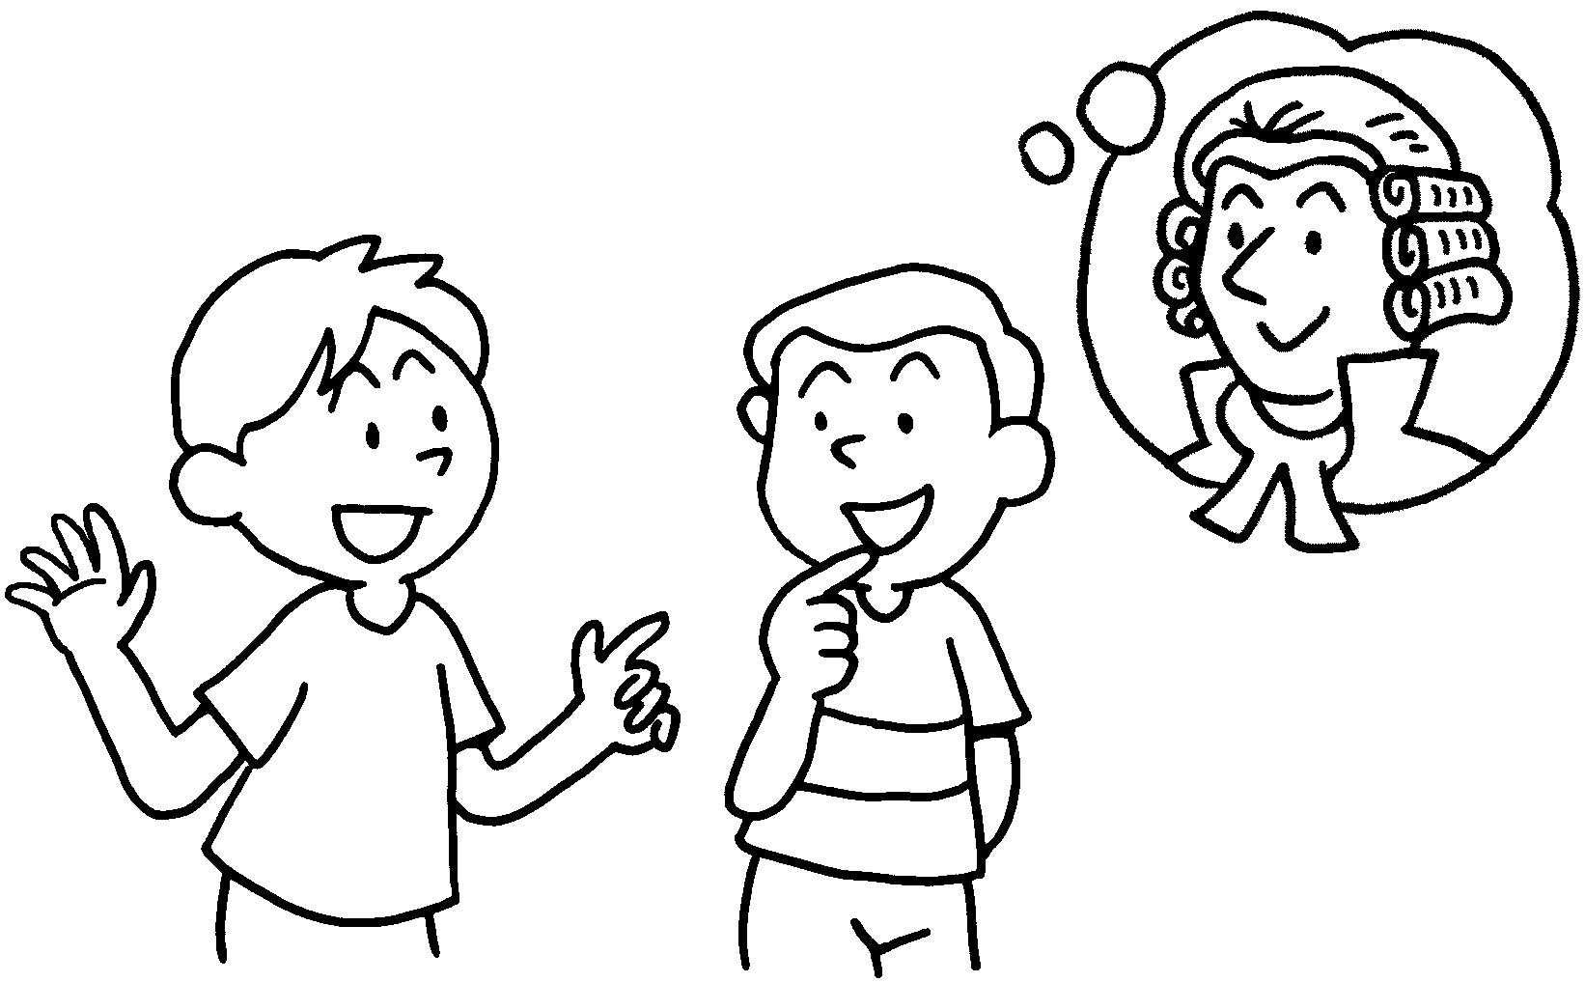 |  | A : do you  when you grow up?  B : I .
4  A  B |  | 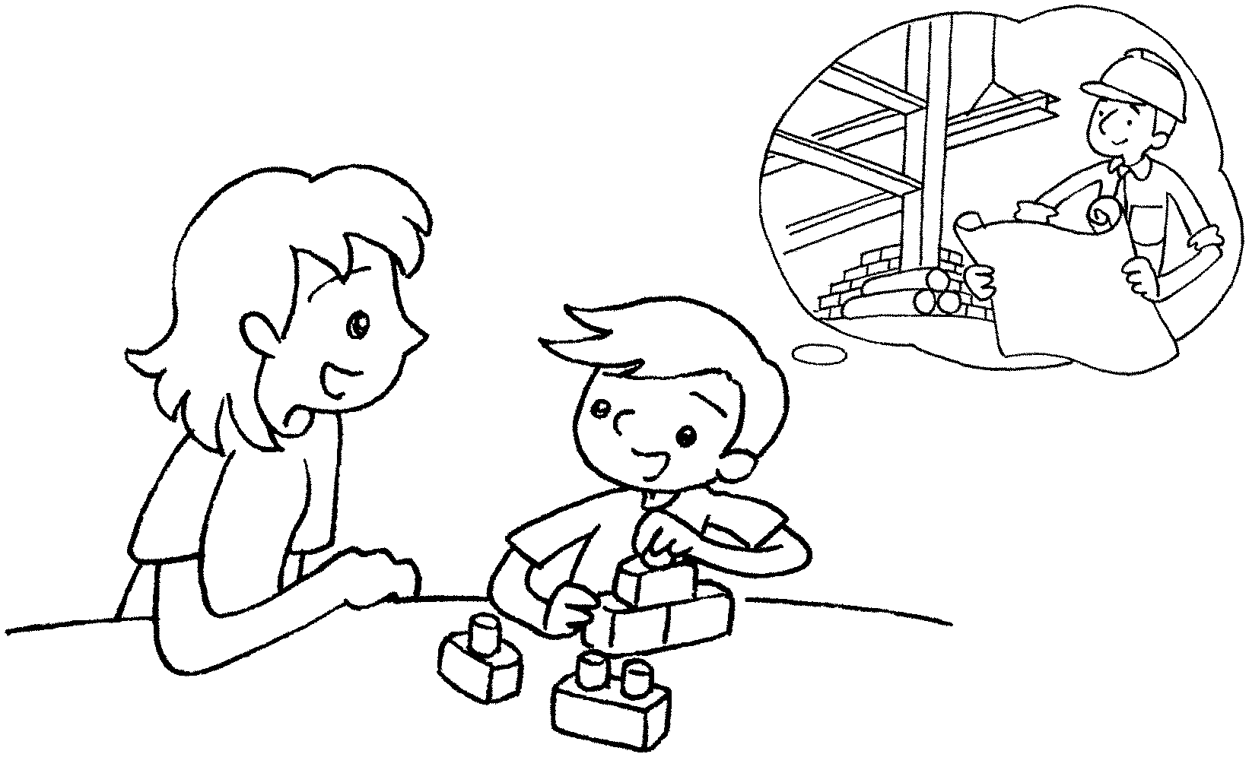 |  | A : do you  when you grow up?  B : I .
5  A  B |  | 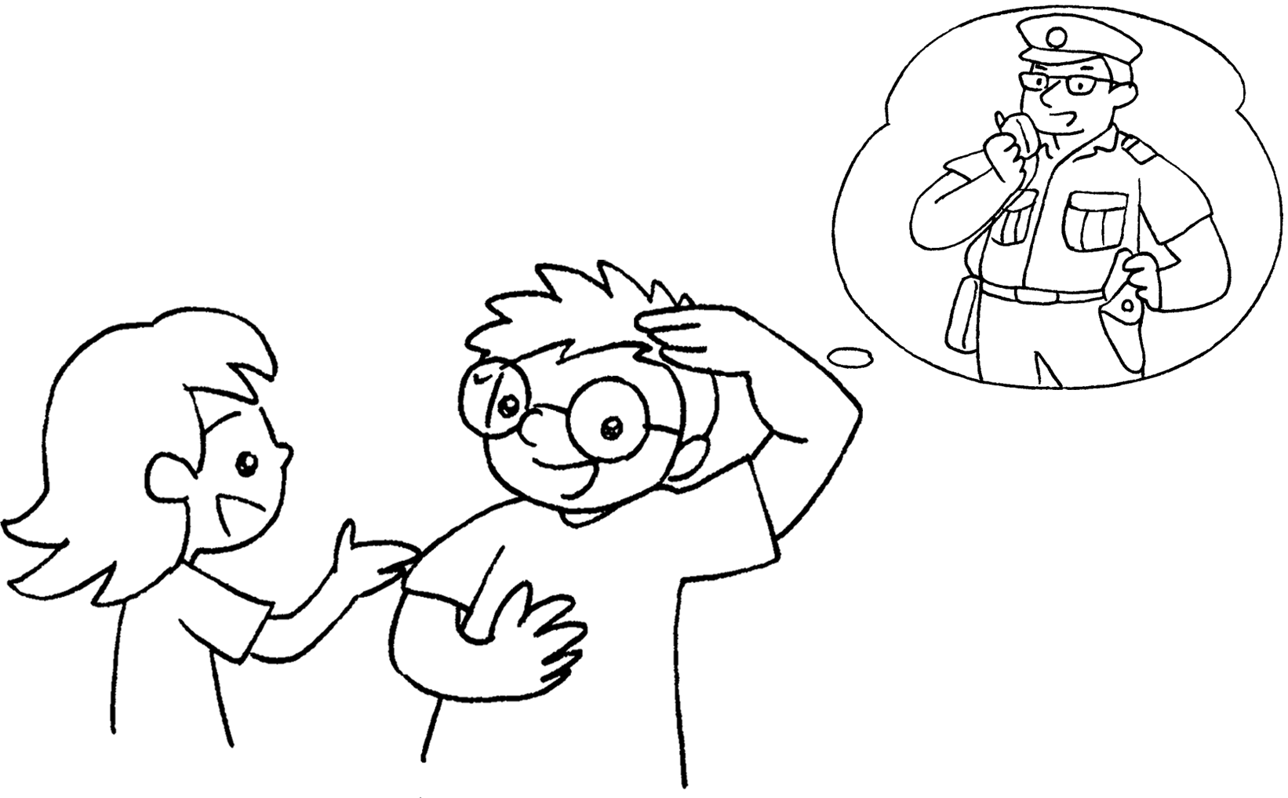 |  | A :  when you grow up?  B : I .
6  A  B |  | 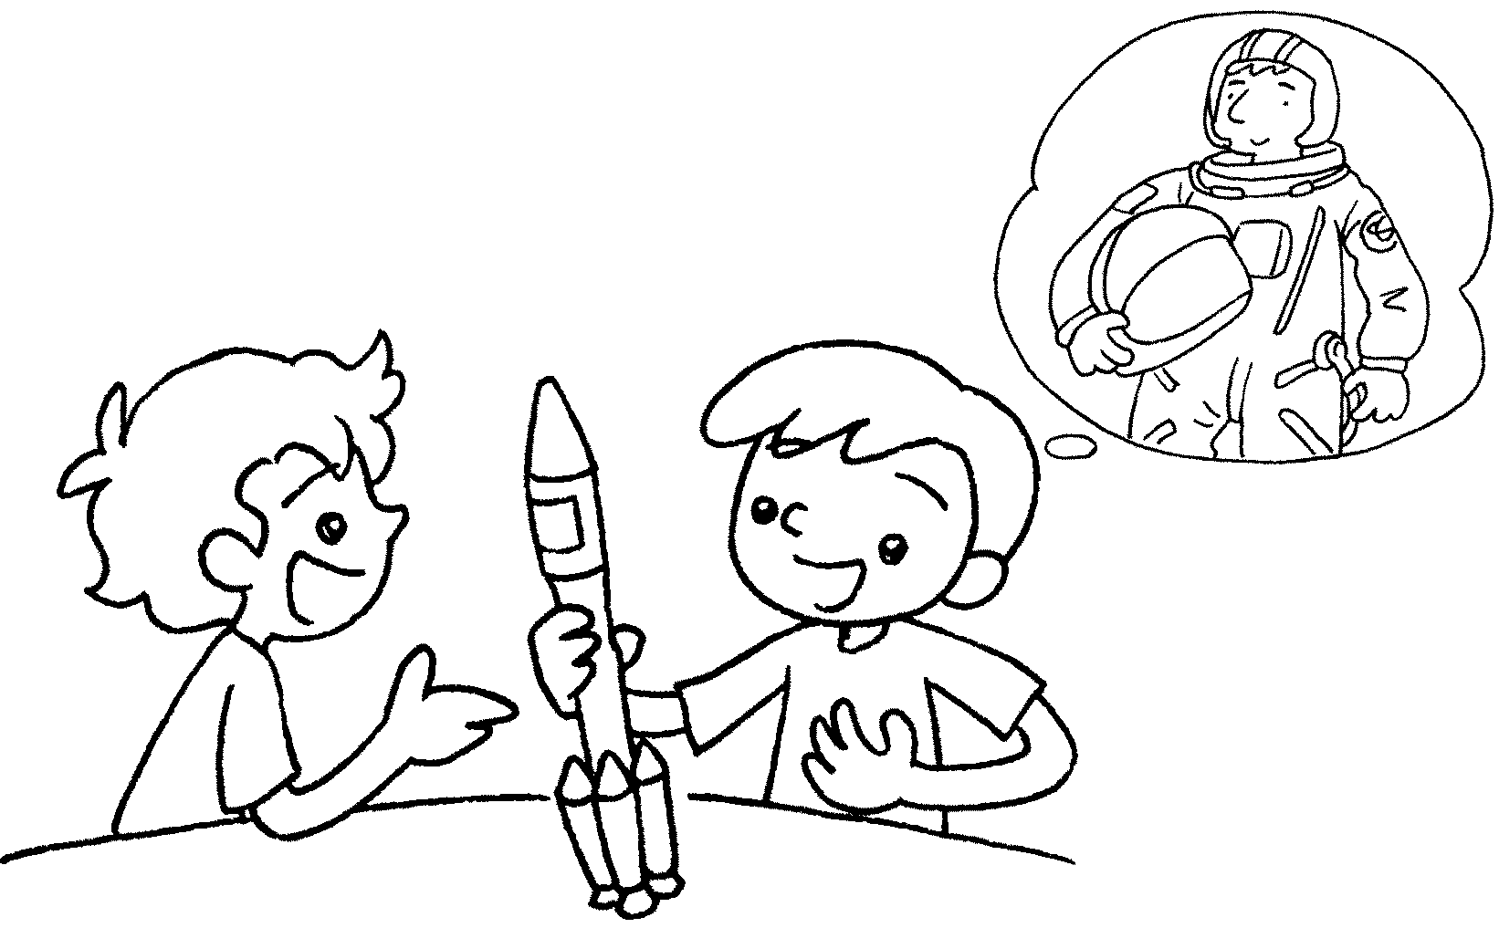 |  | A :  B :


Book 6A Chapter 1 Graded Worksheets
Worksheet 2⬇⬇
- to be
- want to be
to be a model
3 What want to be
want to be a lawyer
4 What want to be
want to be an architect
- What do you want to be
want to be a policeman
- What do you want to be when you grow up?
I want to be an astronaut.

