Finish the sentences.
will …
If … become
1 | 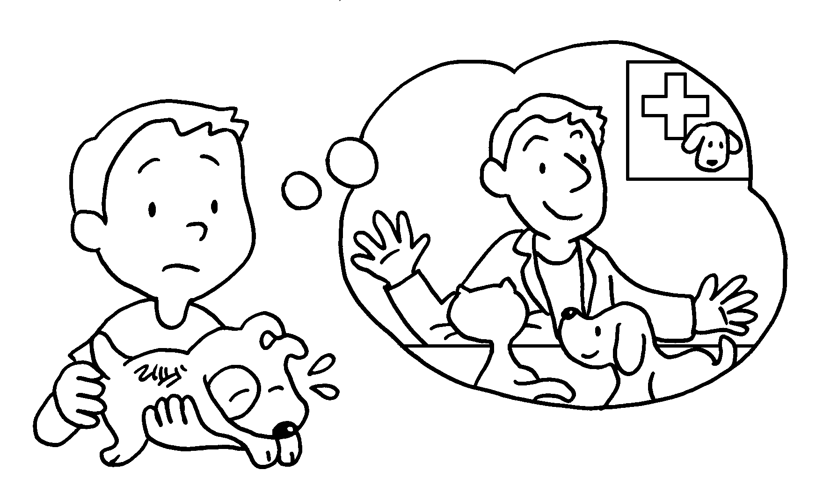 | I a vet, I will cure all the sick animals.
2 | 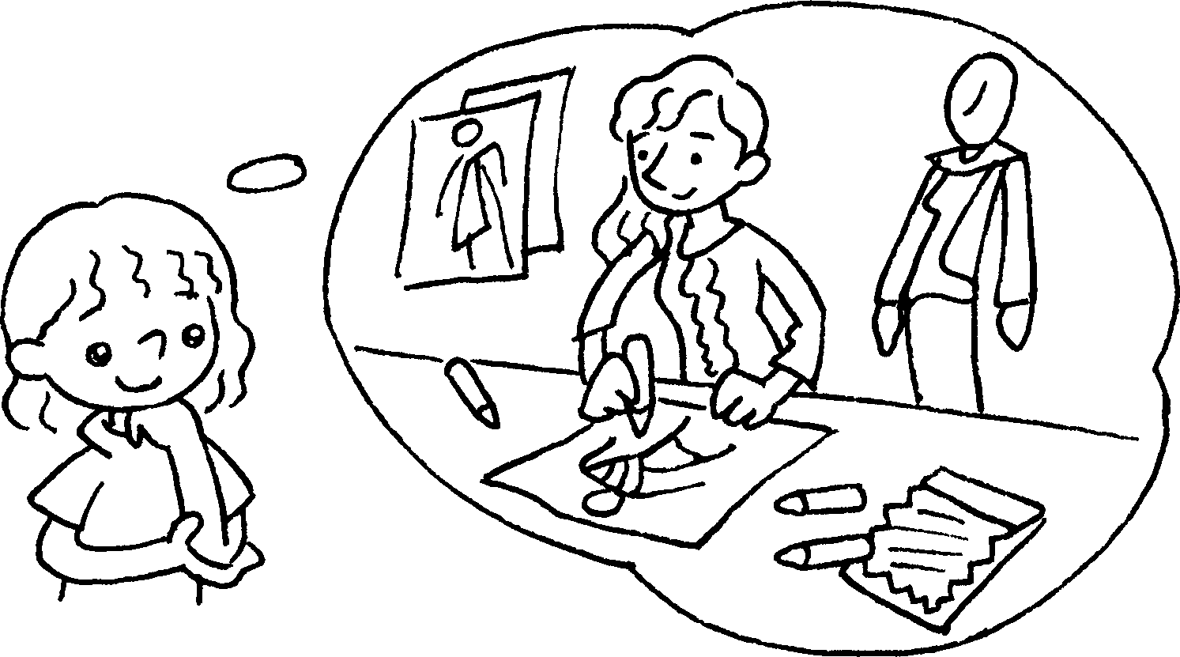 | I a fashion designer, I will design many beautiful clothes.
3 | 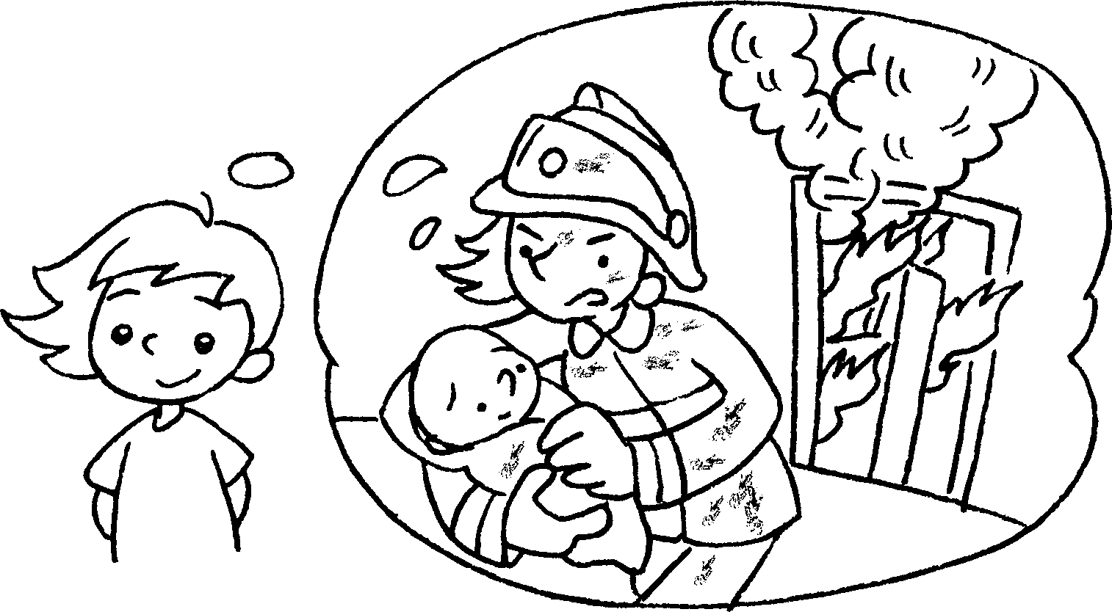 | If I become a firewoman, I  ( save ) people from fires.
4 | 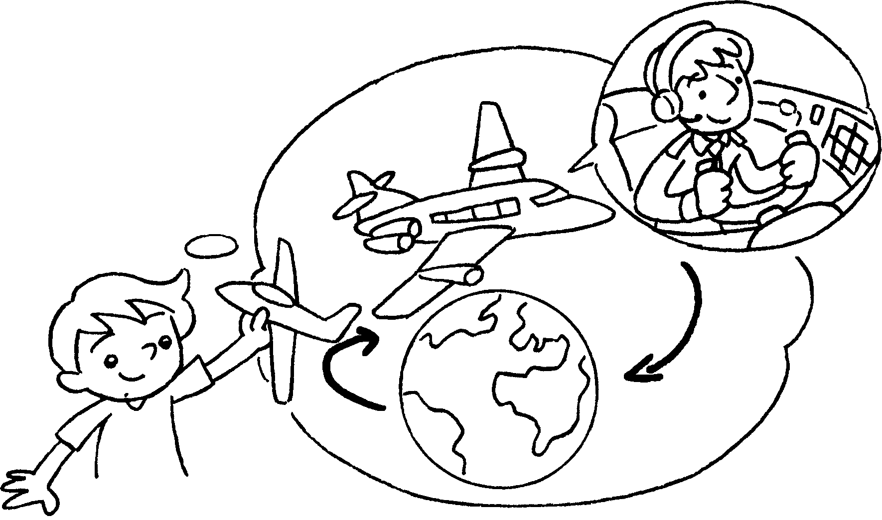 | If I become a pilot, I ( fly ) to many places.
5 | 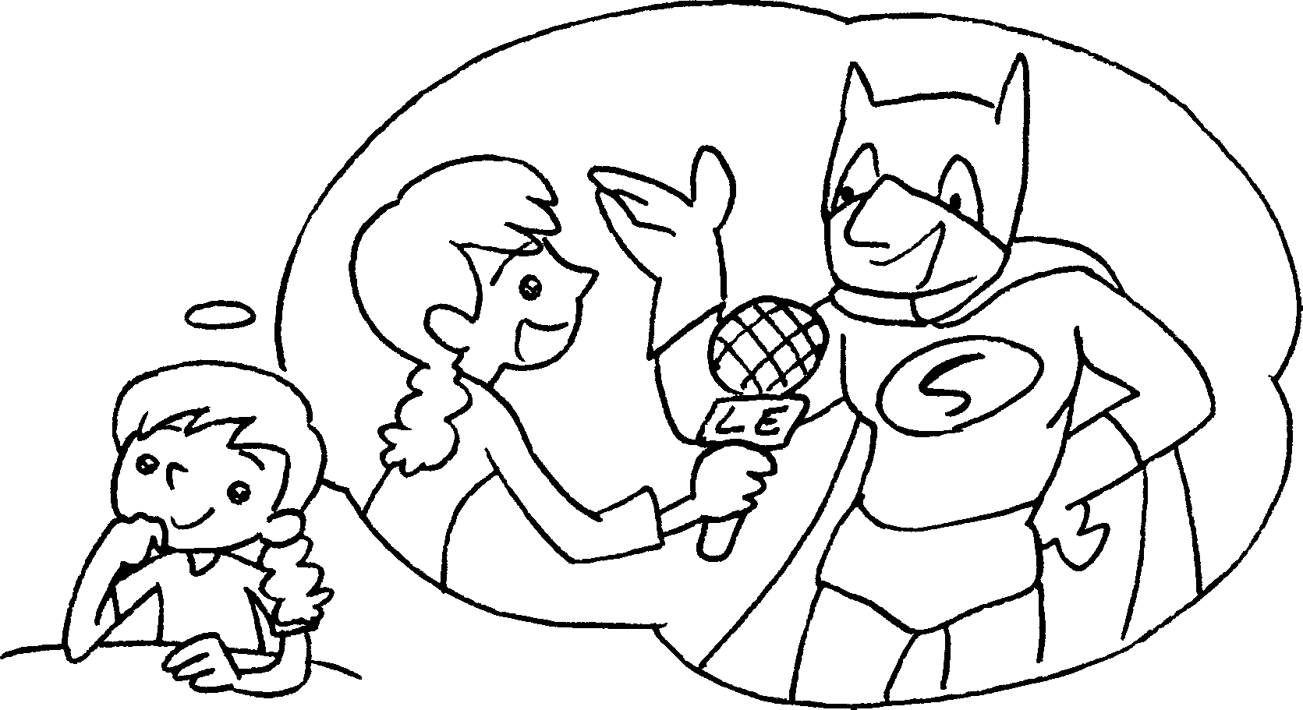 | I a reporter, I  ( interview ) famous people.
6 | 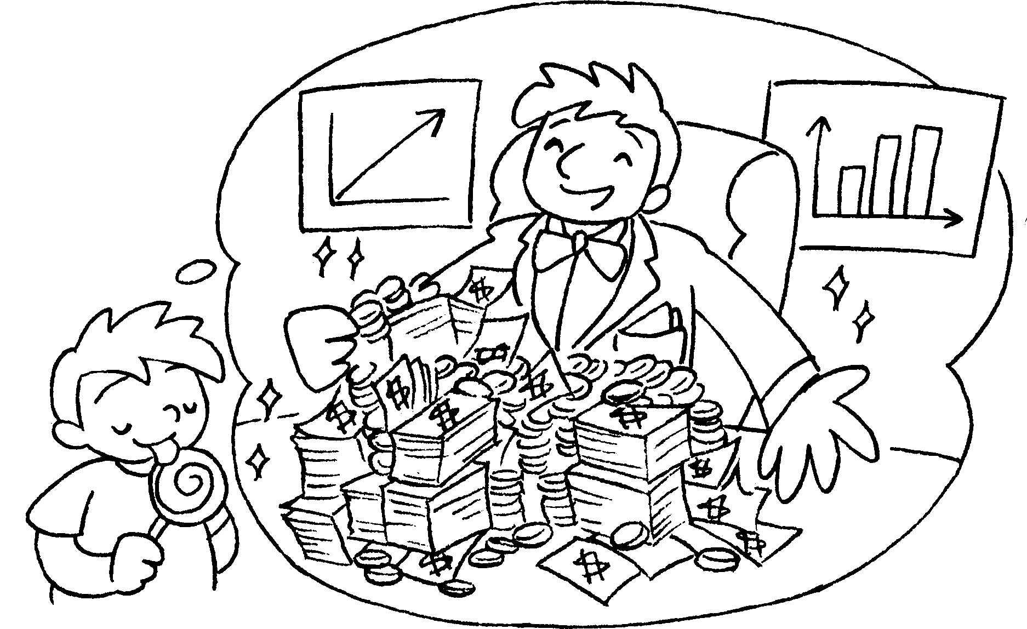 | I a businessman, I  ( earn ) a lot of money.


Book 6A Chapter 1 Graded Worksheets
Worksheet 3⬇
1 If become
2 If become
3 will save
4 will fly
5 If become will interview
6 If become will earn

