Finish the sentences.

interview famous people save people from fires cure
fly to many places earn a lot of money design

1 | 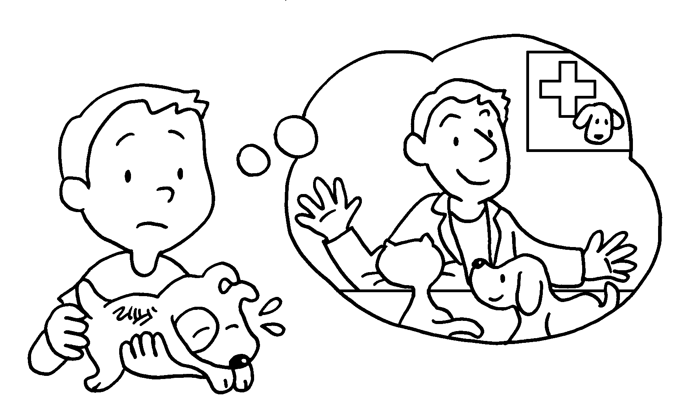 | If I become a vet, I will ___________ all the sick animals.
2 | 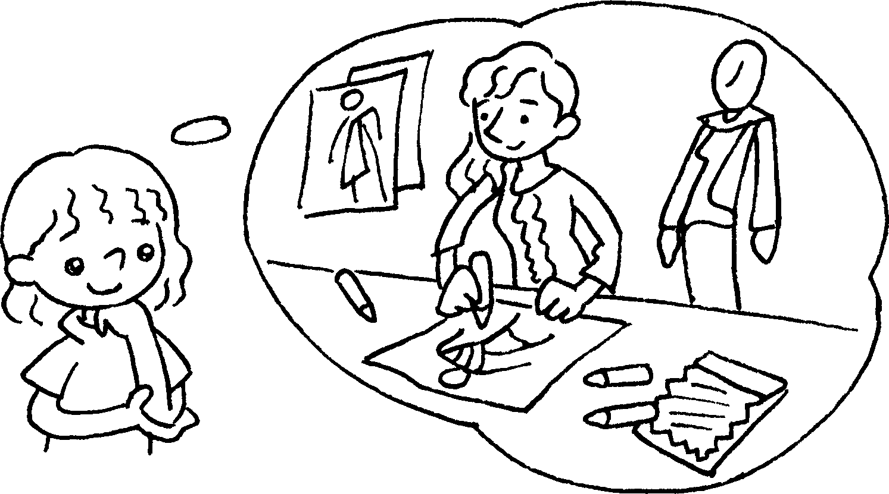 | I become a fashion designer, I will _______________ many beautiful clothes.
3 | 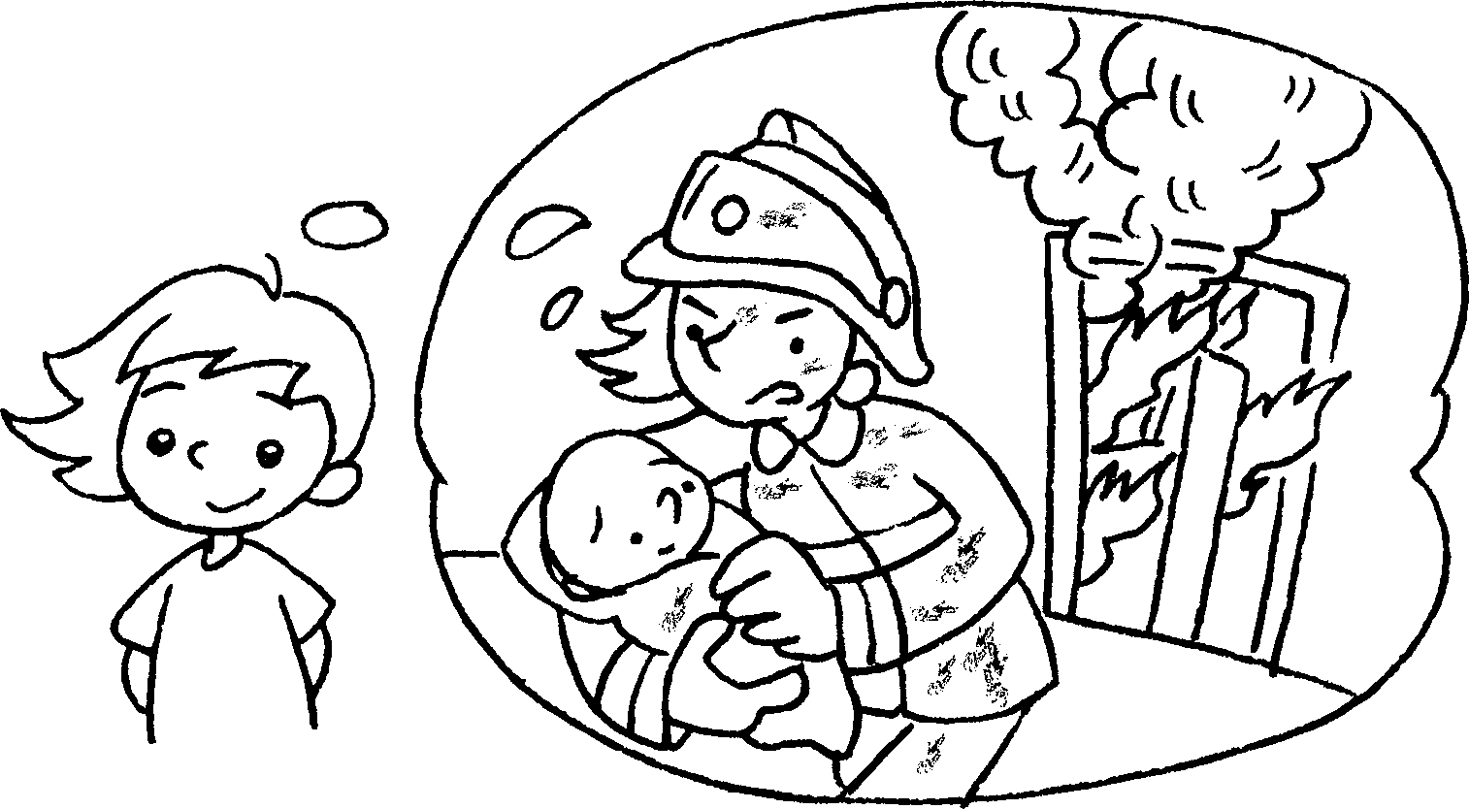 | If a firewoman, I  .
4 | 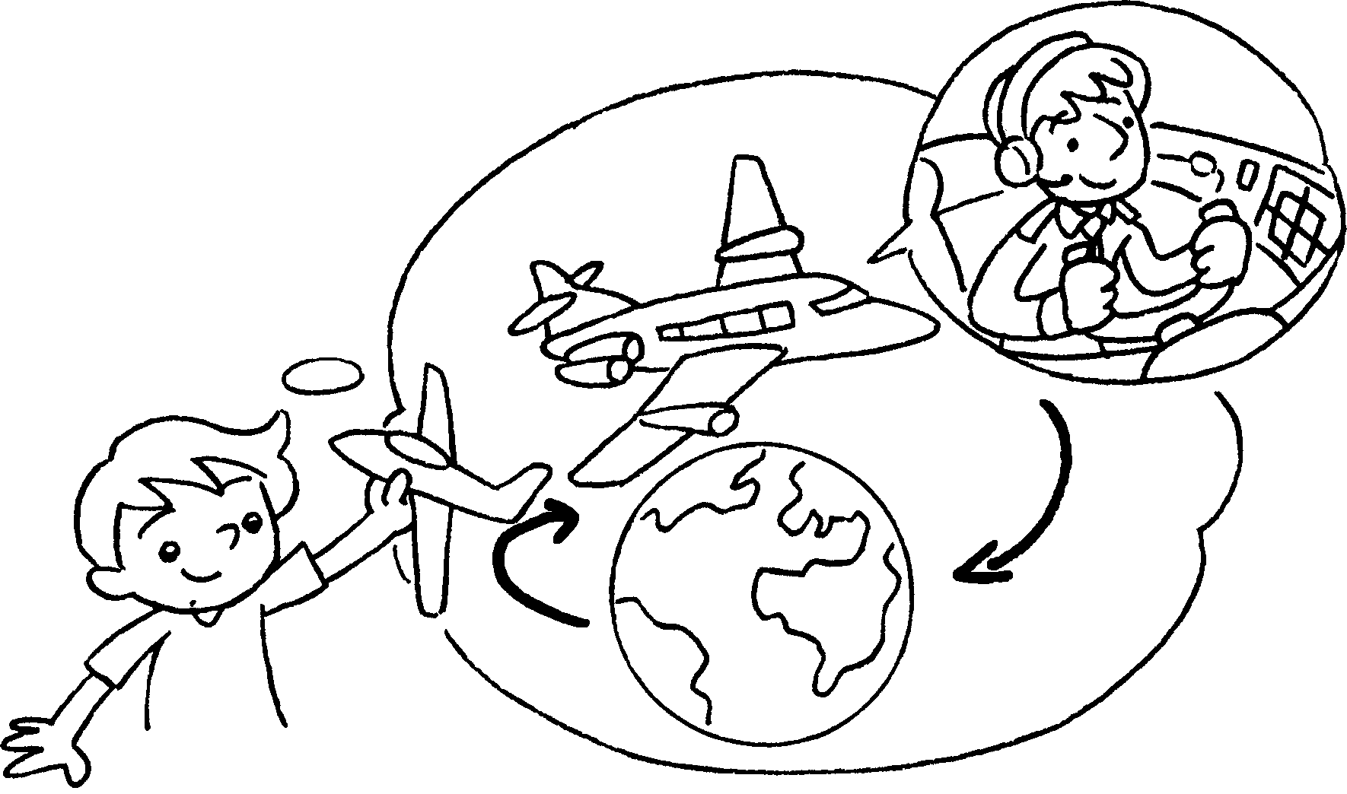 | a pilot, I  .
5 | 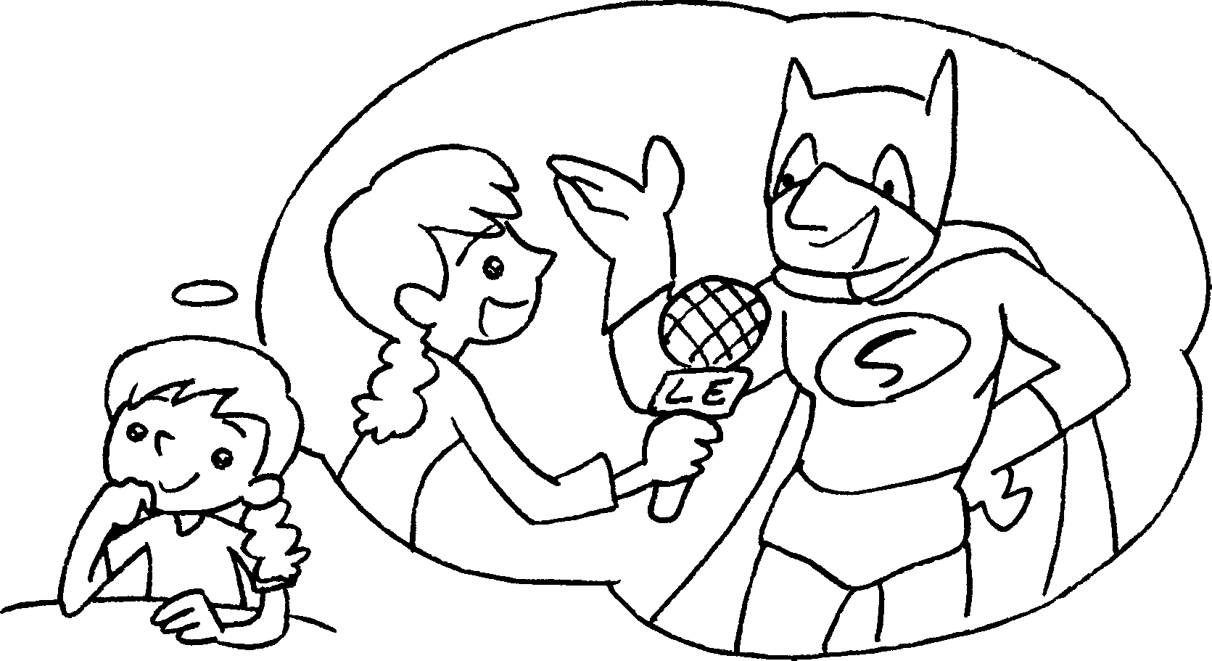 | a reporter, I  .
6 | 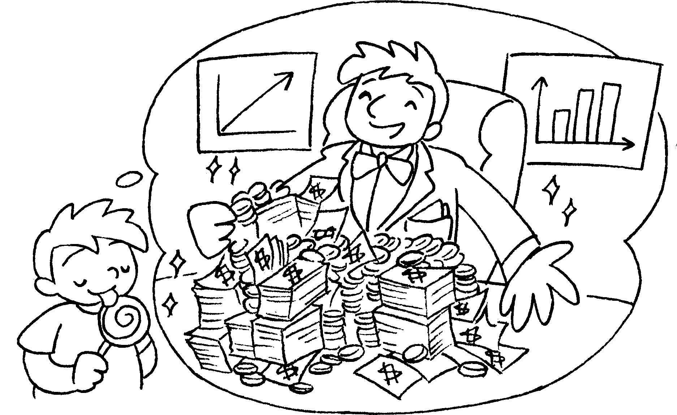 | a businessman, I  .


Book 6A Chapter 1 Graded Worksheets
Worksheet 3⬇⬇
- cure
- If design
- I become will save people from fires
- If I become will fly to many places
- If I become will interview famous people
- If I become will earn a lot of money

