Finish the sentences.

interview cure earn famous people people from fires
save fly design to many places a lot of money
1 | 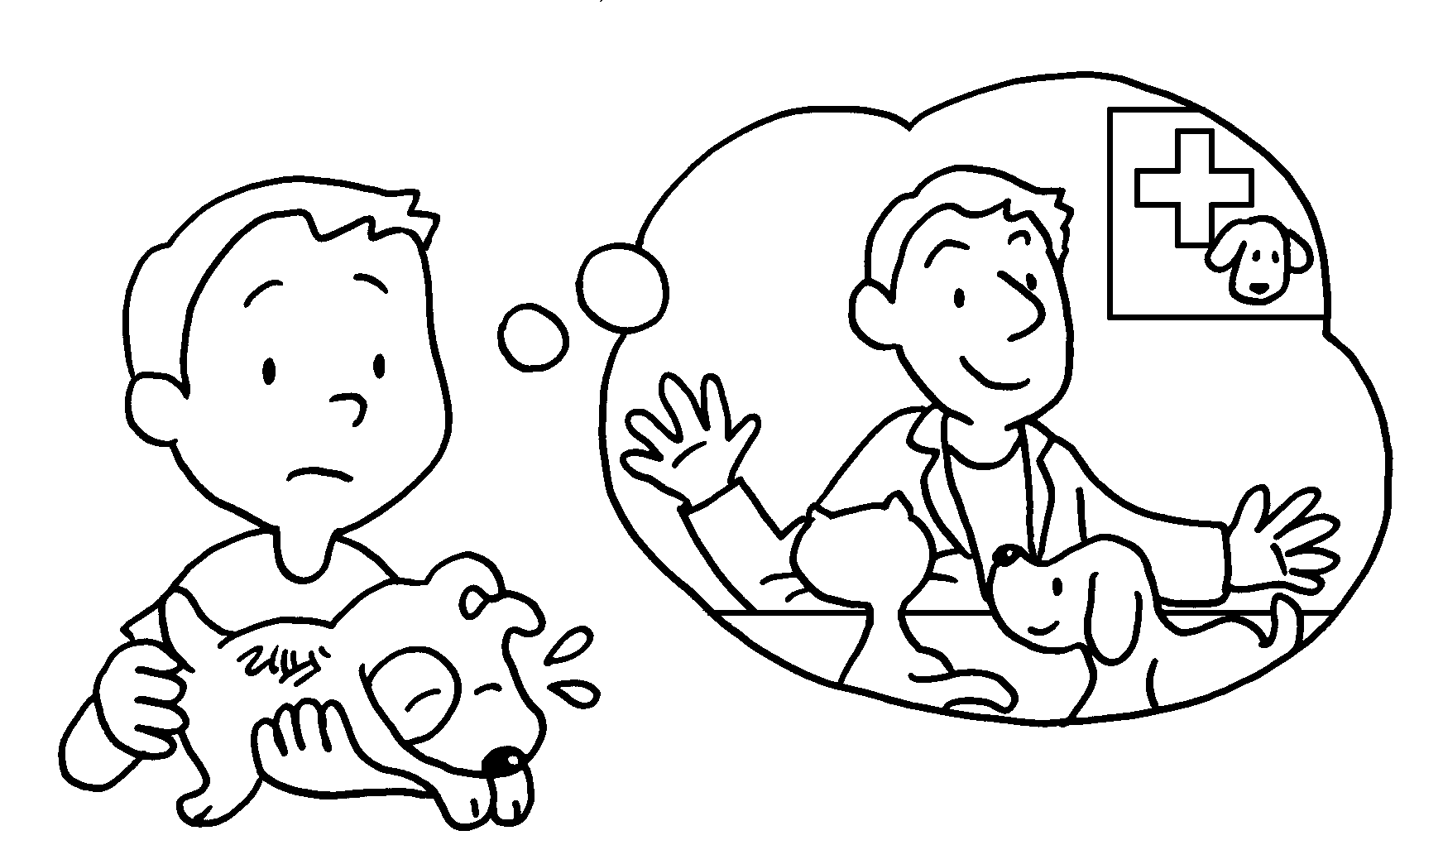 | If I become a vet, I will ___________ all the sick animals.
2 | 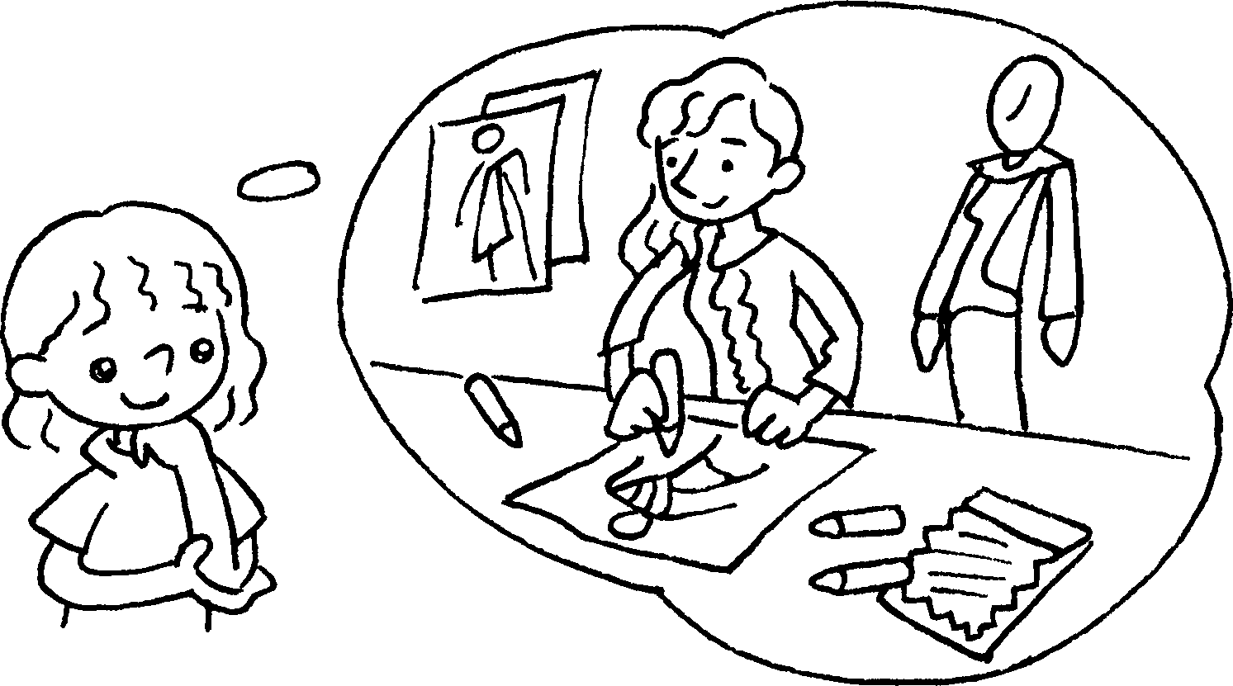 | I become a fashion designer, I will _______________ many beautiful clothes.
3 | 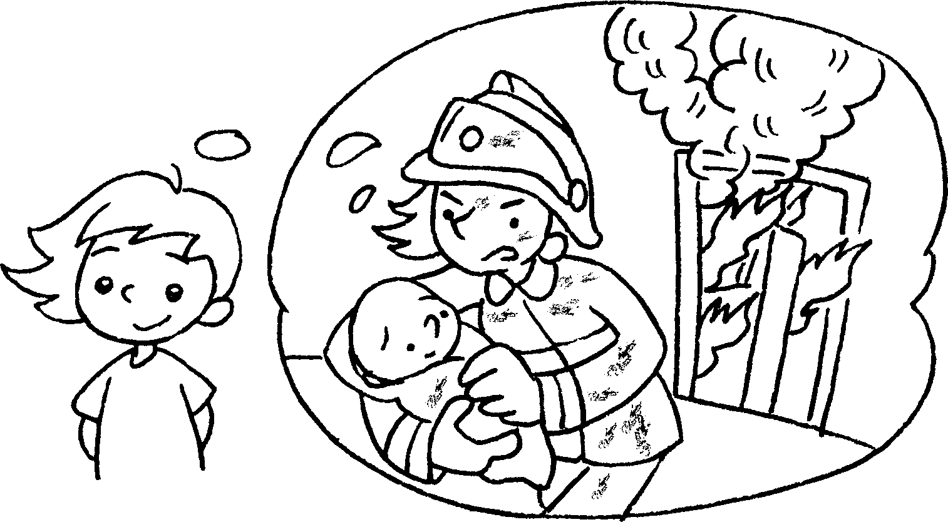 | If a firewoman, I  .
4 | 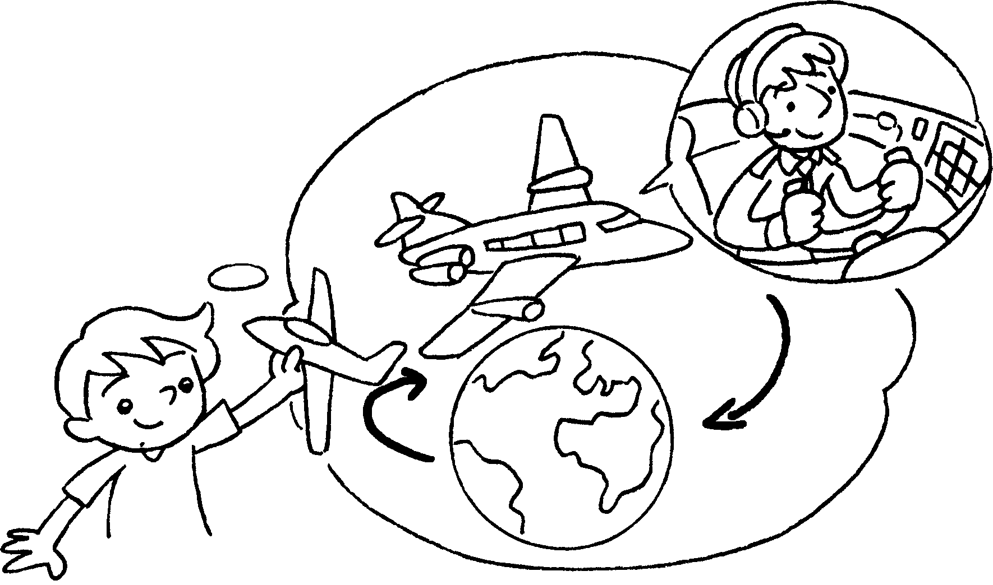
5 | 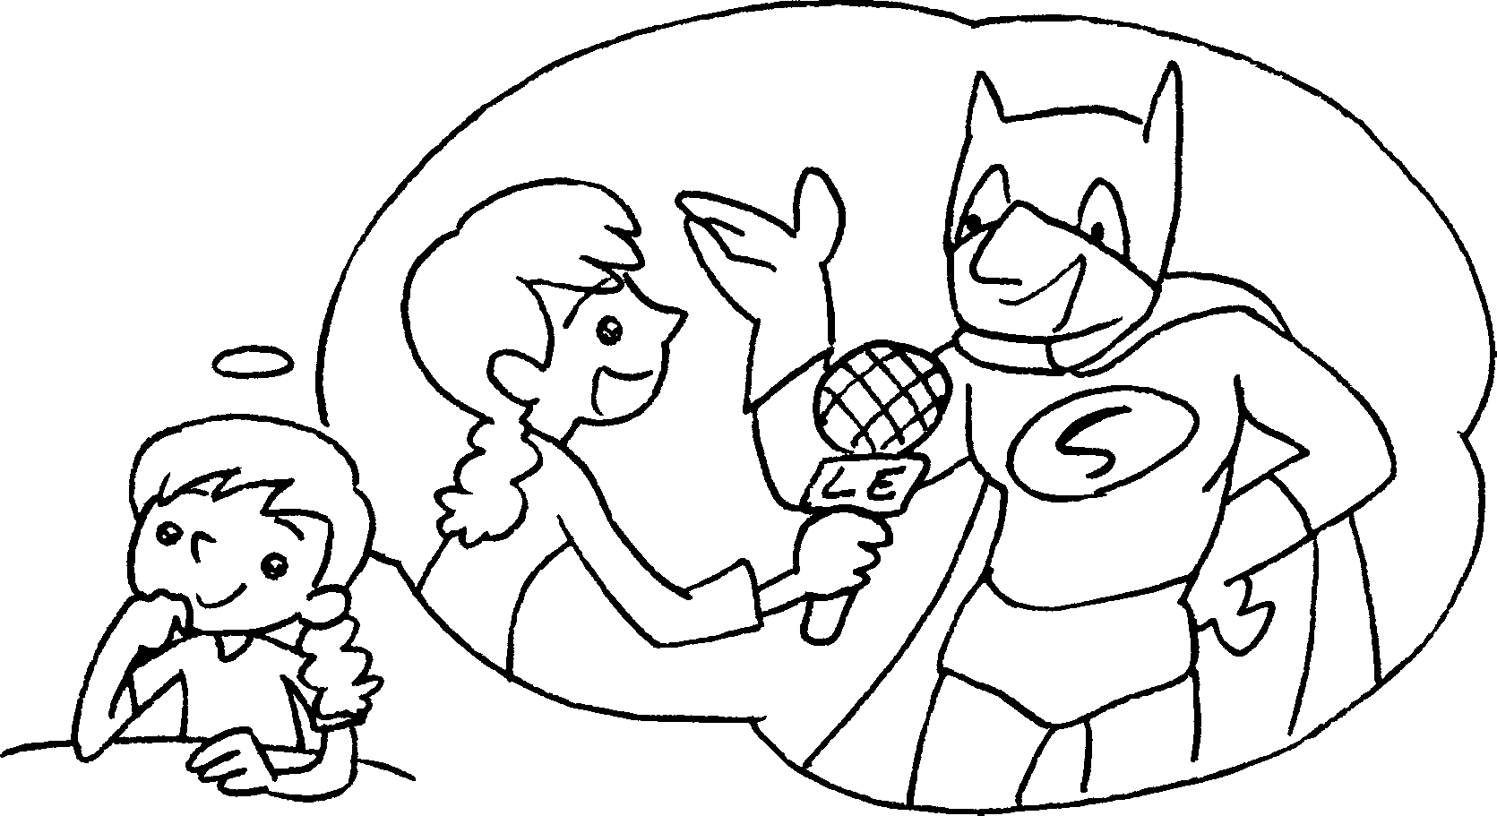
6 | 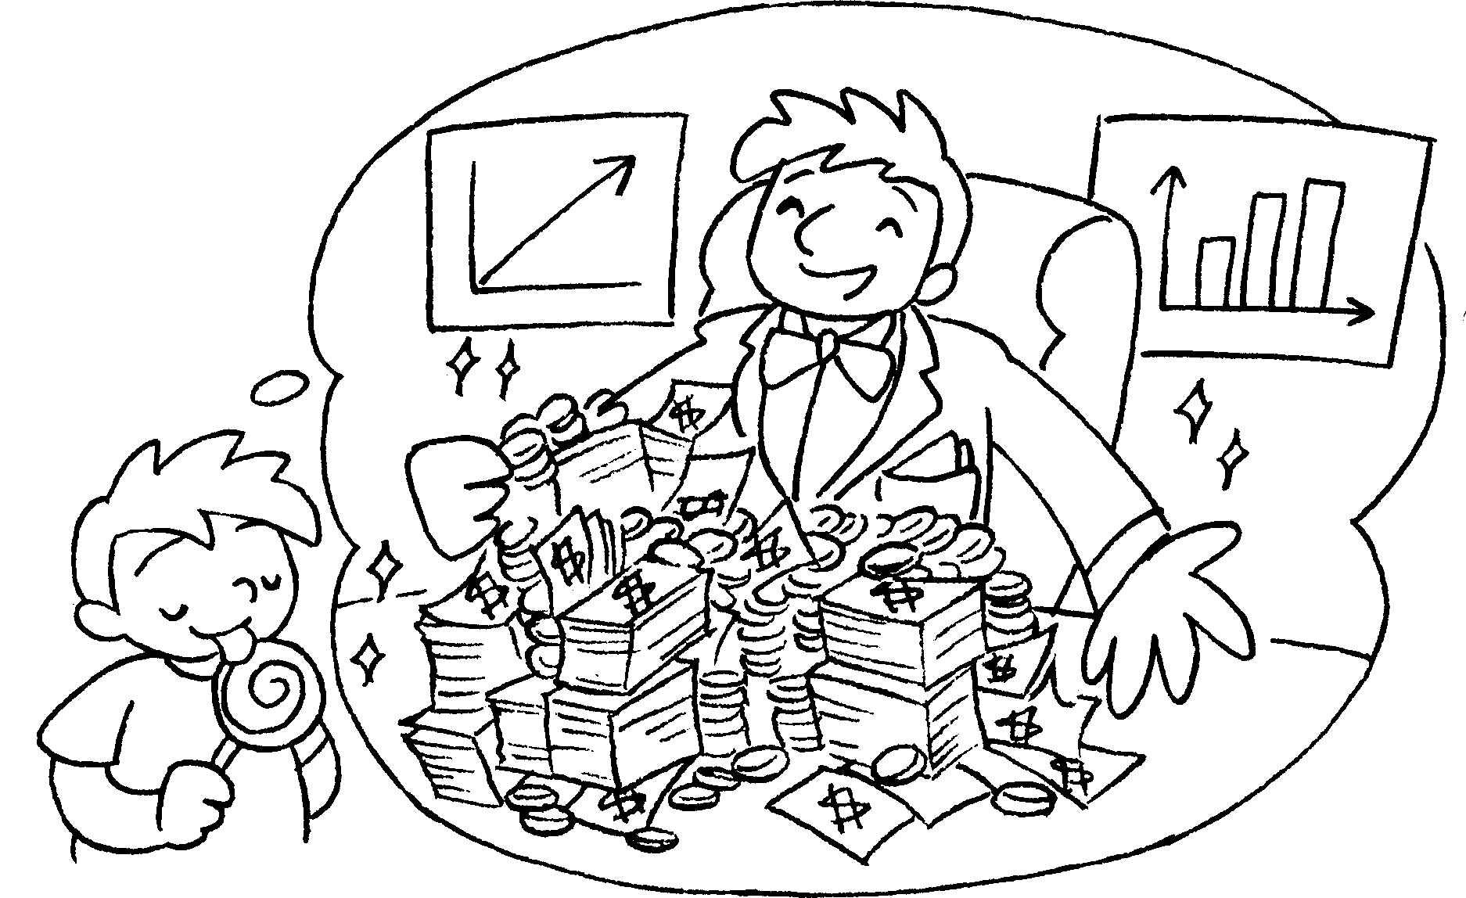


Book 6A Chapter 1 Graded Worksheets
Worksheet 3⬇⬇⬇
- cure
- If design
- I become will save people from fires
- If I become a pilot, I will fly to many places.
- If I become a reporter, I will interview famous people.
- If I become a businessman, I will earn a lot of money.

