- What do you want to be?
Do you want to be a grown-up? Why / Why not? Read this story and find out what Ricky thinks.

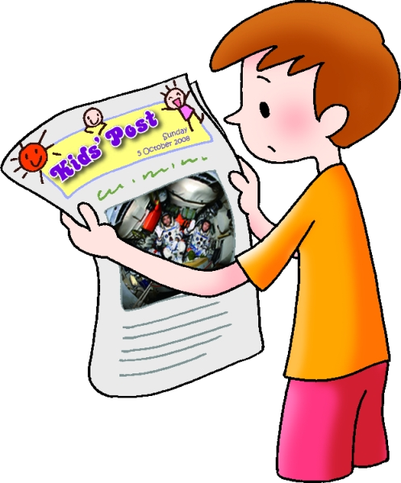
Ricky was upset. His mother said he could not watch TV. His father said he could not play computer games. He shouted, ‘I want to be a grown-up and do anything I like.’ Then he ran to his bedroom.

Ricky started reading a newspaper.


China’s Heroes in Space

Zhai Zhigang, Liu Boming and Jing Haipeng flew into space on Shenzhou 7 in September 2008.
Kids’ Post
Sunday
5th October 2008

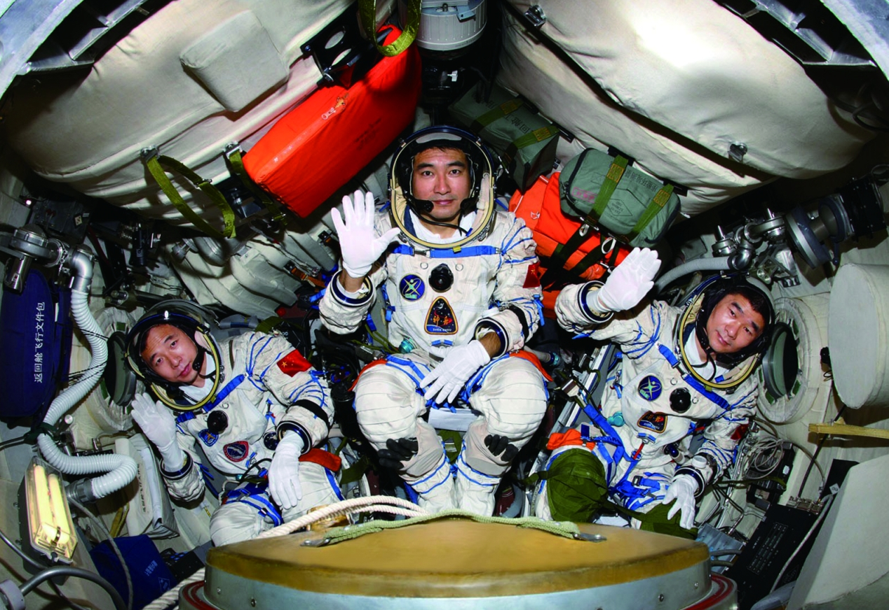
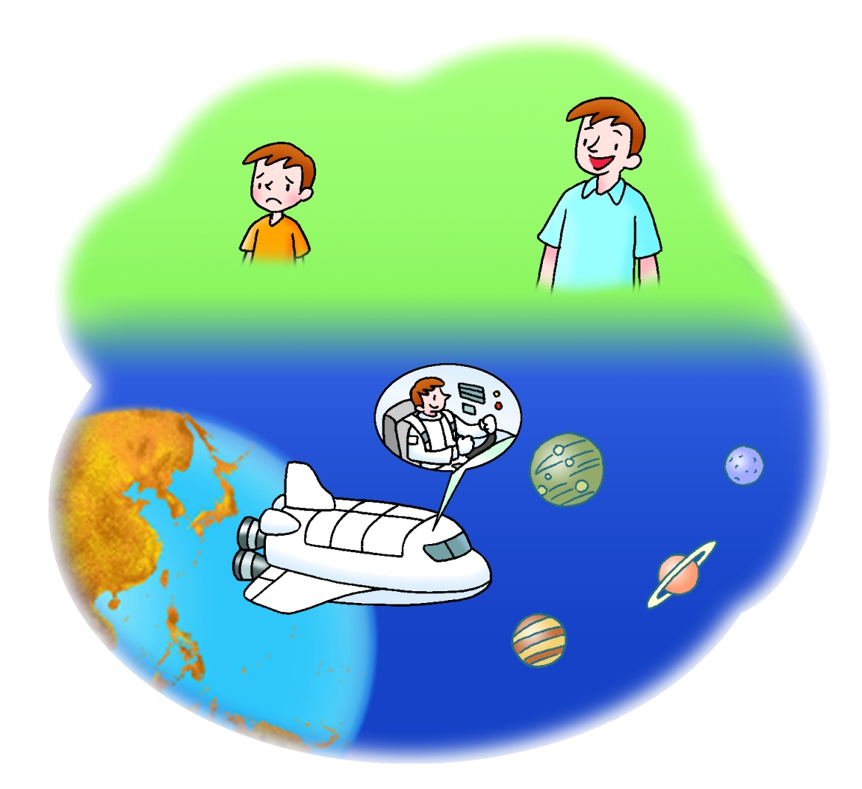

‘These astronauts have such an exciting life. I want to be an astronaut when I grow up. If I become an astronaut, I’ll visit different planets,’ thought Ricky.

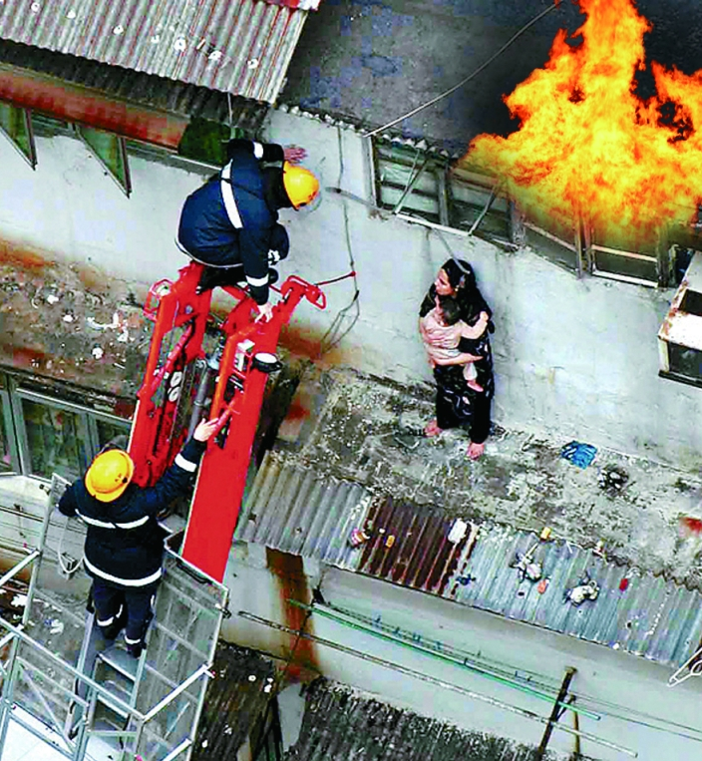  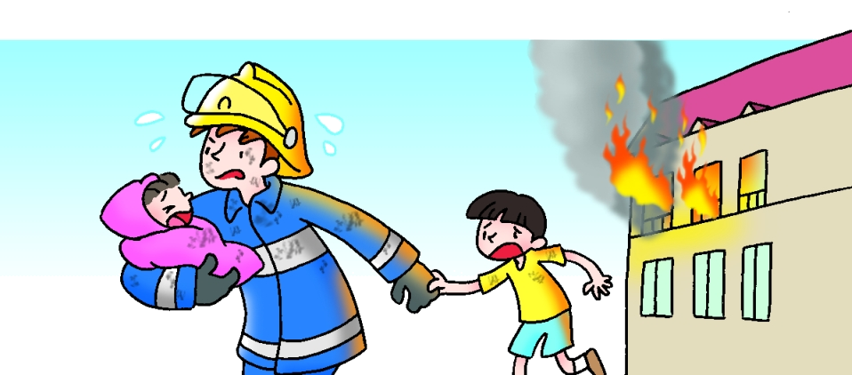  Firemen Rescue Family  Firemen saved a family from a fire in Mong Kok yesterday. |  | ‘Firemen do a really important job,’ thought Ricky. ‘If I become a fireman, I’ll help people in danger. They’ll call me their hero.’

Lang Lang is Back  Lang Lang will play two concerts at the Hong Kong Cultural Centre next month. |  | ‘Lang Lang can play the piano all day long. I want to be a computer programmer when I grow up. If I become a computer programmer, I’ll play computer games all day.’

Then Ricky noticed some other headlines.
Parents worry about flu Parents queue for 24 hours to
outbreak in schools apply for secondary schools
Father saves boy from sea


Ricky knew it was wrong to shout at his parents. He went to say sorry to them.
 Primary Longman Elect 6A © Pearson Education Asia Limited 2009

