Leaflets
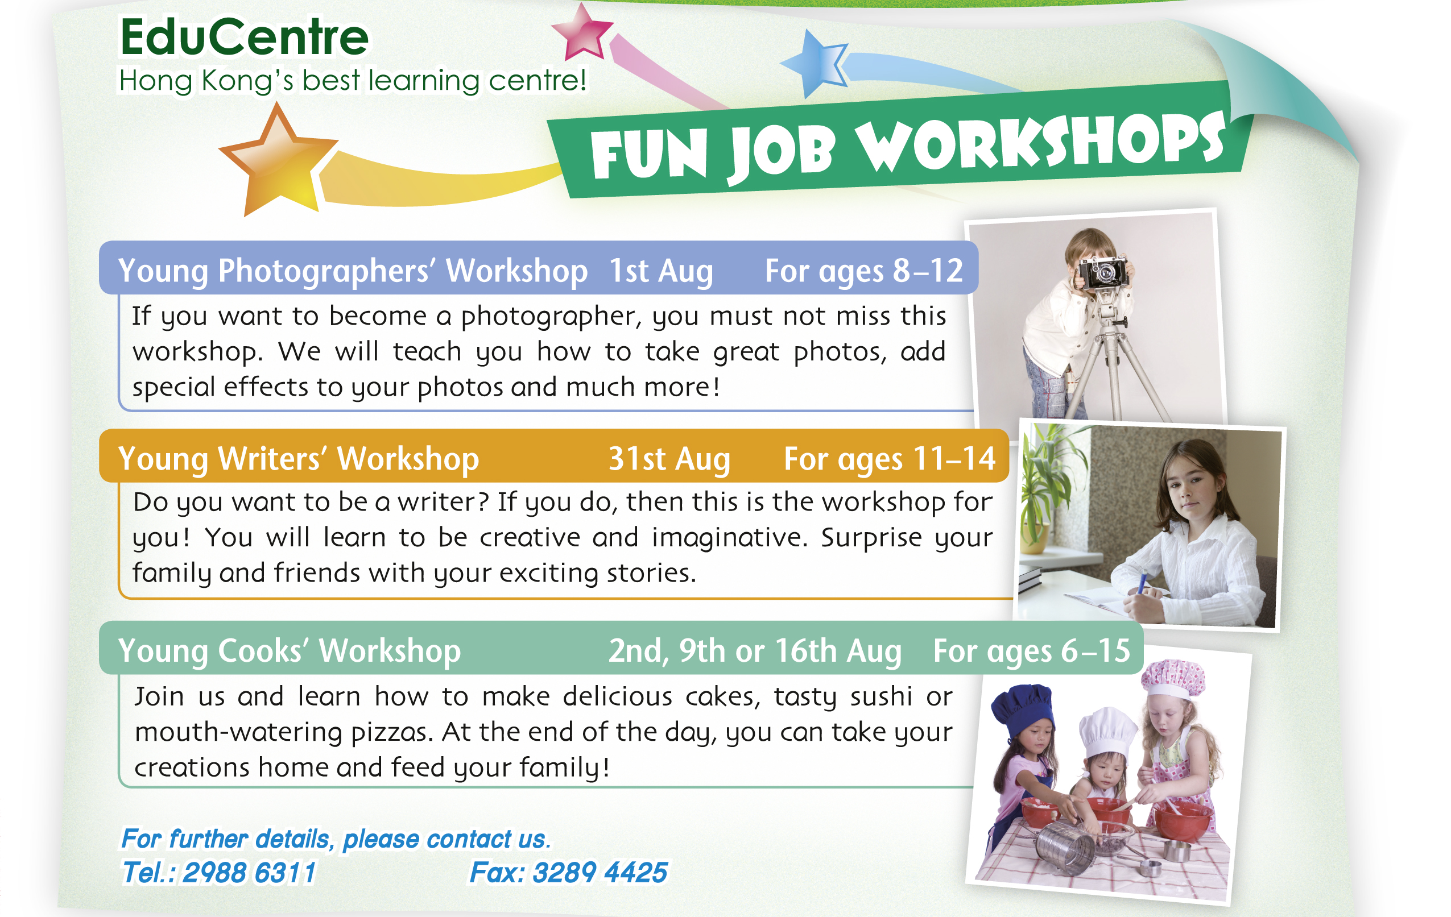

Write the answers and blacken  the circles.

1 What is ‘EduCentre’?
____________________________________________________________________

2 Sandy goes to the workshop on the first day of August. Which workshop is it?
____________________________________________________________________

3 If you want to talk to the staff at EduCentre, which number should you call?
___________________________________________________________________
_

4 Read the description about the ‘Young Cooks’ Workshop’. What does ‘mouth-watering’ mean?
 A. make you feel thirsty
 B. juicy
 C. the size of a mouth
 D. looks delicious

5 Which sentence about the ‘Young Writers’ Workshop’ is NOT true?
 A. The workshop takes place at the end of August.
 B. The workshop is for children who want to be writers in the future.
 C. The workshop is only for primary pupils.
 D. Children will become more creative and imaginative after the
workshop.

6 The leaflet tells us ___ . (You can choose more than one answer.)
 A. what we can learn from the workshops
 B. how to be a better photographer
 C. how to make cakes, sushi and pizzas
 D. when the workshops are held

Answers:
1 (The name of) a learning centre. 2 Young Photographers’ Workshop.
3 2988 6311 4 D 5 C 6 A,

