Choose and write.
attentive brave calm caring
creative fit good-looking hard-working
outgoing patient strong understanding

1 | 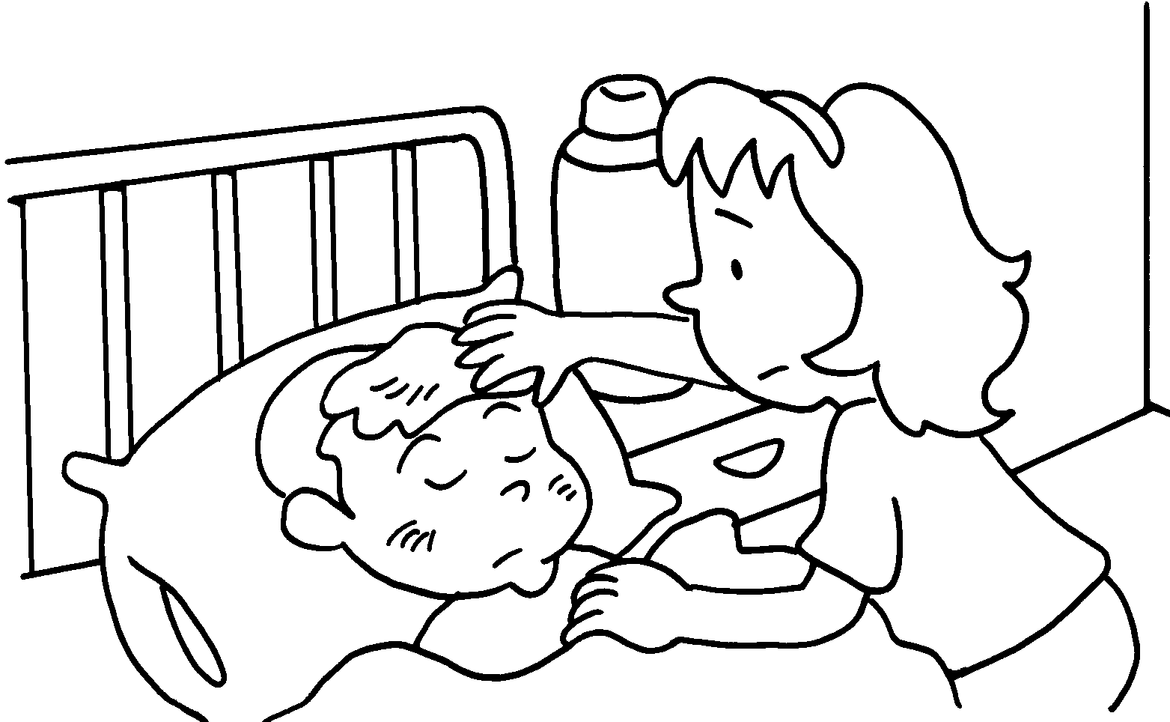 | 2 |  | 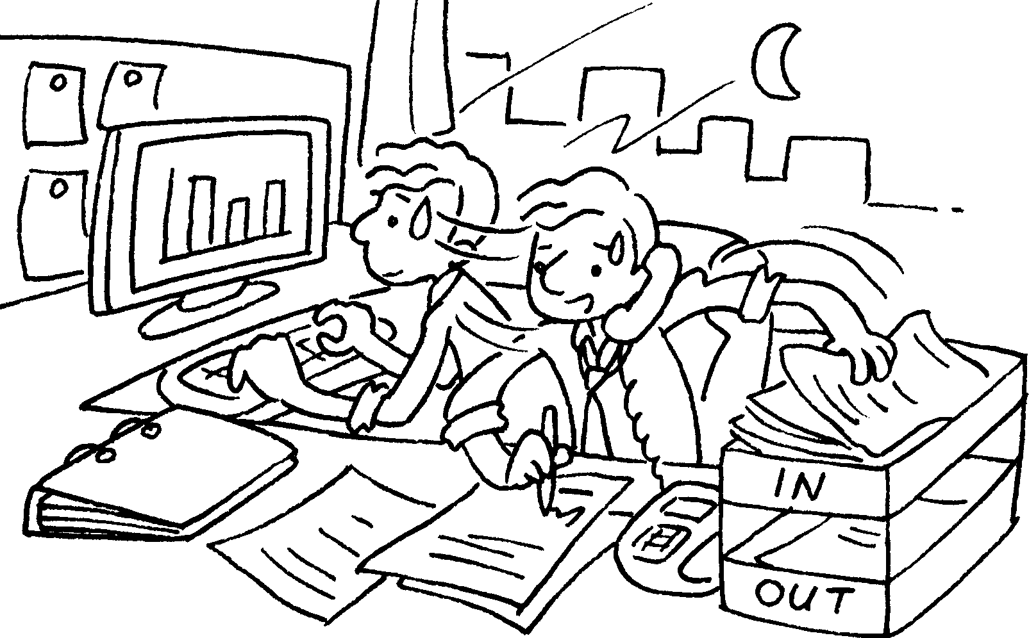 |  | 3 | 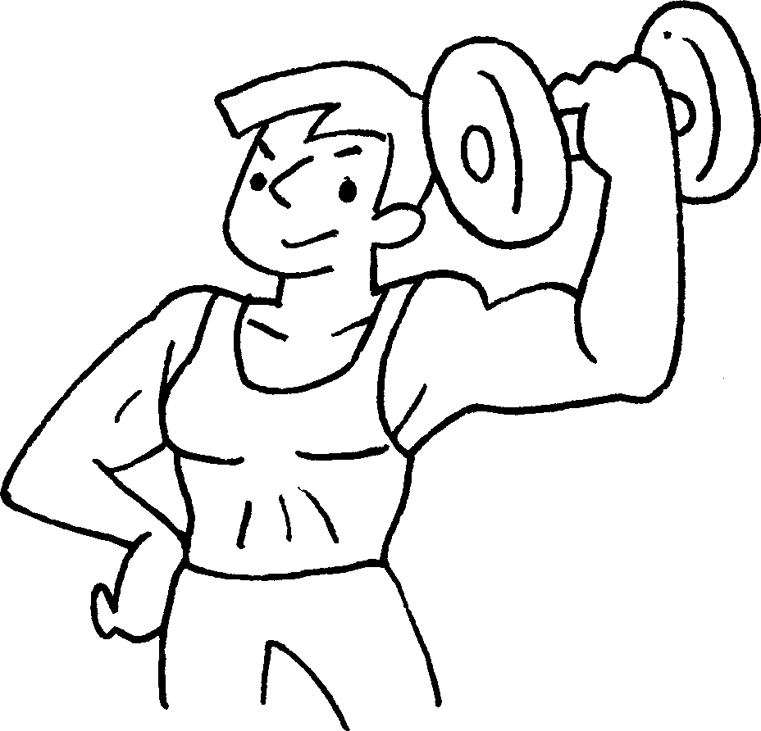
4 | 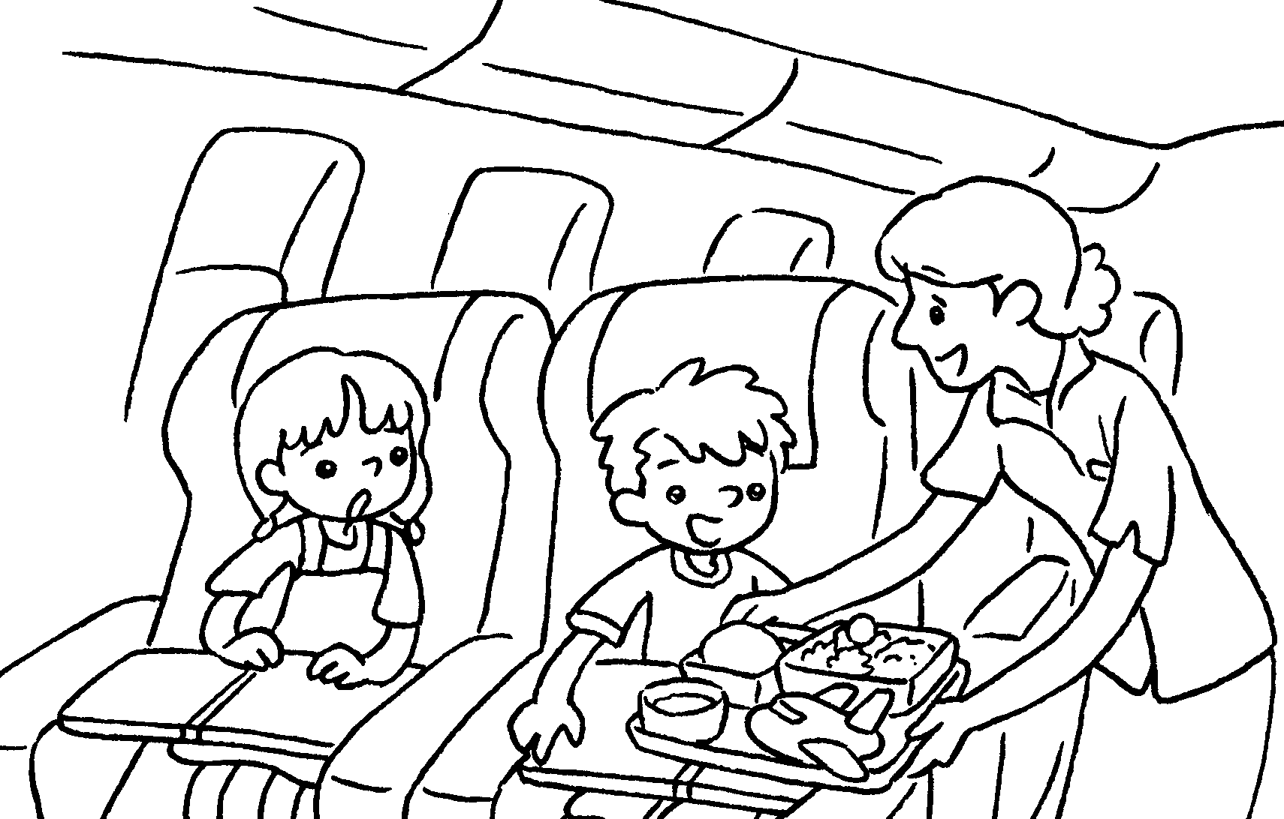 | 5 |  | 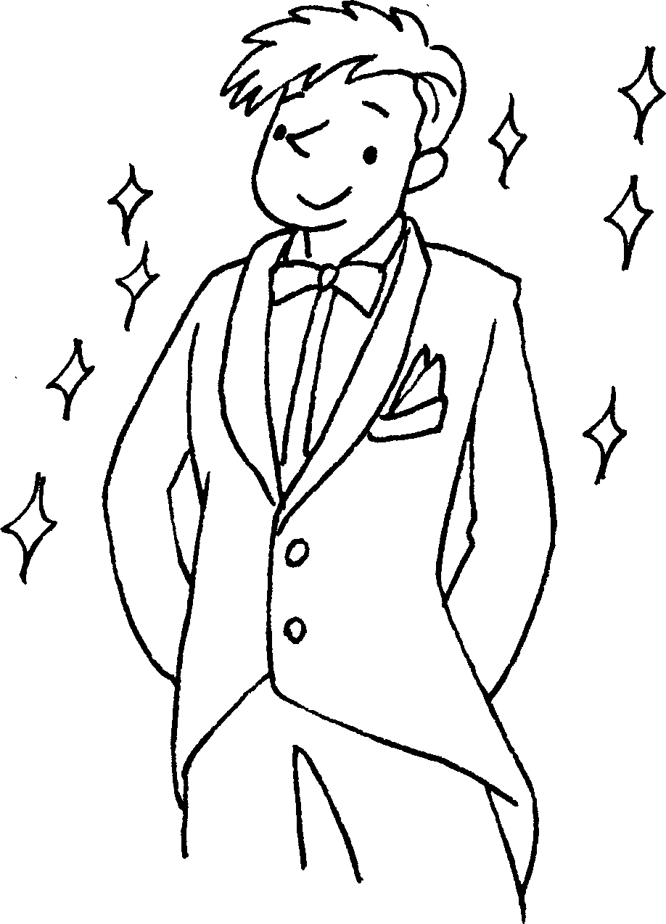 |  | 6 | 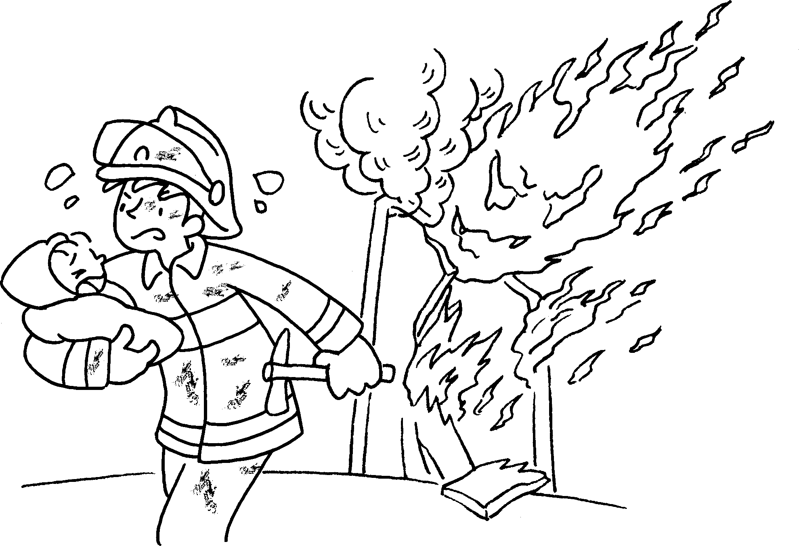
7 | 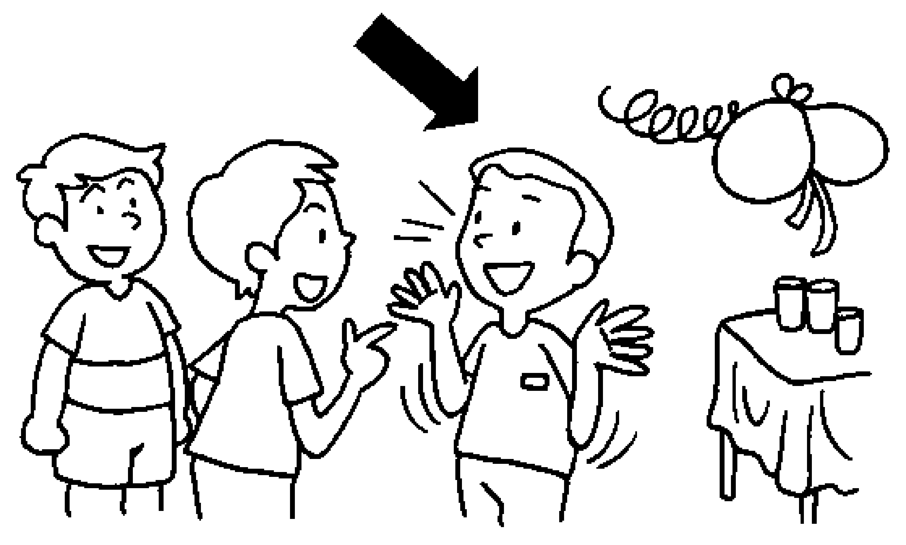 | 8  My daughter is sick. May I leave early?  No problem. |  | 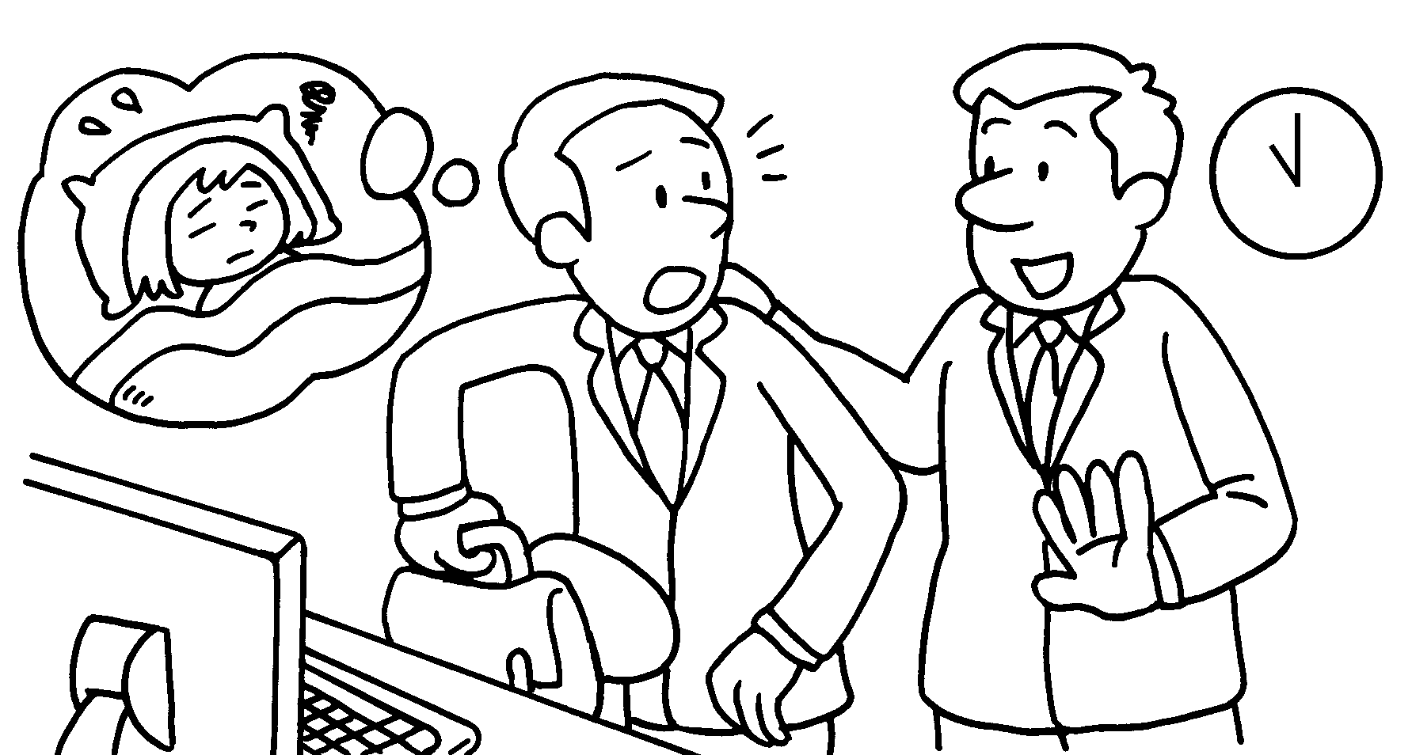 |  | 9 | 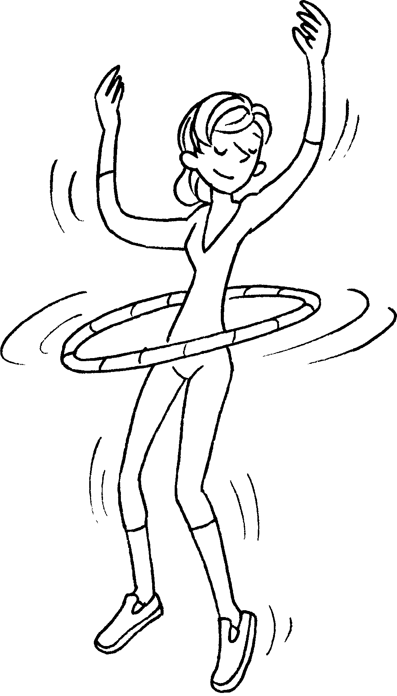
10  I can make shelves with these shoe boxes. | 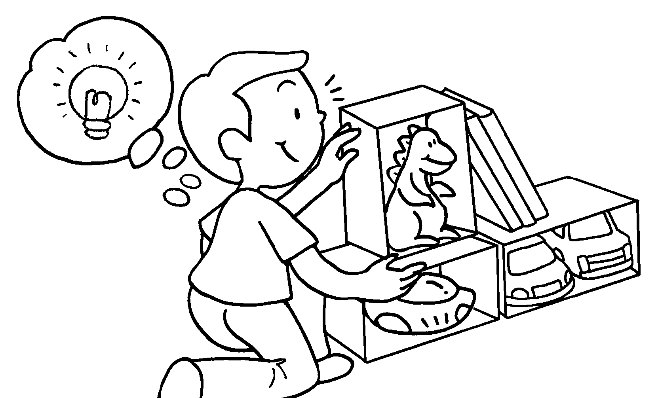 | 11 | 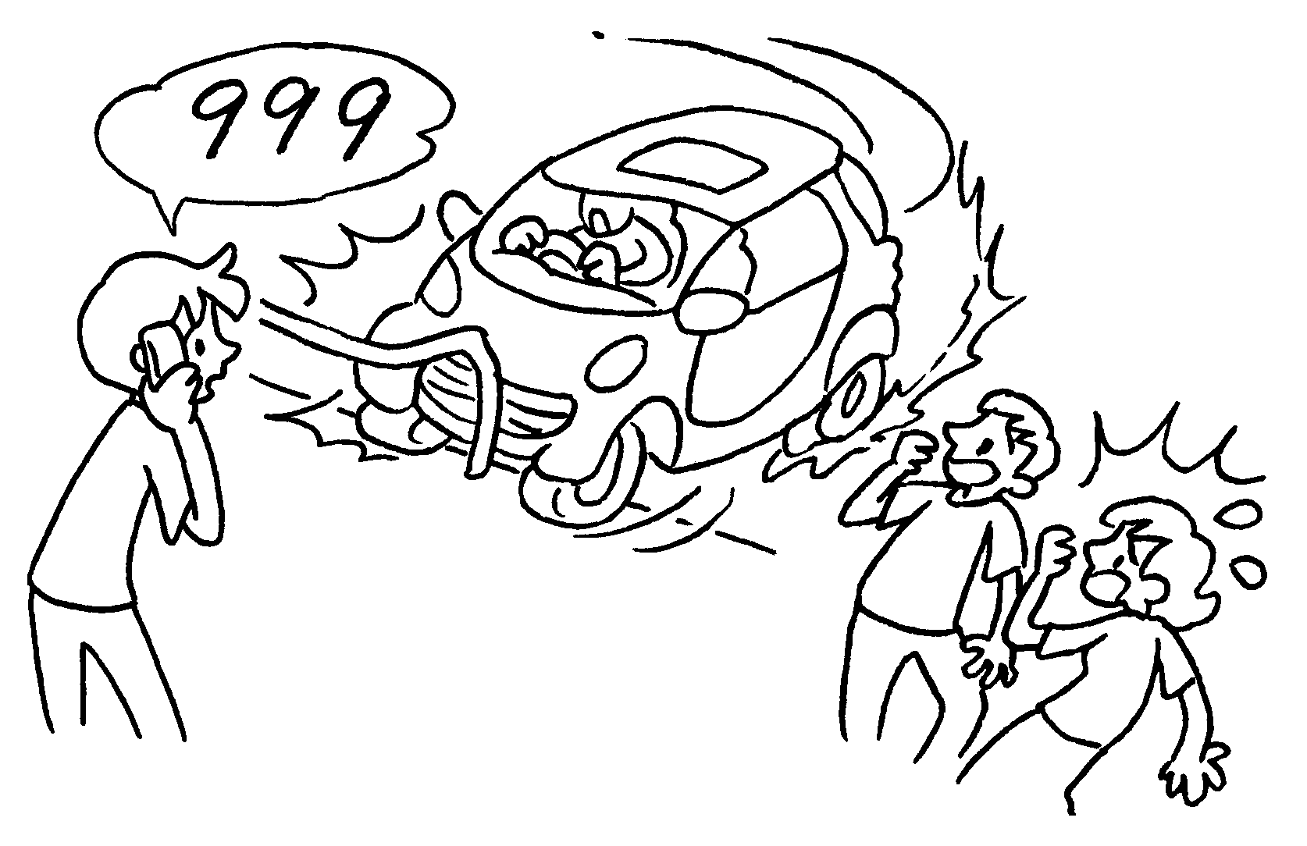 |  | 12 | 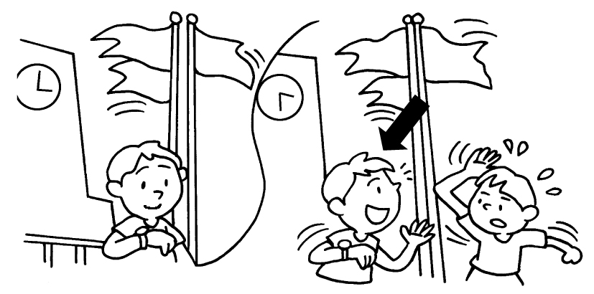


Book 6A Chapter 2 Graded Worksheets
Worksheet 1⬇
- caring 2 hard-working 3 strong
4 attentive 5 good-looking 6 brave
7 outgoing 8 understanding 9 fit
10 creative 11 calm 12 patient

