How would you describe the people? Write the adjectives.

1 | 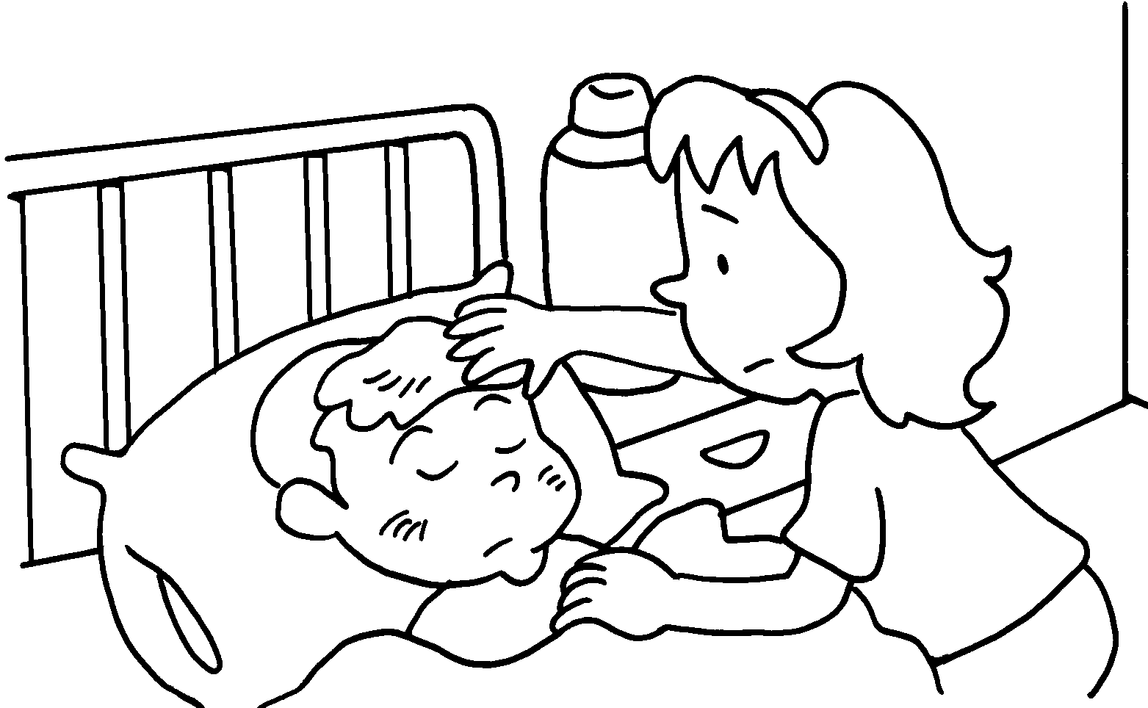 | 2 | 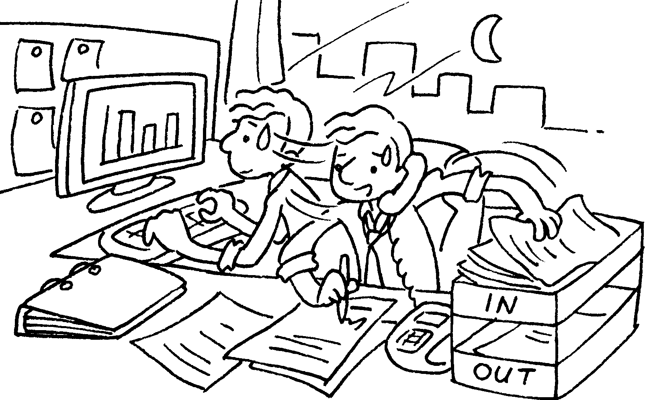 | 3 | 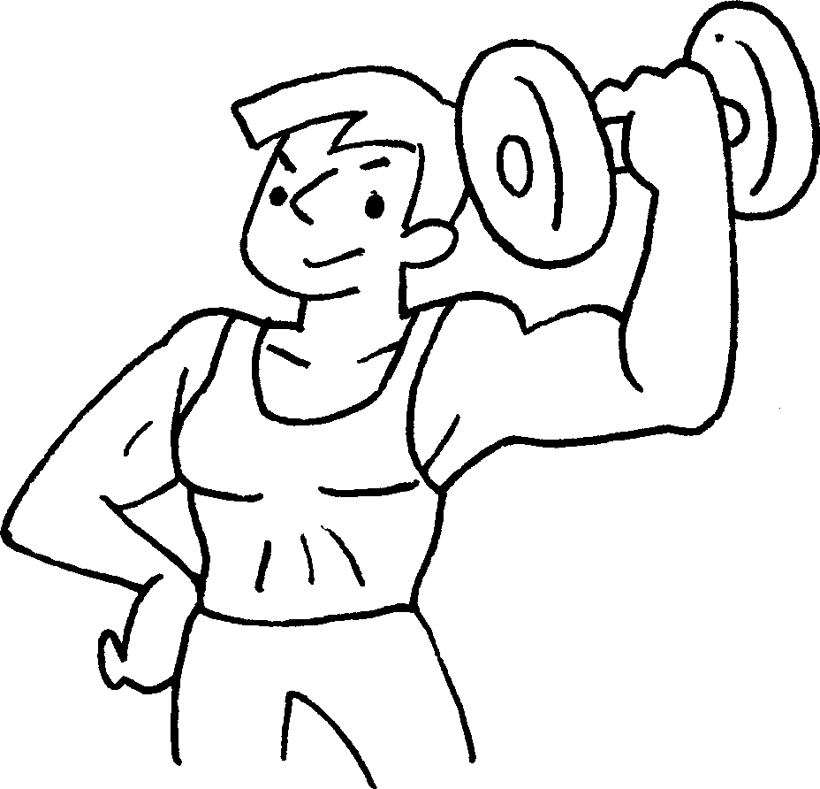
 | c __ __ __ __ __ |  | hard-w __ __ __ __ __ __ |  | s __ __ __ __ __

4 | 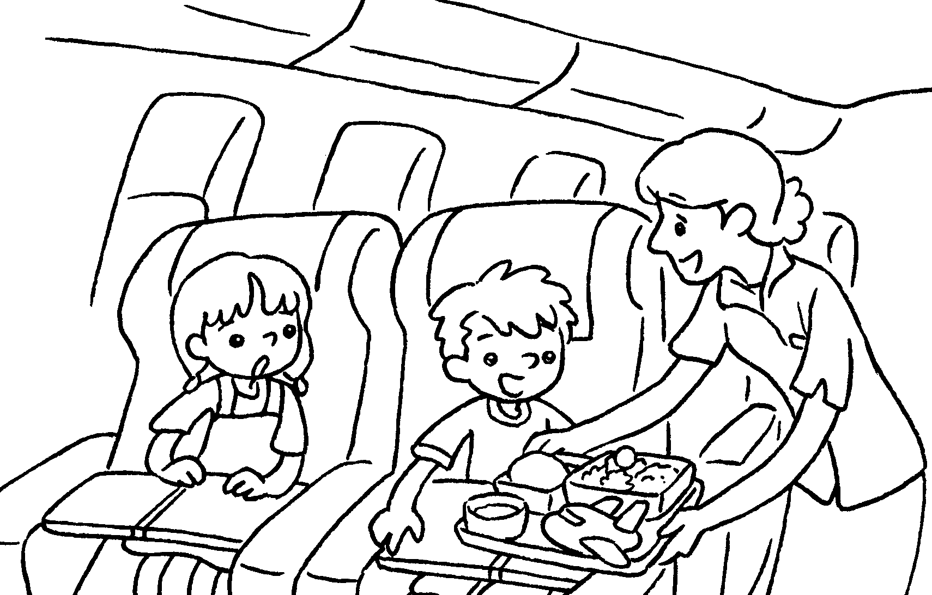 | 5 | 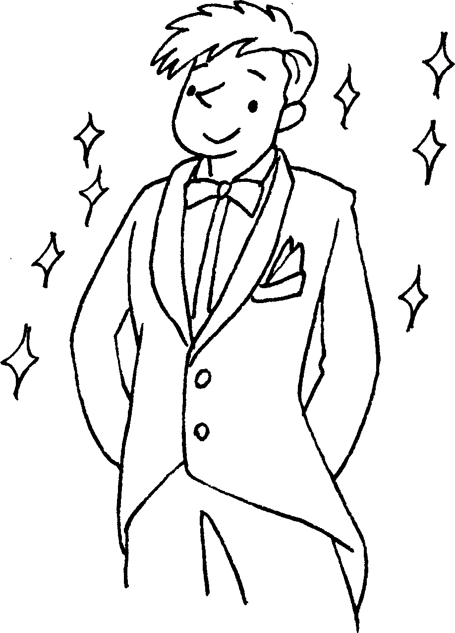 | 6 | 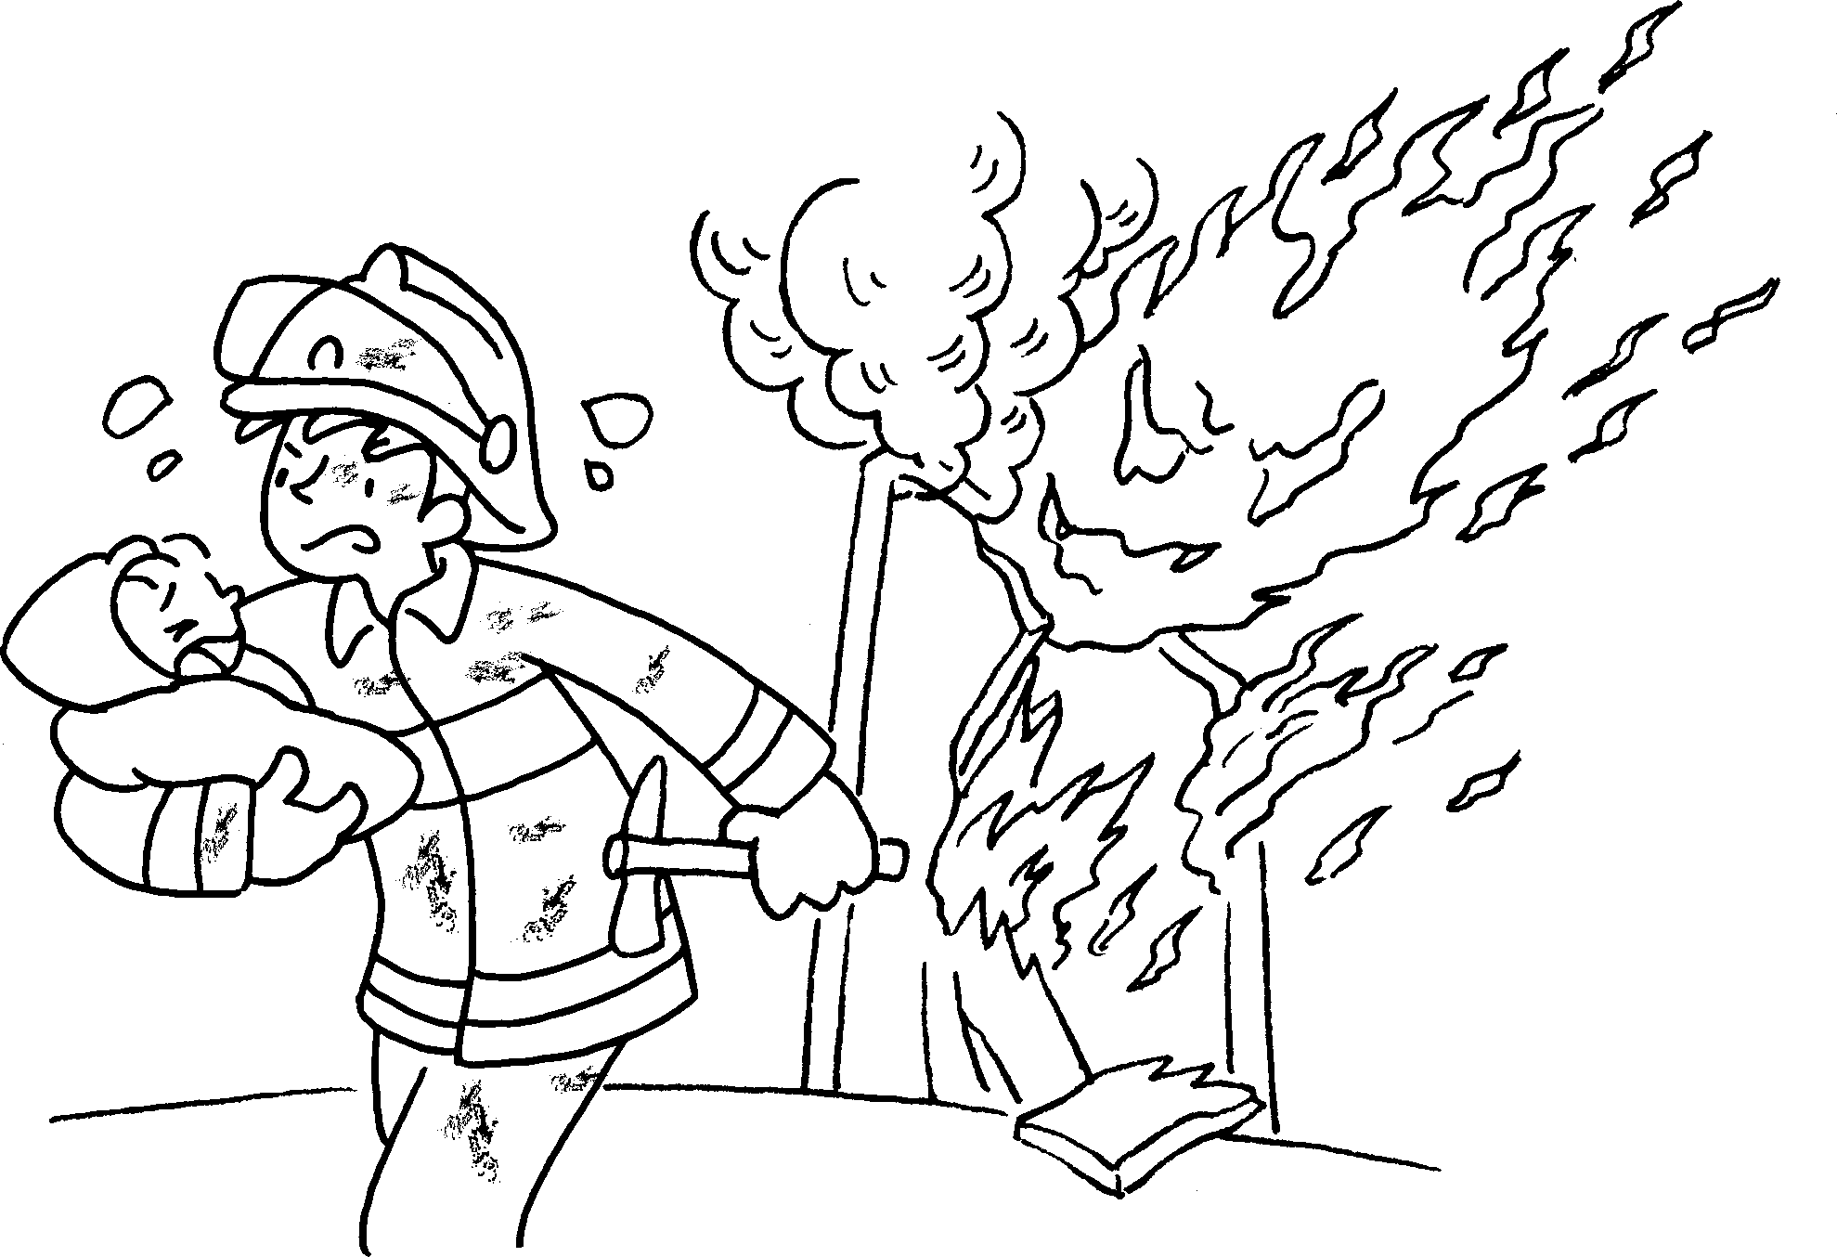
a __ __ __ __ __ __ __ __ |  |  | good-l __ __ __ __ __ __ |  | b __ __ __ __

7 | 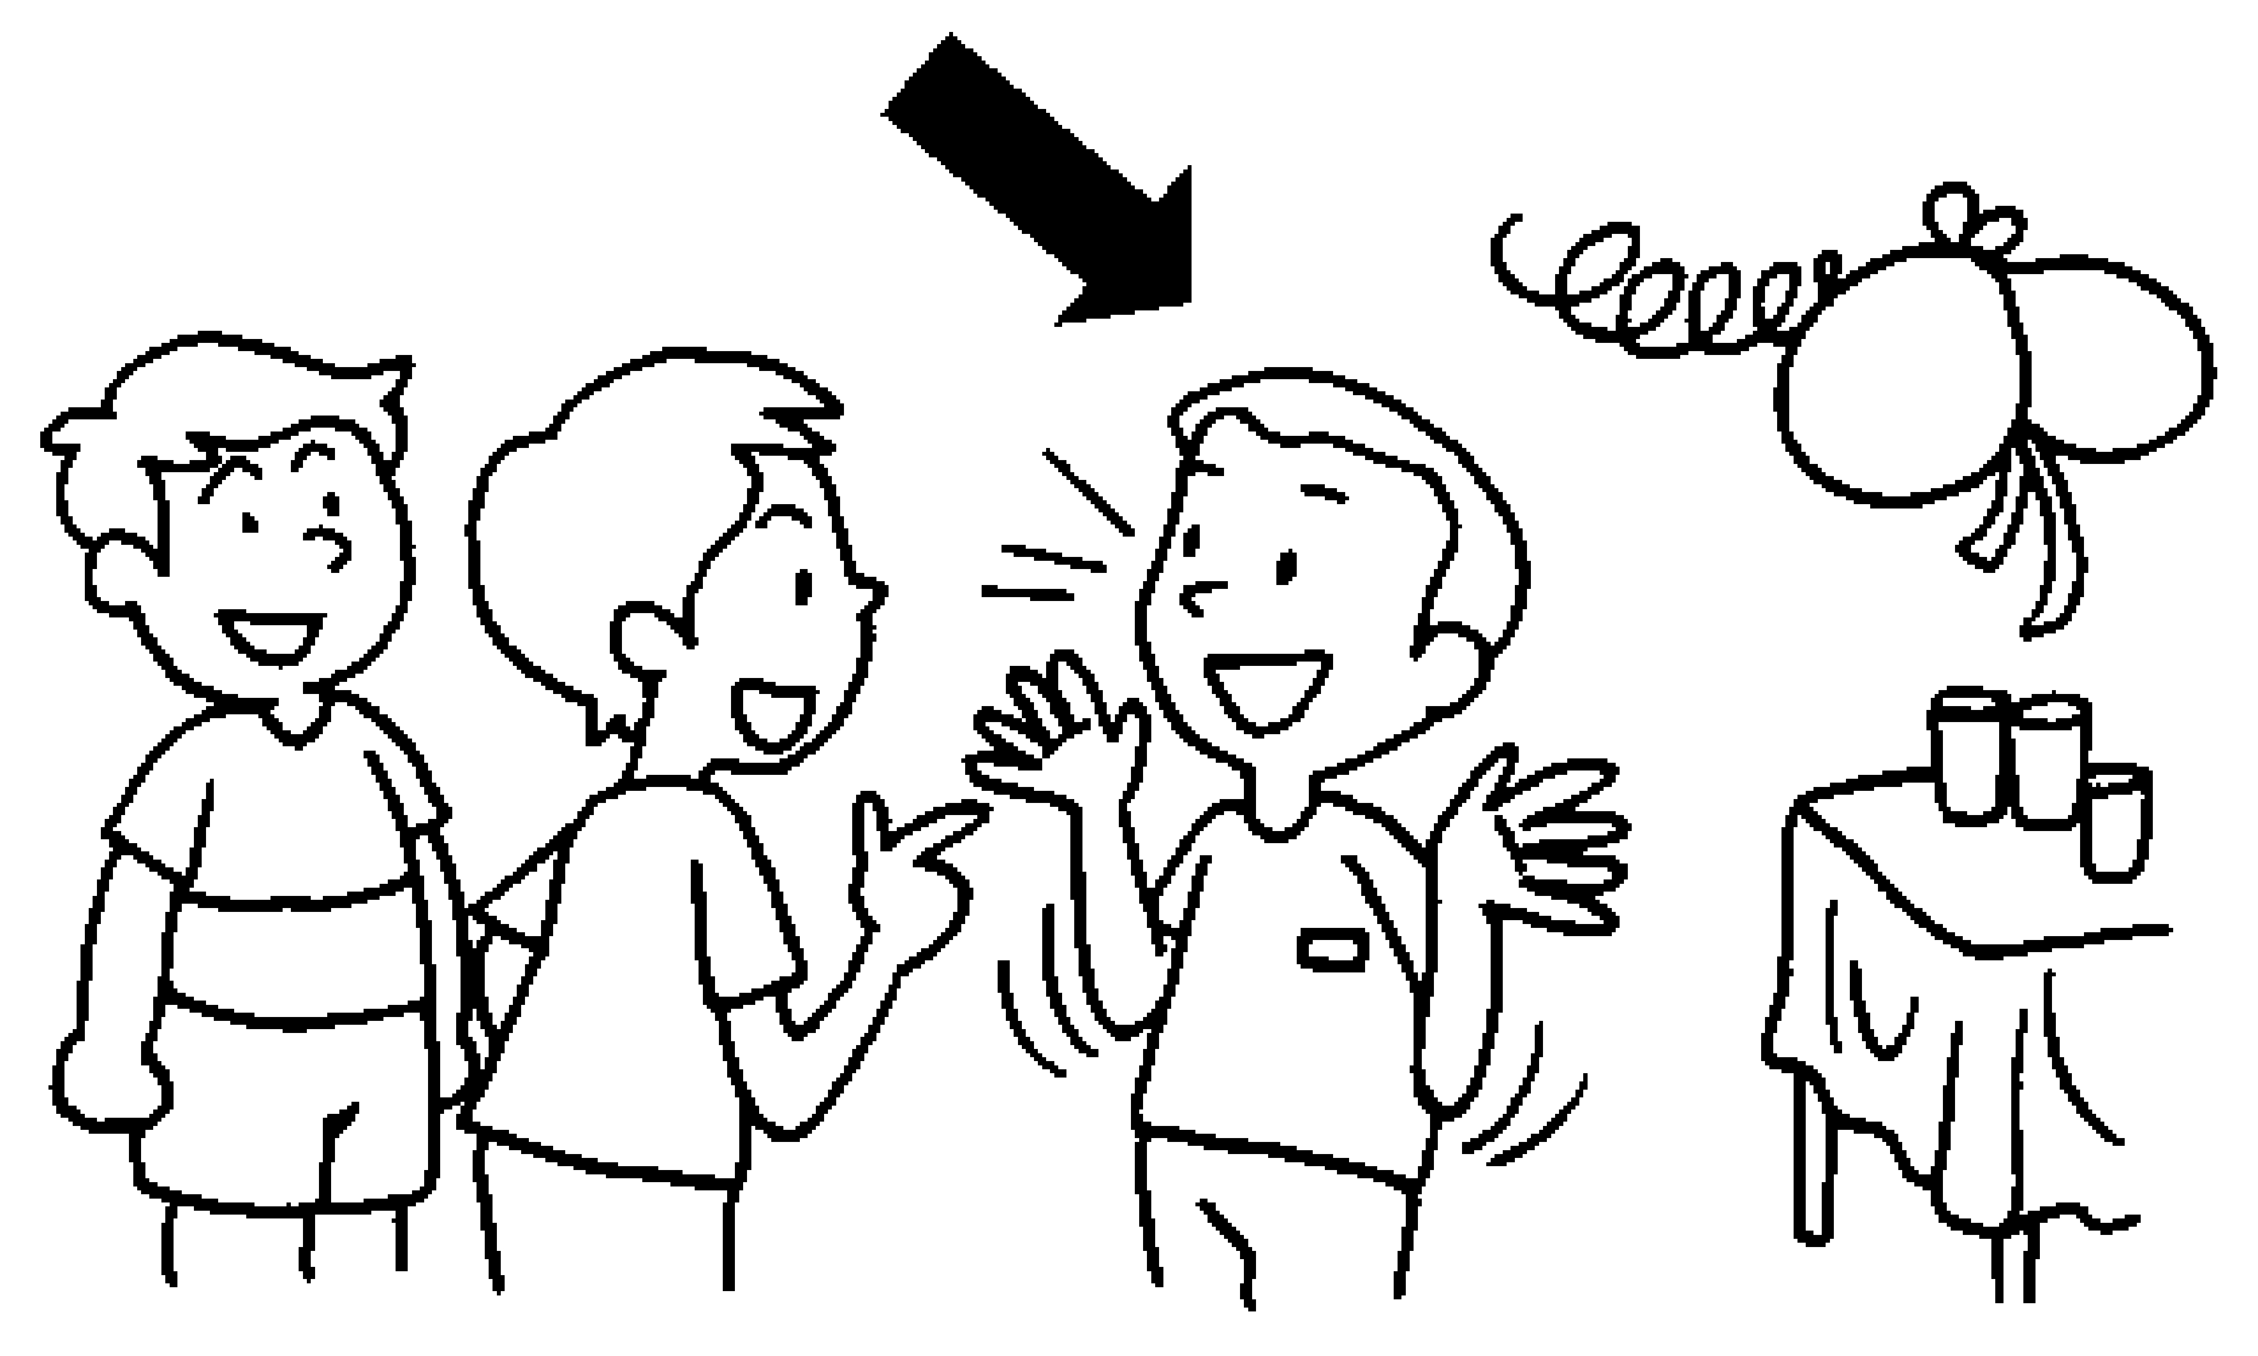 | 8  My daughter is sick. May I leave early?  No problem. |  | 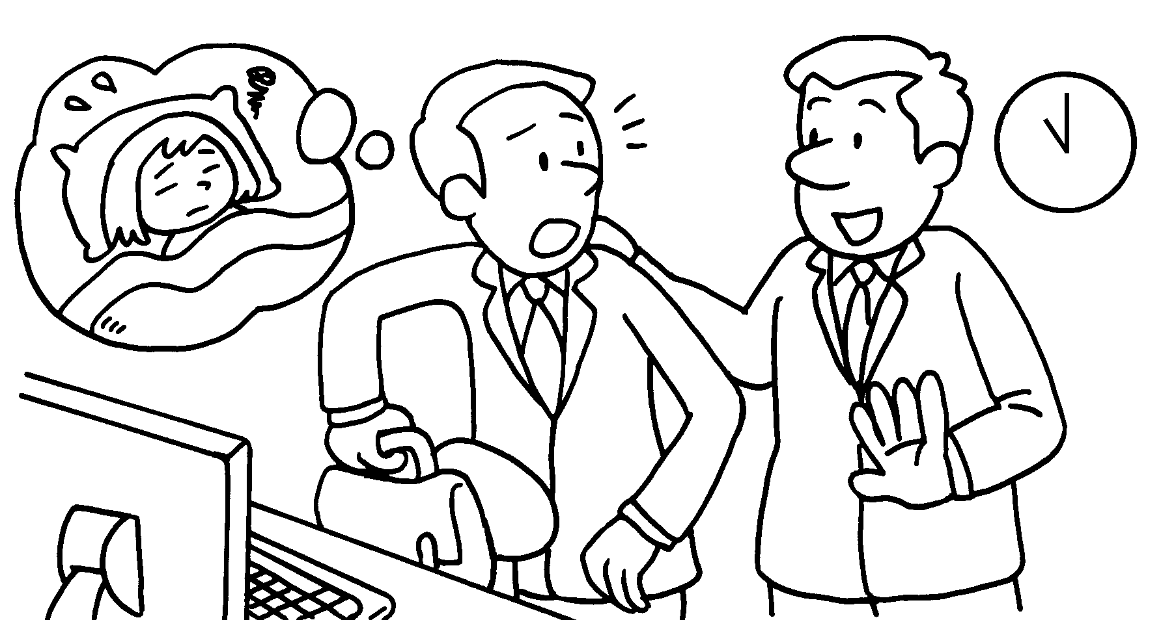 | 9 | 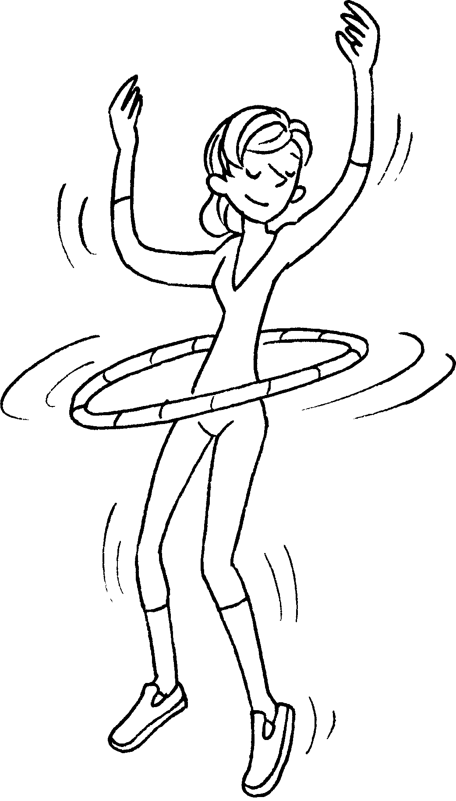
 | o __ __ __ __ __ __ __ |  | und __ __ __ __ __ __ __ ing |  |  |  | f __ __

10  I can make shelves with these shoe boxes. | 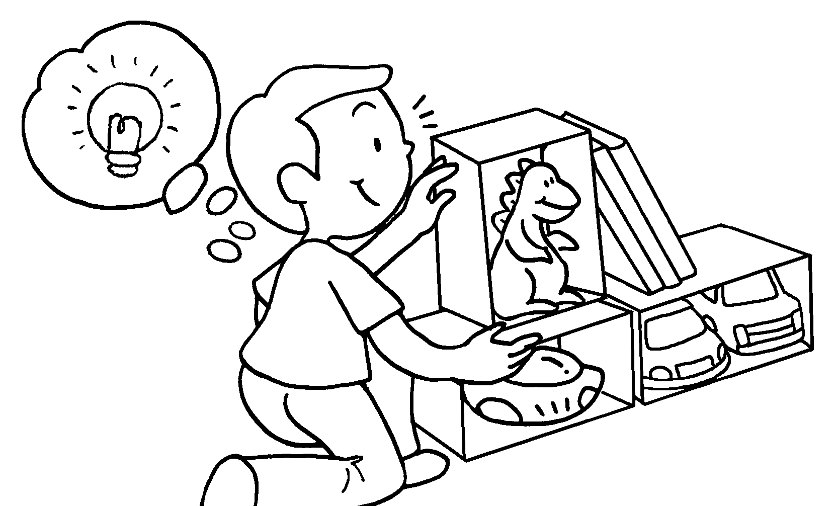 | 11 | 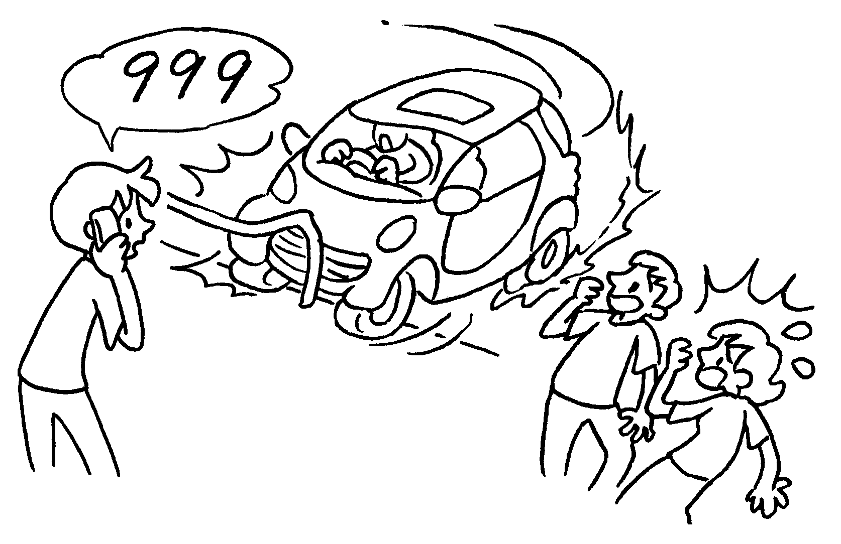 | 12 | 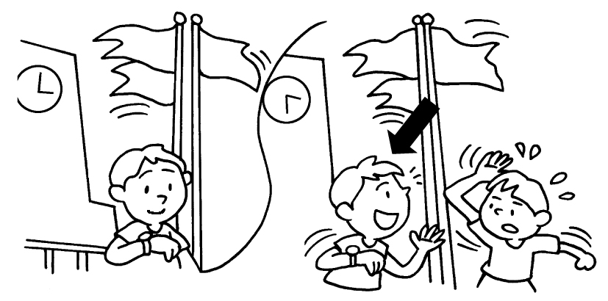
 | c __ __ __ __ __ __ __ | c __ __ __ |  |  | p __ __ __ __ __ __


Book 6A Chapter 2 Graded Worksheets
Worksheet 1⬇⬇
- c a r i n g 2 hard-w o r k i n g 3 s t r o n g
4 a t t e n t i v e 5 good-l o o k i n g 6 b r a v e
7 o u t g o i n g 8 und e r s t a n d ing 9 f i t
10 c r e a t i v e 11 c a l m 12 p a t i e n t

