What are the job requirements of these people? Finish the sentences using ‘need to be’.

1 | I need to take care of sick people.  I need to save people from fires.  I need to design new clothes.  I need to wear beautiful clothes.  I need to listen to people’s problem. | 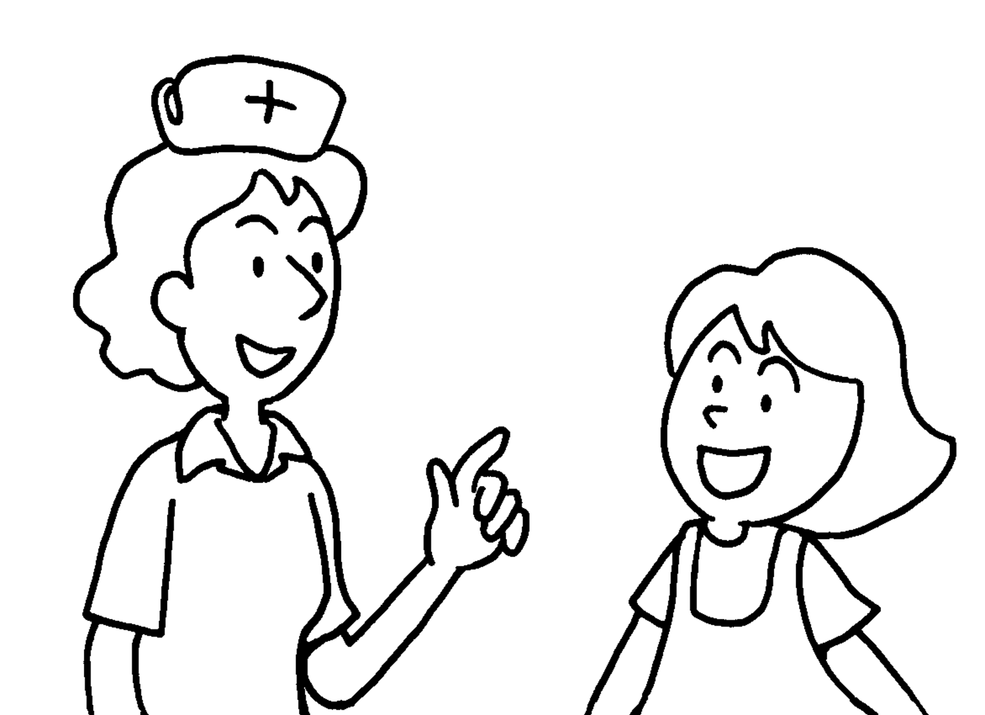 | Nurses  caring.  Fire fighters  Fashion designers  Models  Social workers
2 |  | 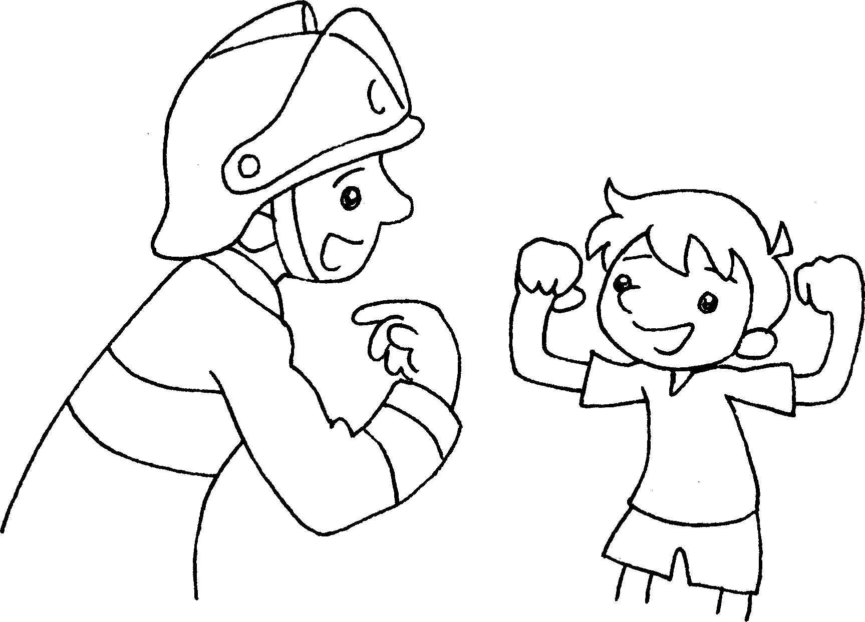
3 |  | 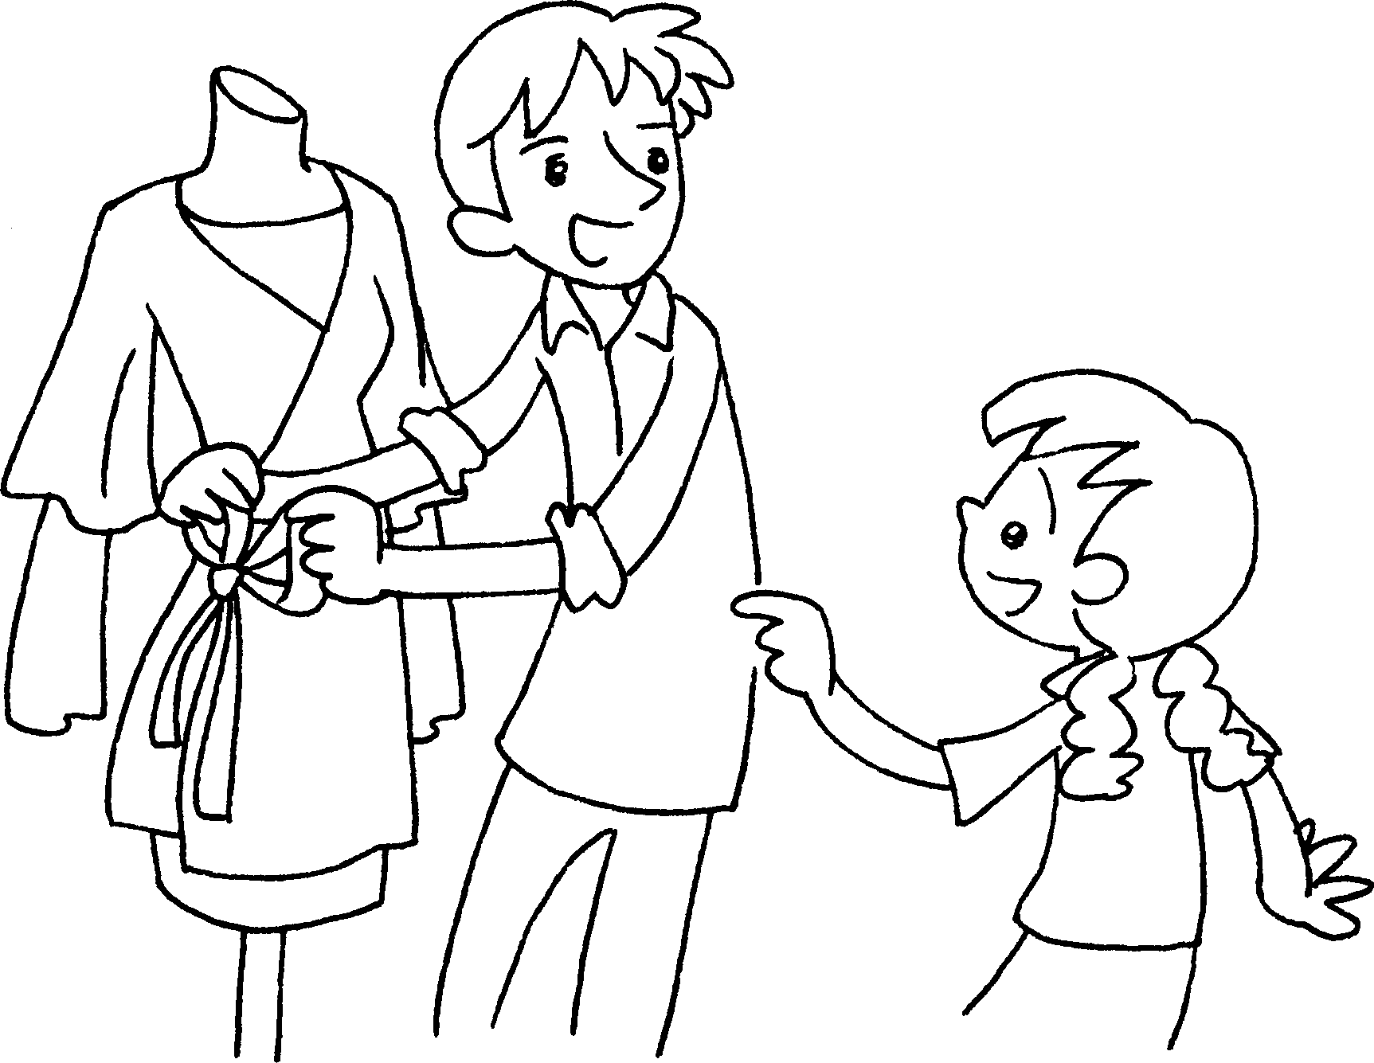
4 |  | 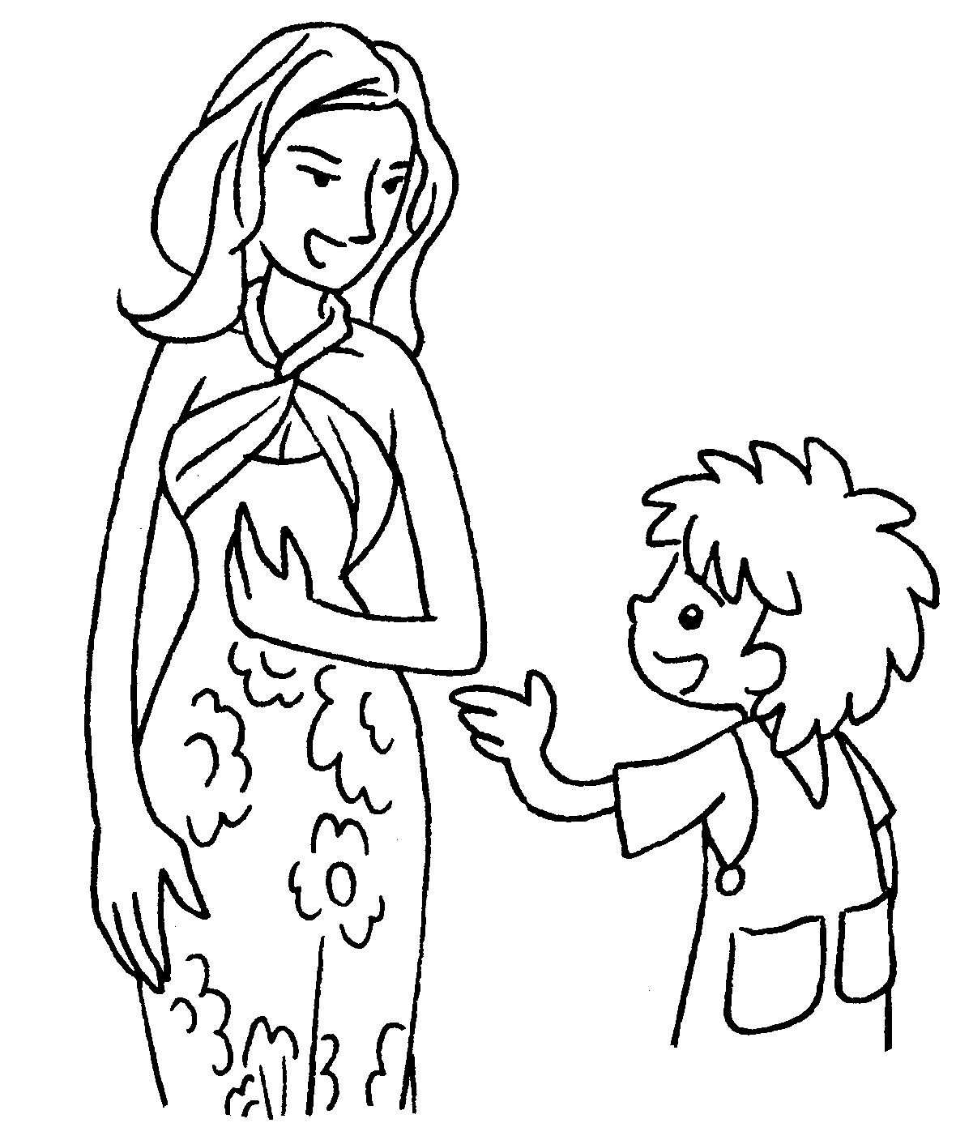
5 |  | 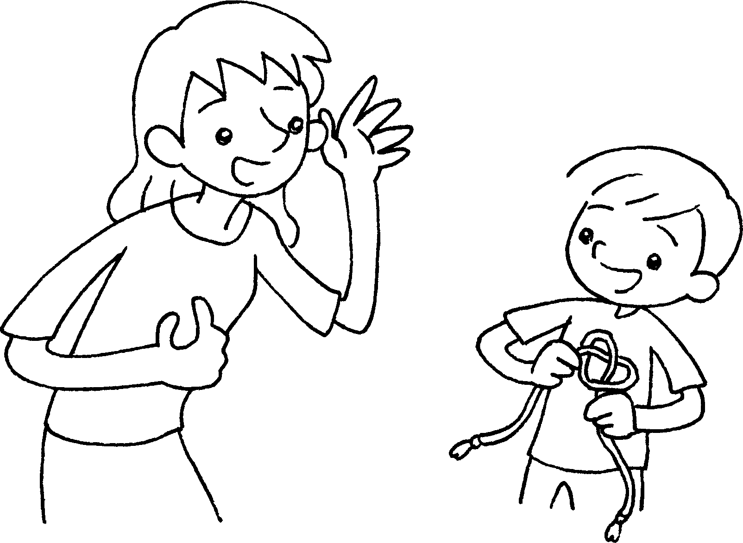



Book 6A Chapter 2 Graded Worksheets
Worksheet 2⬇⬇
- need to be
- need to be strong
- need to be creative
- need to be fit
- need to be patient
(Accept any reasonable answers.)

