What are the people’s jobs? What are their job requirements? Finish the sentences using ‘need to be’.

1 | I need to take care of sick people.  I need to save people from fires.  I need to design new clothes.  I need to wear beautiful clothes.  I need to listen to people’s problem. | 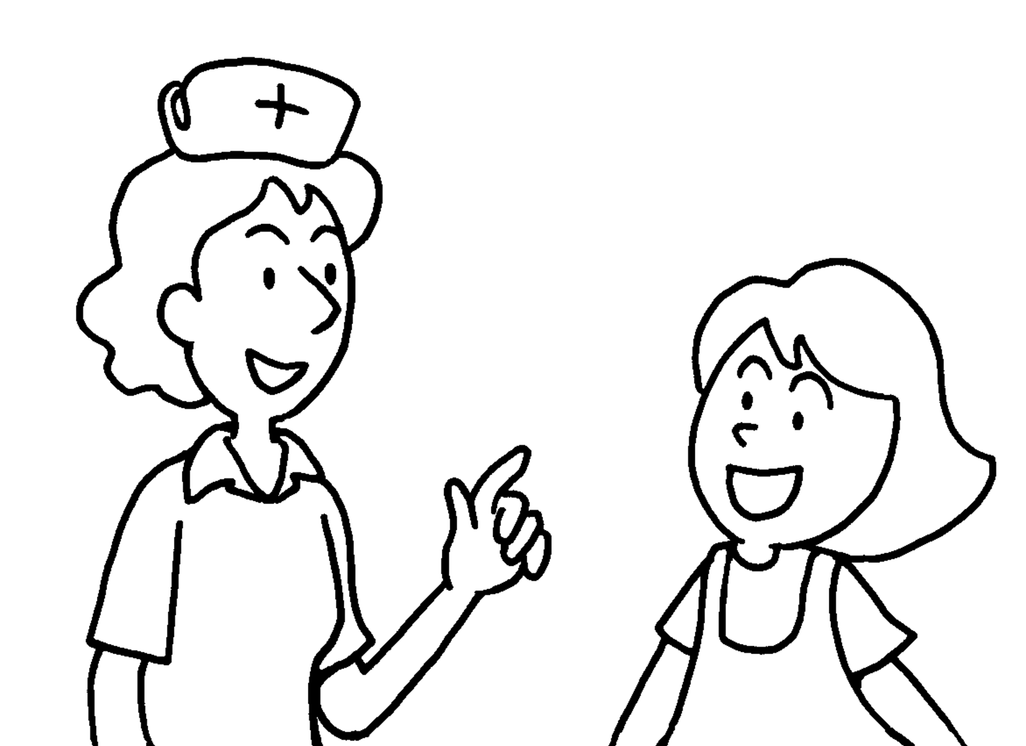 | Nurses  caring.  Fire fighters
2 |  | 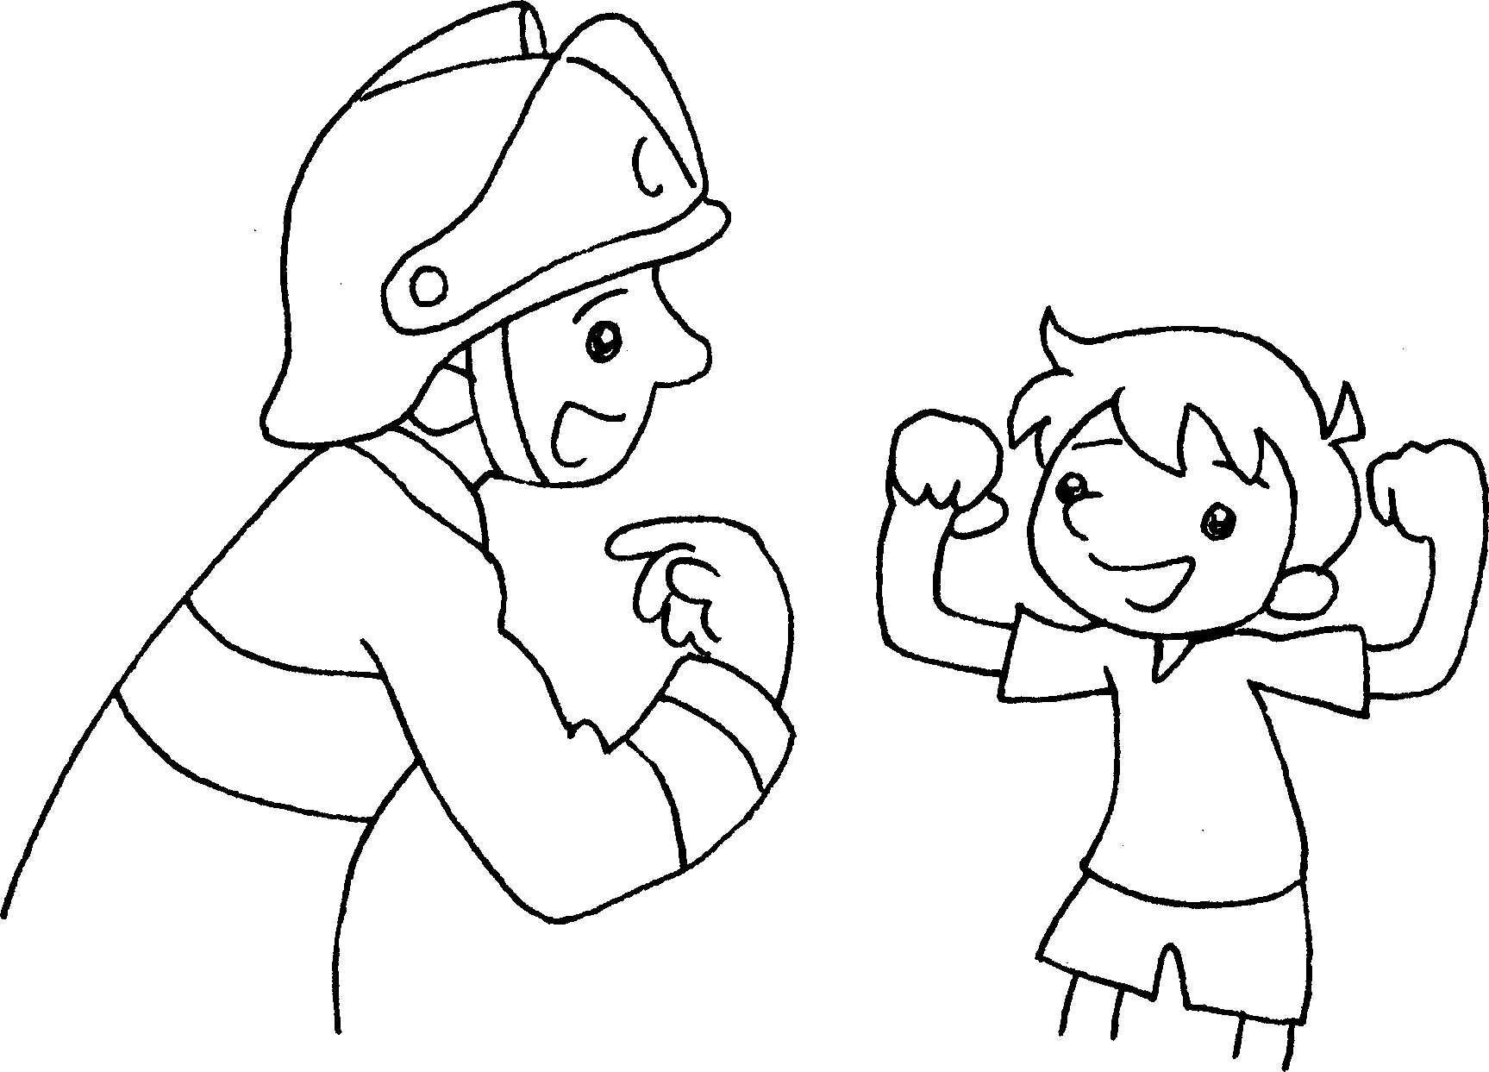
3 |  | 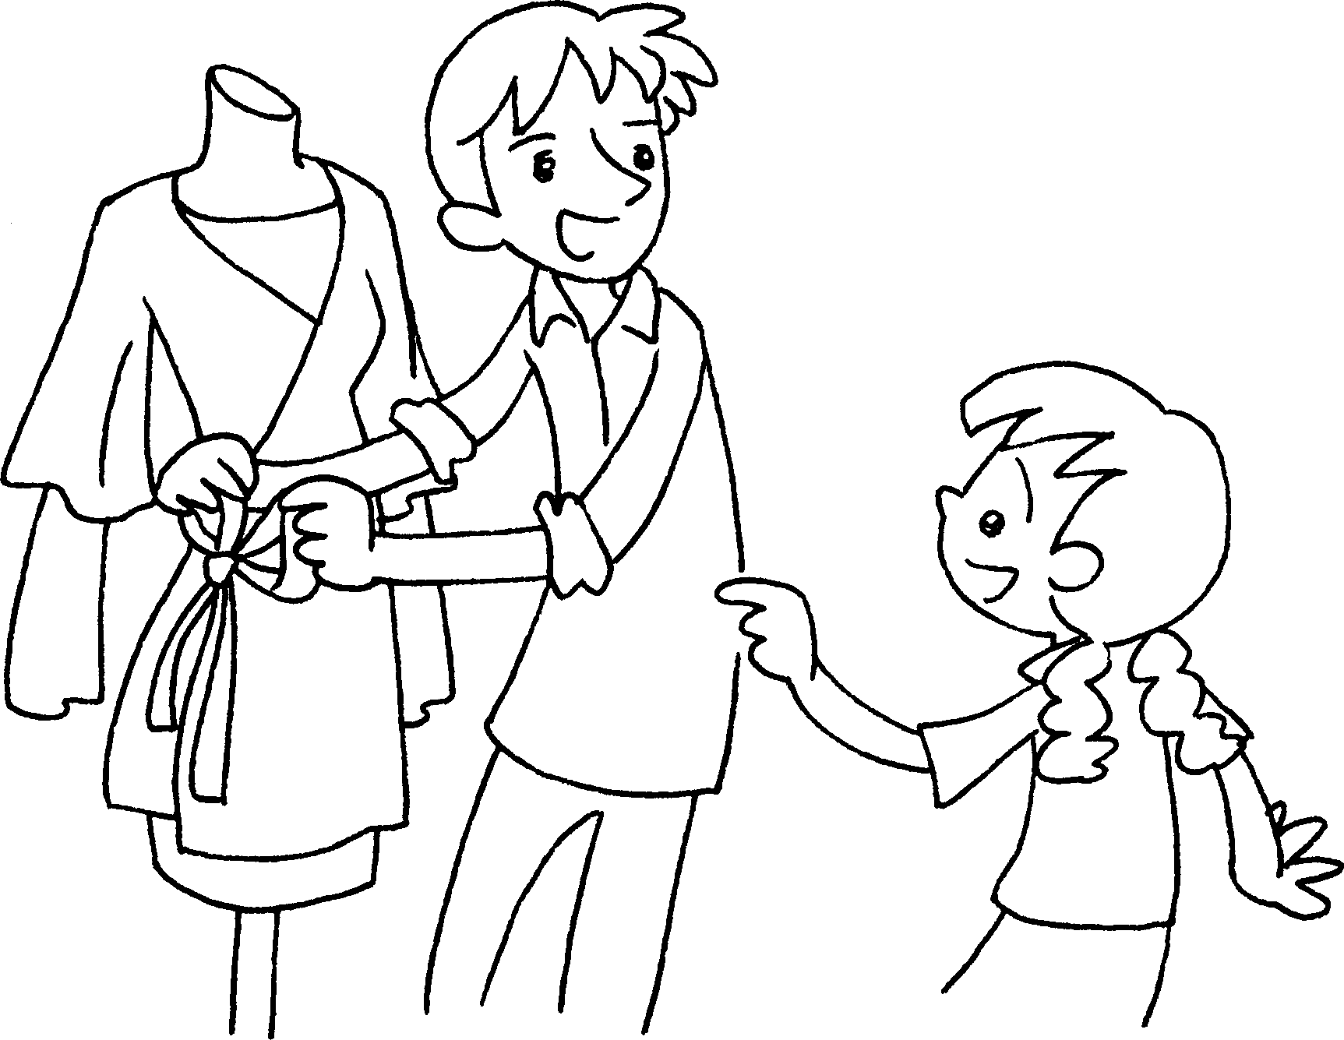
4 |  | 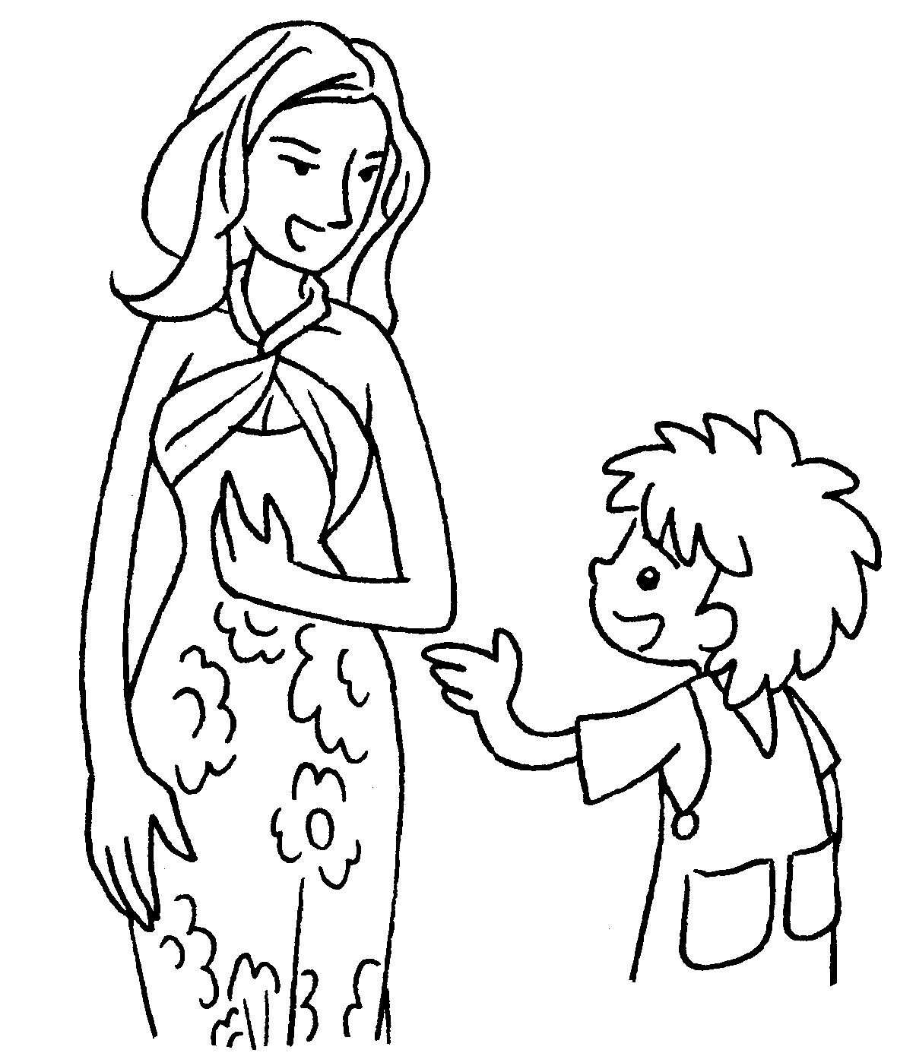
5 |  | 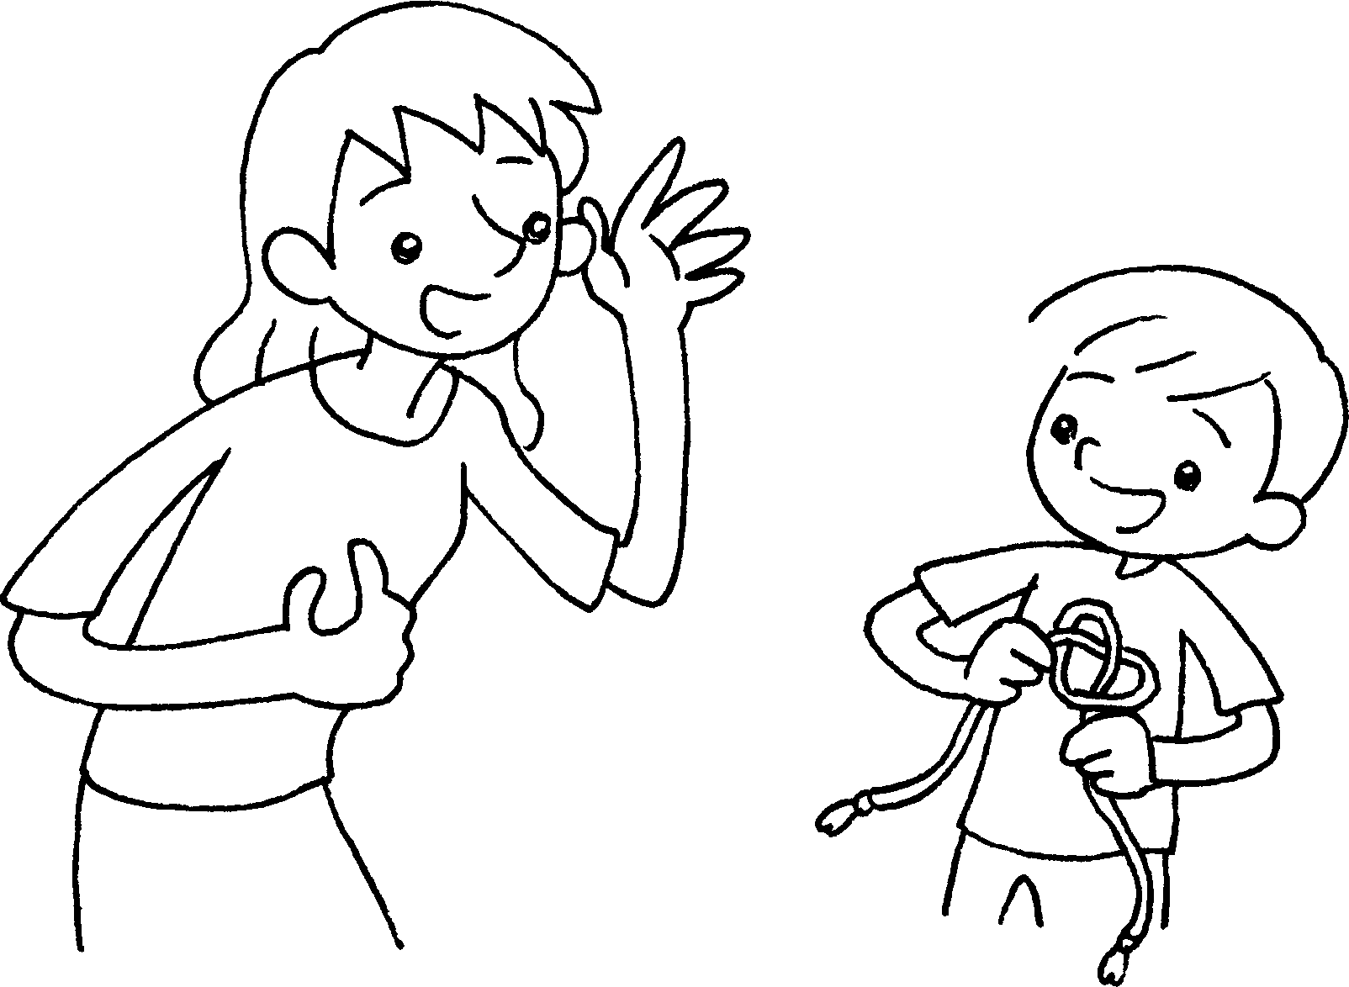



Book 6A Chapter 2 Graded Worksheets
Worksheet 2⬇⬇⬇
- need to be
- need to be strong
- Fashion designers need to be creative.
- Models need to be fit.
- Social workers need to be patient.
(Accept any reasonable answers.)

