A Match the two parts of the sentences.

1 | Models go to bed early | ● |  | ● | A | they can get ideas for their designs
2 | Fire fighters do a lot of exercise every day | ● |  | ● | B | they can interview people from different places
3 | Fashion designers study fashion from around the world | ● |  | ● | C | they can have beautiful skin
4 | Reporters study languages | ● |  | ● | D | they can stay strong

B Finish the sentences using ‘so that’.
1 | Models go to bed early so that they can | 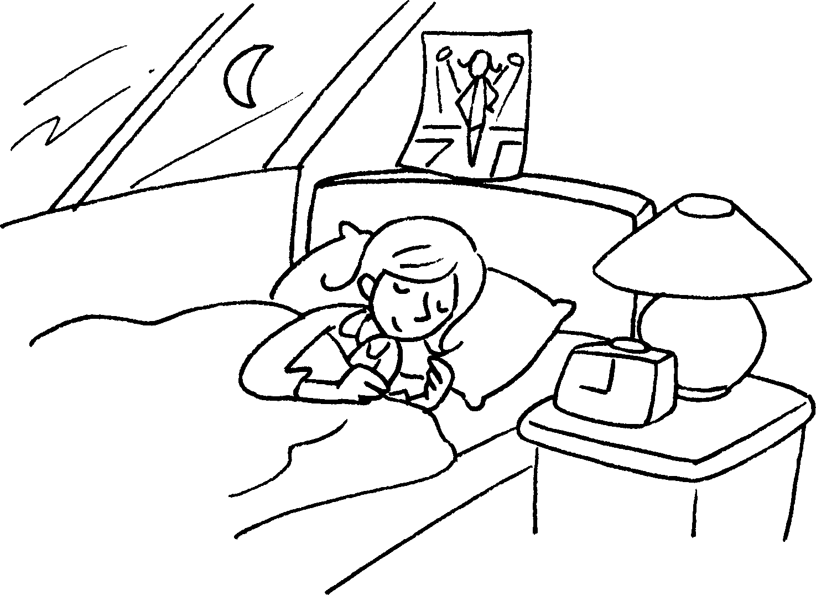
2 | Fire fighters do a lot of exercise every day | 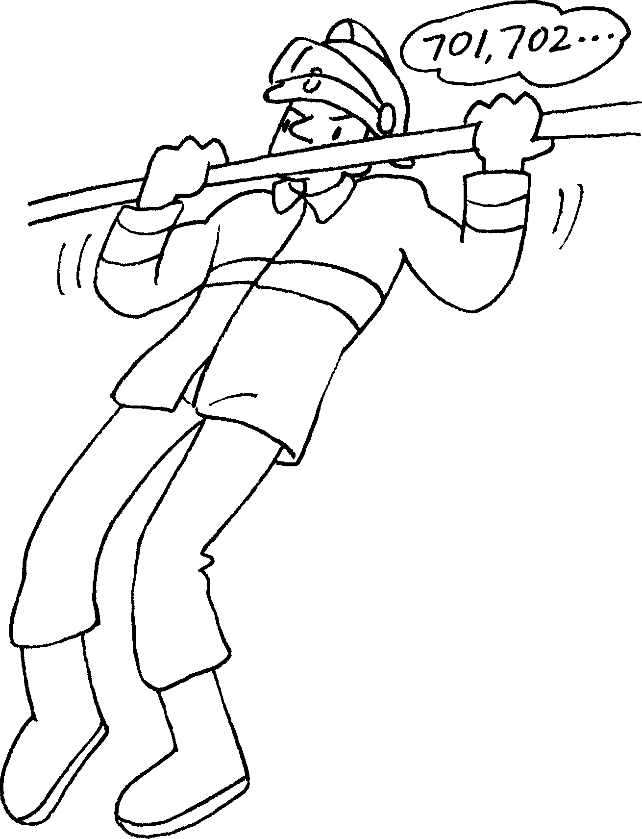
3 | Fashion designers study fashion from around the world | 
4 | Reporters study languages | Hello.  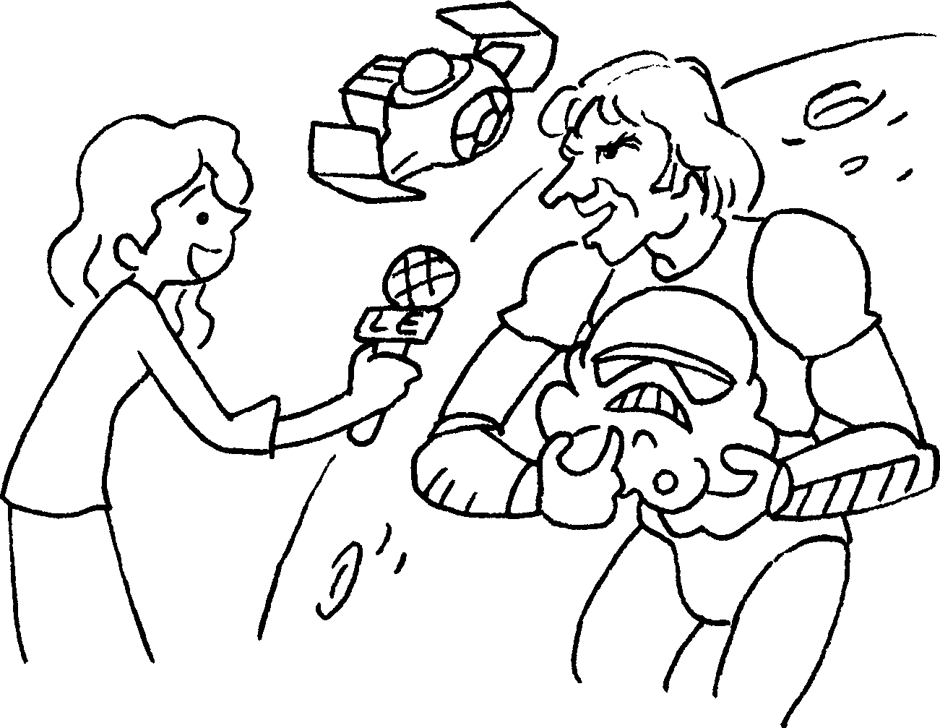


Book 6A Chapter 2 Graded Worksheets
Worksheet 3⬇
A | 1  |  | ● A
 | 2  |  | ● B
 | 3  |  | ● C
 | 4  |  | ● D

B 1 have beautiful skin.
2 so that they can stay strong.
3 so that they can get ideas for their designs.
4 so that they can interview people from different places.

