Finish the sentences using ‘so that’.
1 | Models go to bed early so that they can | 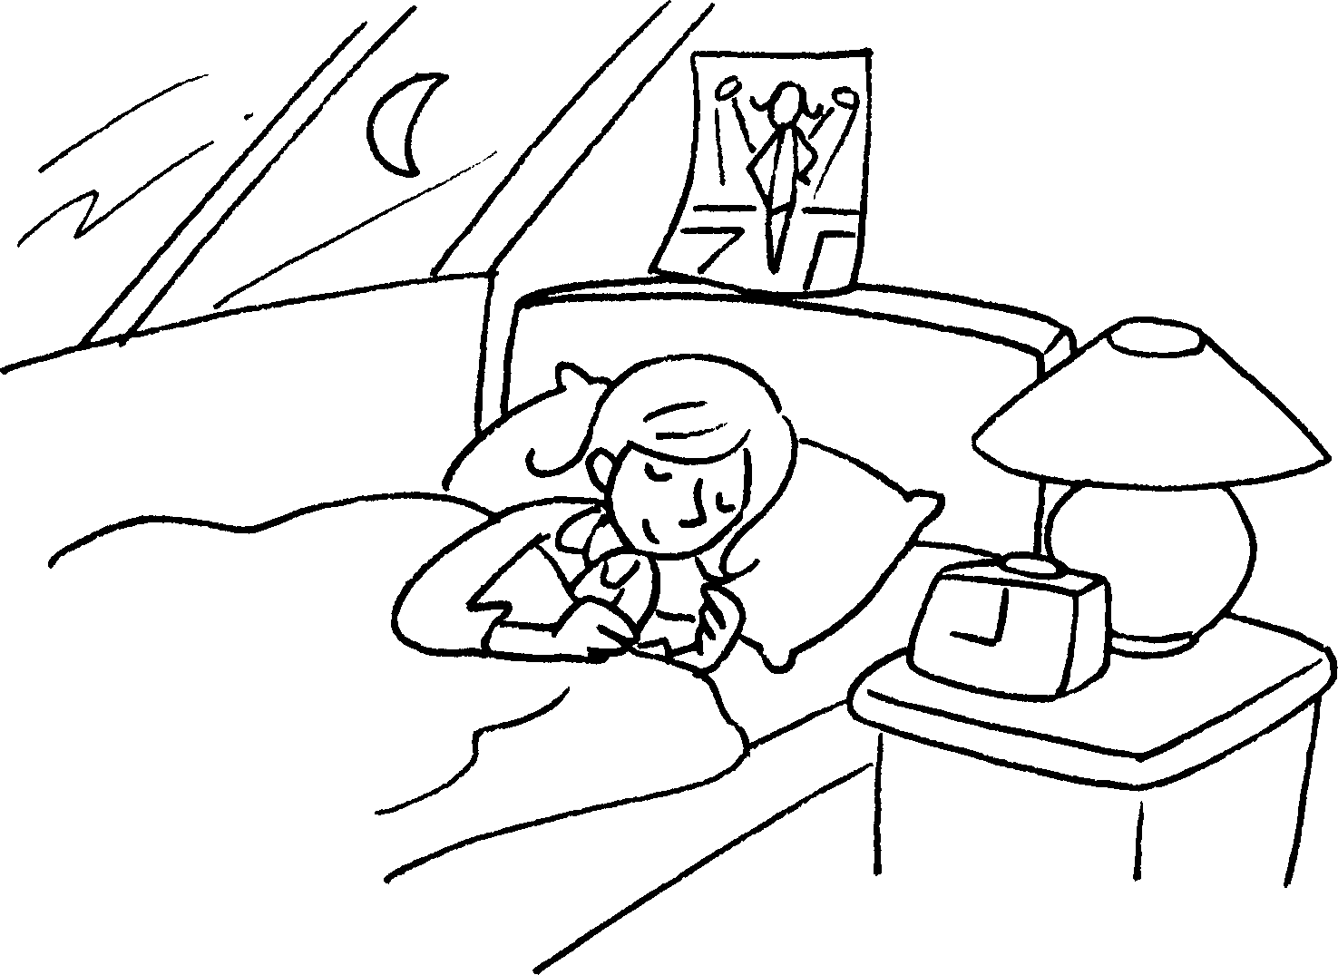  ( have beautiful skin )
2 | Fire fighters do a lot of exercise every day | 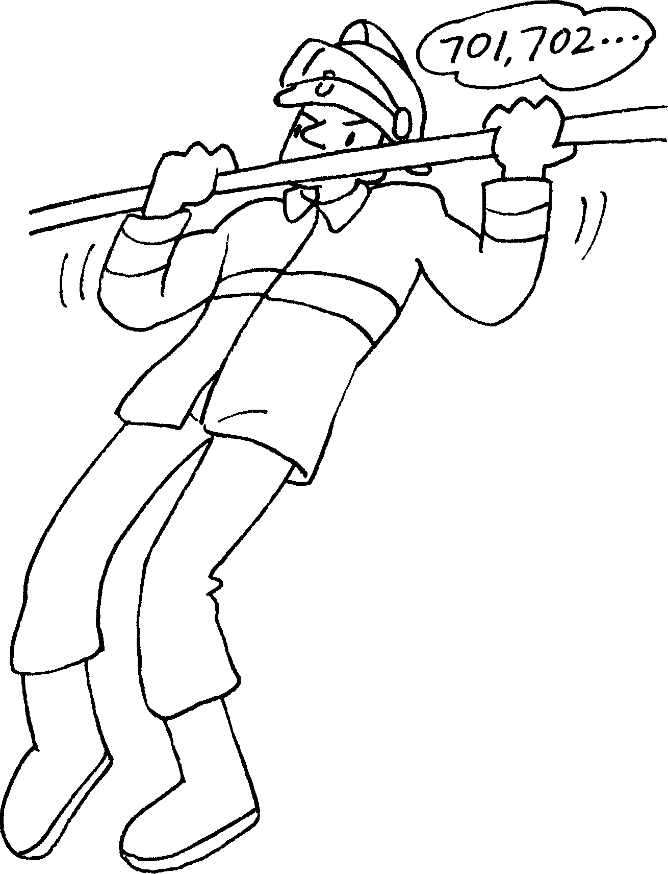  ( stay strong )
3 | Actors and actresses | 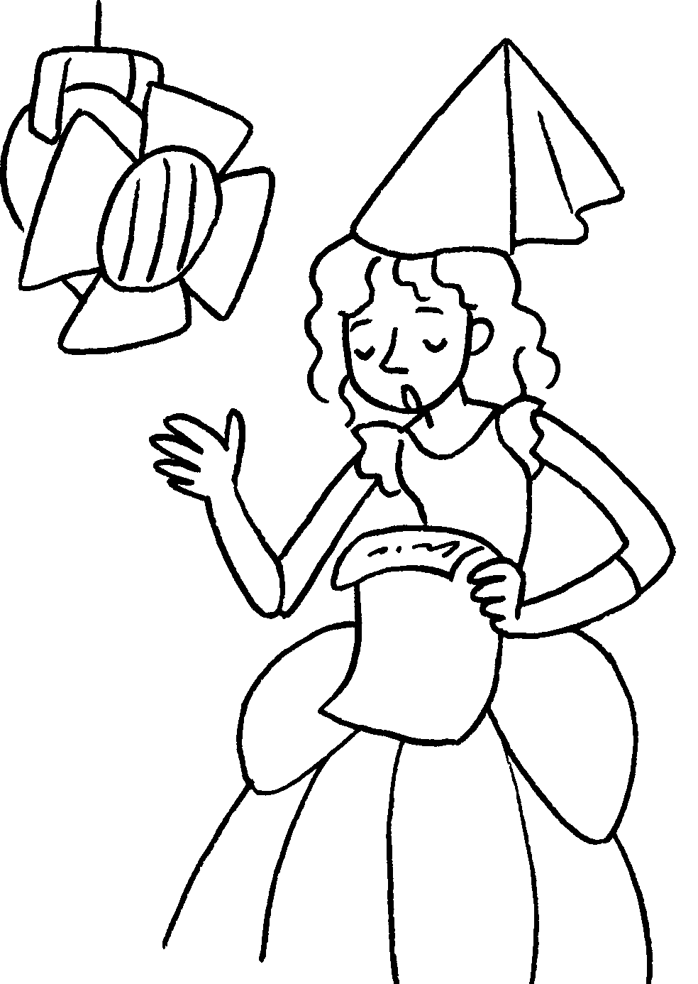  ( do a lot of rehearsals / perform well )
4 | Fashion designers |   ( study fashion from around the world / get ideas for  their designs )
5 | Reporters | Hello.  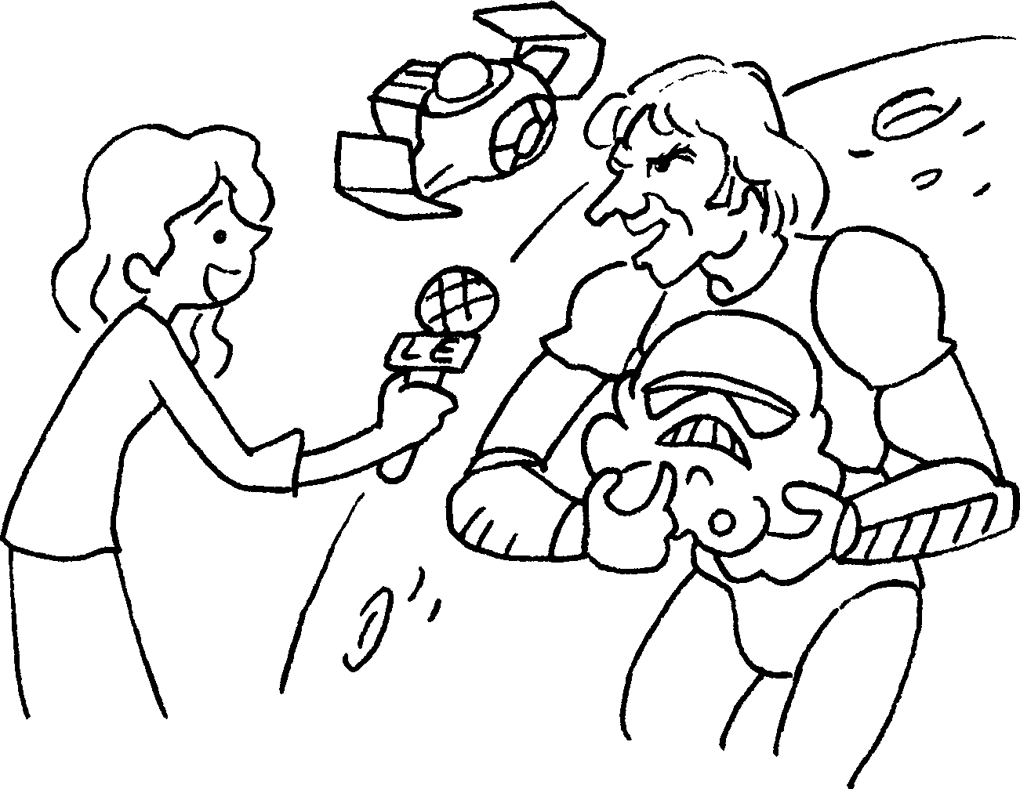  ( study languages / Interview people from different places )


Book 6A Chapter 2 Graded Worksheets
Worksheet 3⬇⬇
1 have beautiful skin.
2 so that they can stay strong.
3 do a lot of rehearsals so that they can perform well.
4 study fashion from around the world so that they can get ideas for their designs.
5 study languages so that they can interview people from different places.

