Finish the sentences using ‘so that’.

do a lot of rehearsals interview people from different places
study fashion from around the world have beautiful skin
do a lot of exercise every day get ideas for their designs
study languages perform well

1 | Models go to bed early so that they can | 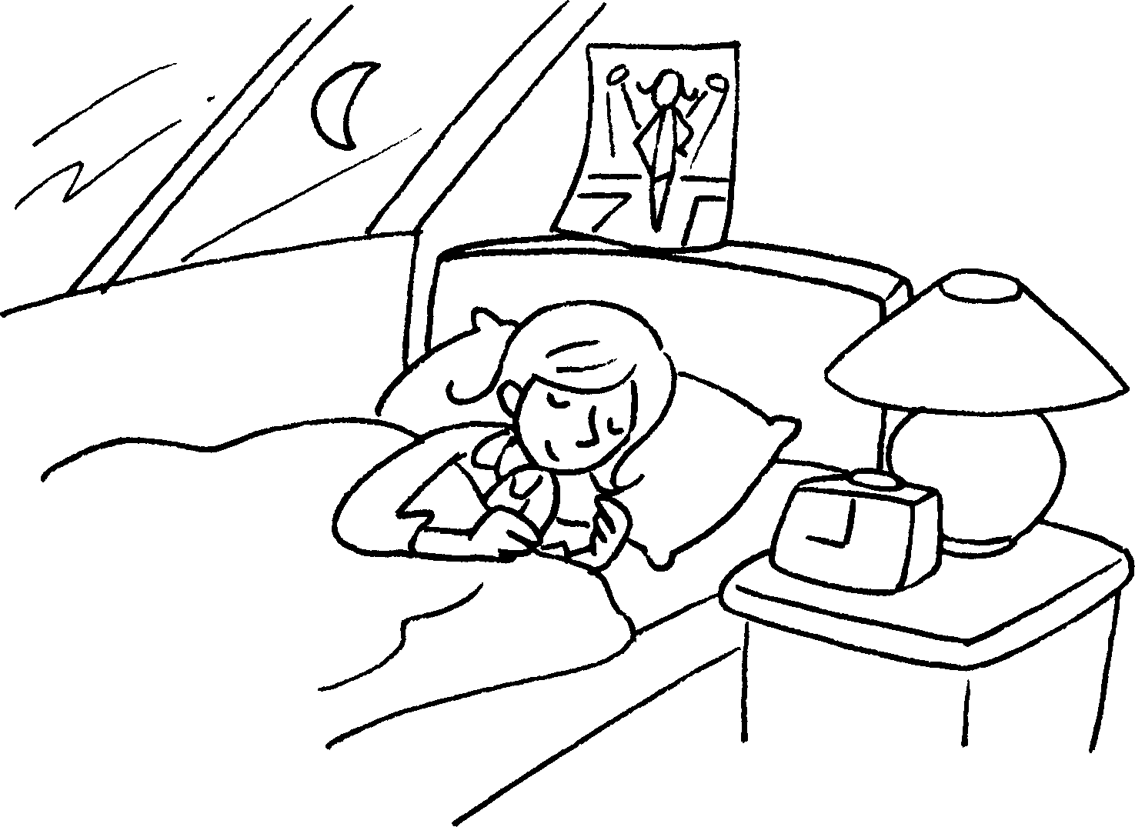
2 | Fire fighters  they can stay strong. | 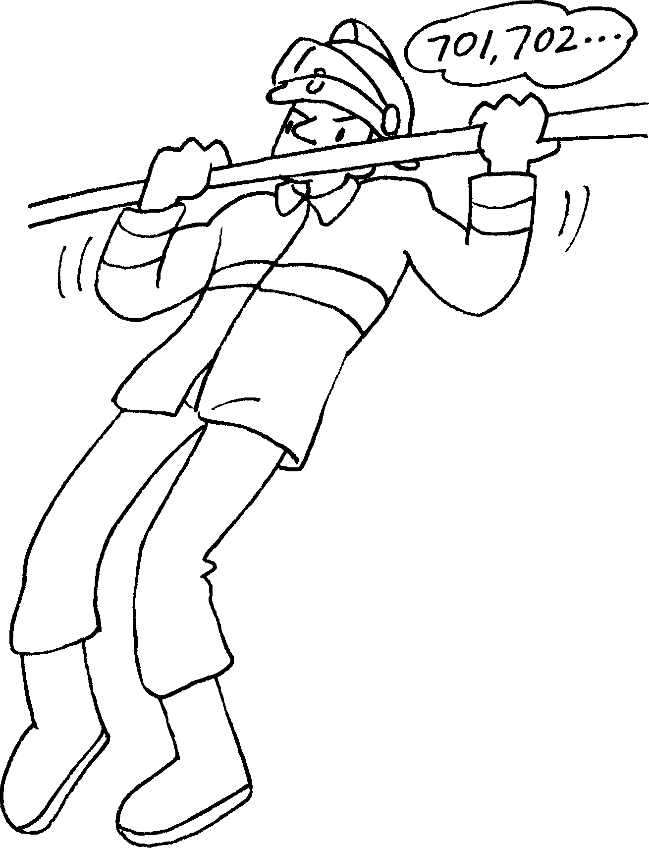
3 | Actors and actresses | 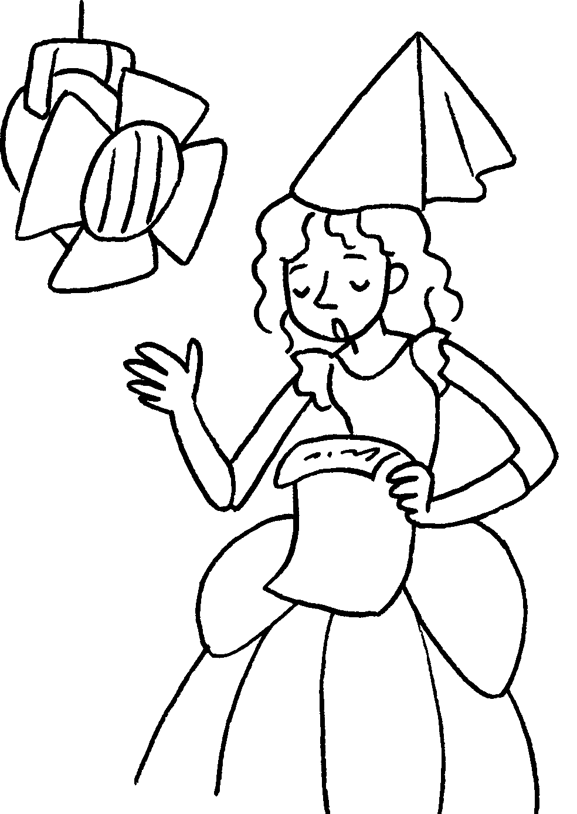
4 | _______________________________________________  _______________________________________________  _______________________________________________  _______________________________________________ | 
5 |  | Hello.  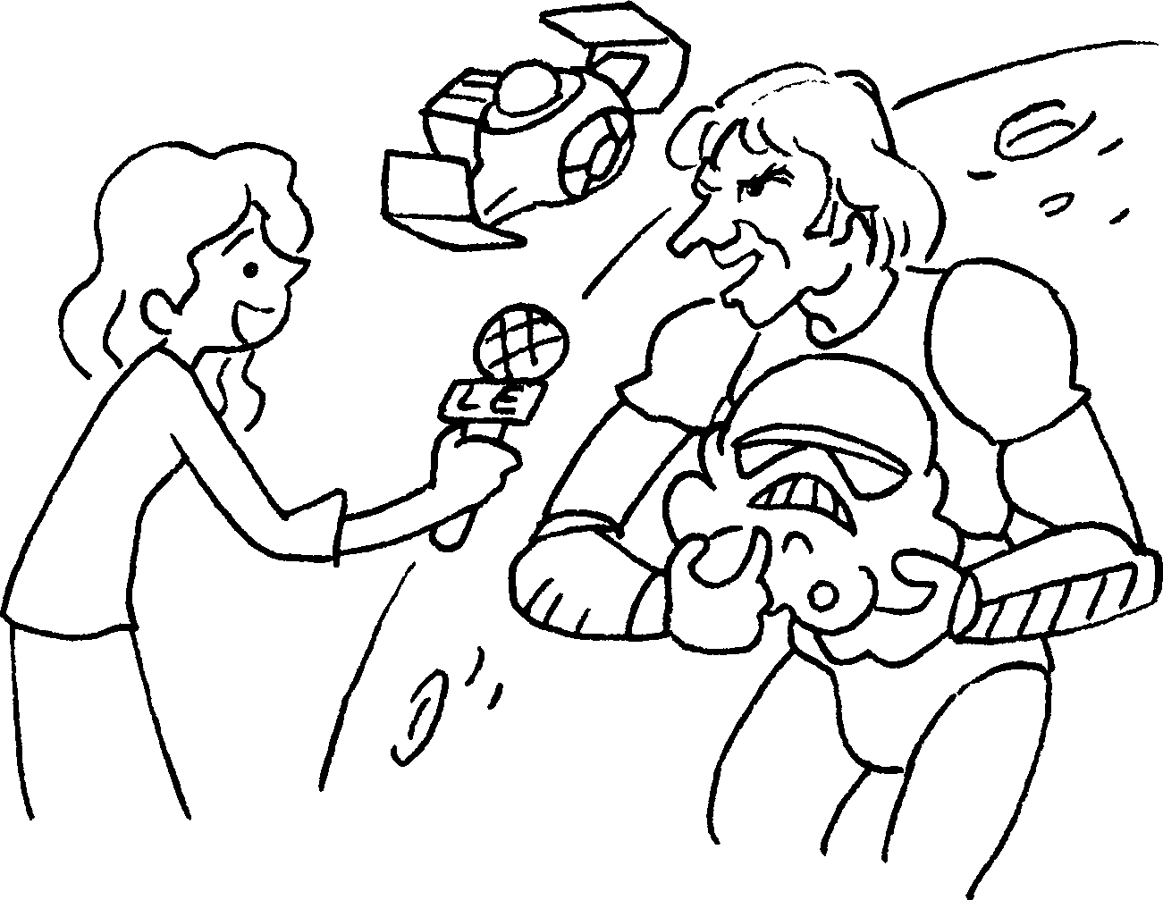


Book 6A Chapter 2 Graded Worksheets
Worksheet 3⬇⬇⬇
1 have beautiful skin.
2 do a lot of exercise every day so that
3 do a lot of rehearsals so that they can perform well.
4 Fashion designers study fashion from around the world so that they can get ideas for their designs.
5 Reporters study languages so that they can interview people from different places.

