Choose and write.

drought | earthquake | typhoon

1 | 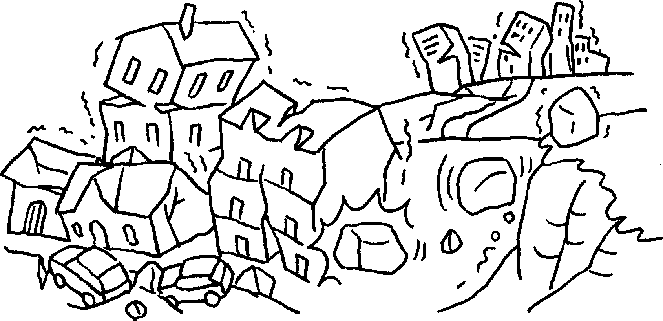 | 2 | 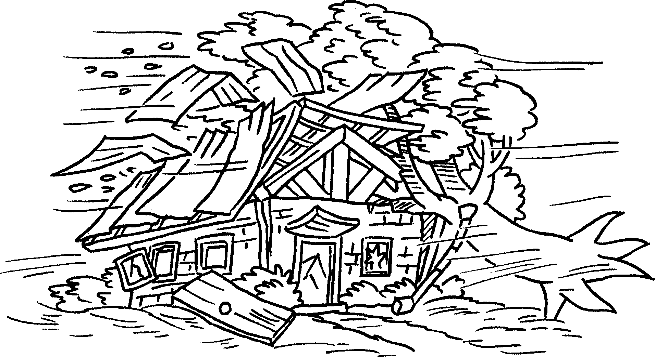 | 3 | 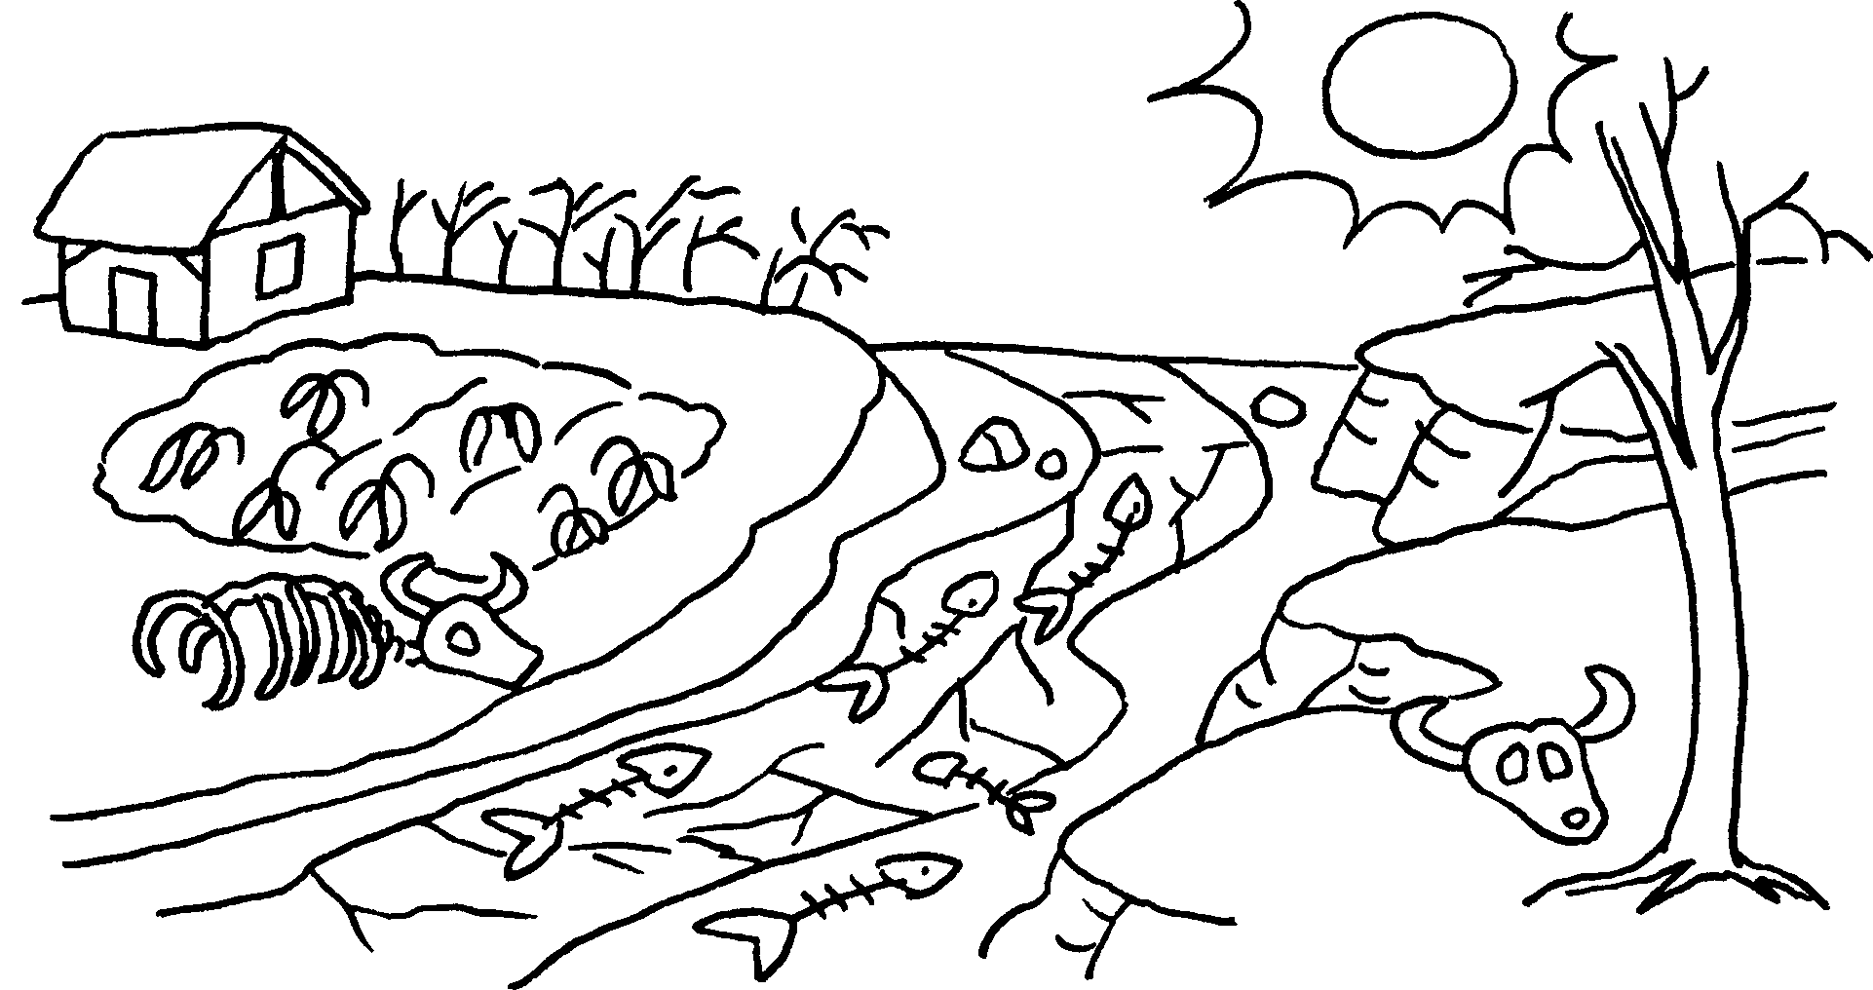
 | an |  | a |  | a

bright | cheap | dirty | dry | healthy | poor | strong

4 | 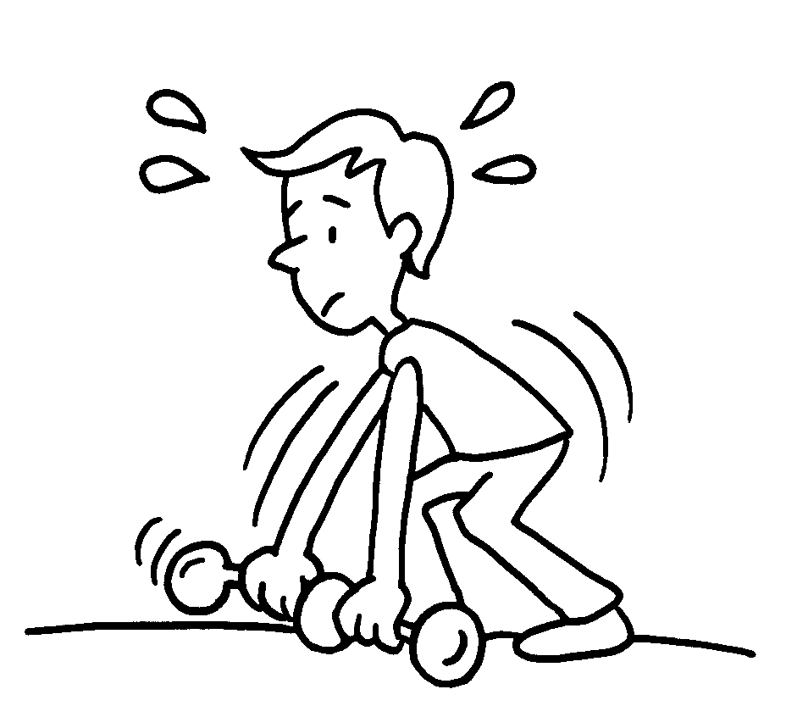 |  |  | 5 | 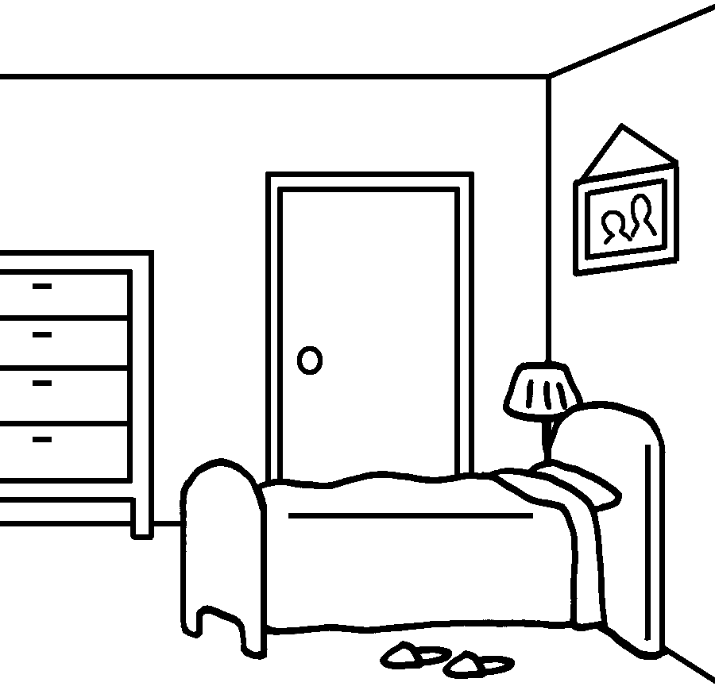 | 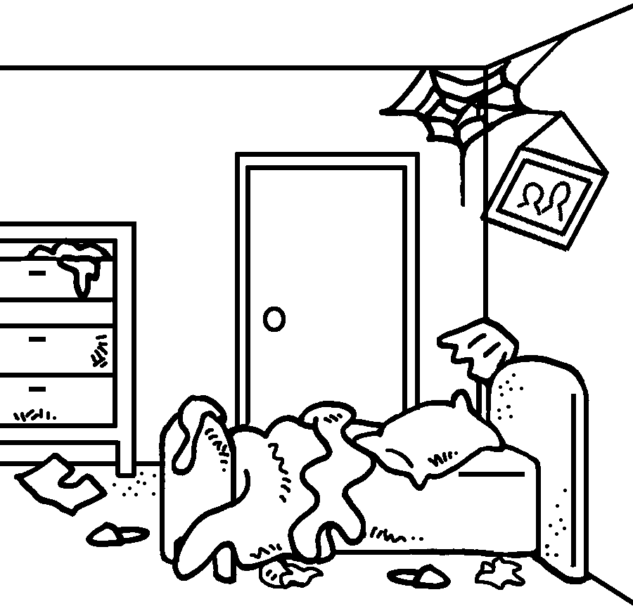
 | weak |  |  |  | clean
6 |  | 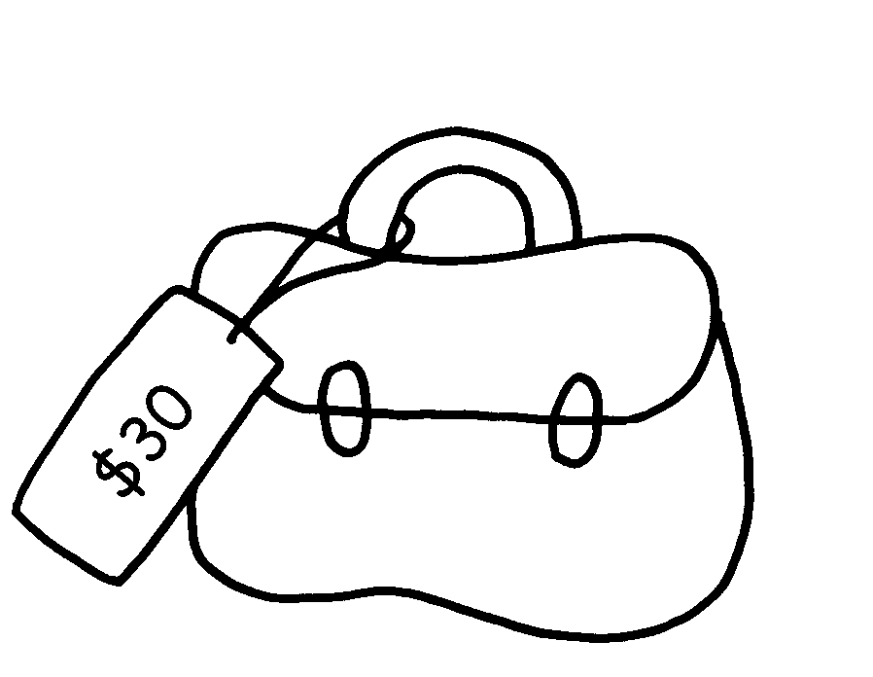 |  | 7 | 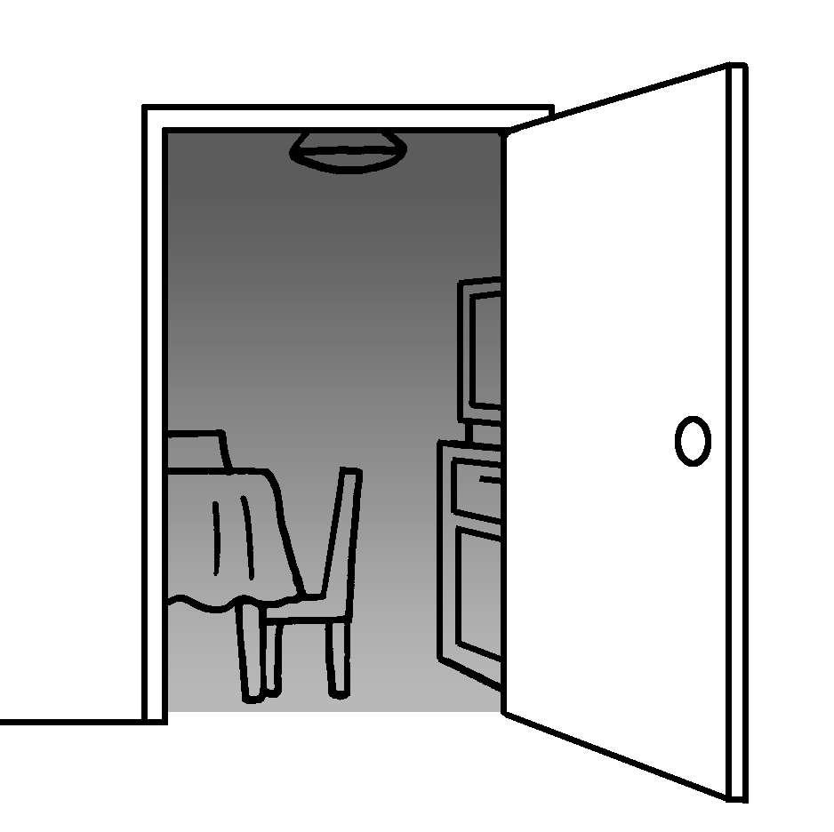 | 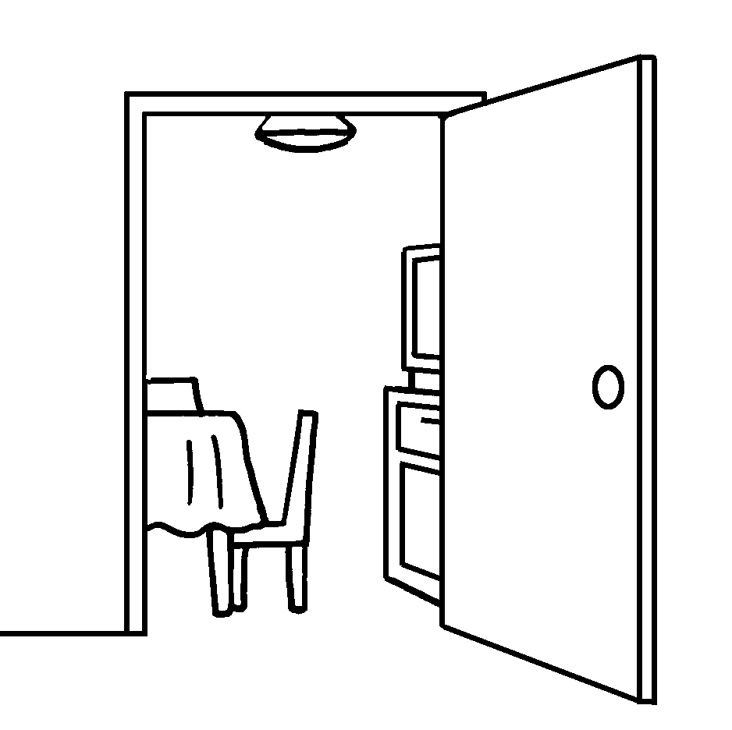
 | expensive |  |  |  | dark
8 | 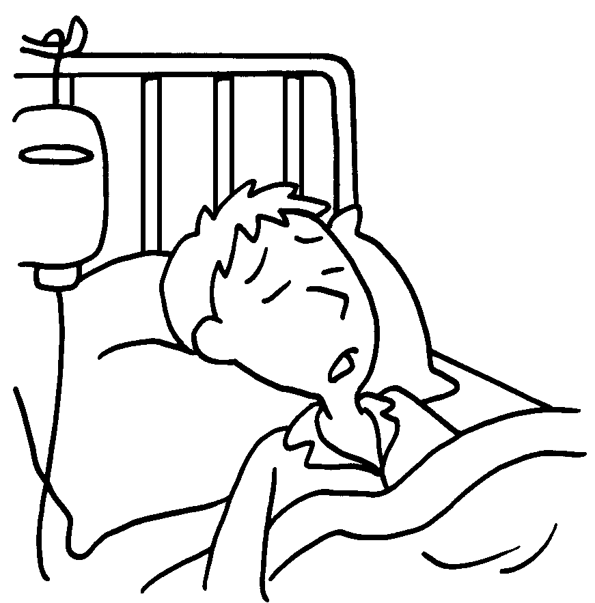 |  |  | 9 | 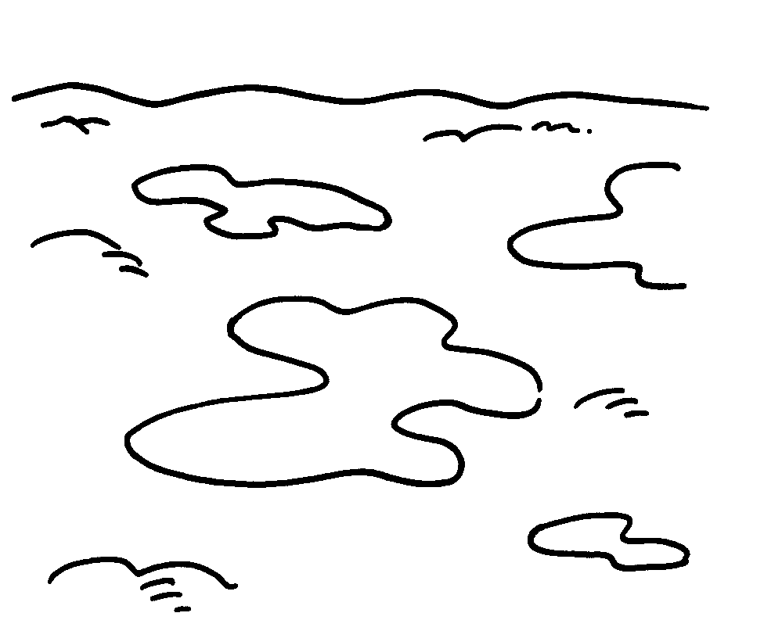 | 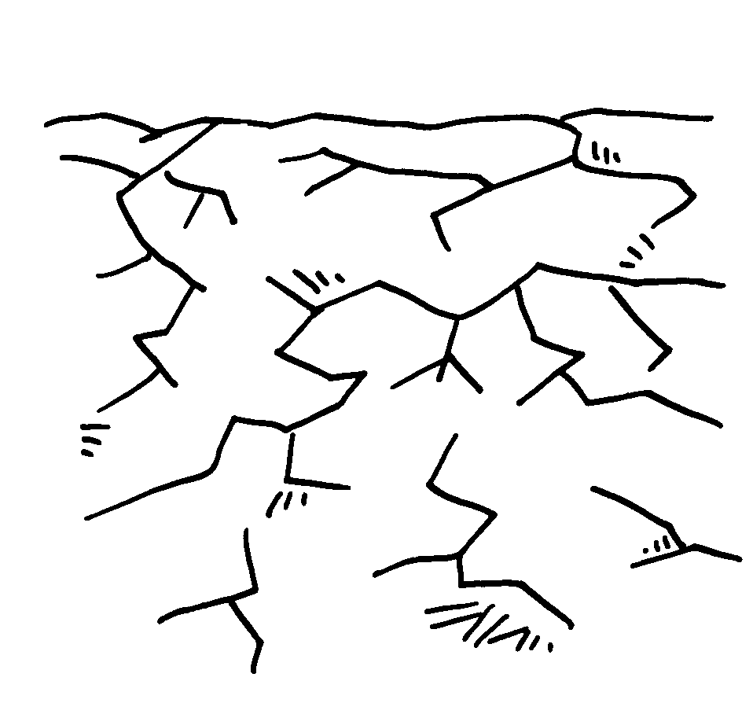
 | sick |  |  |  | wet
 |  | 10 |  |  | 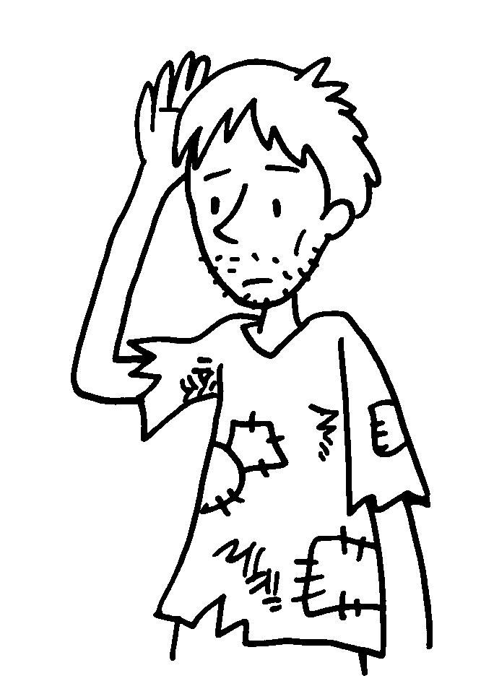
 |  |  | rich


Book 6A Chapter 3 Graded Worksheets
Worksheet 1⬇
- earthquake
- typhoon
- drought
- strong
- dirty
- cheap
- bright
- healthy
- dry
- poor

