Finish the sentences.

because | too

1 | 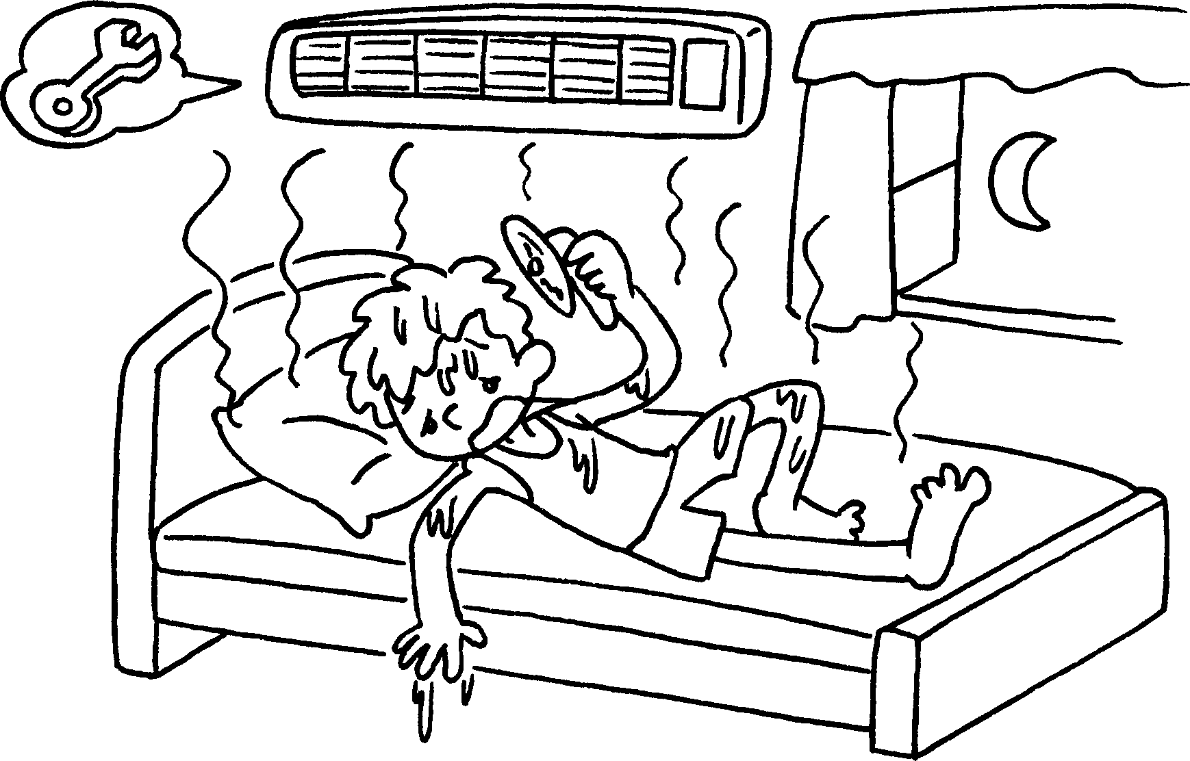 |  | He can’t sleep well it’s too hot.
2 | 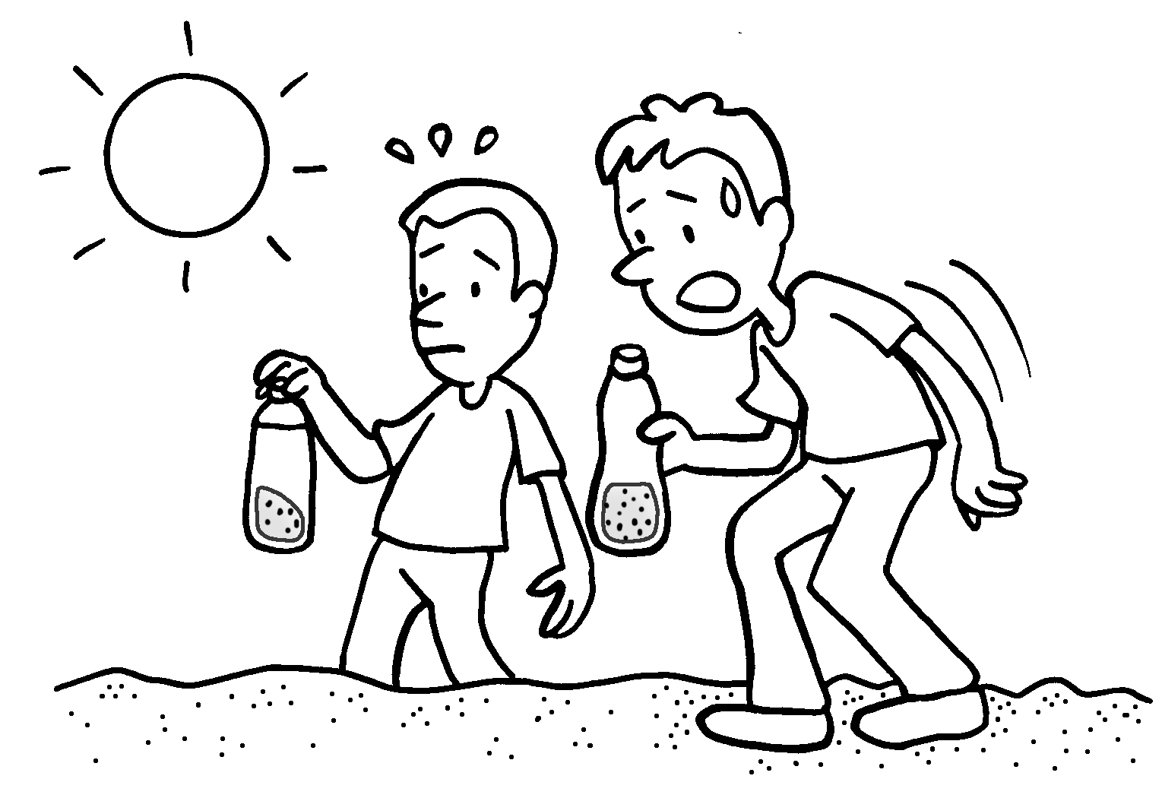 |  | We can’t drink the water because it’s  dirty.
3 | 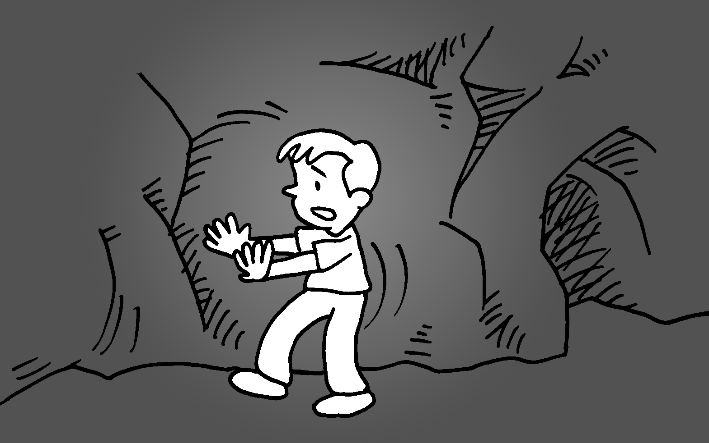 |  | I can’t see clearly  it’s dark.
4 | 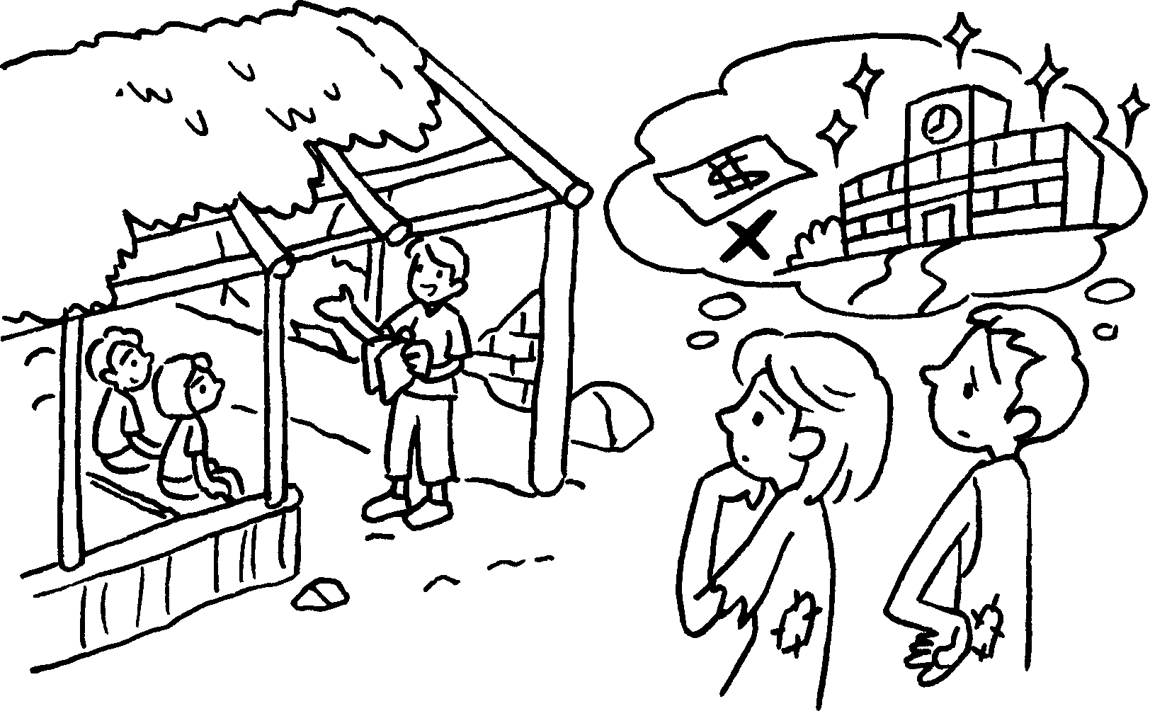  poor |  | People can’t rebuild the schools  they’re  .
5 | 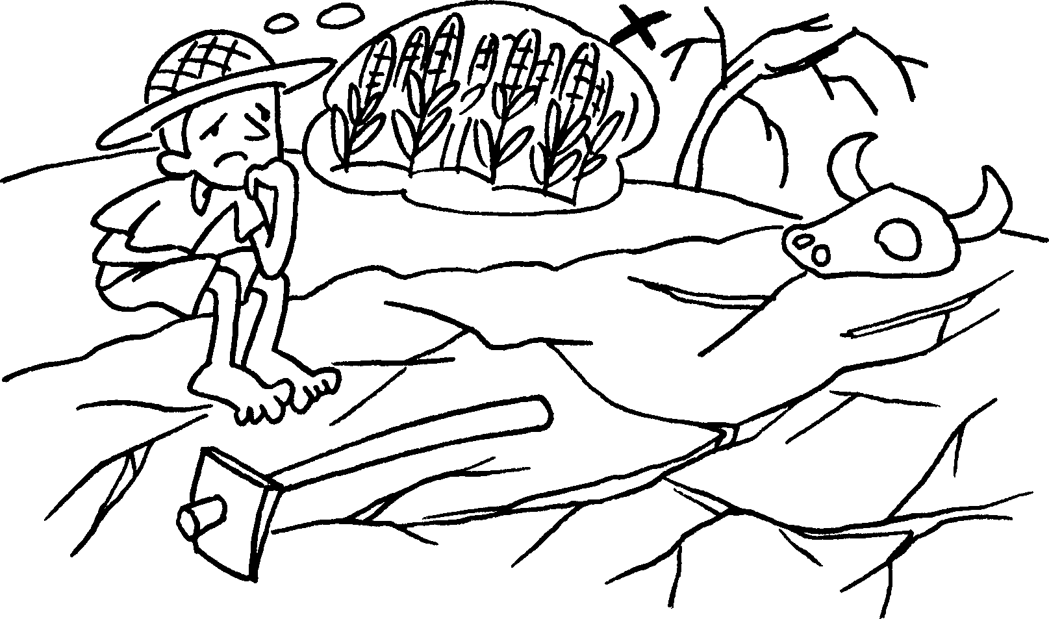  dry |  | People can’t grow food  the land is .


Book 6A Chapter 3 Graded Worksheets
Worksheet 2⬇
- because
- too
- because too
4 because too poor
5 because too dry

