Finish the sentences.

too because dark poor dry dirty

1 | 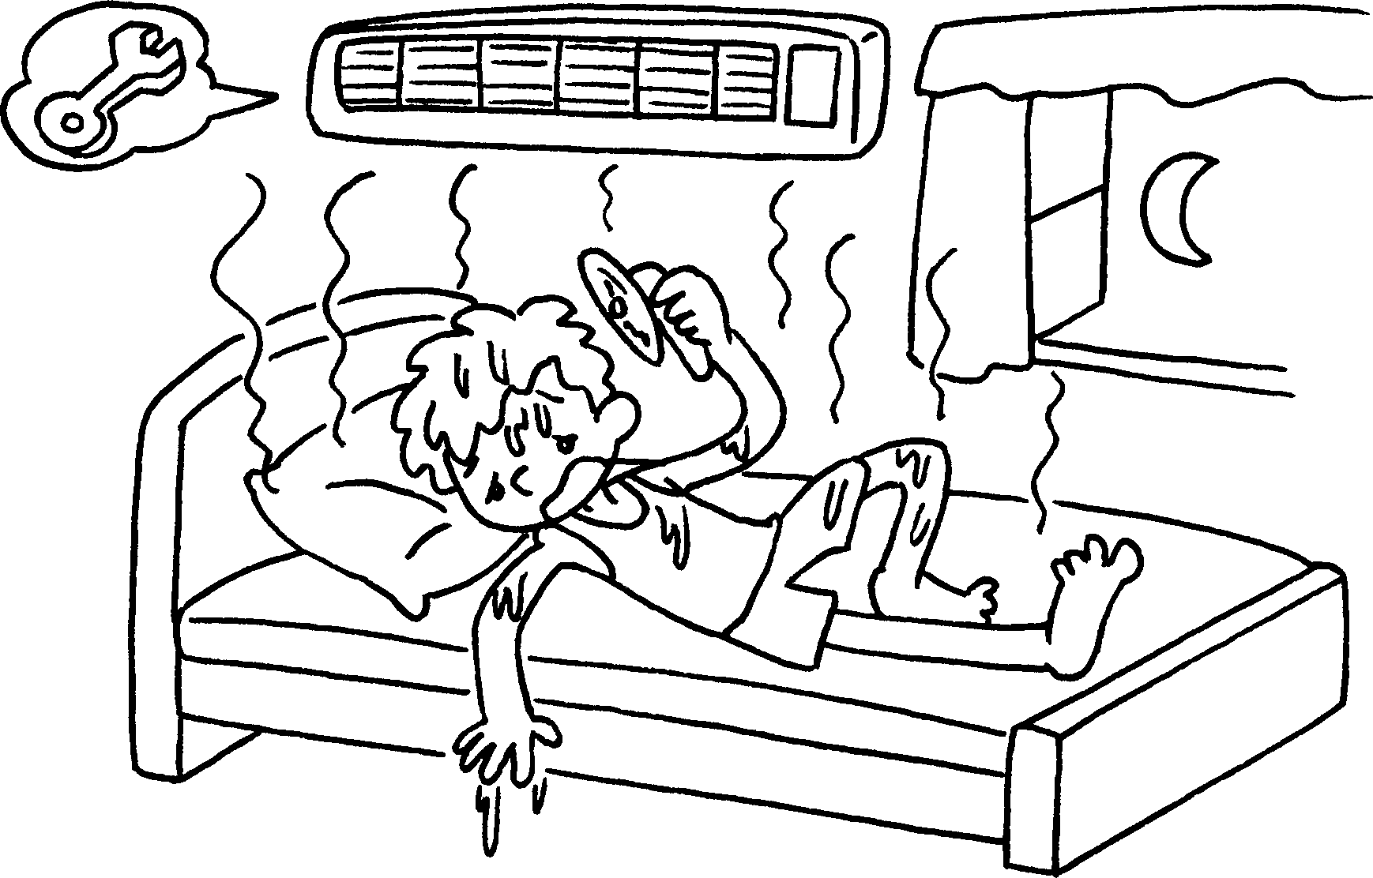 |  | He can’t sleep well it’s too hot.
2 | 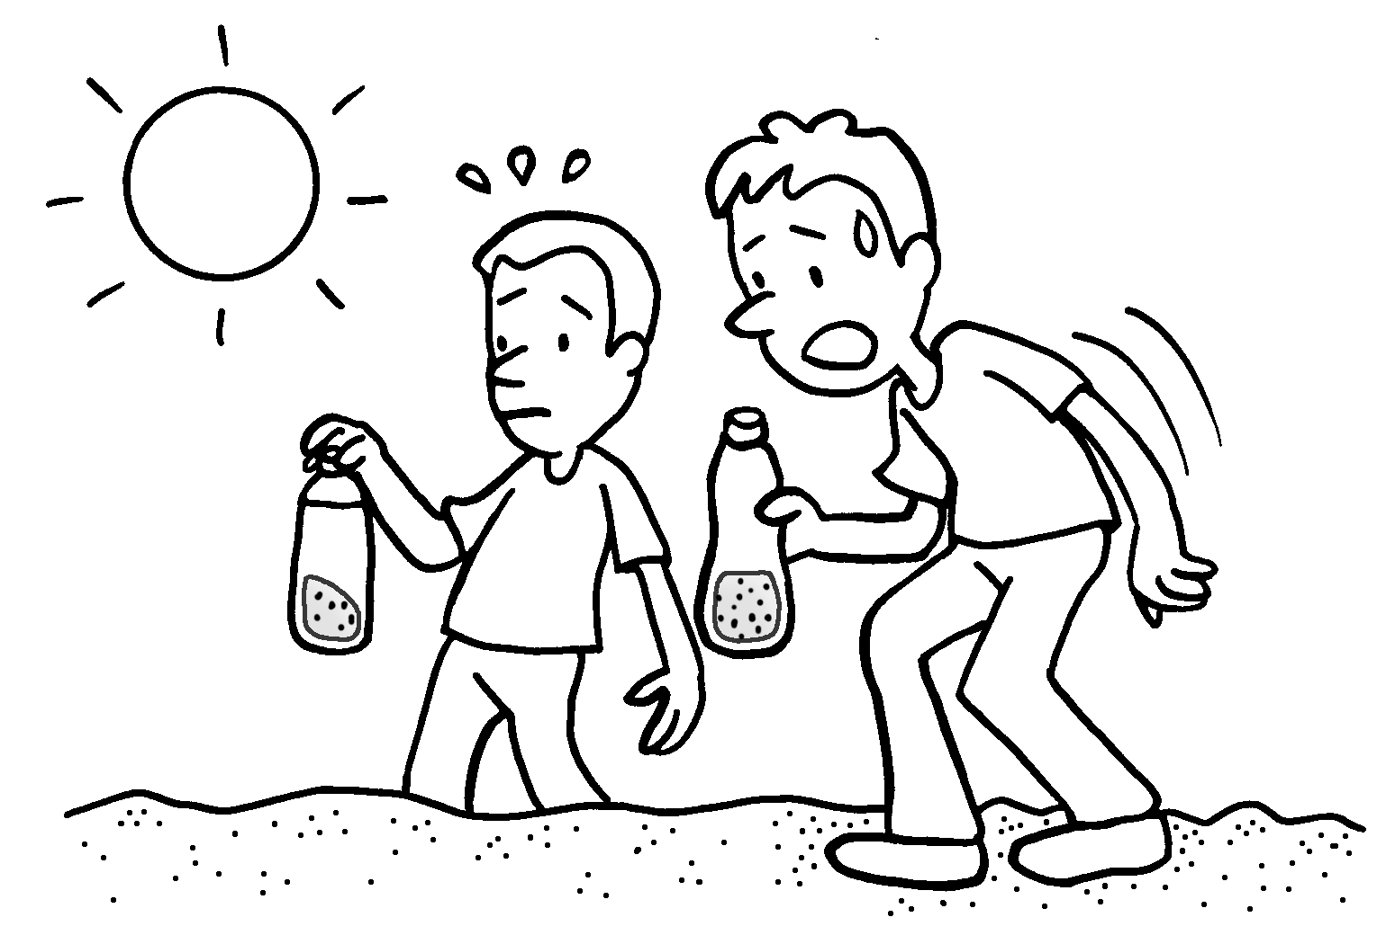 |  | We can’t drink the water it’s .
3 | 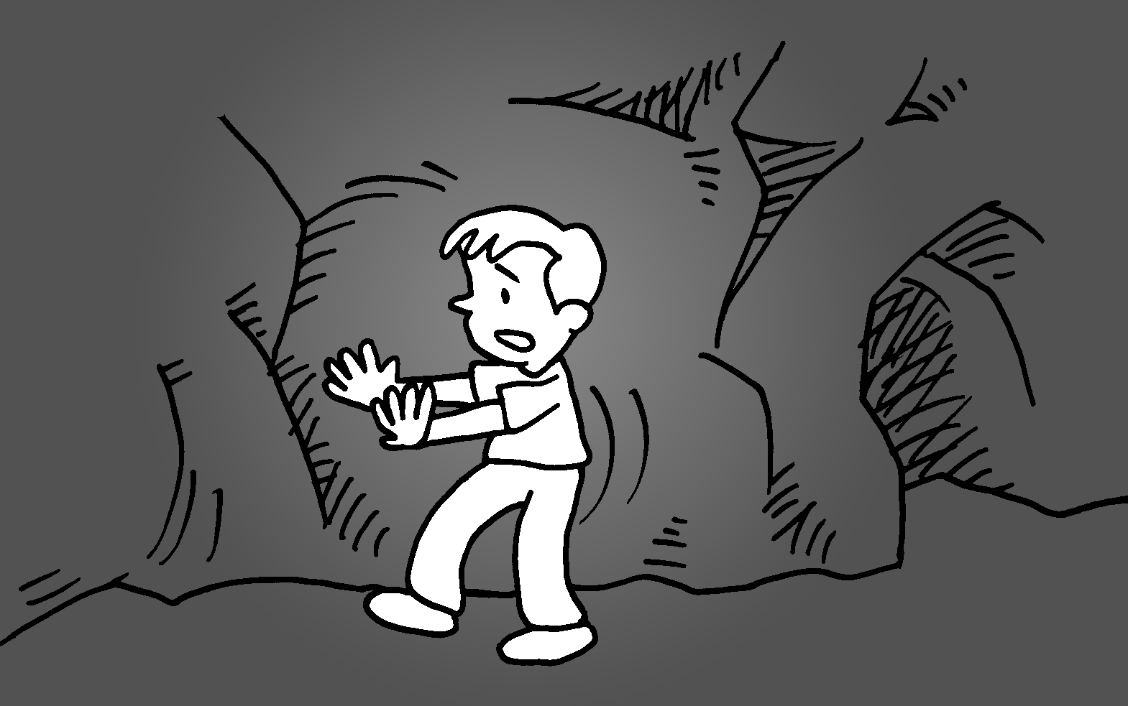 |  | I can’t see clearly  it’s .
4 | 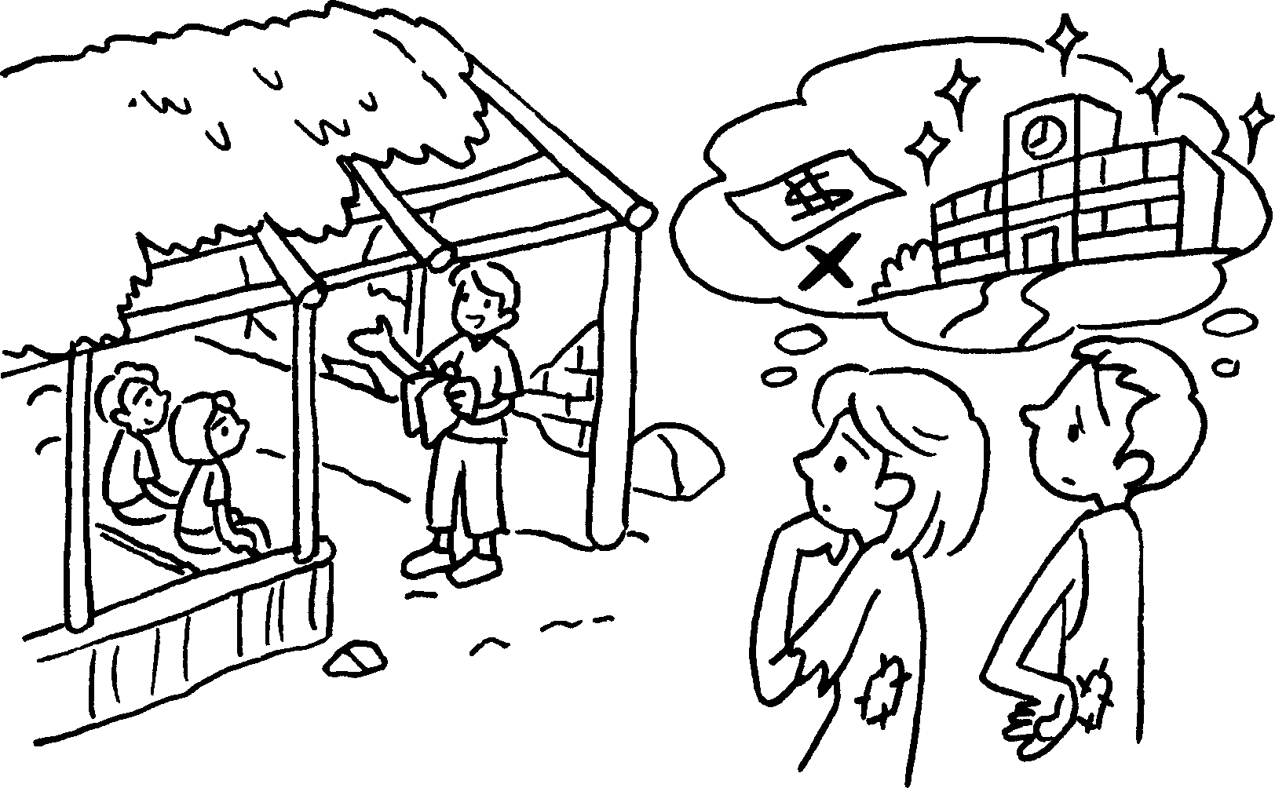 |  | People can’t rebuild the schools  they’re  .
5 | 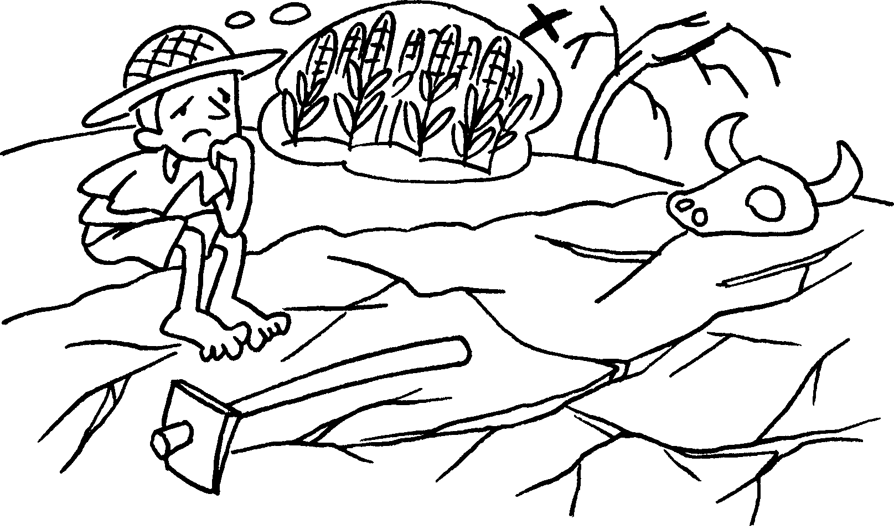 |  | People can’t grow food  the land is .


Book 6A Chapter 3 Graded Worksheets
Worksheet 2⬇⬇
- because
- because too dirty
- because too dark
4 because too poor
5 because too dry

