Finish the sentences.

because | too

1 | 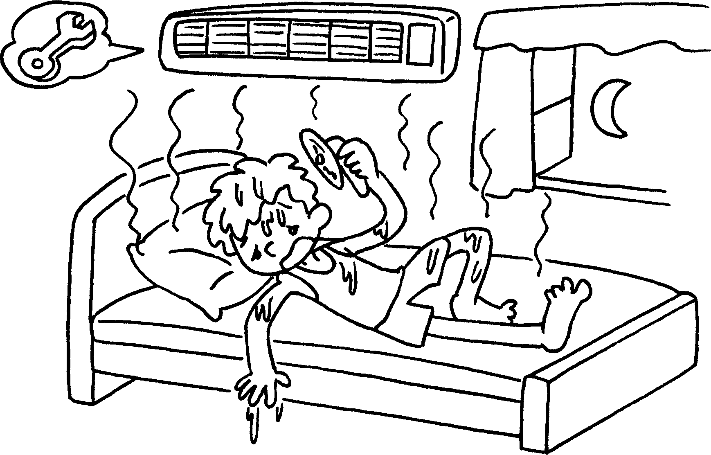 |  | He can’t sleep well it’s too hot.
2 | 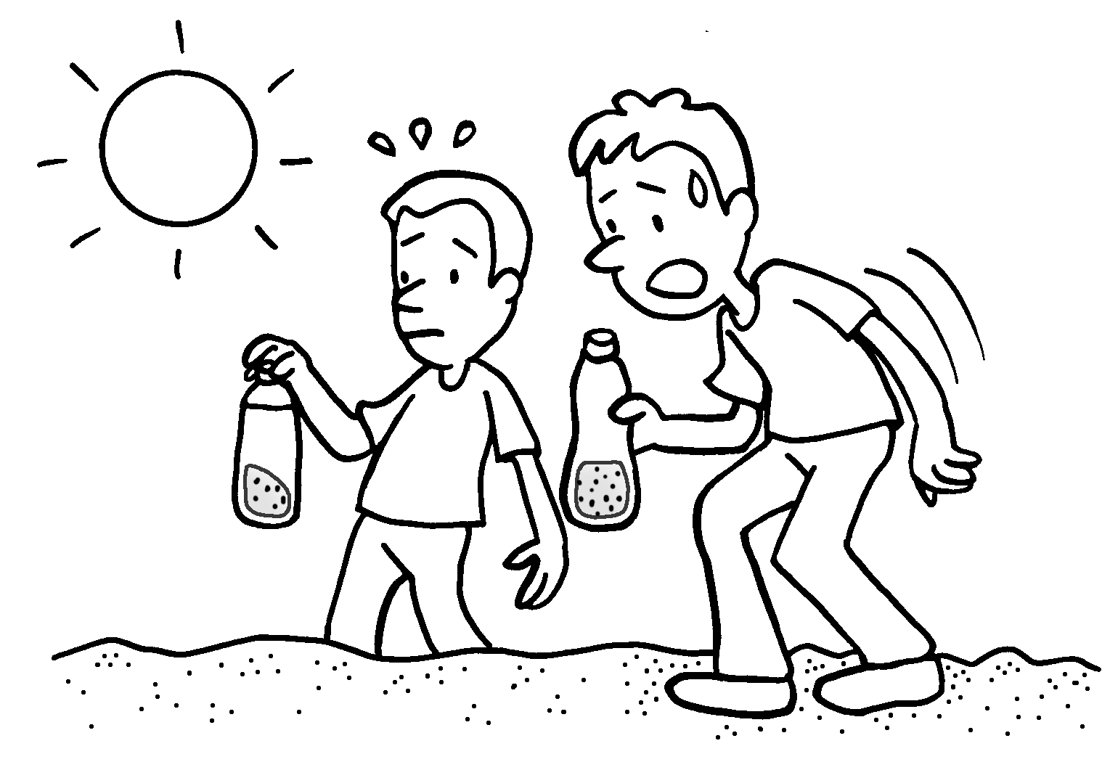 |  | We can’t drink the water it’s too .
3 | 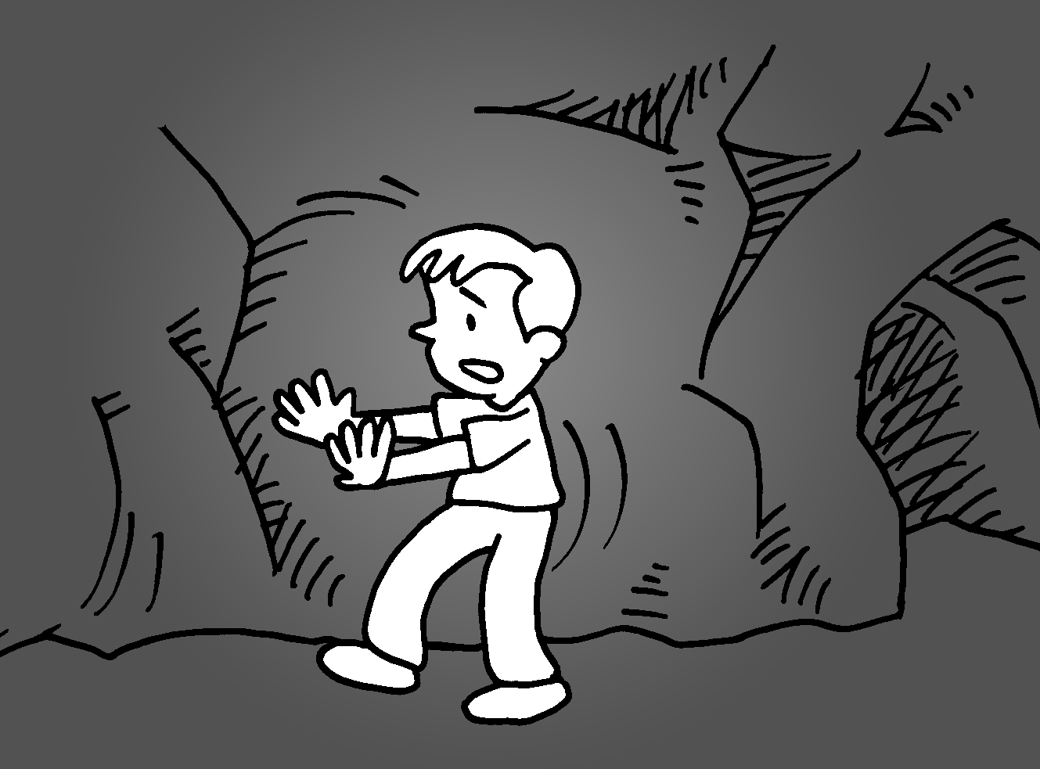 |  | I can’t see clearly  it’s .
4 | rebuild the schools  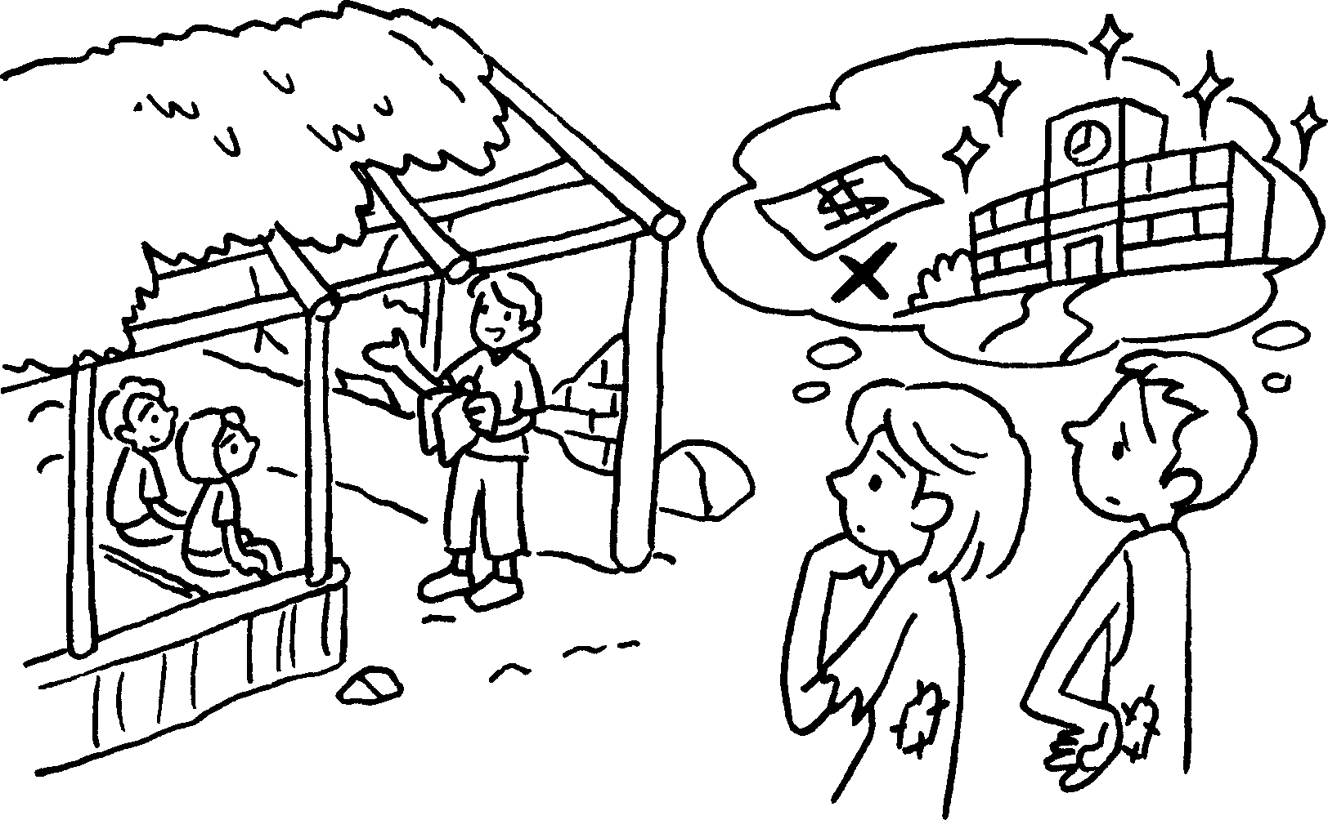 |  | People  they’re  .
5 | grow food  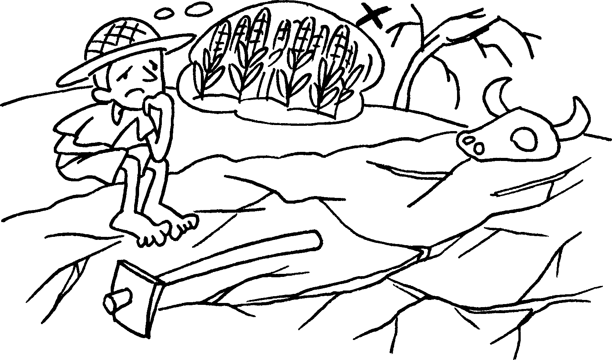 |  | People  the land is  .


Book 6A Chapter 3 Graded Worksheets
Worksheet 2⬇⬇⬇
- because
- because dirty
- because too dark
4 can’t rebuild the schools because too poor
5 can’t grow food because too dry
(Accept any reasonable answers.)

