Choose and write.

enough | very few | very little

1 | 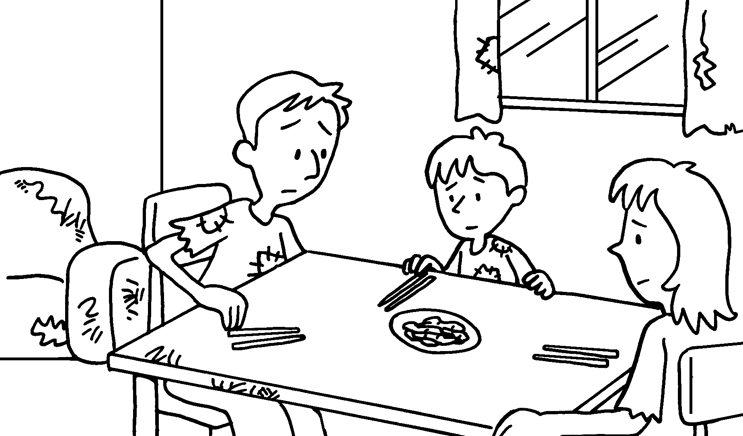 |  | There is food.
2 | 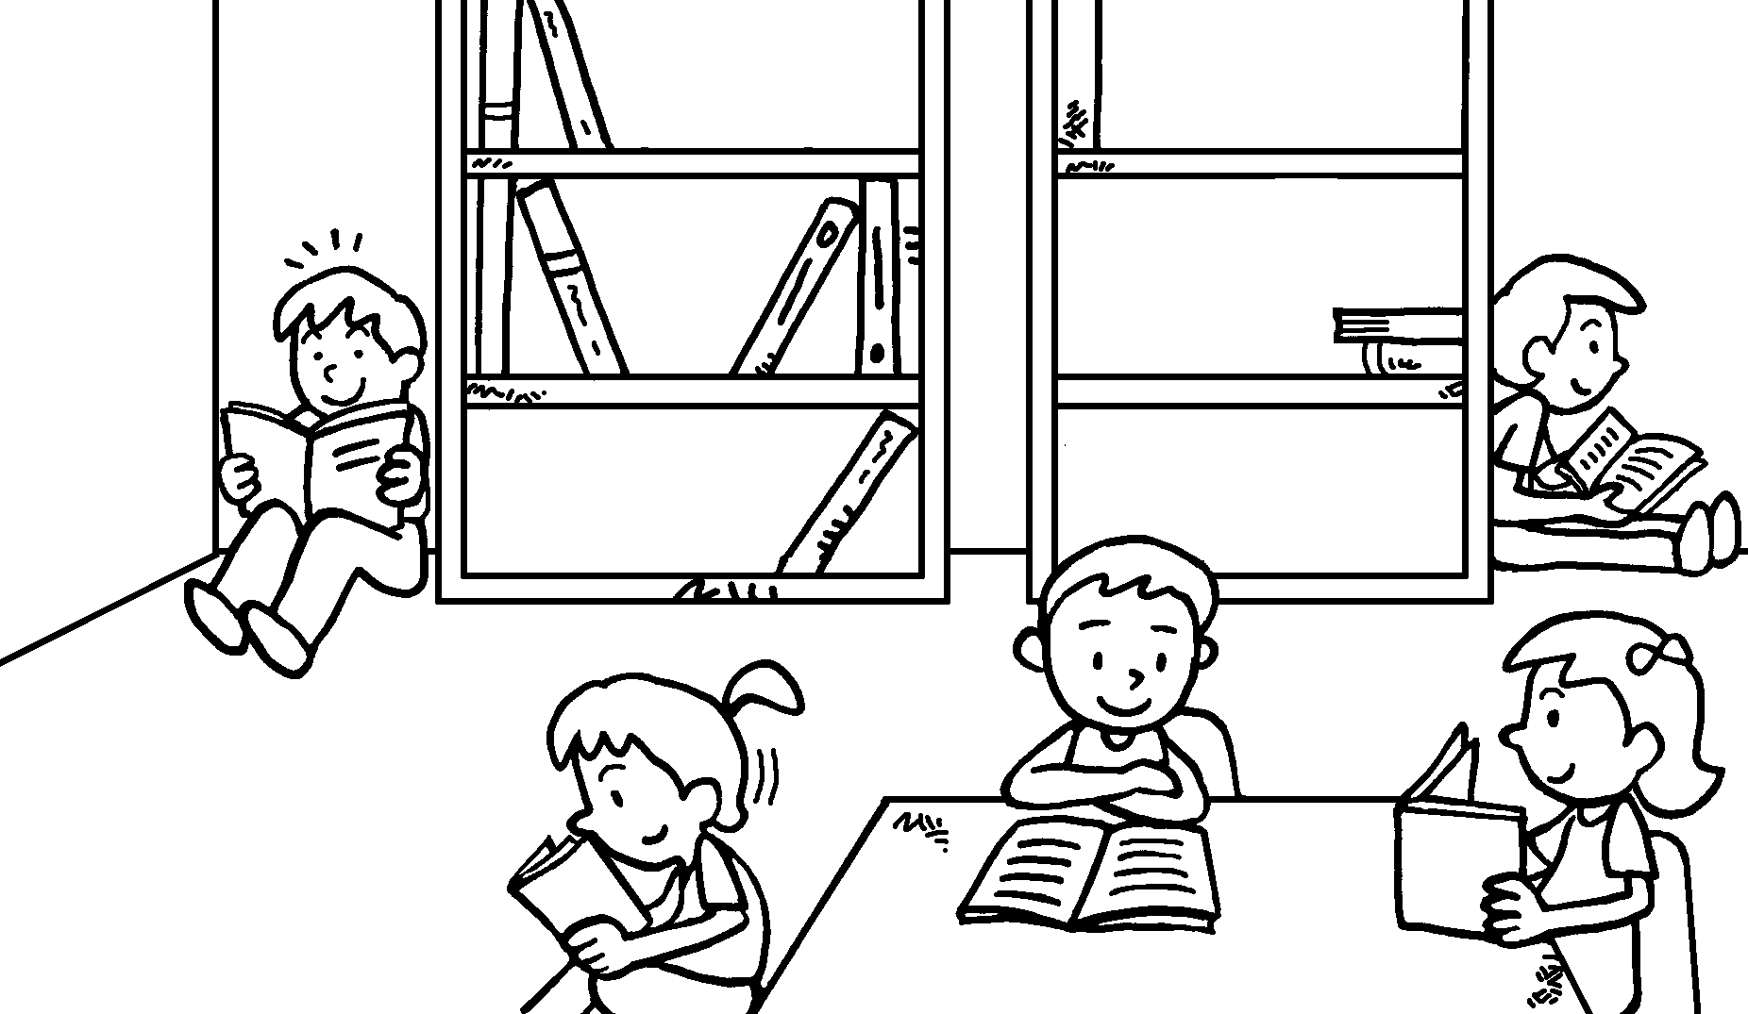 |  | There are books.  There are not chairs.
3 | 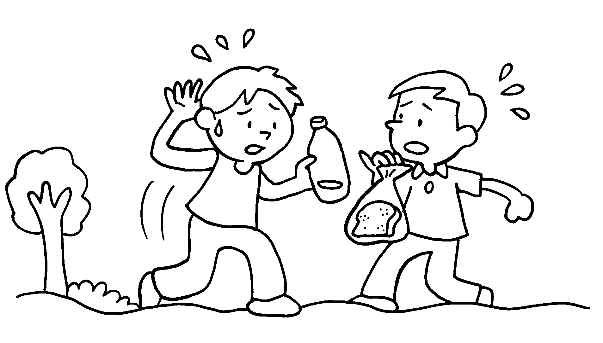 |  | There is not water.  There is bread.
4 | 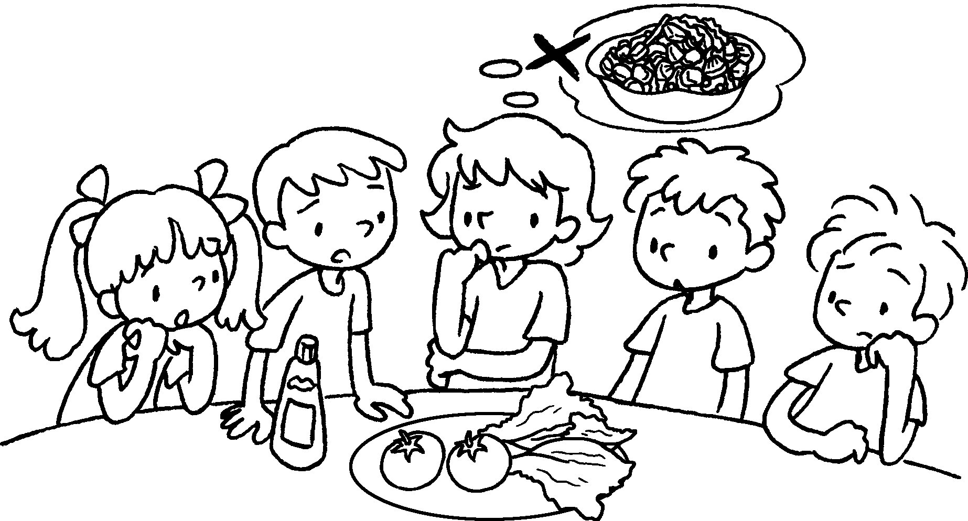 |  | There are vegetables.  There are tomatoes.


Book 6A Chapter 3 Graded Worksheets
Worksheet 3⬇
- very little
- very few
enough
- enough
very little
- very few
very few

