Finish the sentences.

enough | very few | very little

tomatoes bread chairs

1 | 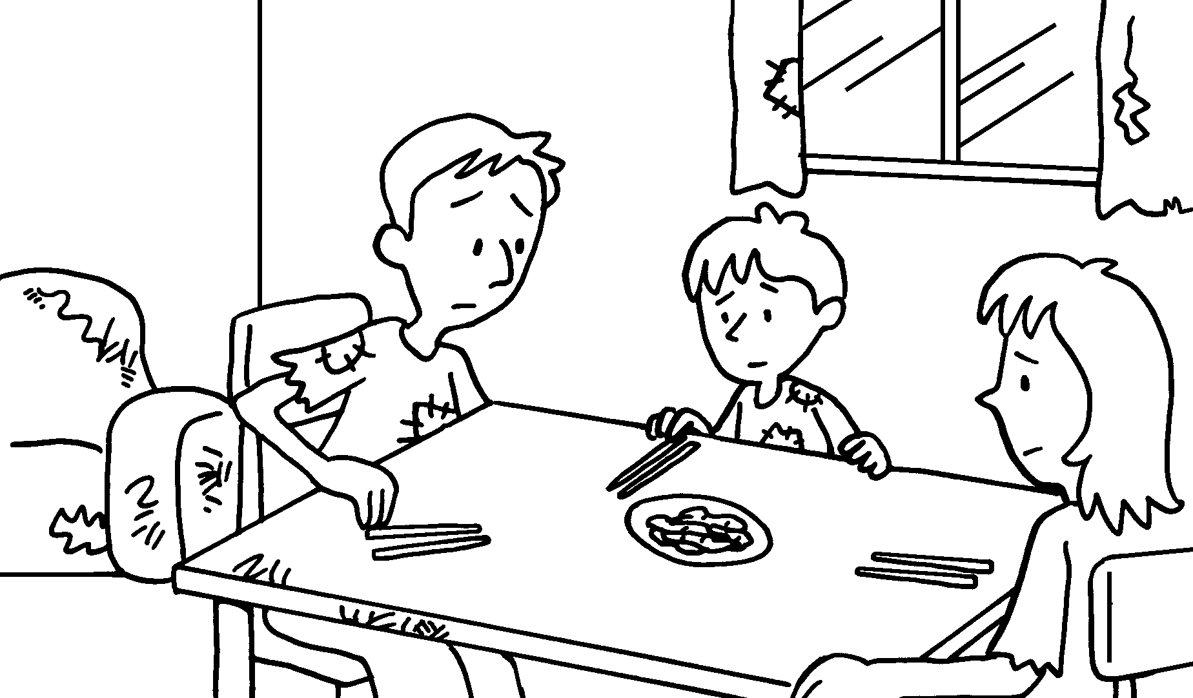 |  | There is food.
2 | 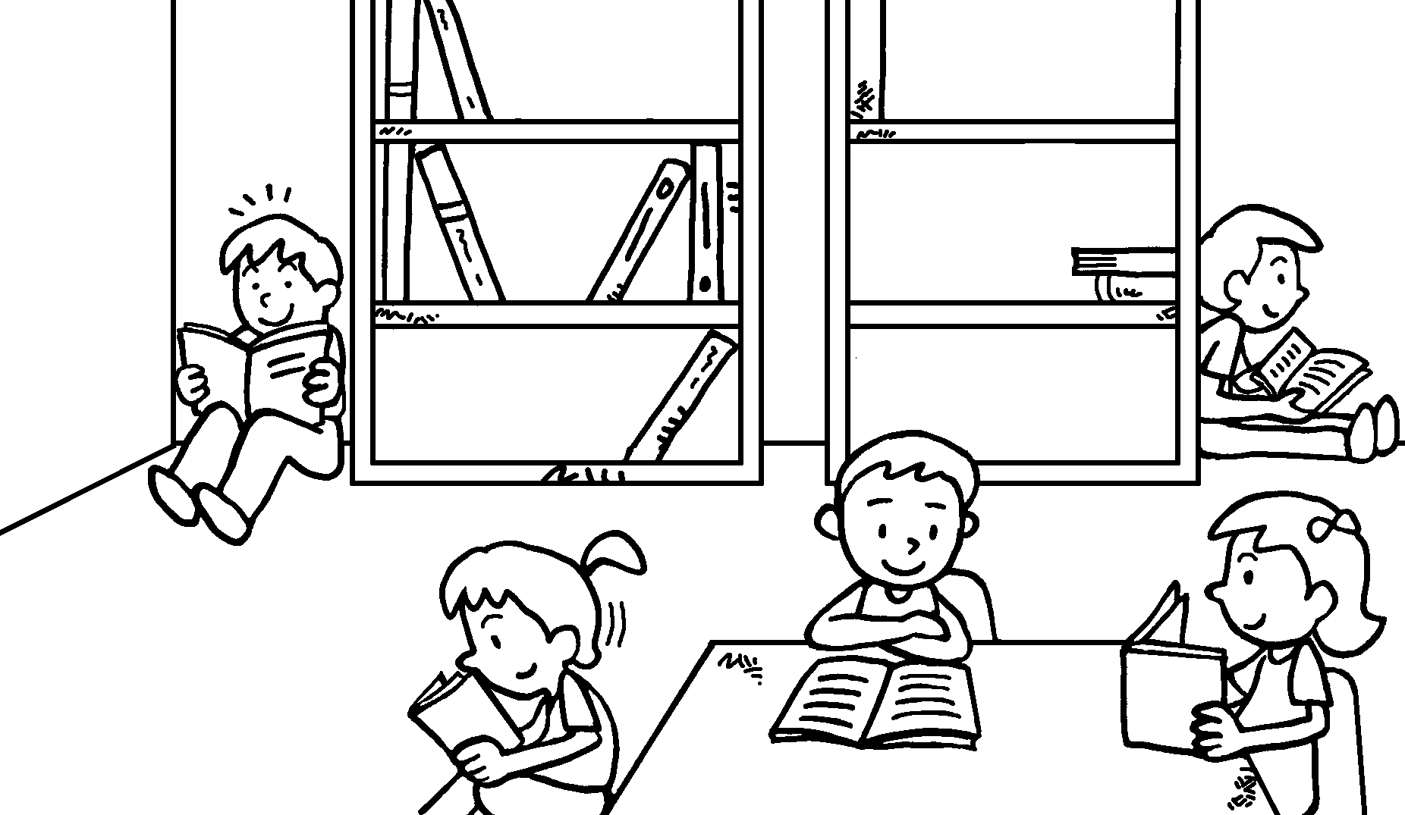 |  | There are books.  There are not  _______________ .
3 | 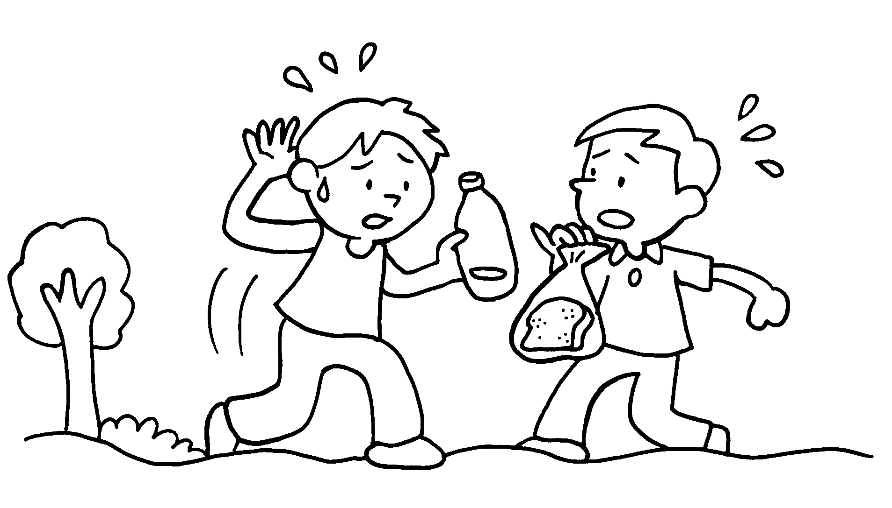 |  | There is not water.  There is  _______________ .
4 | 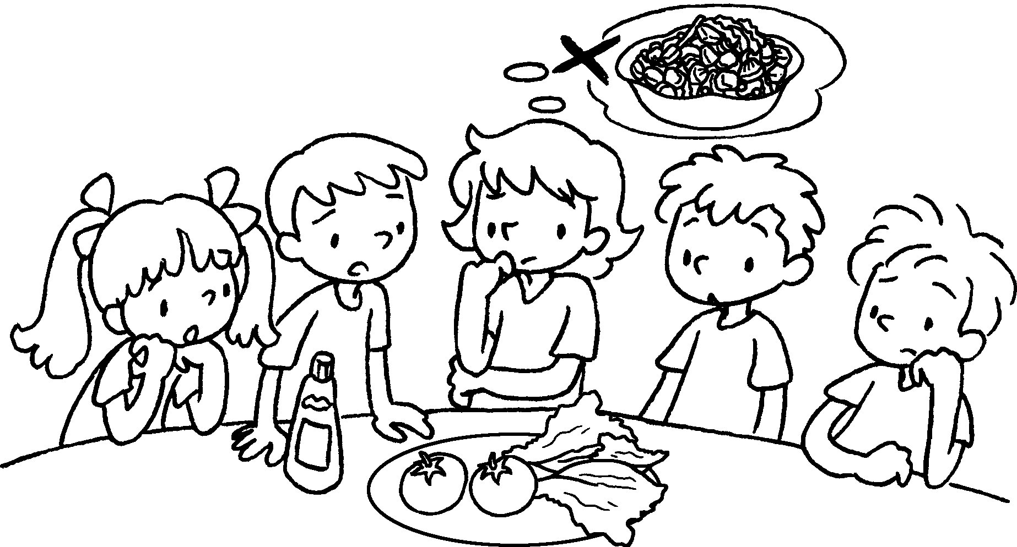 |  | There are vegetables.  There are  _______________ .


Book 6A Chapter 3 Graded Worksheets
Worksheet 3⬇⬇
- very little
- very few
enough chairs
- enough
very little bread
- very few
very few tomatoes

