Finish the sentences.

enough | very few | very little

1 | 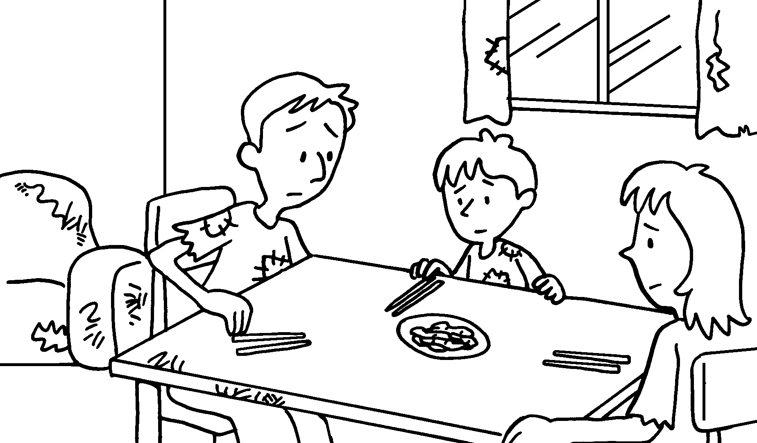 |  | There is food.
2 | 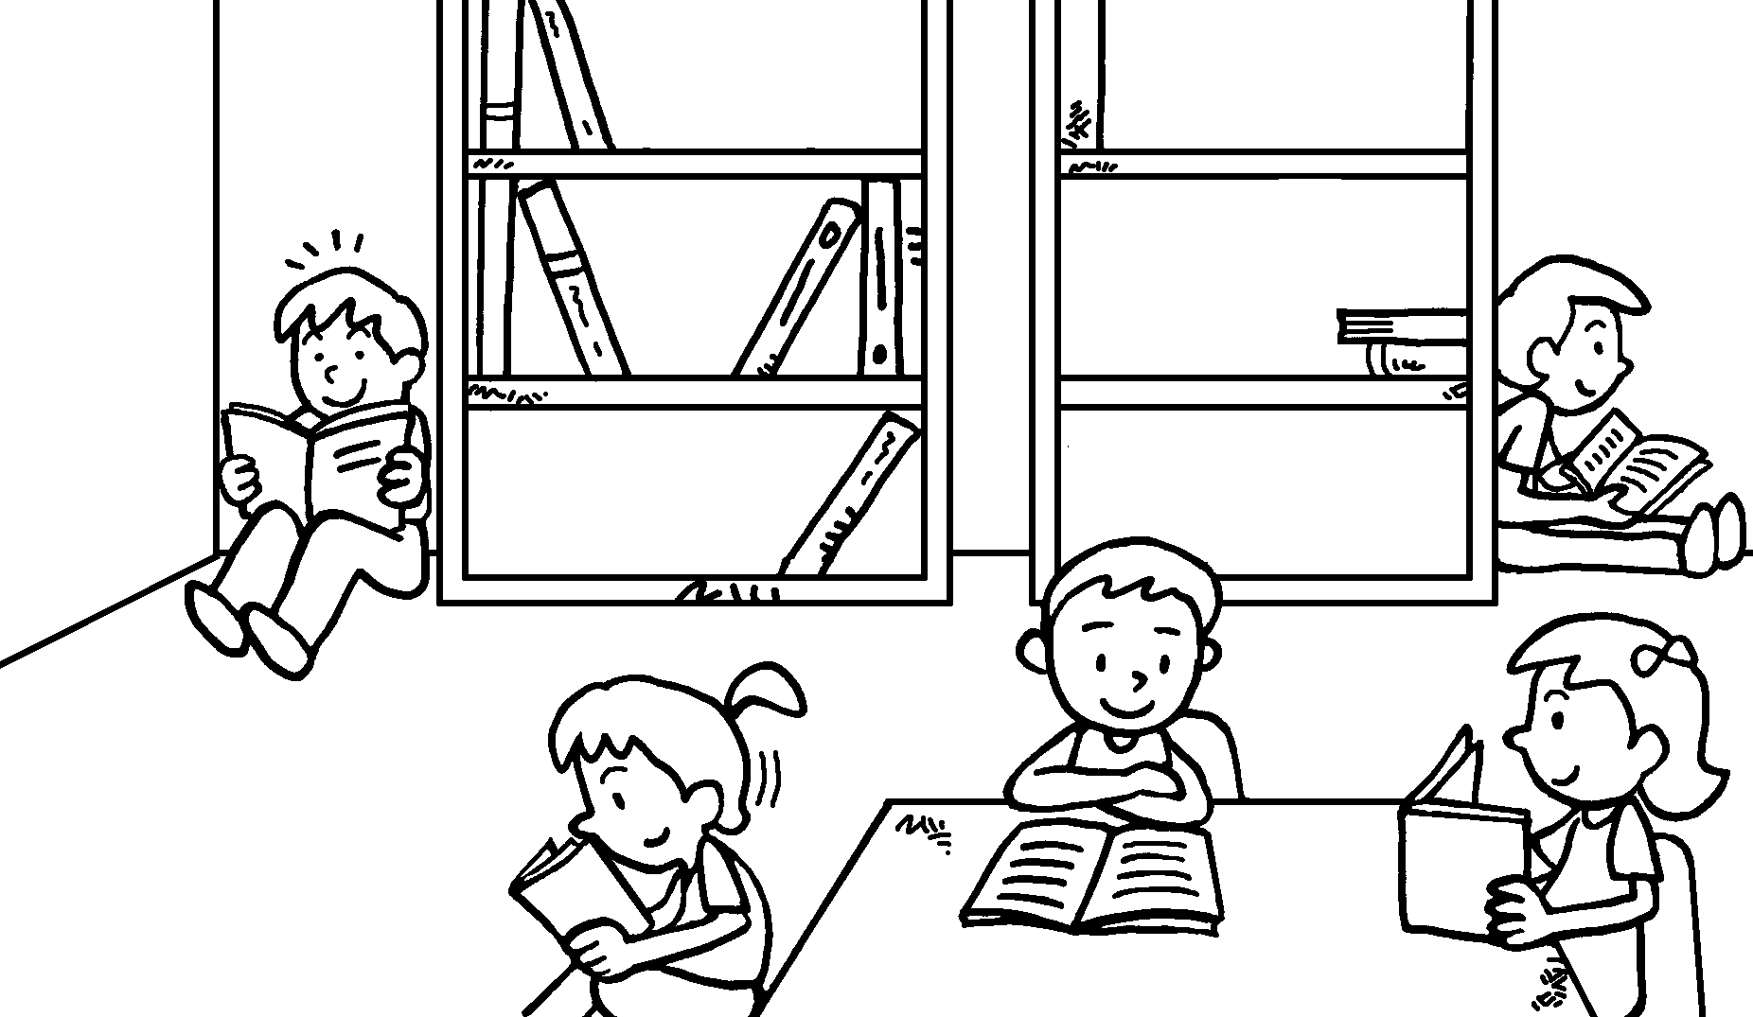 |  | There are books.  There ________ not  c .
3 | 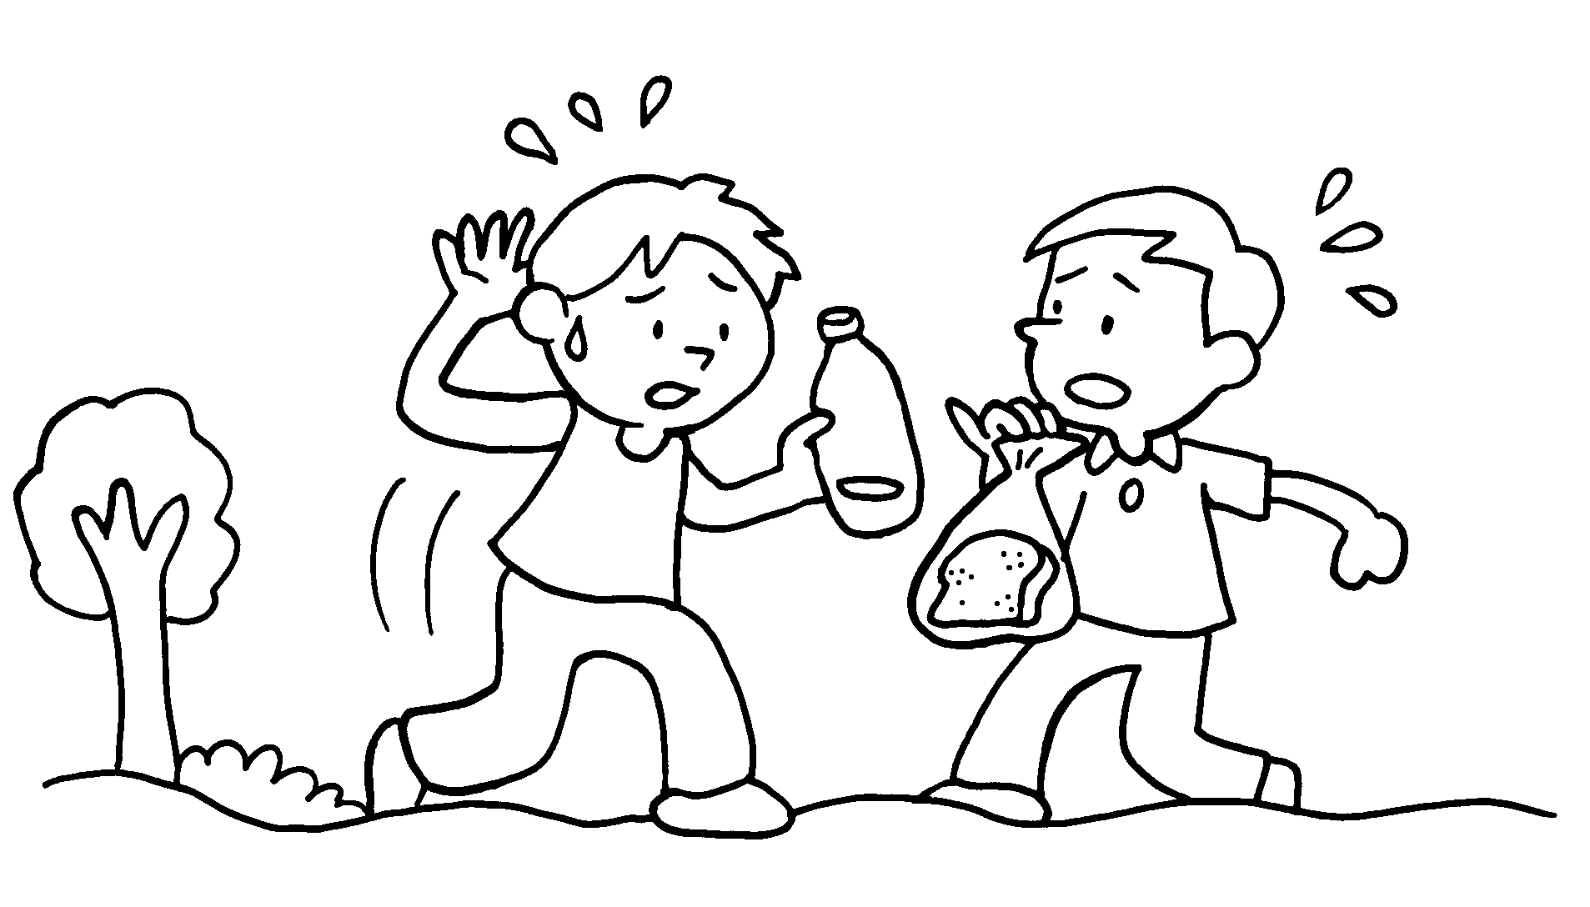 |  | There _________ not water.  There is  b .
4 | 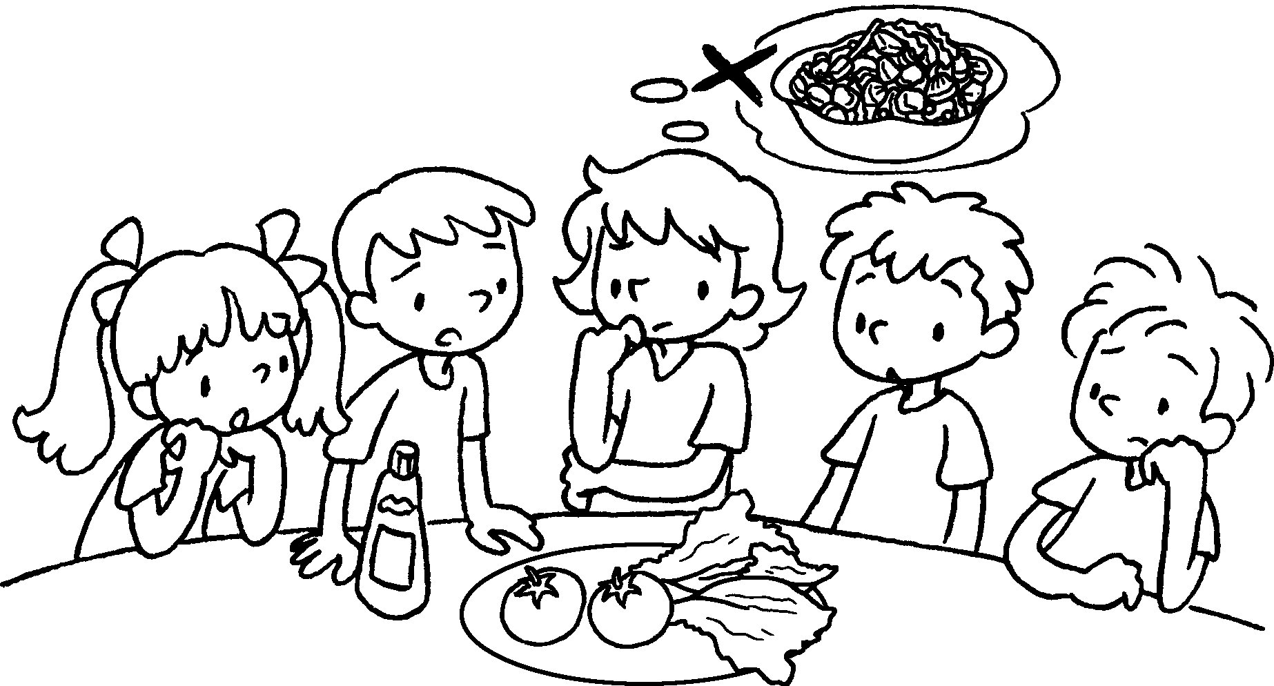 |  | There are vegetables.  There  t .


Book 6A Chapter 3 Graded Worksheets
Worksheet 3⬇⬇⬇
1 very little
2 very few
are enough chairs
3 is enough
very little bread
4 very few
are very few tomatoes

