Posters
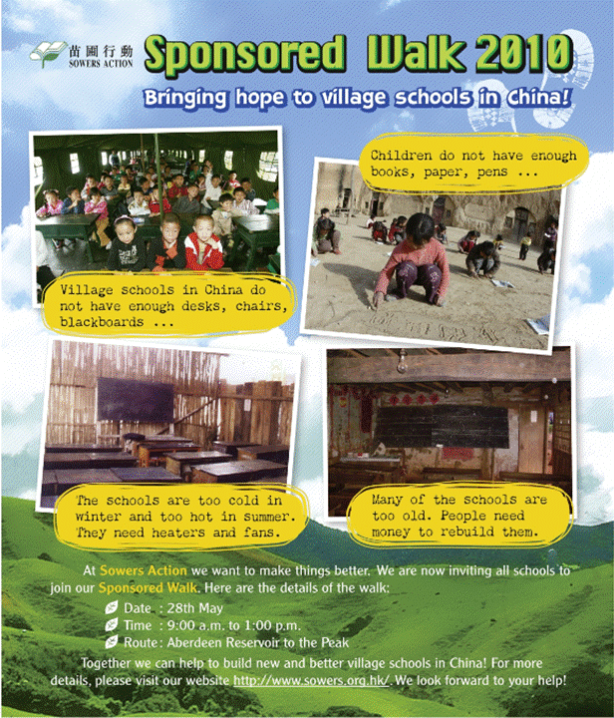
Write the answers and blacken  the circles.

1 How long does it take to complete the walk?
__________________________________________________________________

2 Where does the walk start and end?
__________________________________________________________________

3 The purpose of the walk is to .
 A. raise money to build new and better village schools in China
 B. raise money to rebuild villages in China
 C. collect books, paper and pens for children in China
 D. make things better at Sowers Action

4 Who will join the walk? (You can choose more than one answer.)
 A. teachers in Hong Kong  B. pupils in Hong Kong
 C. teachers in China  D. children in China

5 What problems do village schools in China have? (You can choose more than one answer.)
 A. Children do not want to write with pens.
 B. There is not enough money to rebuild old schools.
 C. The classrooms have too many chairs.
 D. The classrooms do not have heaters in winter.

6 Read the last line: We look forward to your help! What does this mean?
 A. We look at the front.
 B. We hope you can join the walk.
 C. We want you to look at the front.
 D. You must help us.

Answers: (Accept any reasonable answers.)
1 (About) four / 4 hours. 2 (From) Aberdeen Reservoir to The Peak.
3 A 4 A, B 5 B, D 6 B

