Choose and write.

charity walk | craft stall |  | flags | money |  |  | old books
old people’s home |  | second-hand stall |  |  | old toys | raffle tickets
1
2
3
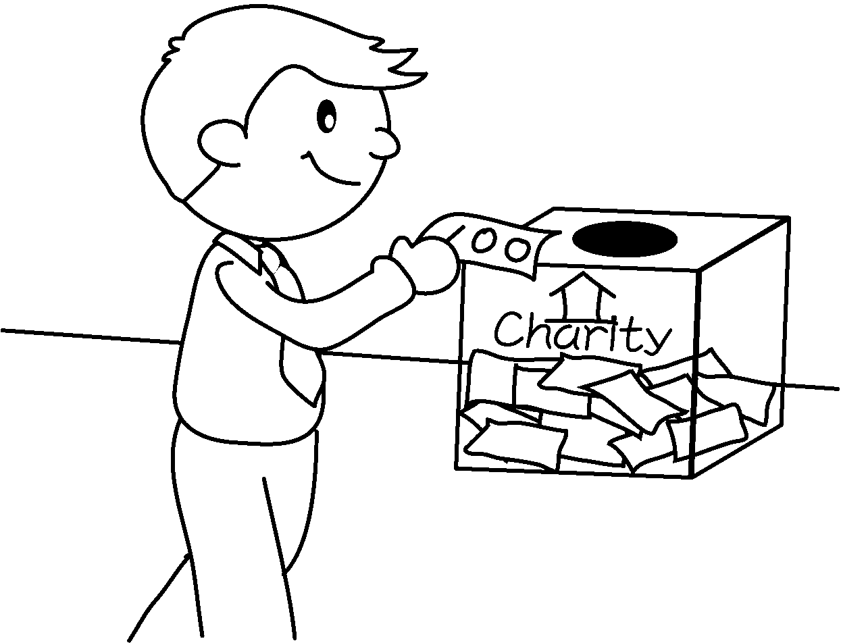 | 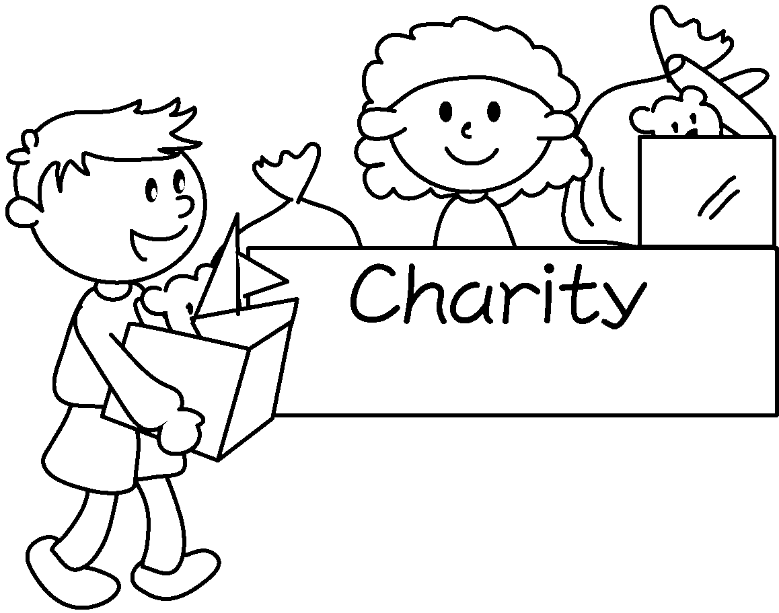 | 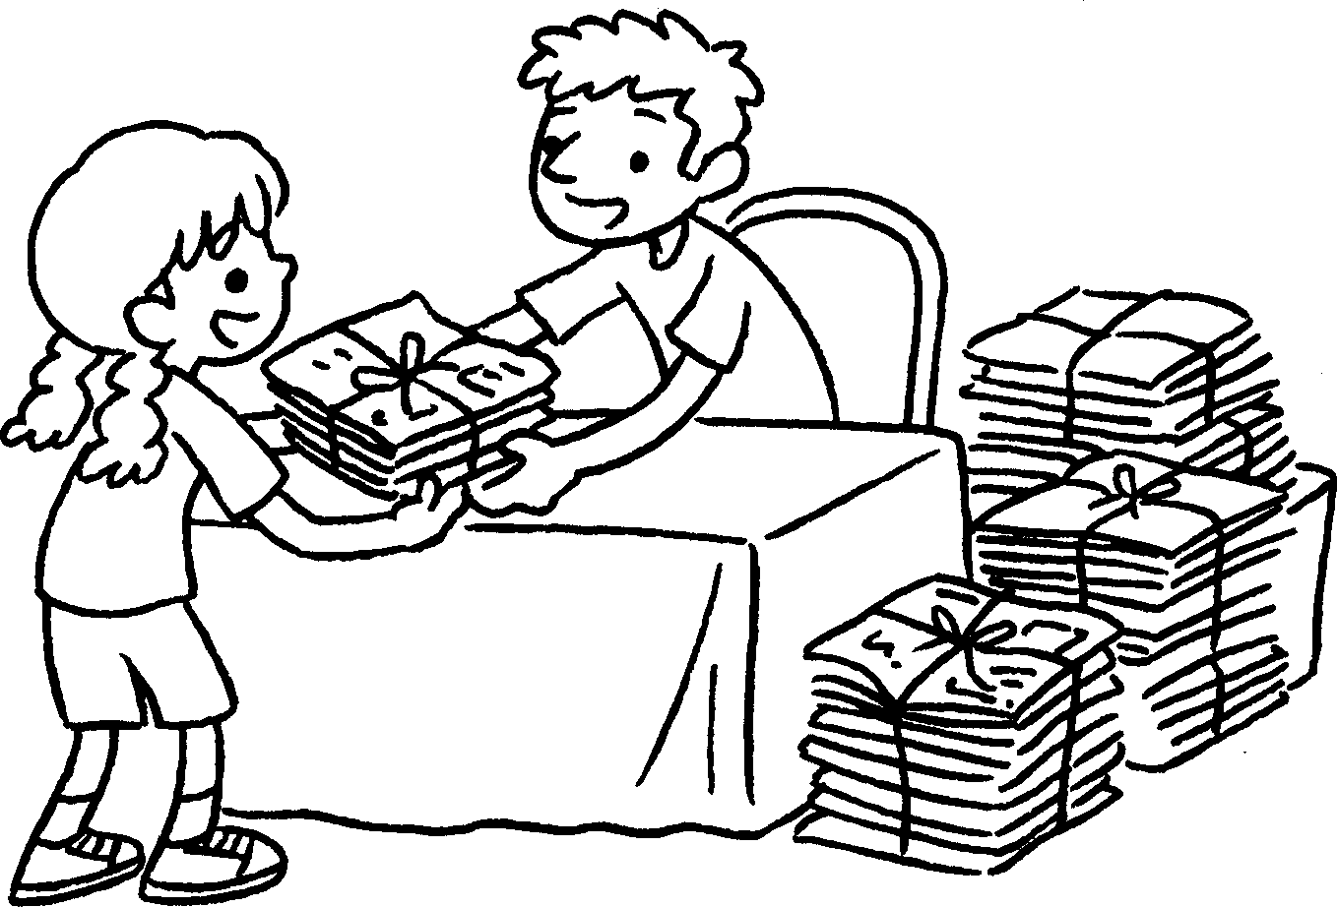
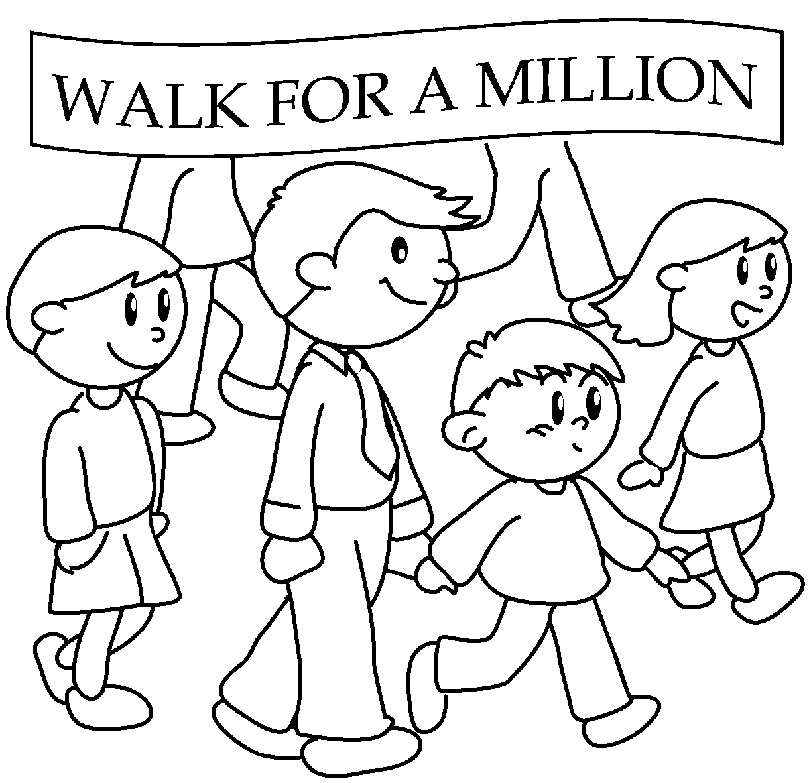  4  5  6  7  8  9 |  | 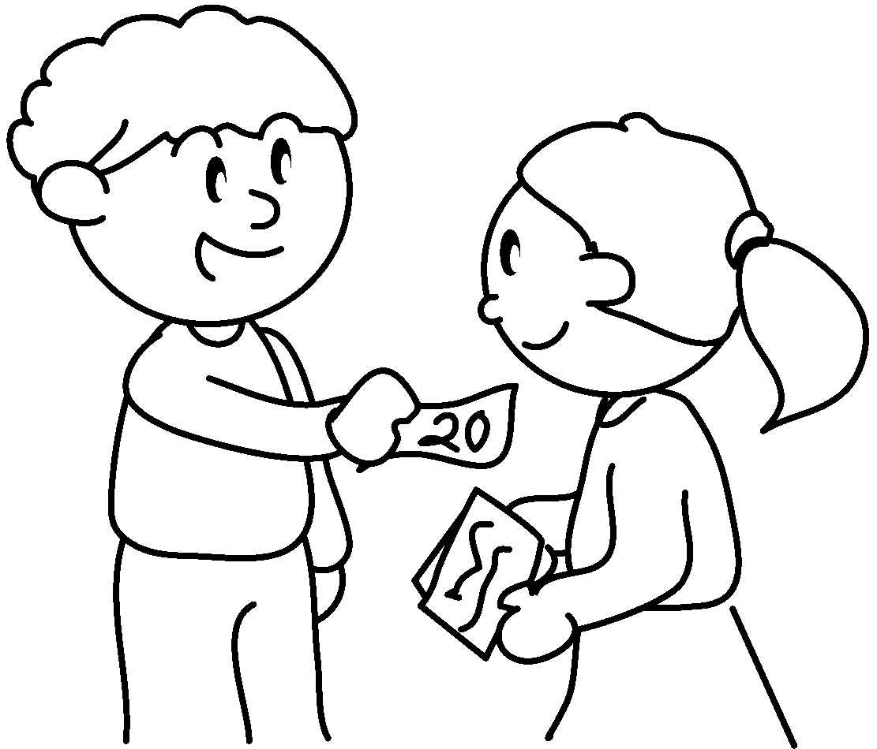
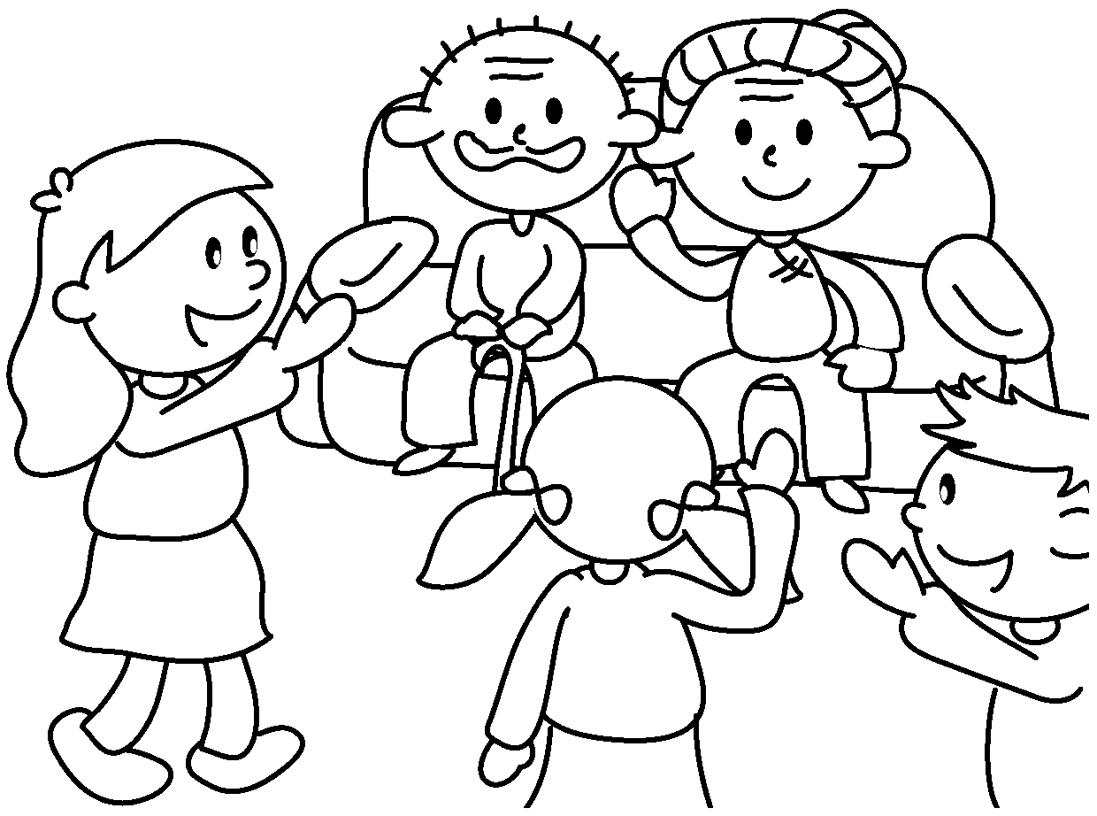 | 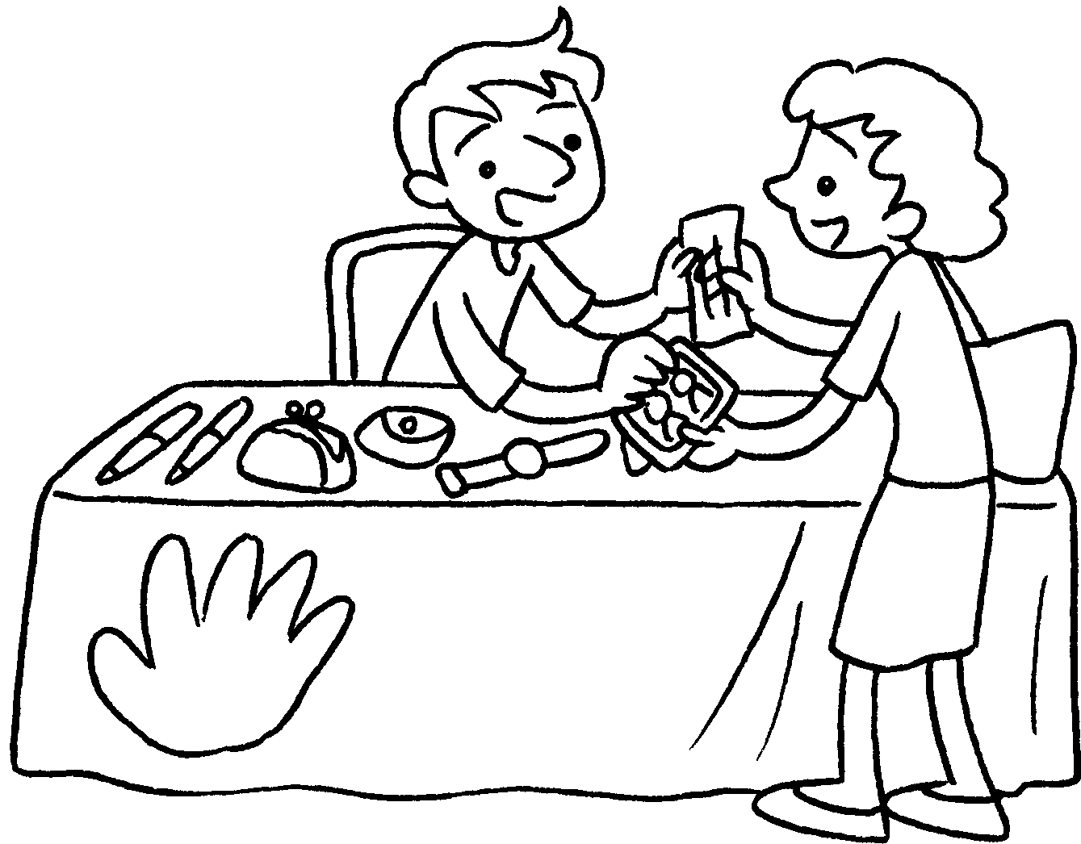  2nd | 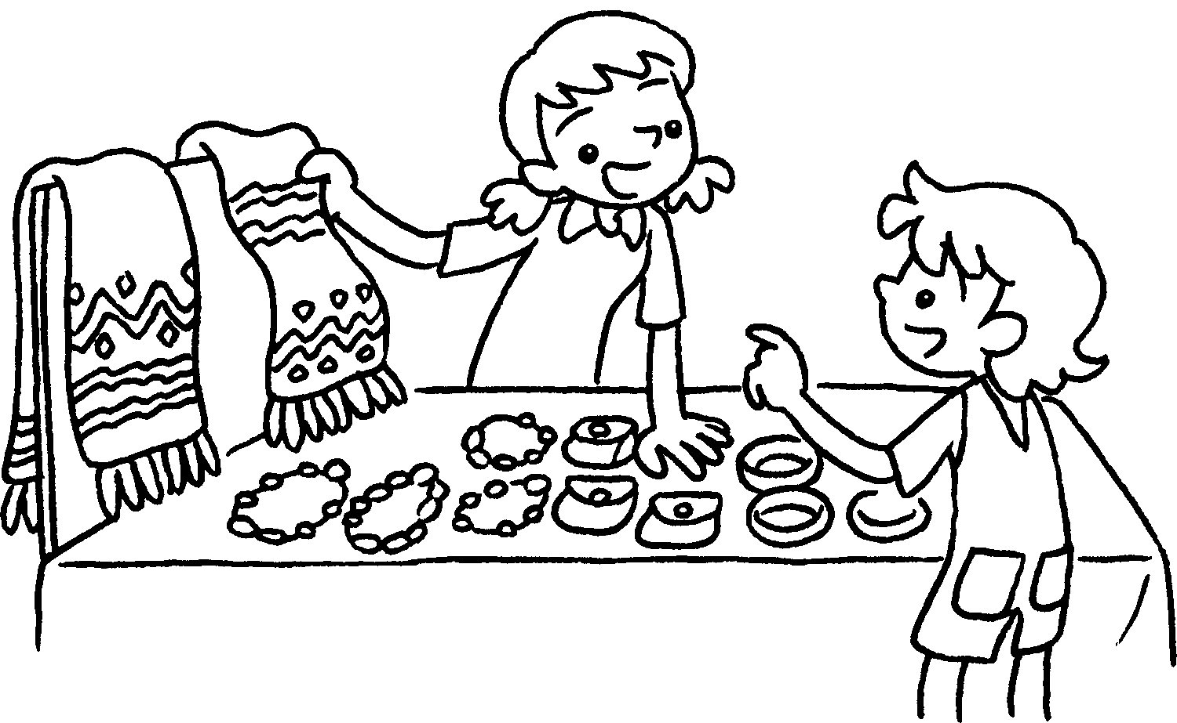

1 | donate to charity
2 | collect
3 | collect
4 | go on a
5 | buy / sell
6 | buy / sell
7 | visit an
8 | run a
9 | run a


Book 6A Chapter 4 Graded Worksheets
Worksheet 1⬇
- money
- old toys
- old books
- charity walk
- flags
- raffle tickets
- old people’s home
- second-hand stall
- craft stall

