Choose and write.

buy run sell go on visit donate collect

charity walk | craft stall |  | flags | money |  |  | old books
old people’s home |  | second-hand stall |  |  | old toys | raffle tickets
1
2
3
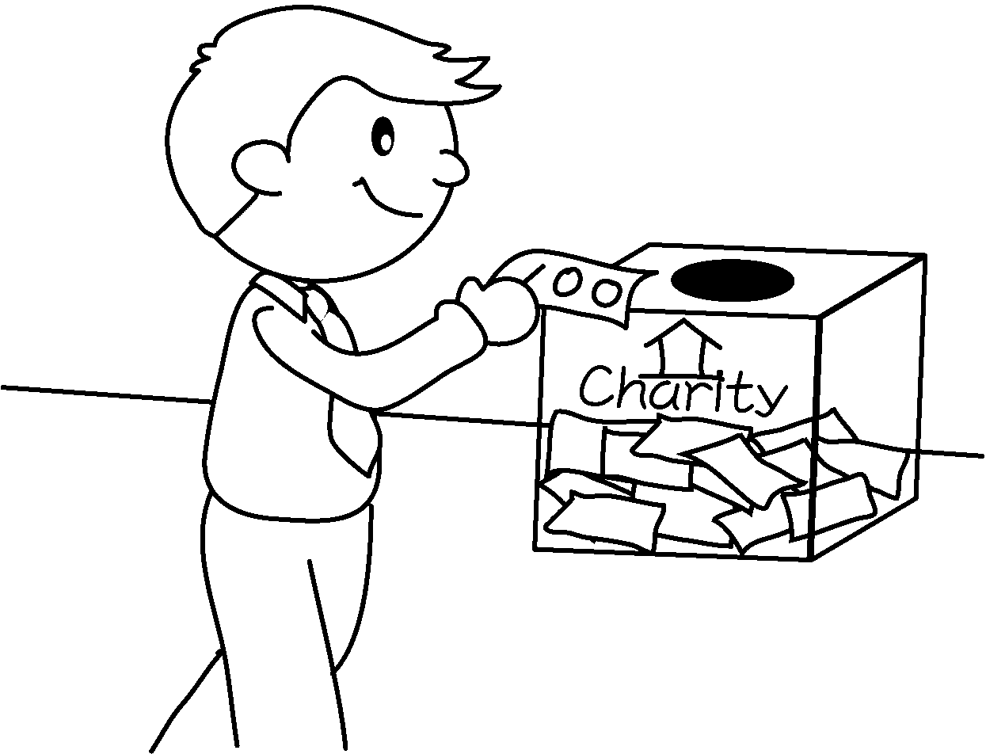 | 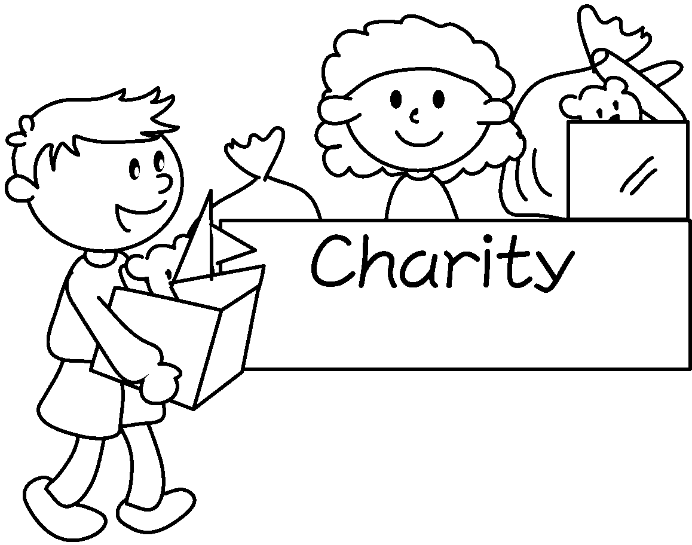 | 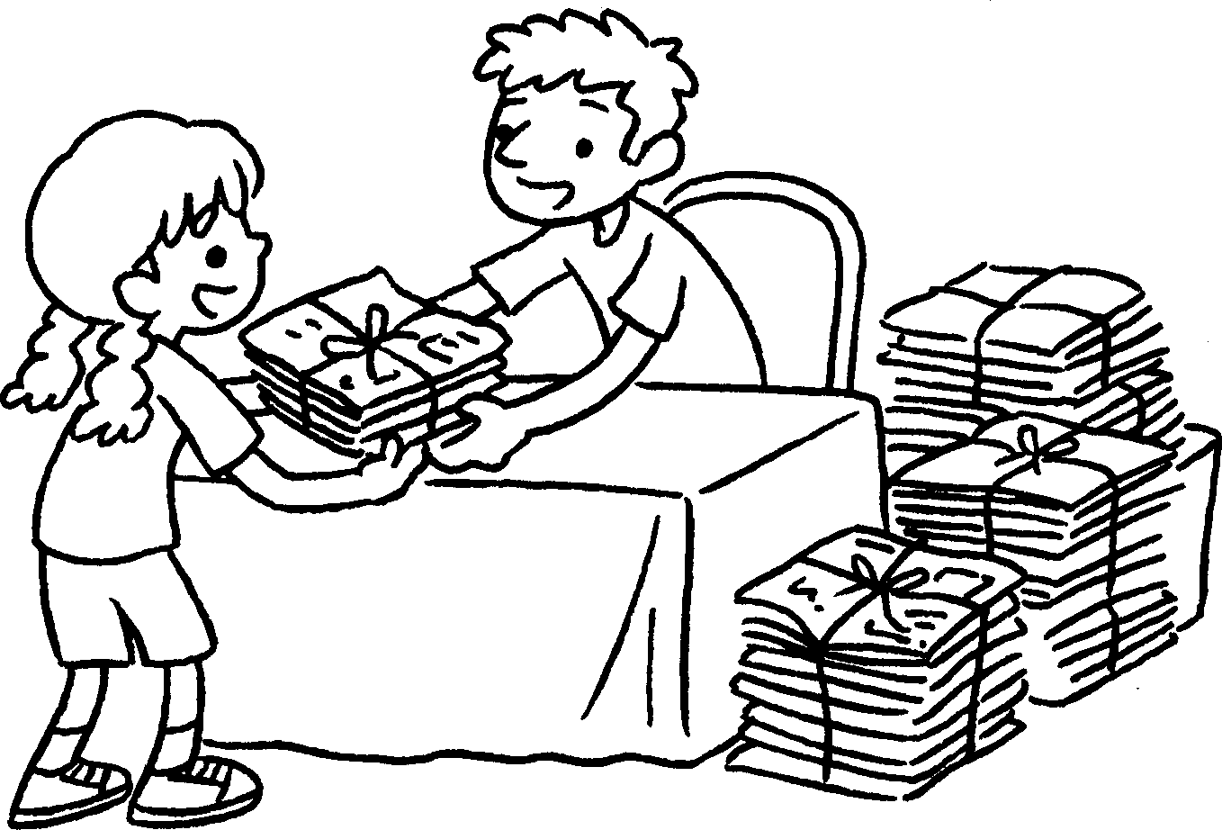
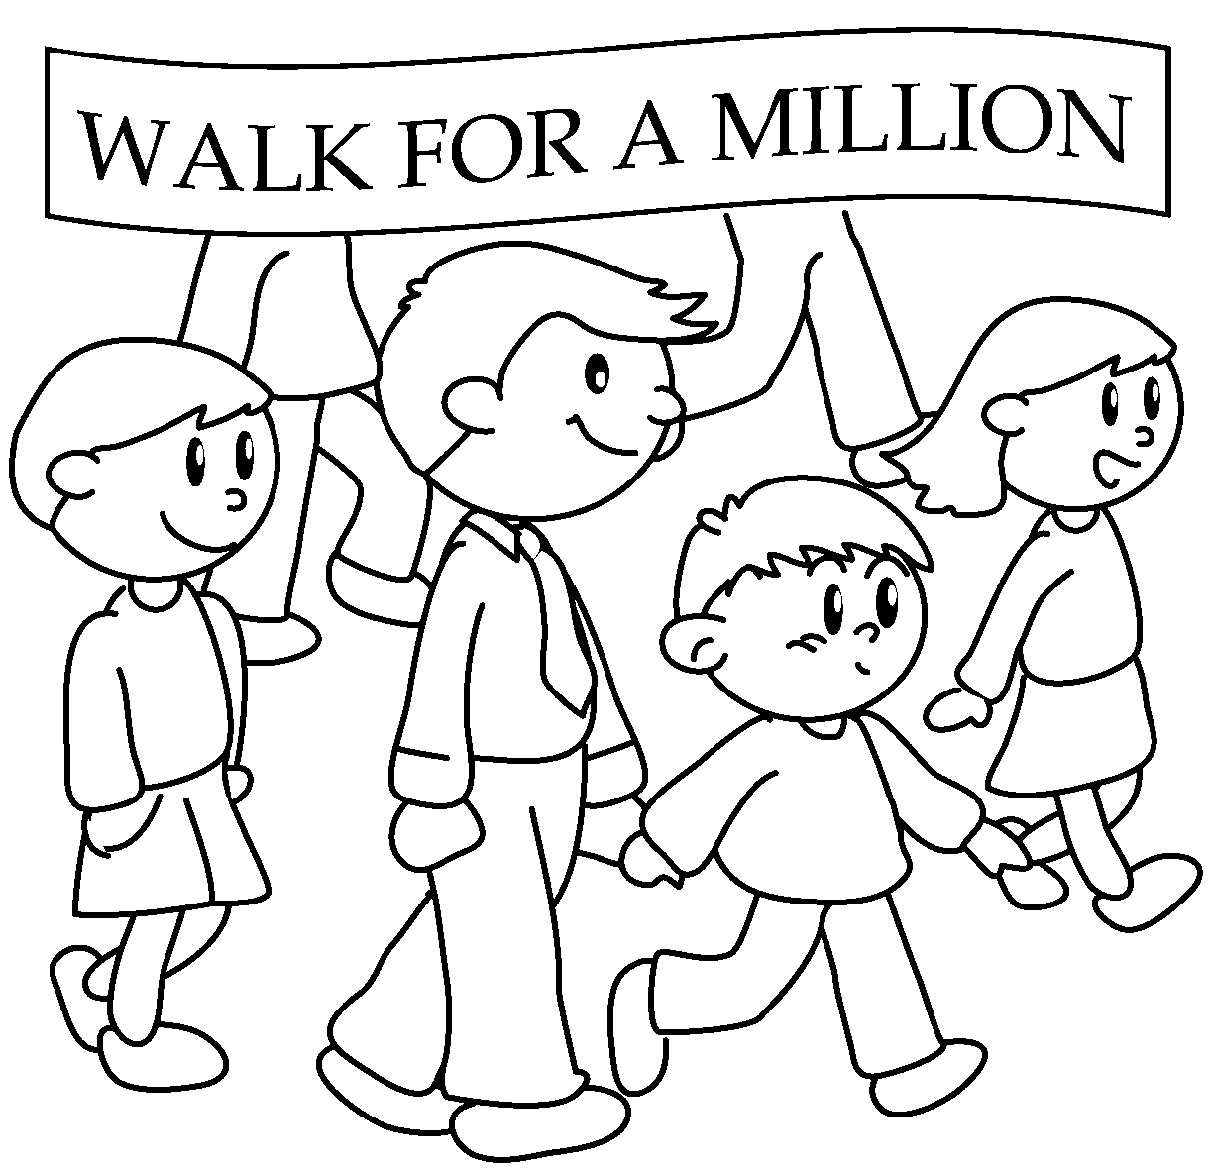  4  5  6  7  8  9 |  | 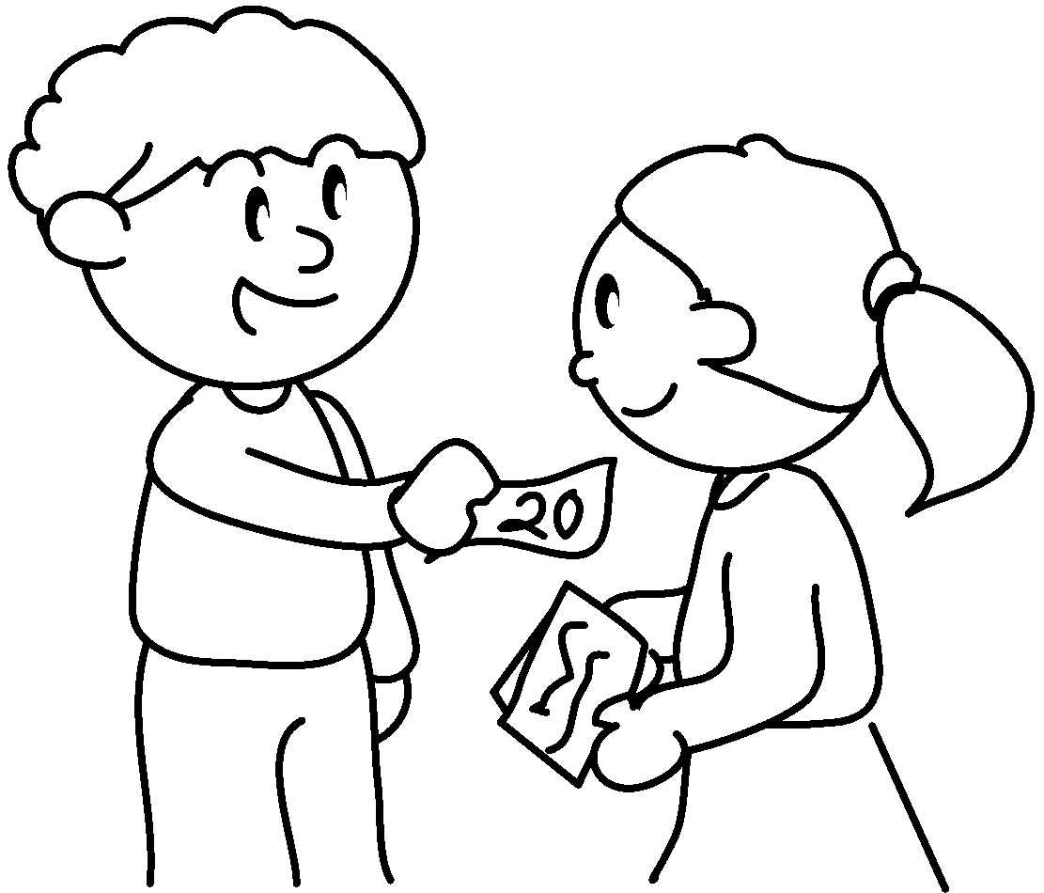
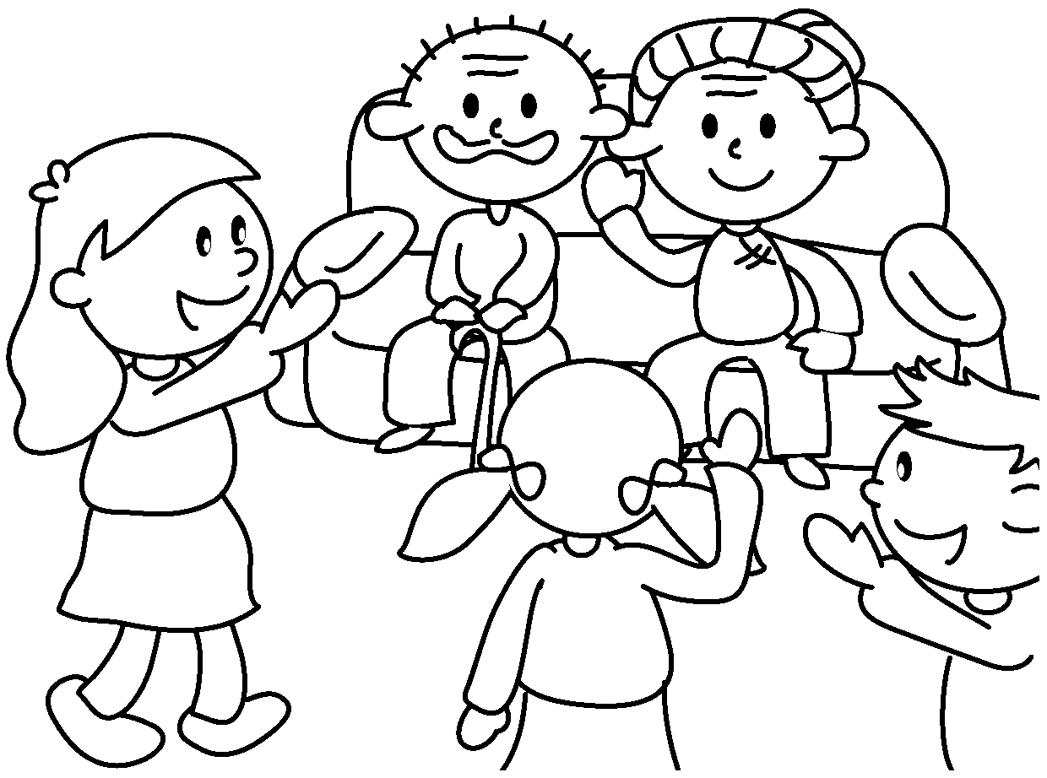 | 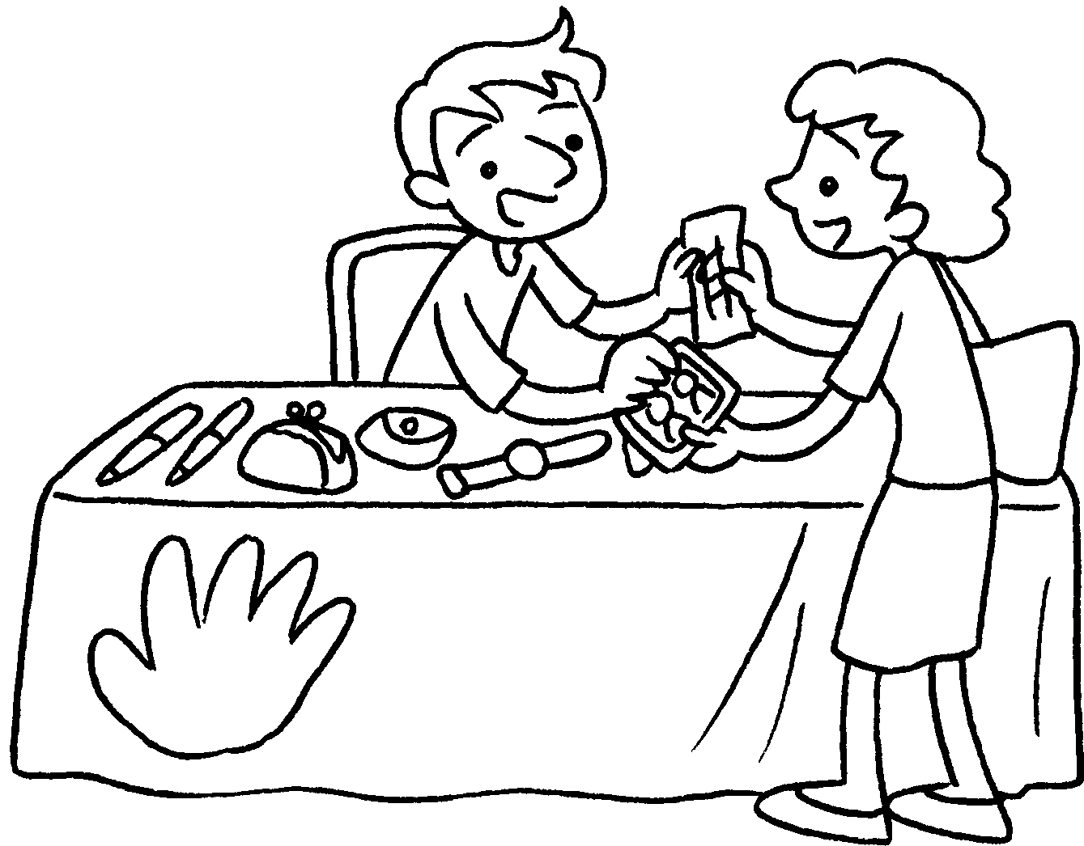  2nd | 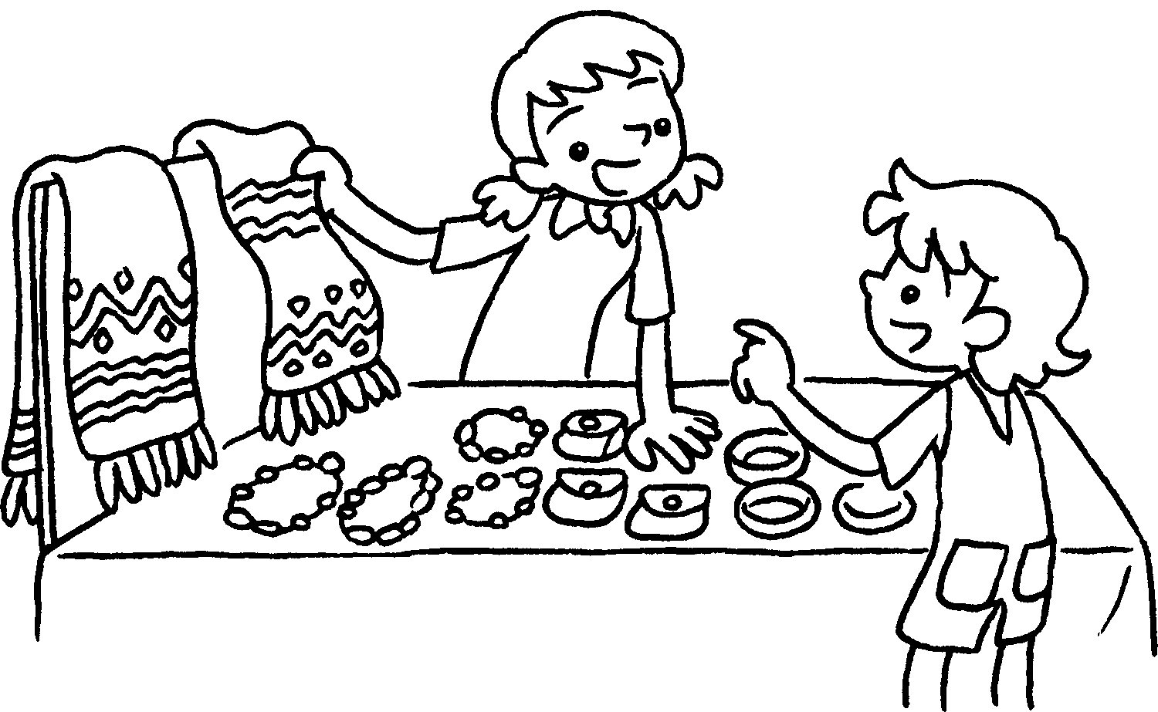

1 | to charity
2
3
4 | a
5
6
7 | an
8 | a
9 | a


Book 6A Chapter 4 Graded Worksheets

Worksheet 1⬇⬇
- donate money
- collect old toys
- collect old books
- go on charity walk
- sell flags
- buy raffle tickets
- visit old people’s home
- run second-hand stall
- run craft stall

