Choose and write.

either | or | Shall | we

1 |   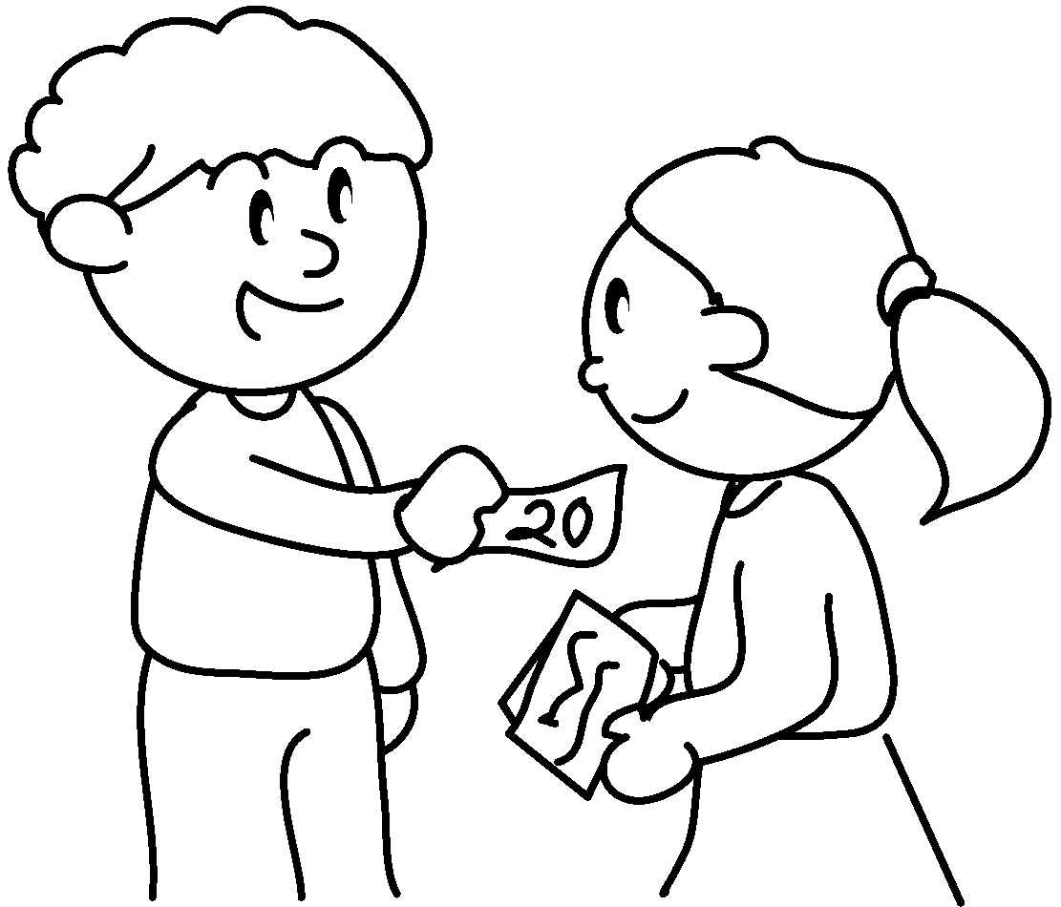  A |  | A : sell raffle  tickets?
2  A  B | 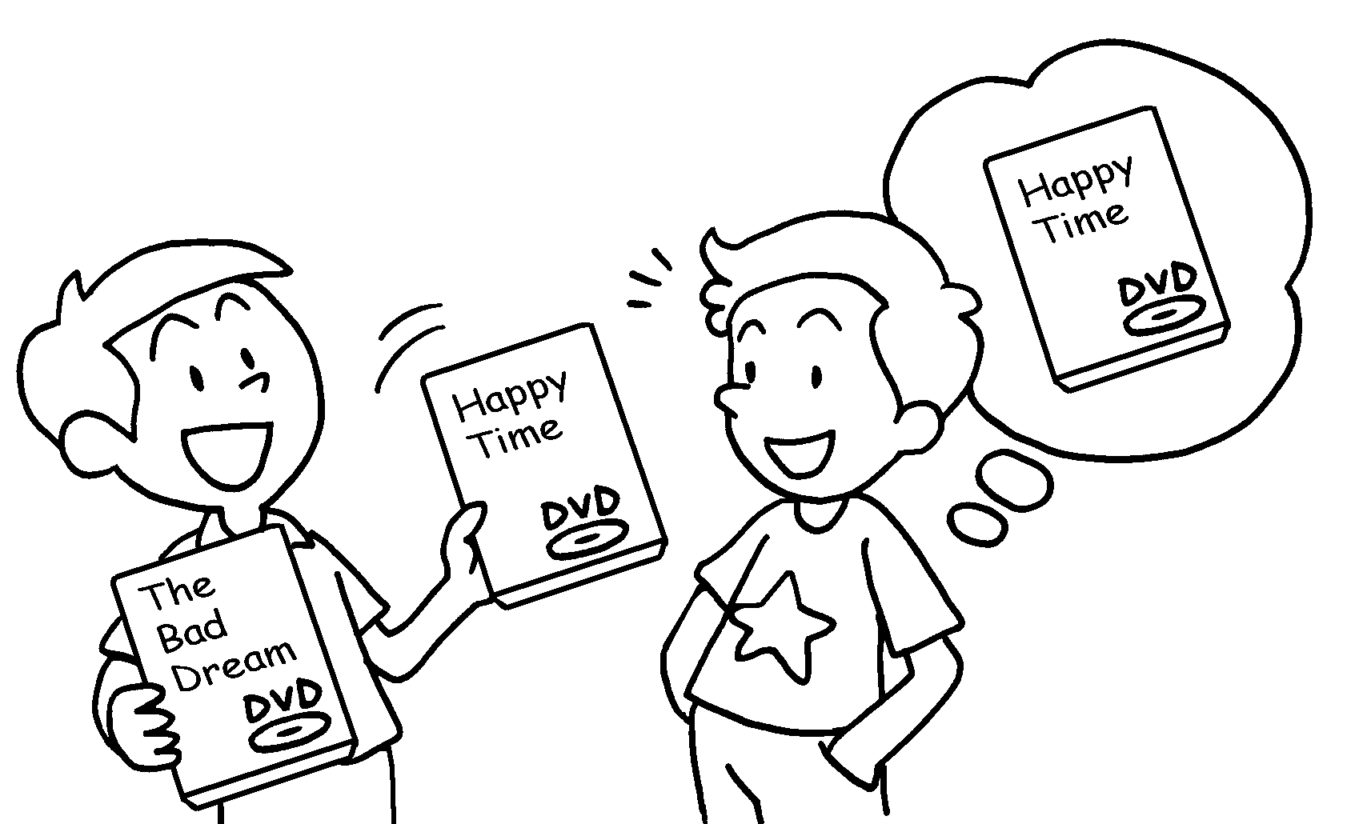 |  | A : We can watch The  Bad Dream Happy Time.  B : Shall we watch Happy Time?  A : No problem.
3  A  B  A  B | 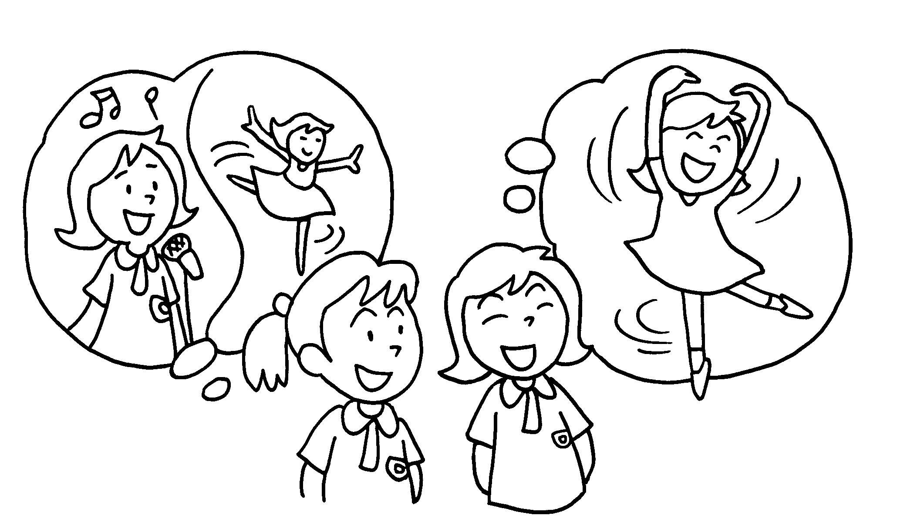 |  | A : We can sing  dance.  B : dance?  I’m good at dancing.  A : That’s a good idea.
4 | 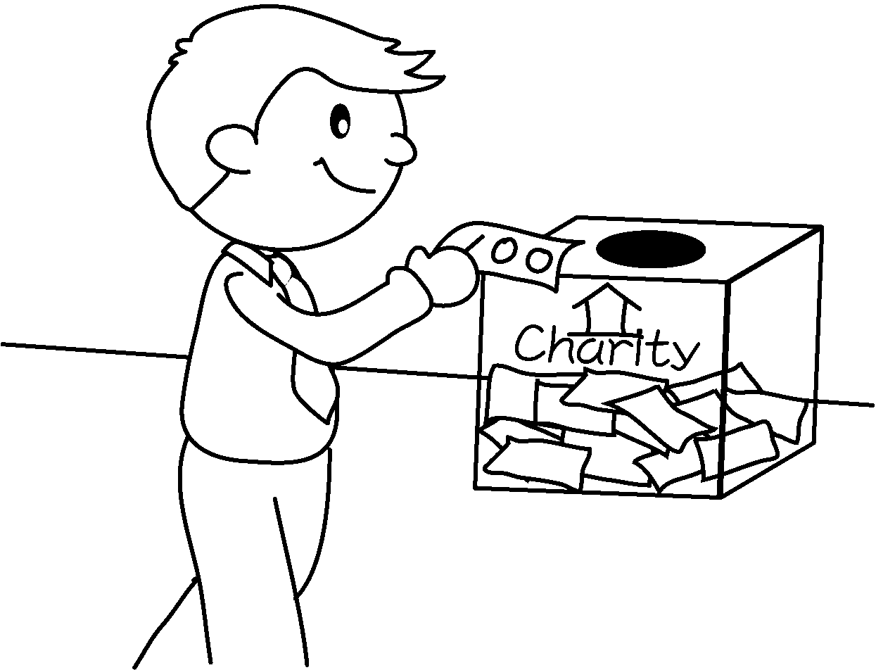  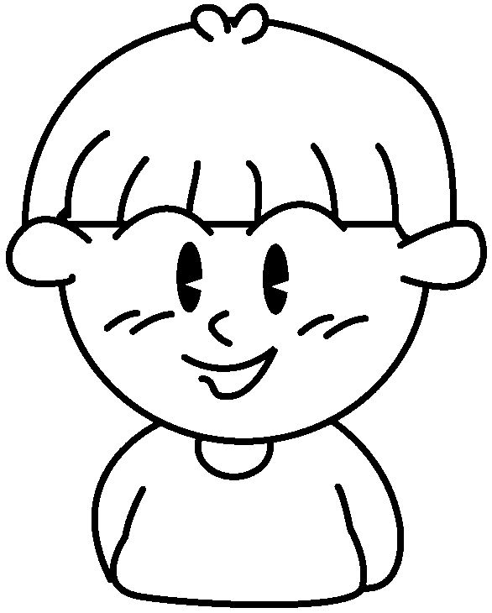  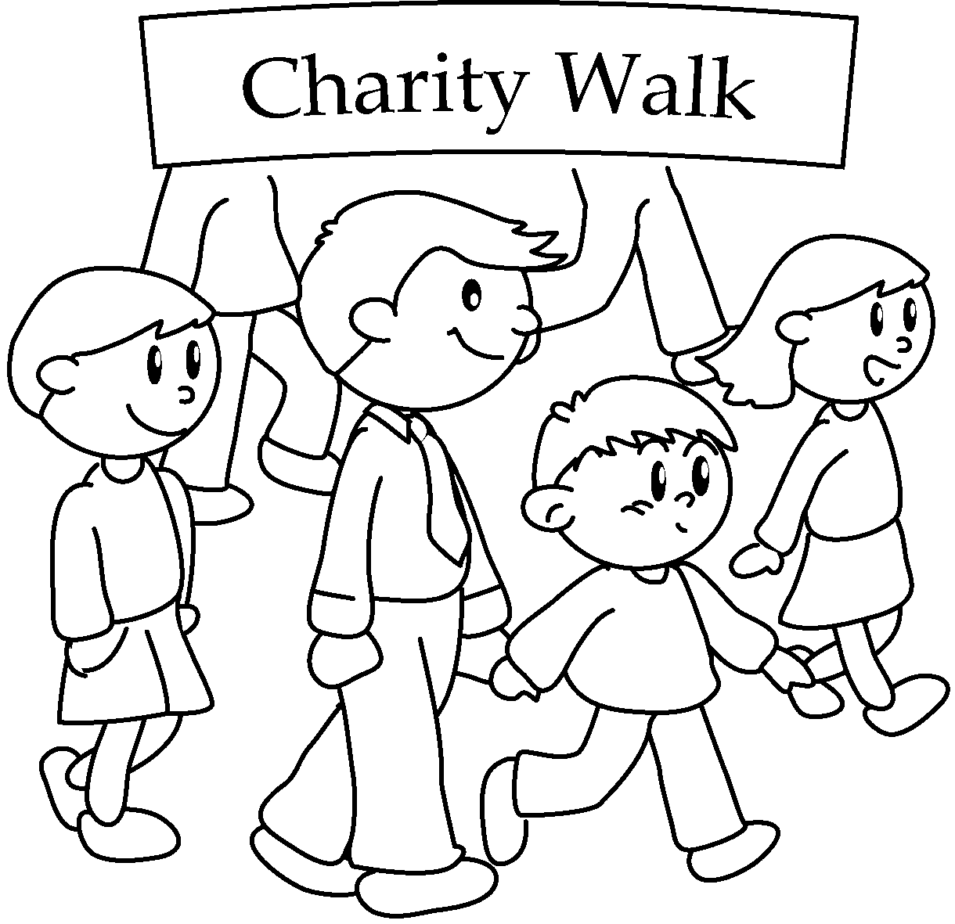  A |  | A : We can go on a  charity walk donate  money to charity.
5 | 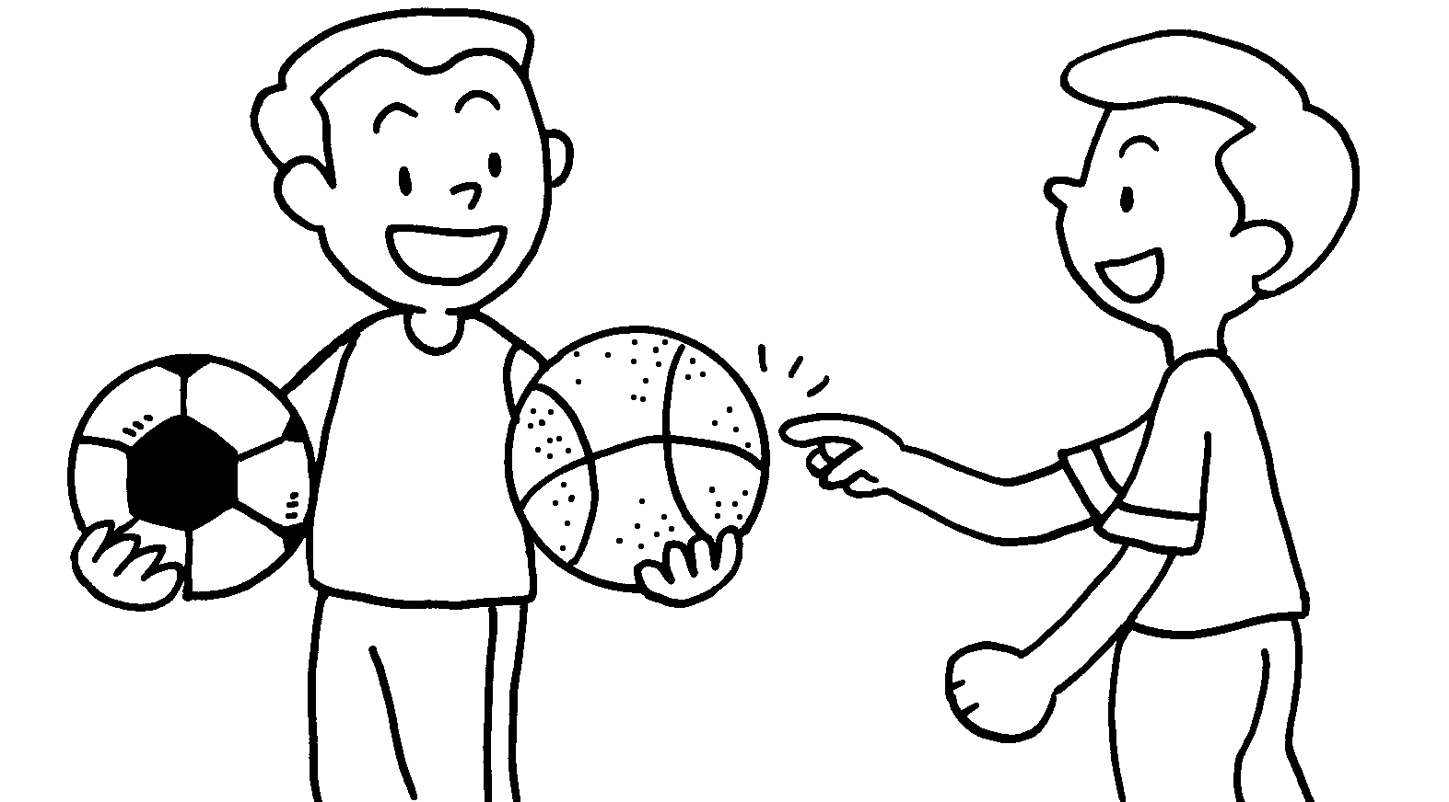 |  | A : We can play  football basketball.  B : play  basketball? I like playing basketball.  A : No problem.


Book 6A Chapter 4 Graded Worksheets
Worksheet 2⬇
- Shall we
- either or
- either or
Shall we
4 either or
5 either or
Shall we

