Finish what the children say.

either … or | Shall we

1 |   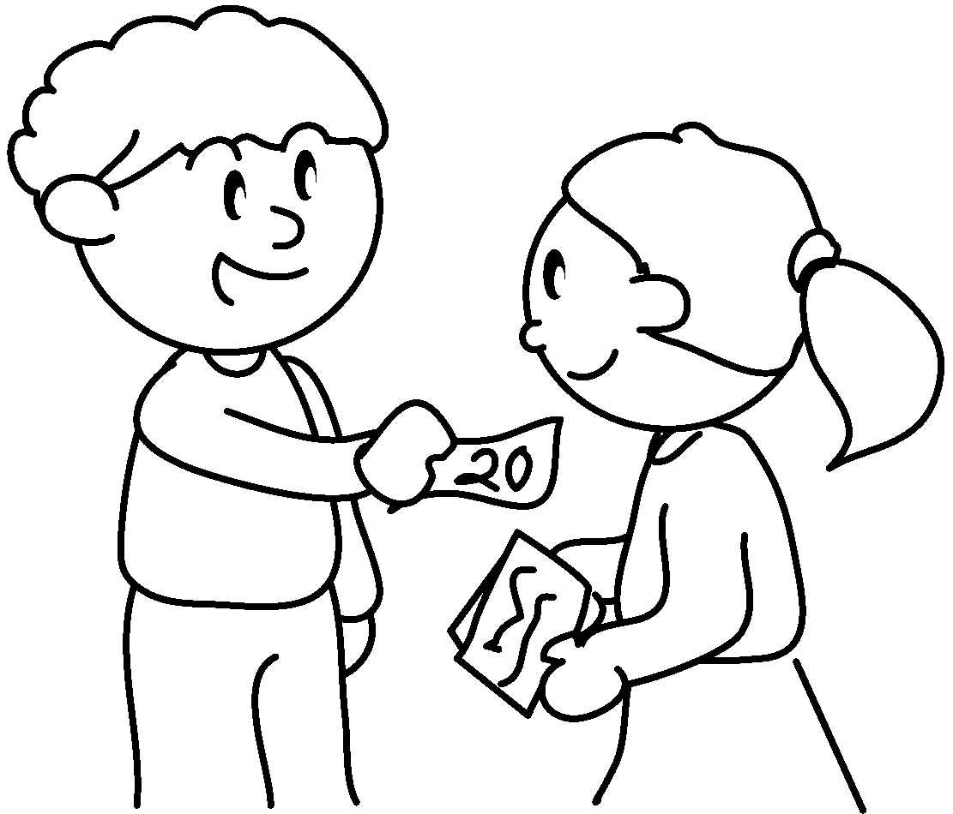  A |  | A : sell raffle  tickets?
2  A  B | 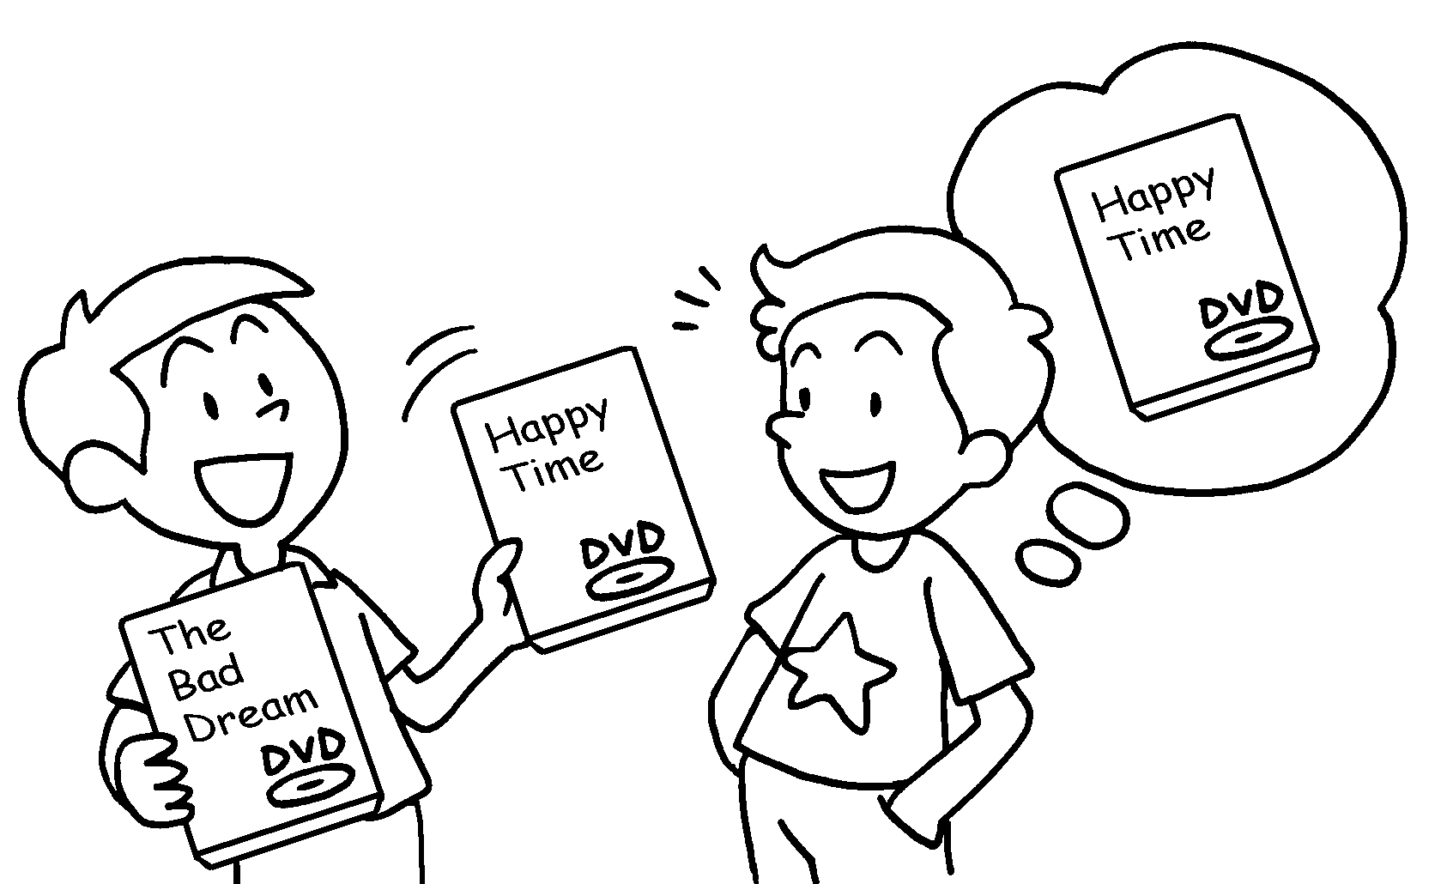 |  | A : We can watch The  Bad Dream Happy Time.  B : Shall we watch Happy Time?  A : No problem.
3  A  B  A  B | 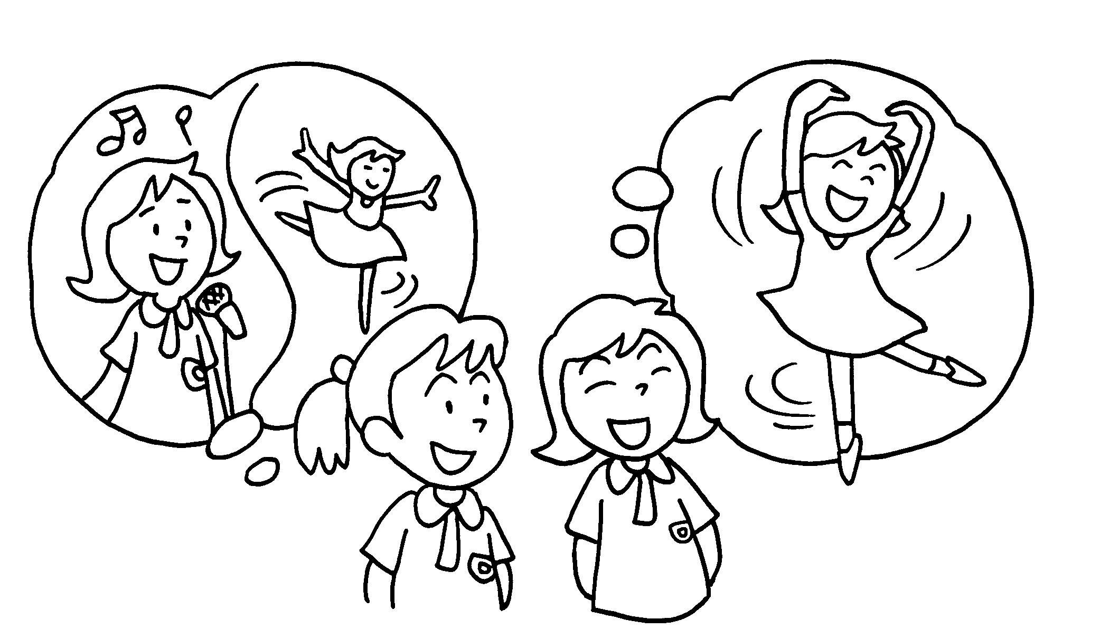  ( sing / dance ) |  | A : We can  .  B : ?  I’m good at dancing.  A : That’s a good idea.
4  ( charity walk / donate money ) | 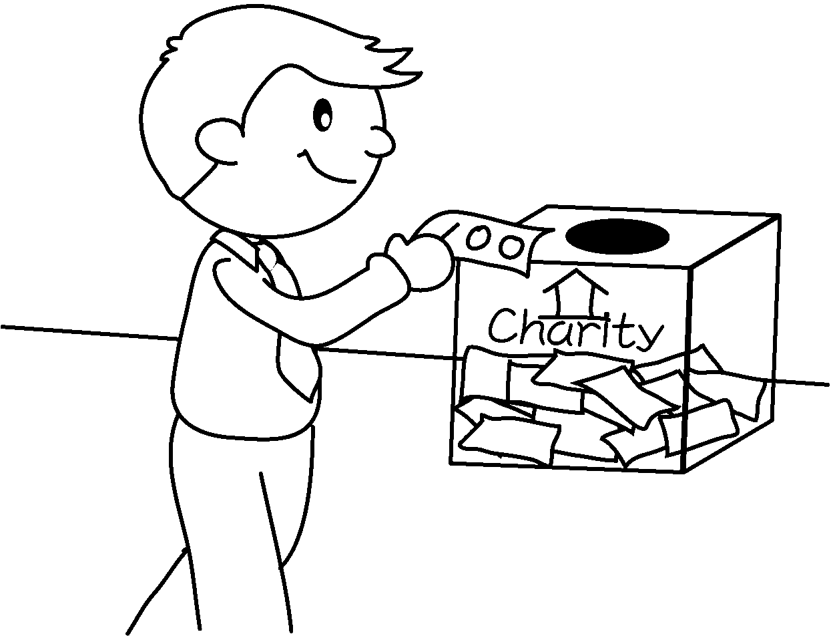  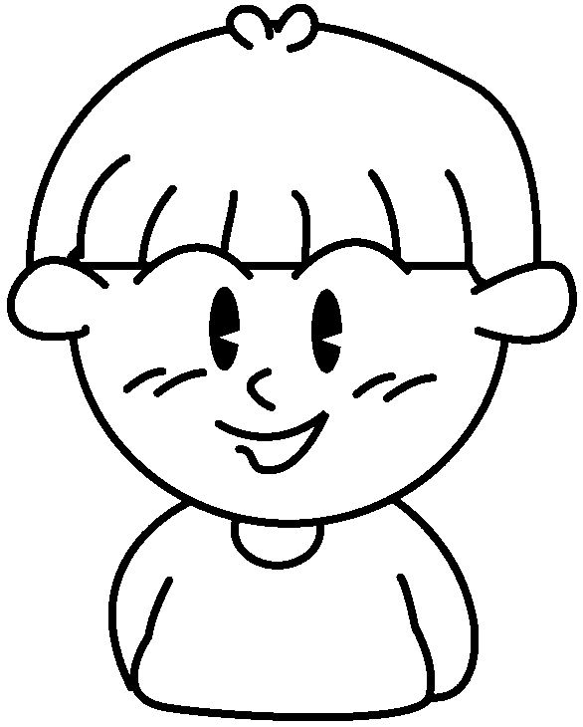  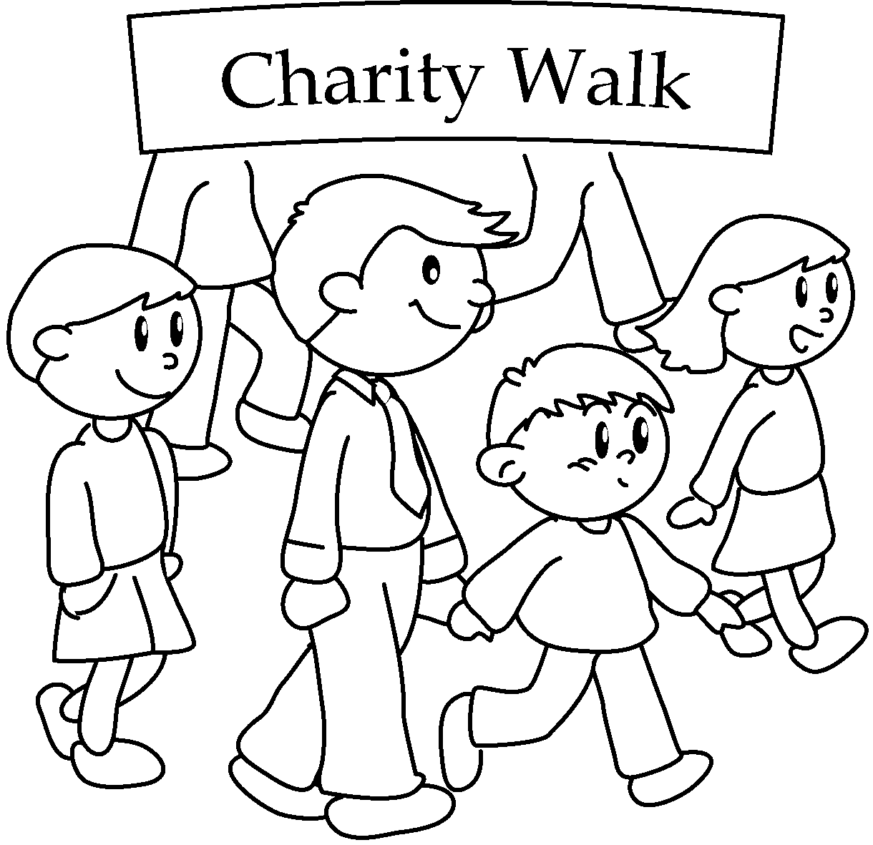  A |  | A : We can __________________________  __________________________________  ________________________ to charity.
5 | 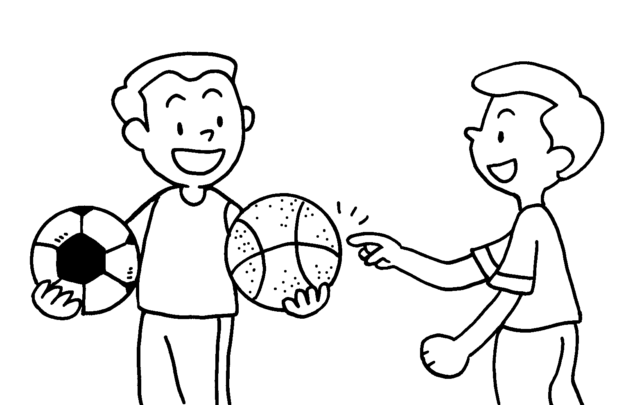  ( football / basketball ) |  | A : We can __________________________  _________________________________ .  B : __________________________________  __________ ? I like playing basketball.  A : No problem.


Book 6A Chapter 4 Graded Worksheets
Worksheet 2⬇⬇
- Shall we
- either or
- either sing / dance or dance / sing
Shall we dance
4 either go on a charity walk or donate money
5 either play football / basketball or basketball / football
Shall we play basketball

