Choose and write.

either … or | Neither … nor

1 | 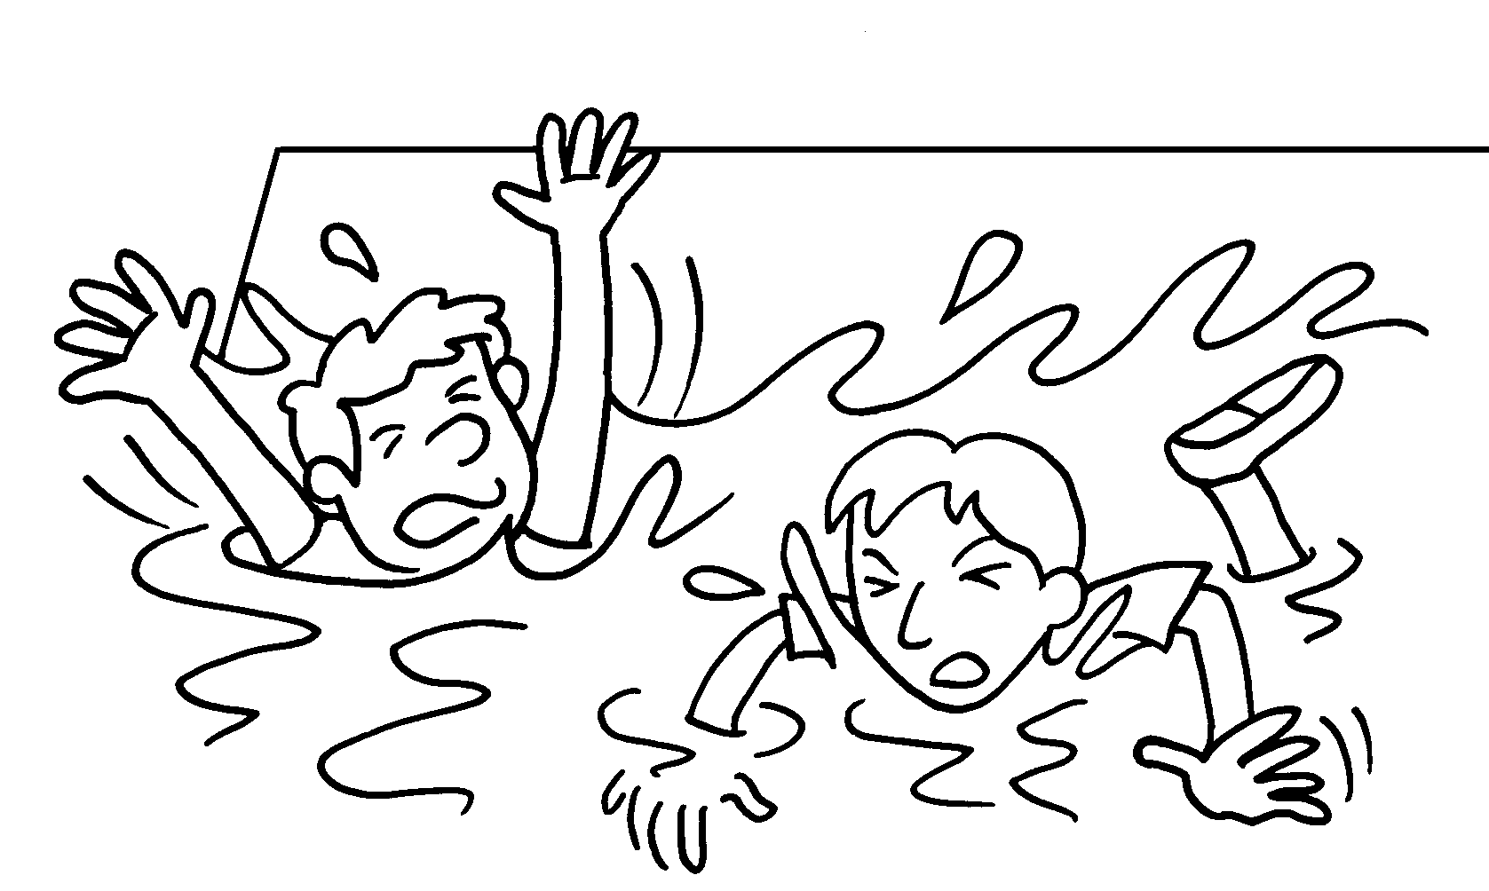 |  | Peter Andy can swim.
2 | 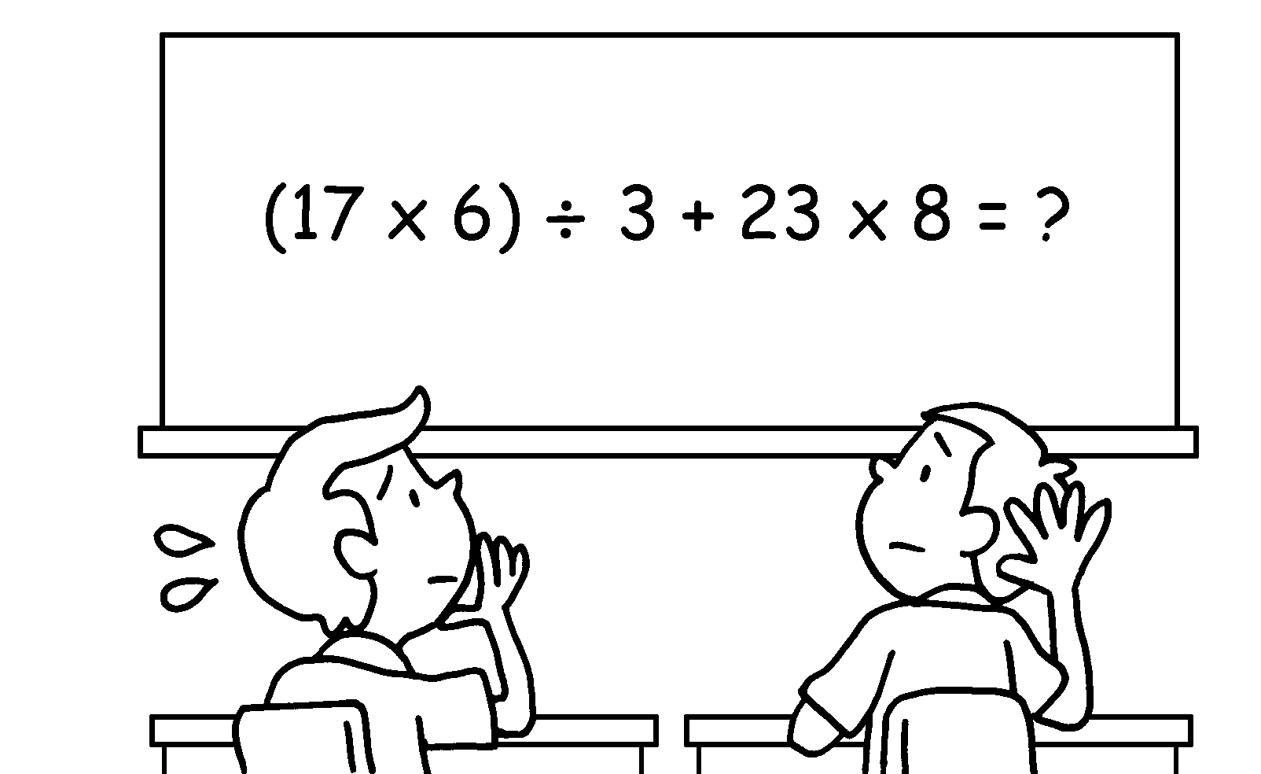 |  | Bob Paul knows the answer.
3 |  |  | Sue can join the Music Club the Art Club.
4 |  |  | They can run a second-hand stall sell flags.
5 | 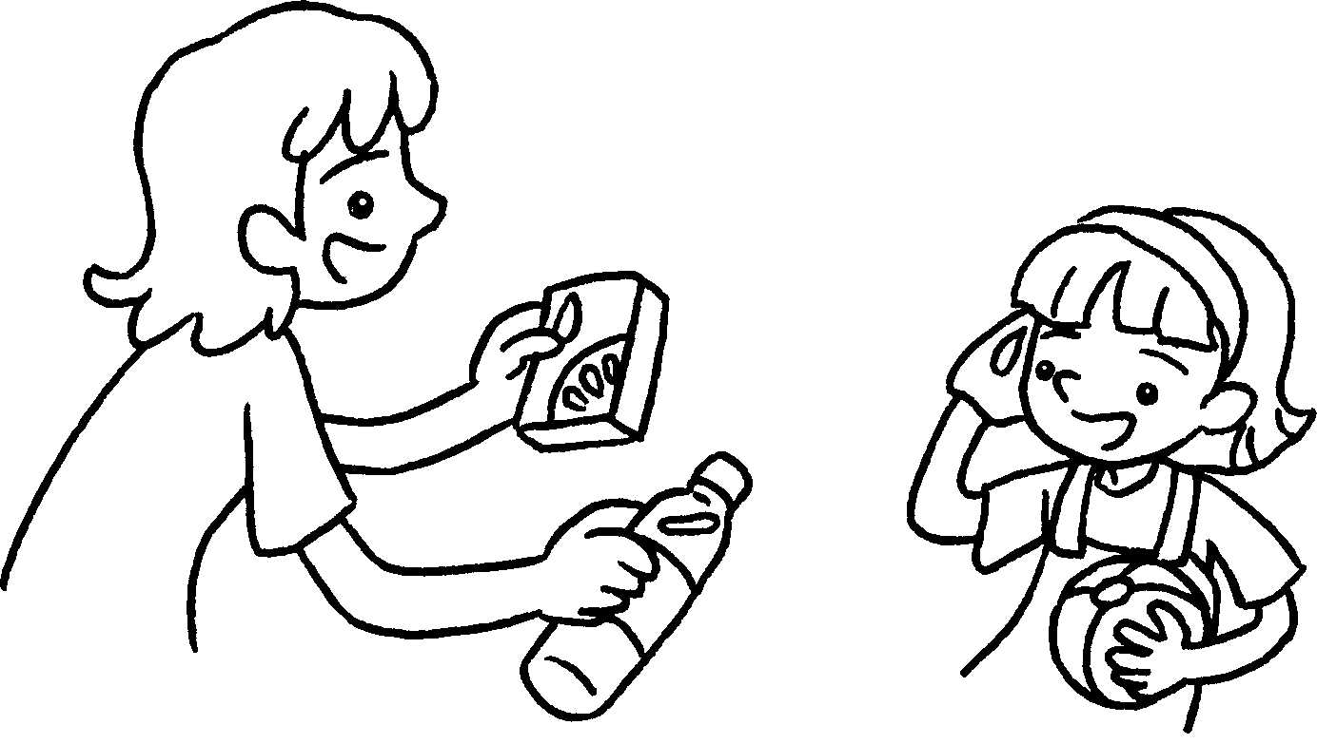  A |  | A : You can drink  water juice.
6 | 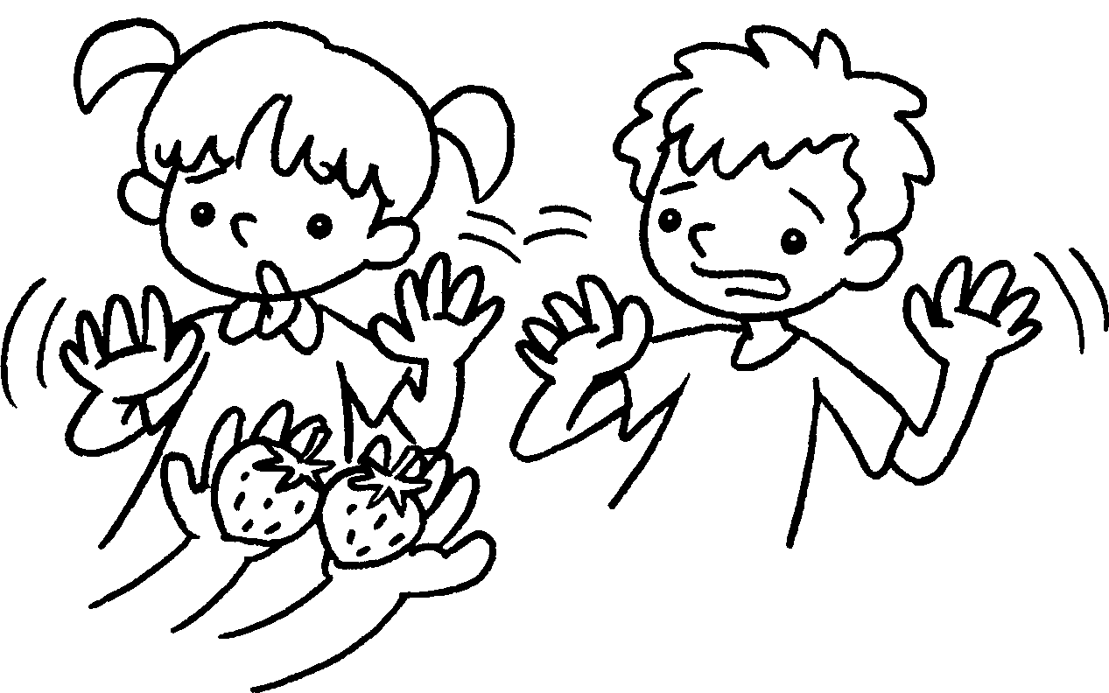 |  | Lucy Ben likes strawberries.


Book 6A Chapter 4 Graded Worksheets
Worksheet 3⬇
- Neither nor
- Neither nor
- either or
- either or
- either or
- Neither nor

