Finish the sentences.

either neither | or nor

1 | 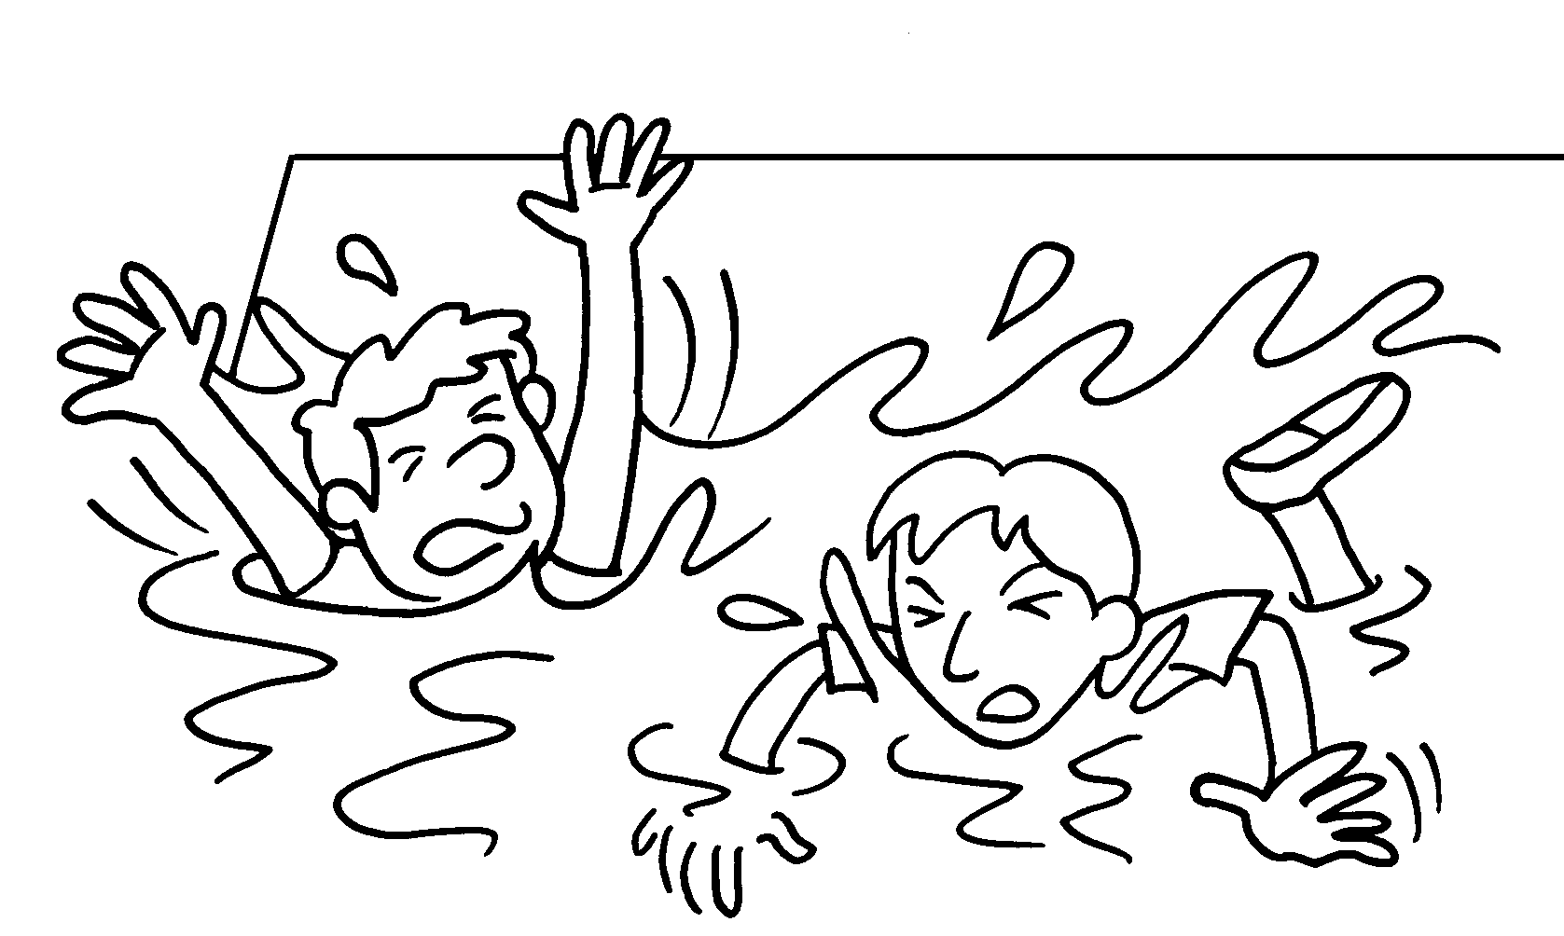 |  | Peter Andy can swim.
2 | 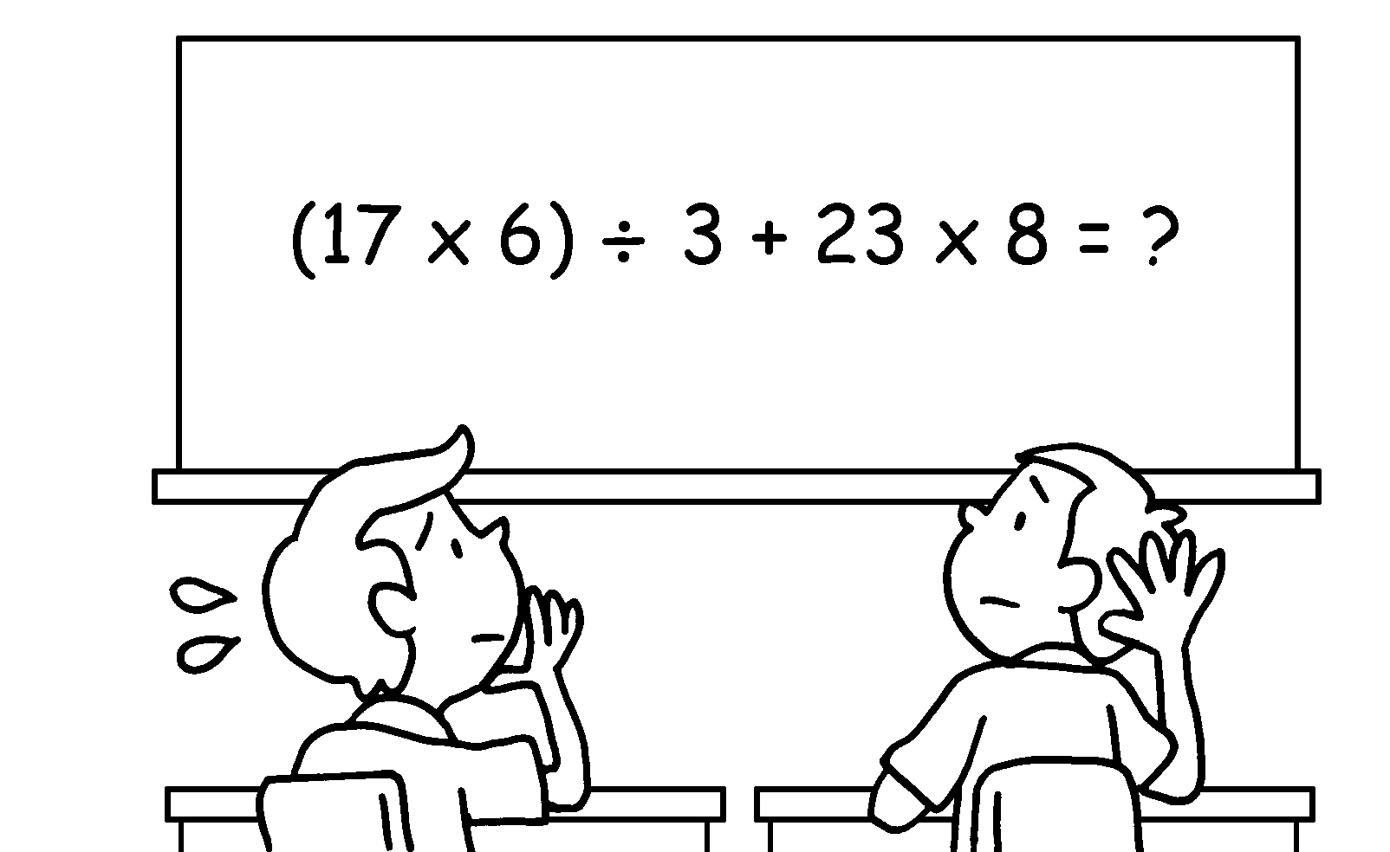 |  | Bob Paul knows the answer.
3 | 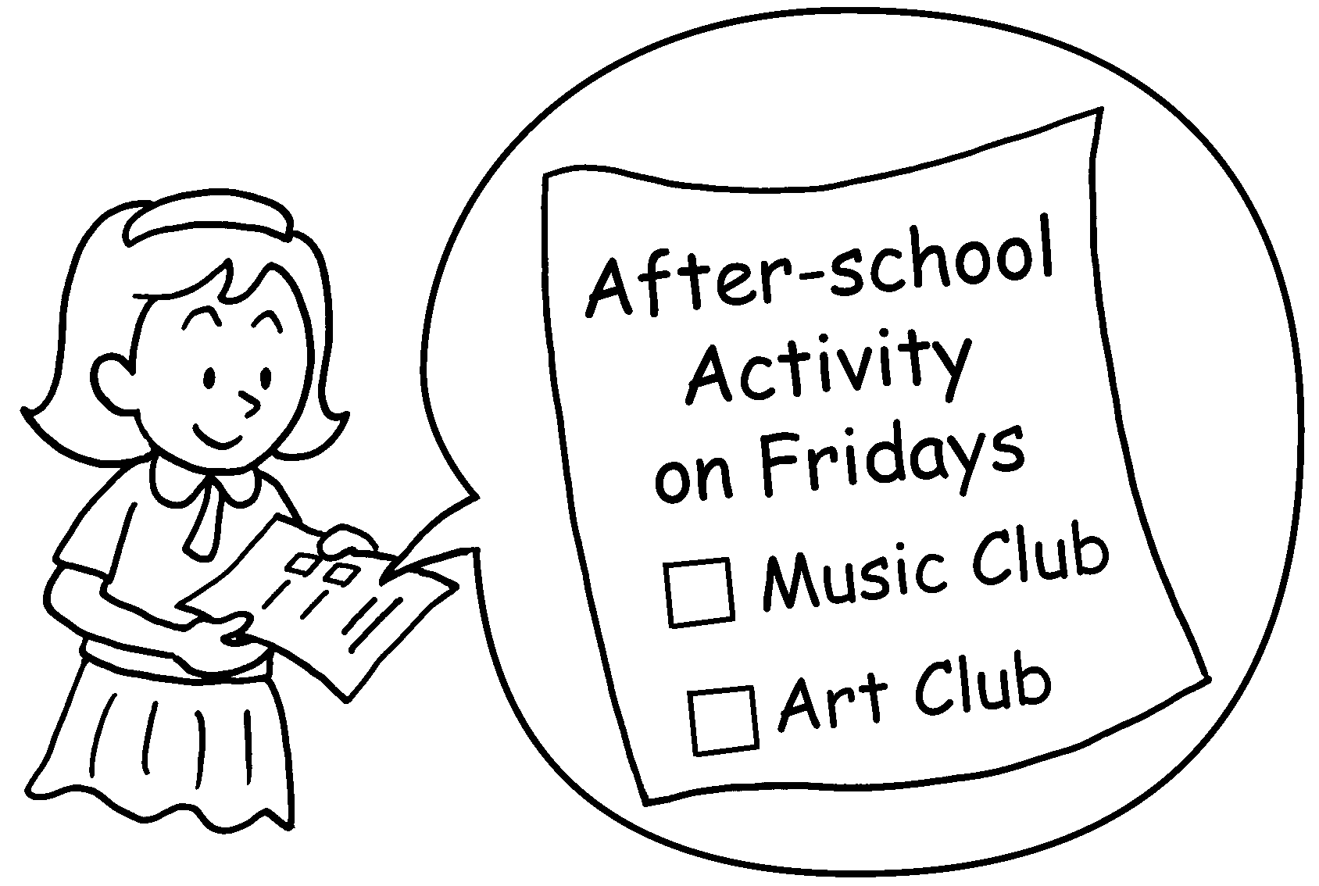 |  | Sue can join the Music Club the Art Club.
4 |  |  | They can  flags.
5 | 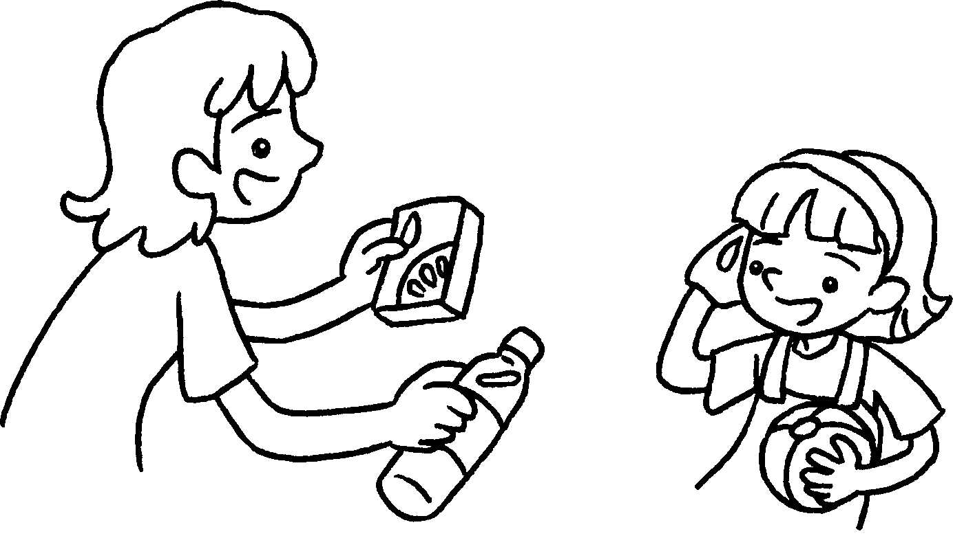  ( drink / water / juice )  A |  | A : You can  .
6 | 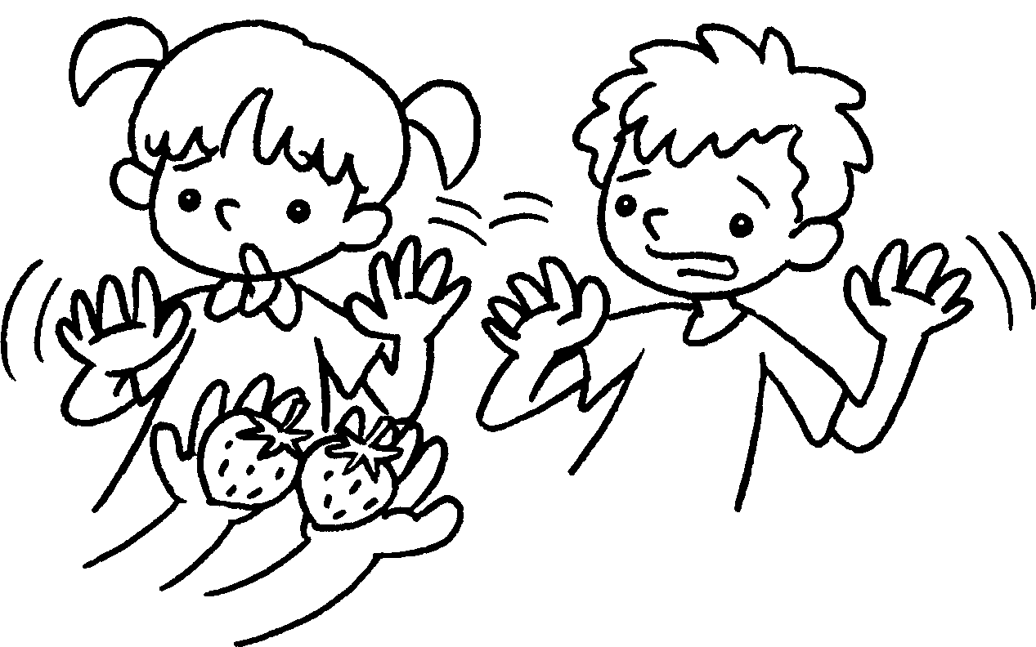  ( like / strawberries ) |  | Lucy Ben  .


Book 6A Chapter 4 Graded Worksheets
Worksheet 3⬇⬇
- Neither nor
- Neither nor
- either or
- either run a second-hand stall or sell
- either drink water / juice or juice / water
- Neither nor likes / like strawberries

