Finish the sentences.

either | neither

1 | 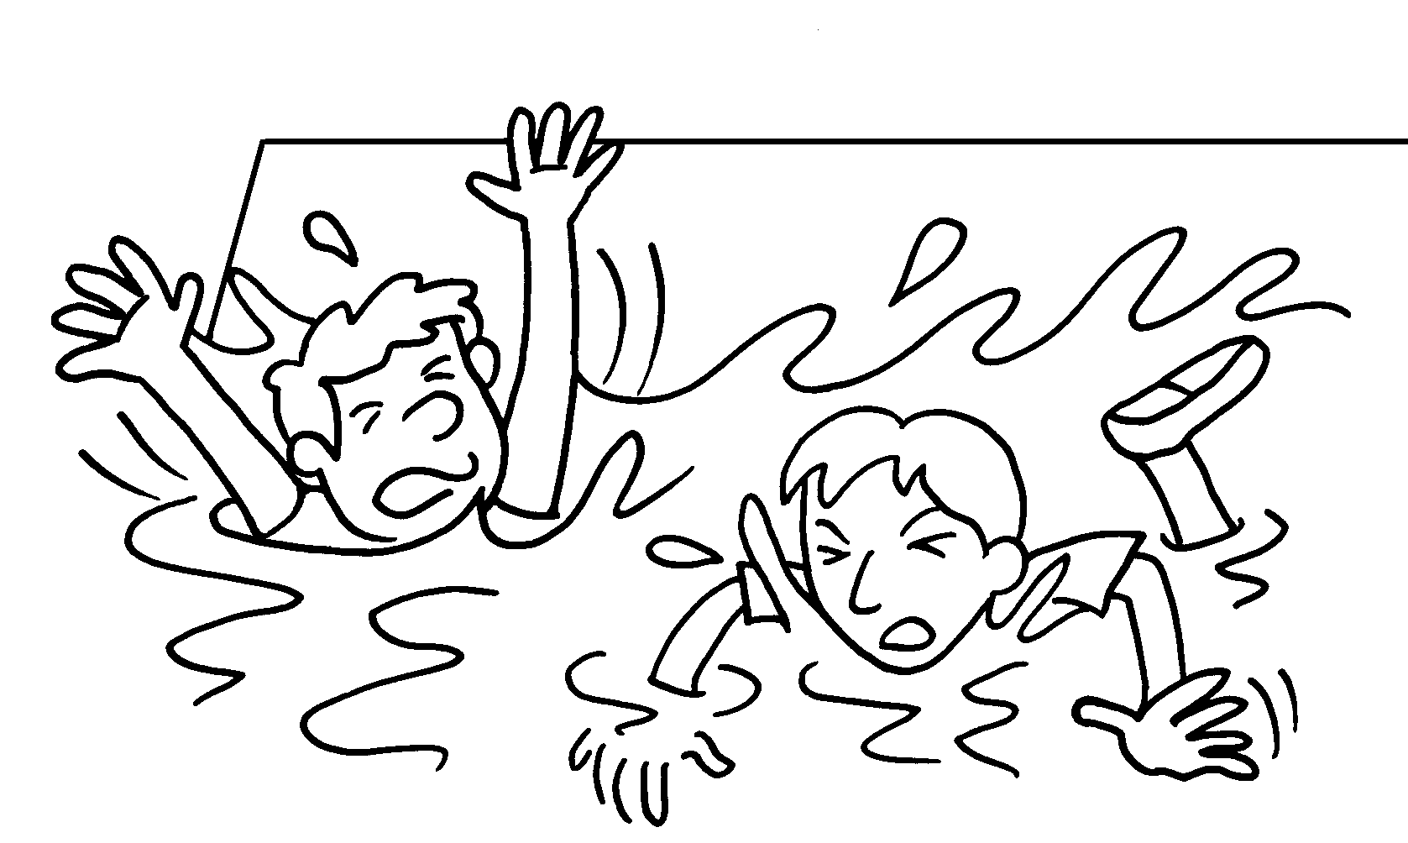 |  | Peter Andy can swim.
2 | 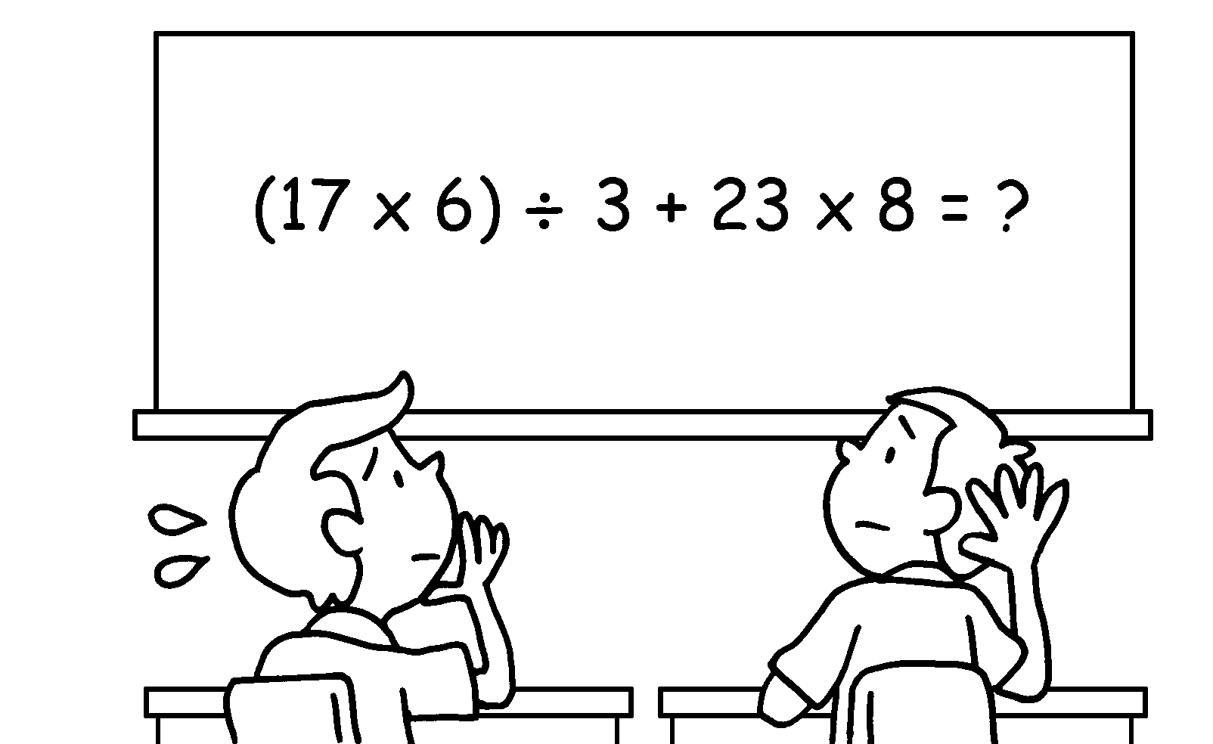 |  | Bob Paul knows the answer.
3 |  |  | Sue can join the Music Club the Art Club.
4 |  |  | They can  flags.
5 | 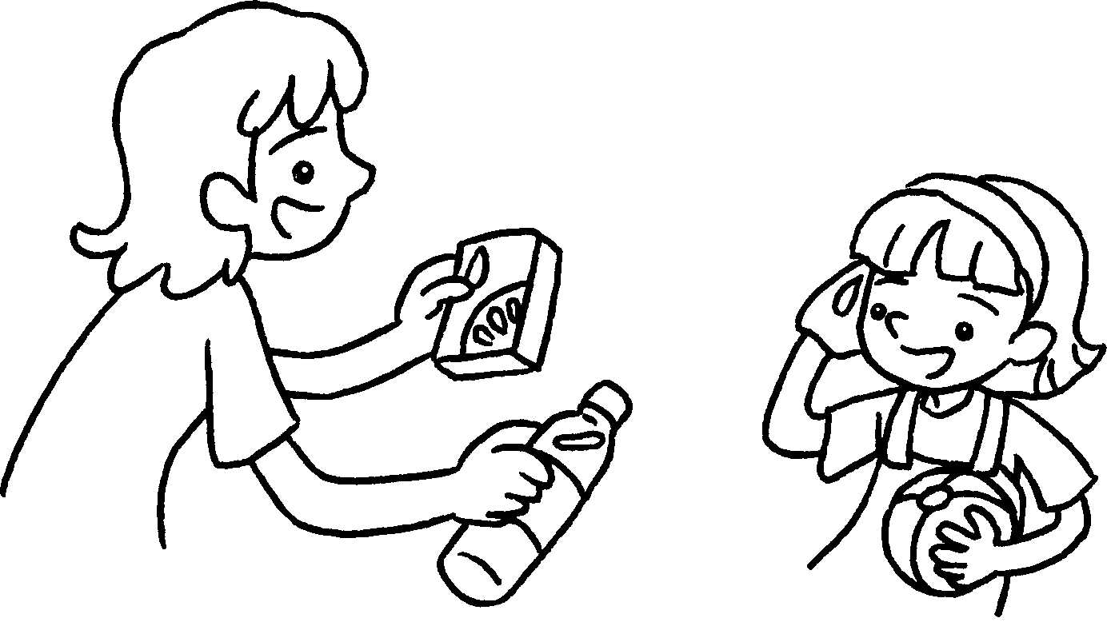  A |  | A : You can  .
6 | 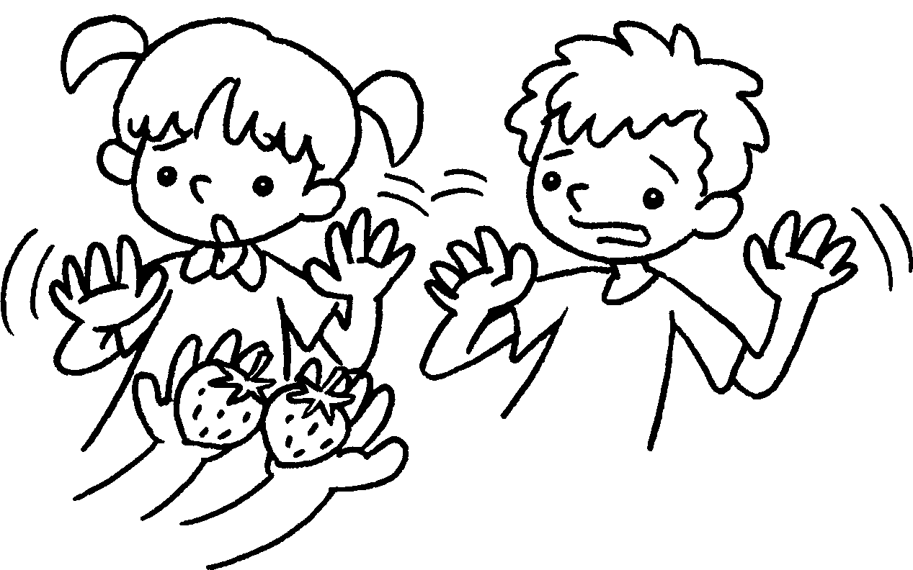 |  | Lucy Ben  .


Book 6A Chapter 4 Graded Worksheets
Worksheet 3⬇⬇⬇
1 Neither nor
2 Neither nor
3 either or
4 either run a second-hand stall or sell
5 either drink water / juice or juice / water
6 Neither nor likes / like strawberries
(Accept any reasonable answers.)

