Choose and write.

find | get | get | give
look | make | set | turn

1 | 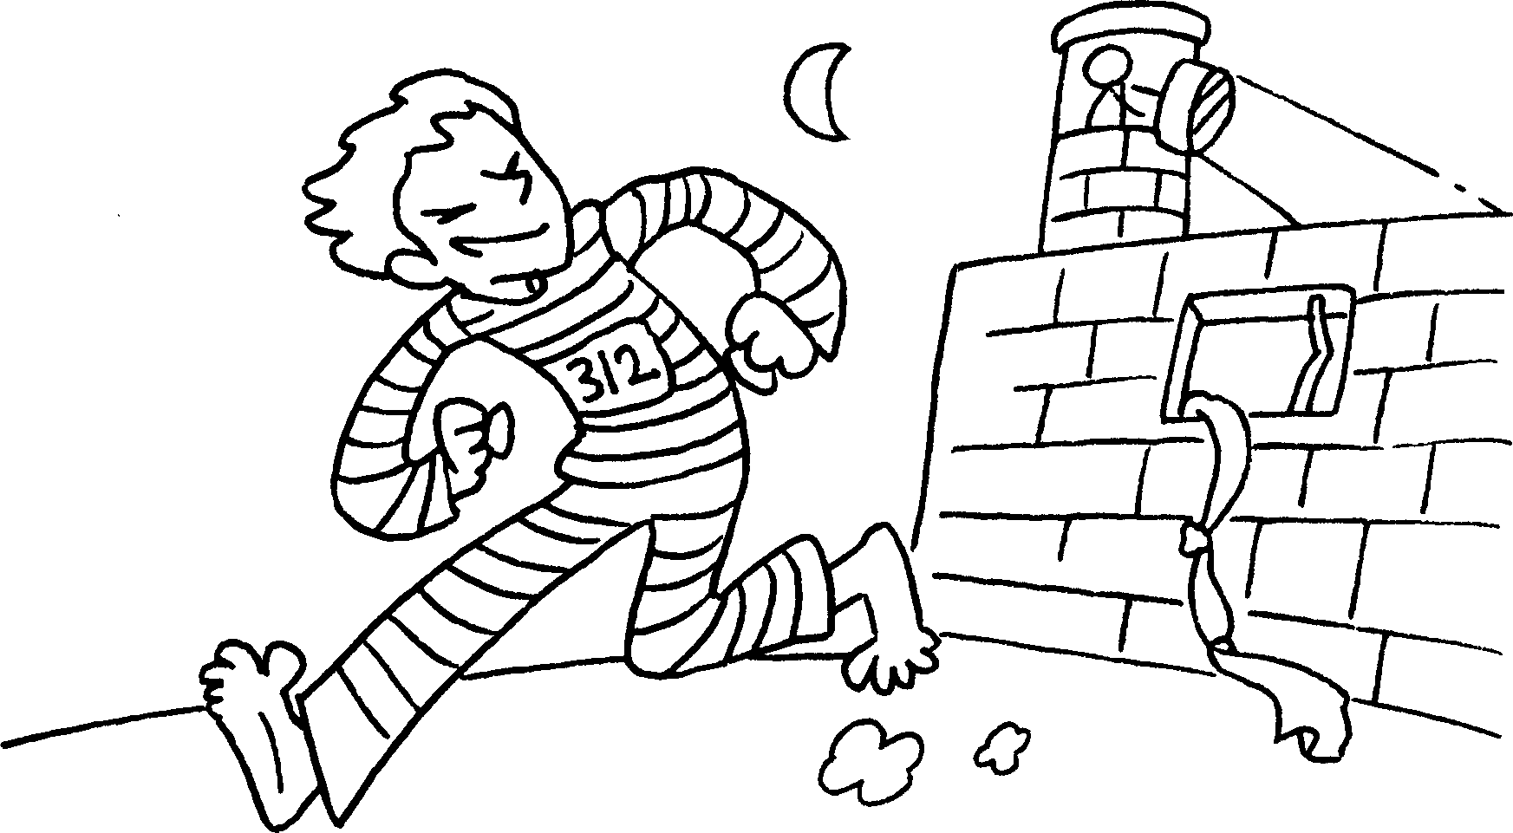 |  | 2 | 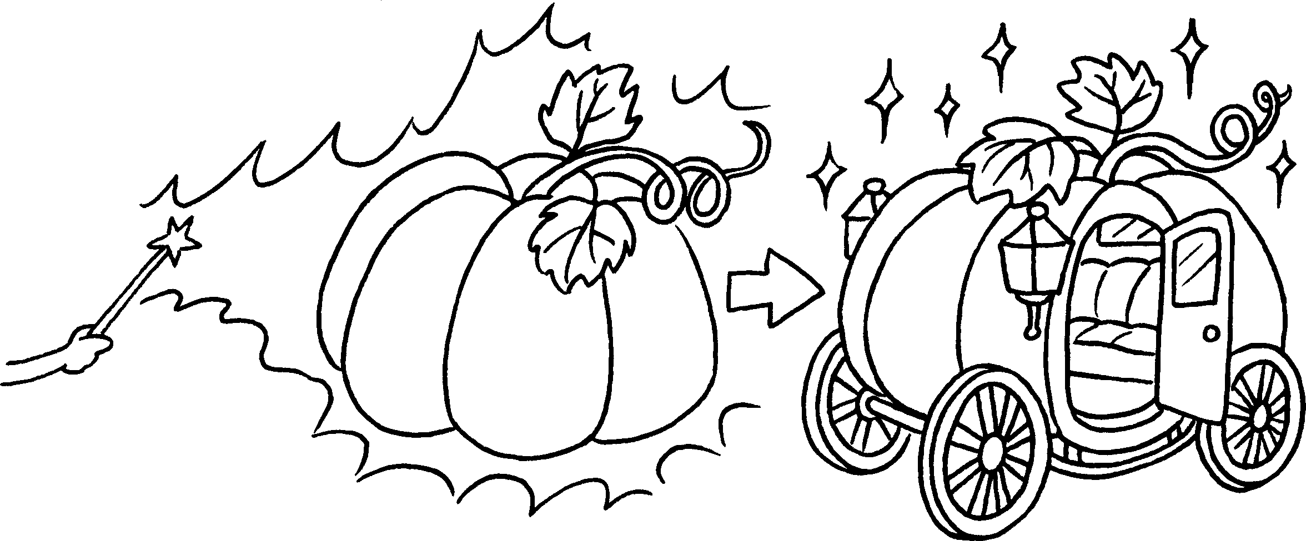
 | away |  |  | into
3 | 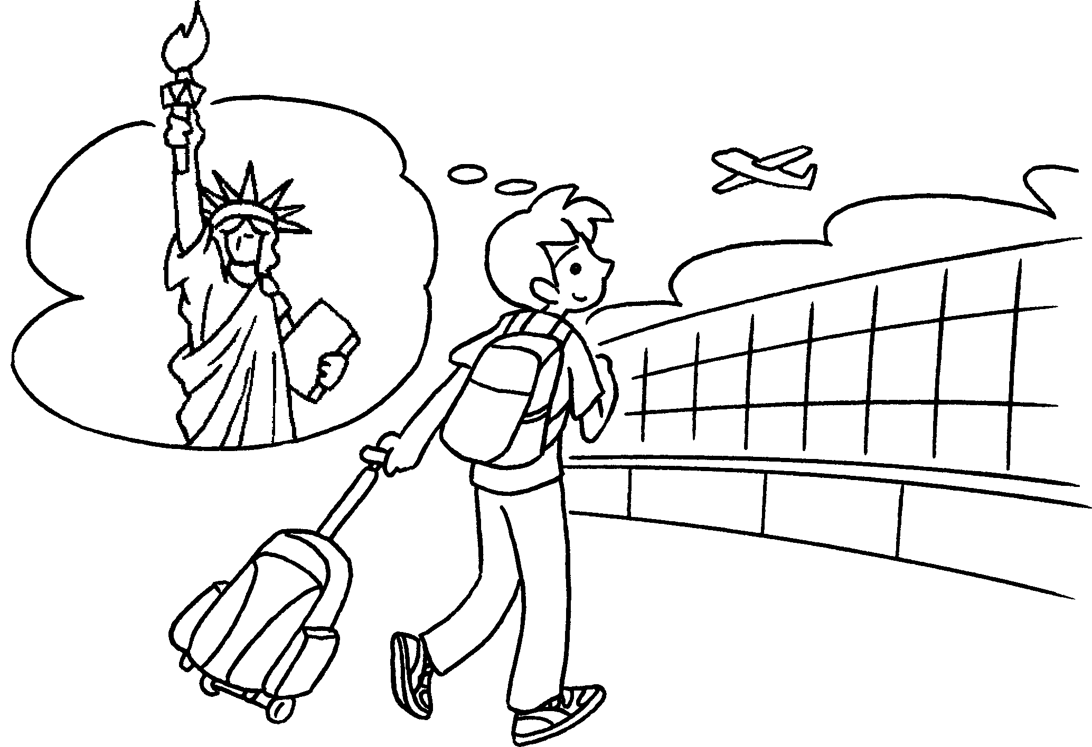 |  | 4 | 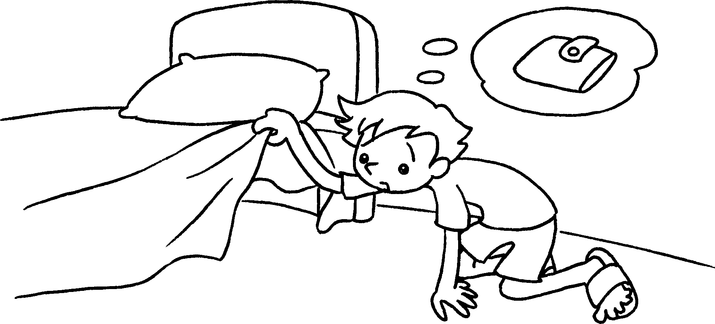
 | off |  |  | for
5 | 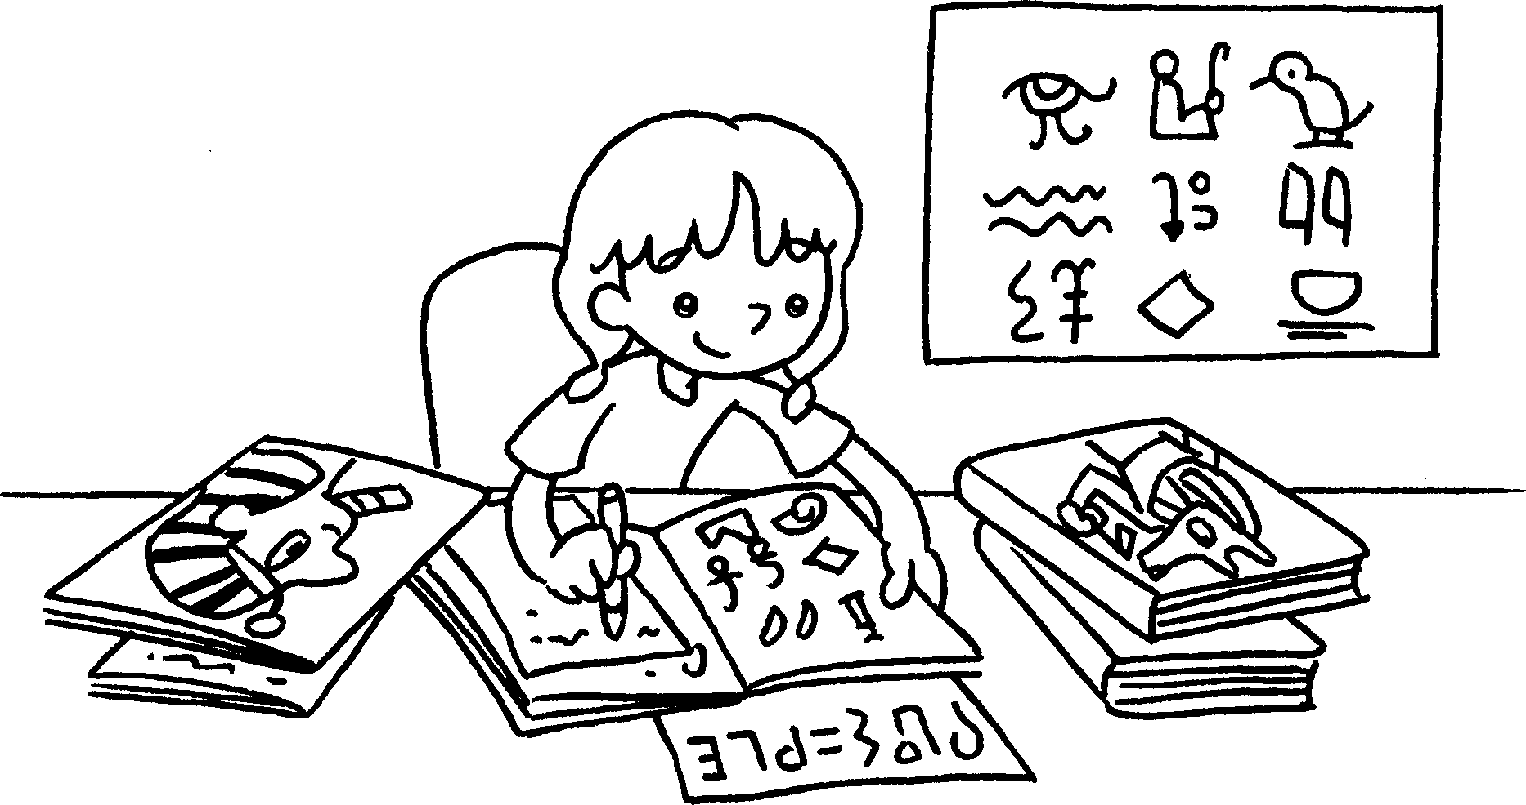  ? |  | 6 | 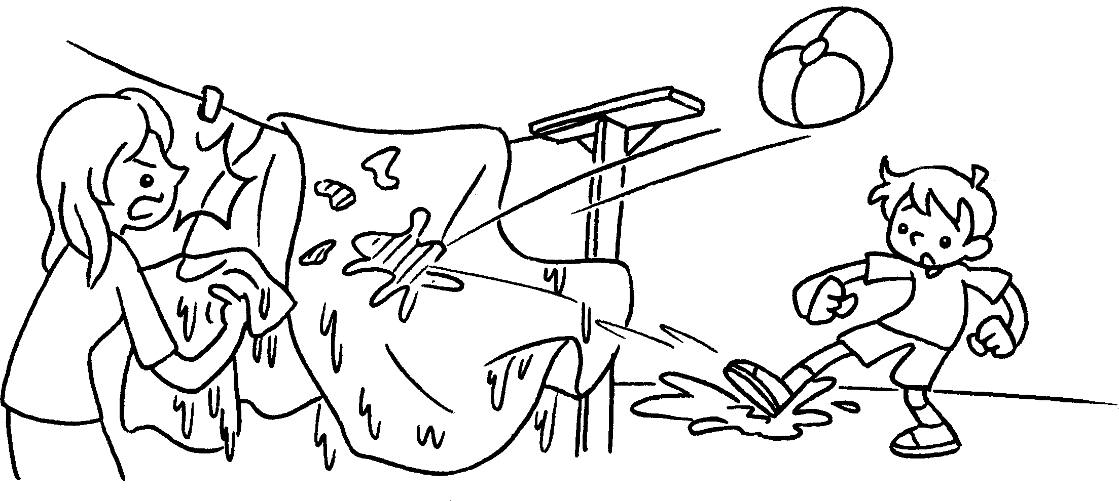
 | out |  |  | into ( trouble )
7 | 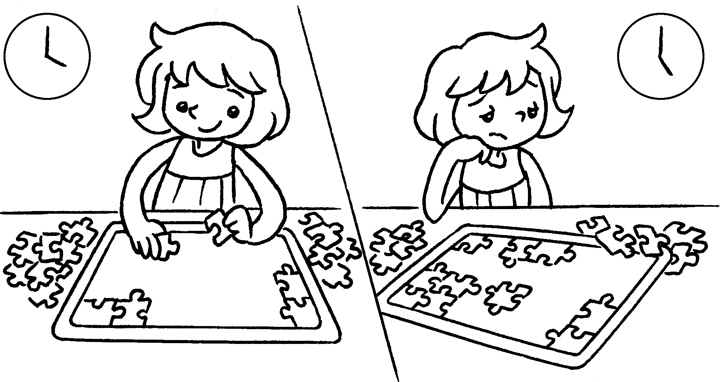 |  | 8 | 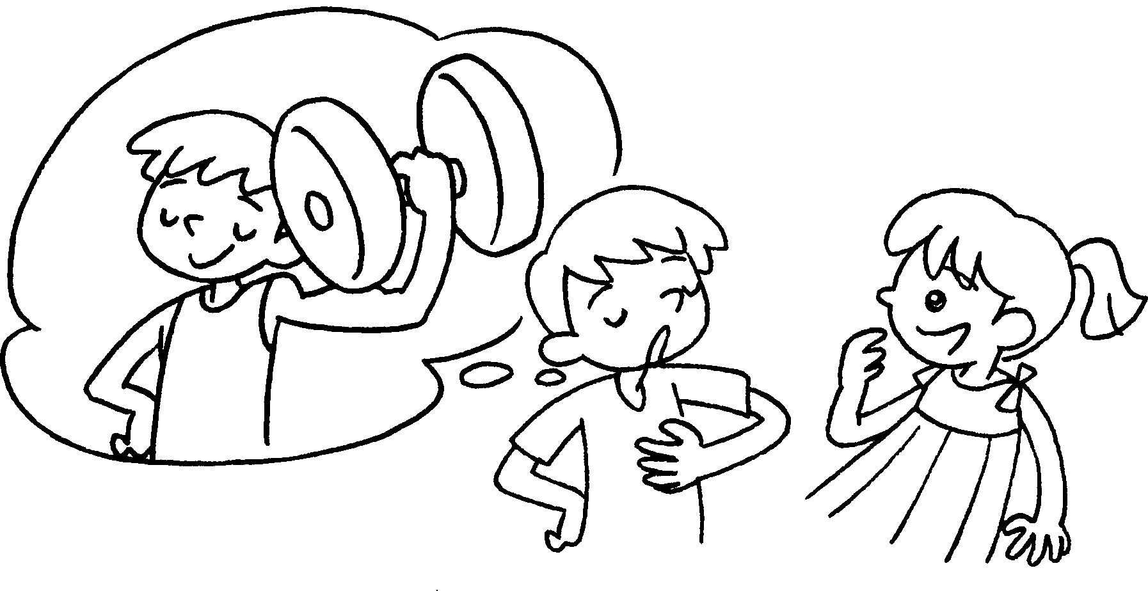
 | up |  |  | up ( a story )


Book 6A Chapter 5 Graded Worksheets
Worksheet 1⬇
- get 2 turn
3 set 4 look
5 find 6 get
7 give 8 make

