Choose and write. You can use some words more than once.

find | get | give | turn | up into out
look | make | set |  | off for away

1 | 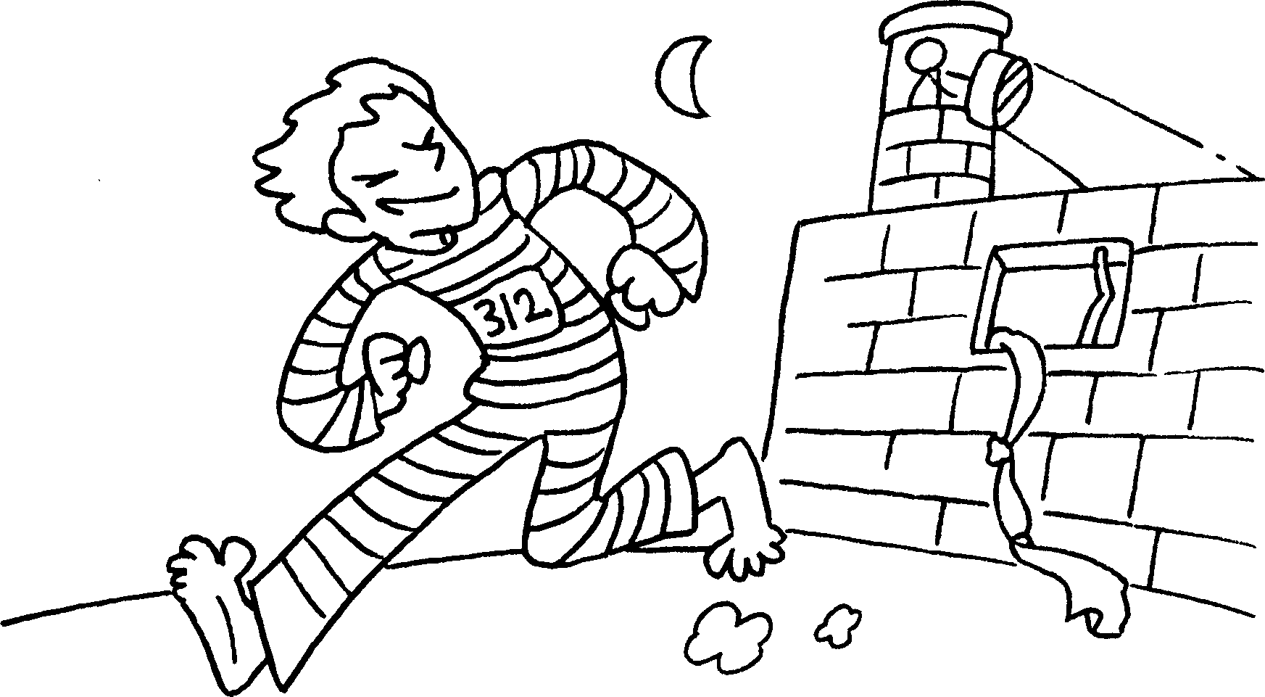 |  | 2 | 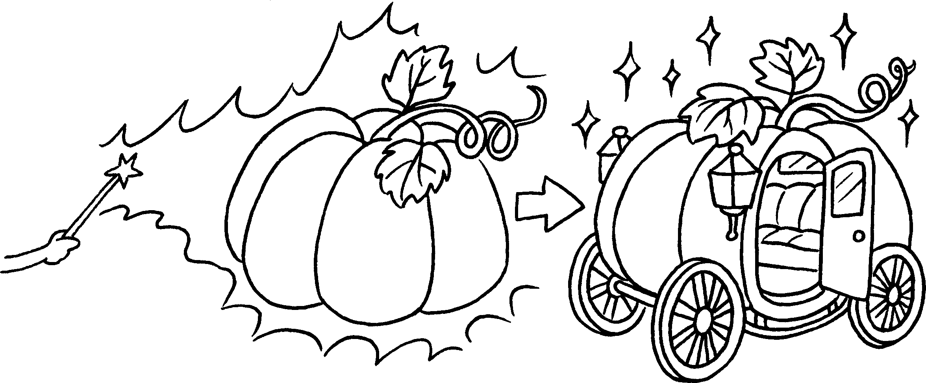
3 | 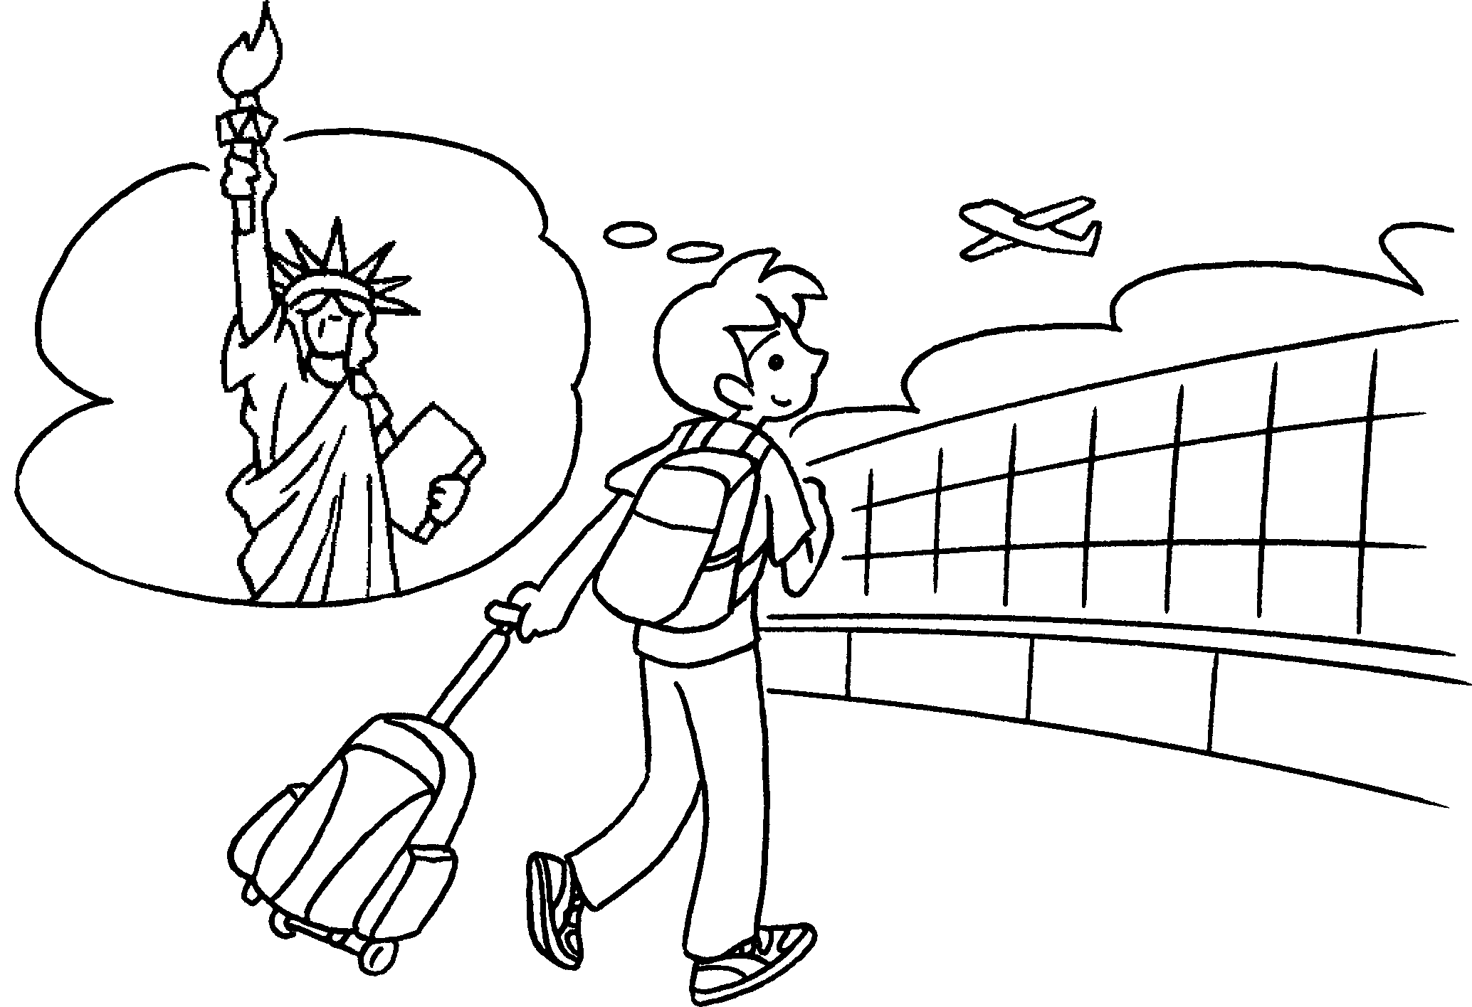 |  | 4 | 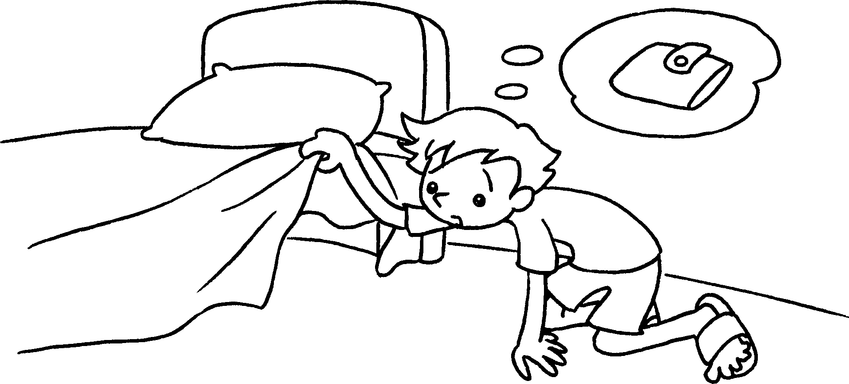
5 | 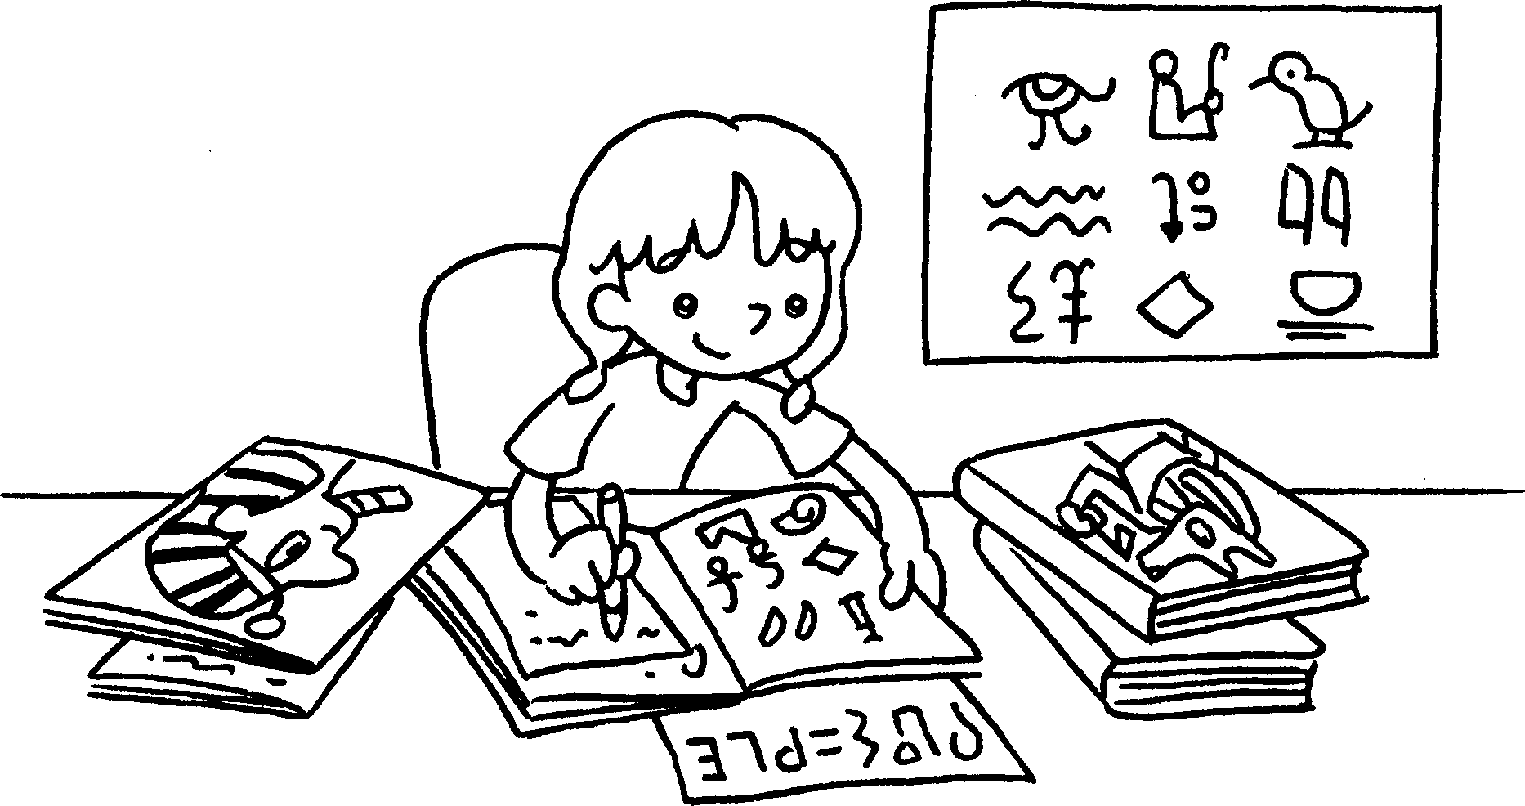  ? |  | 6 | 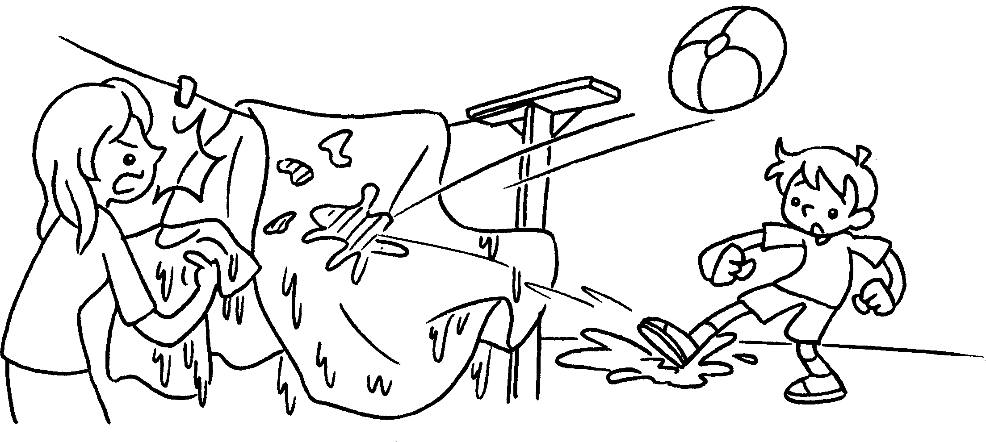
 |  |  |  | ( trouble )
7 | 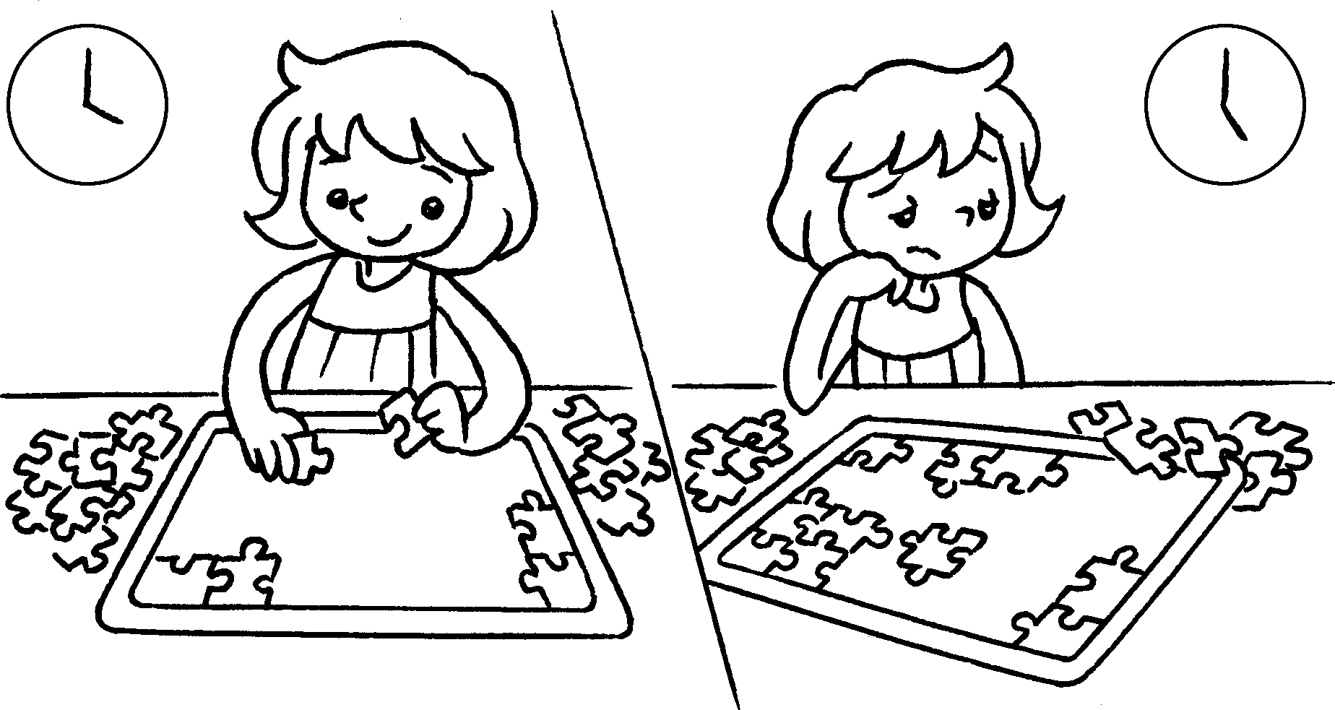 |  | 8 | 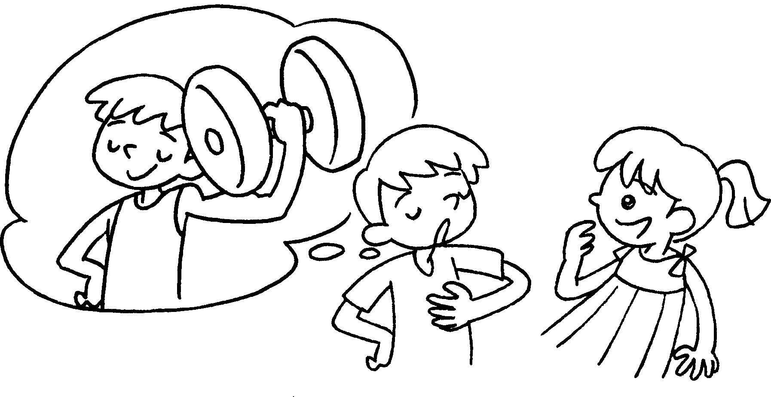
 |  |  |  | ( a story )


Book 6A Chapter 5 Graded Worksheets
Worksheet 1⬇⬇
- get away 2 turn into
3 set off 4 look for
5 find out 6 get into
7 give up 8 make up

