Circle the correct answers.

1 | 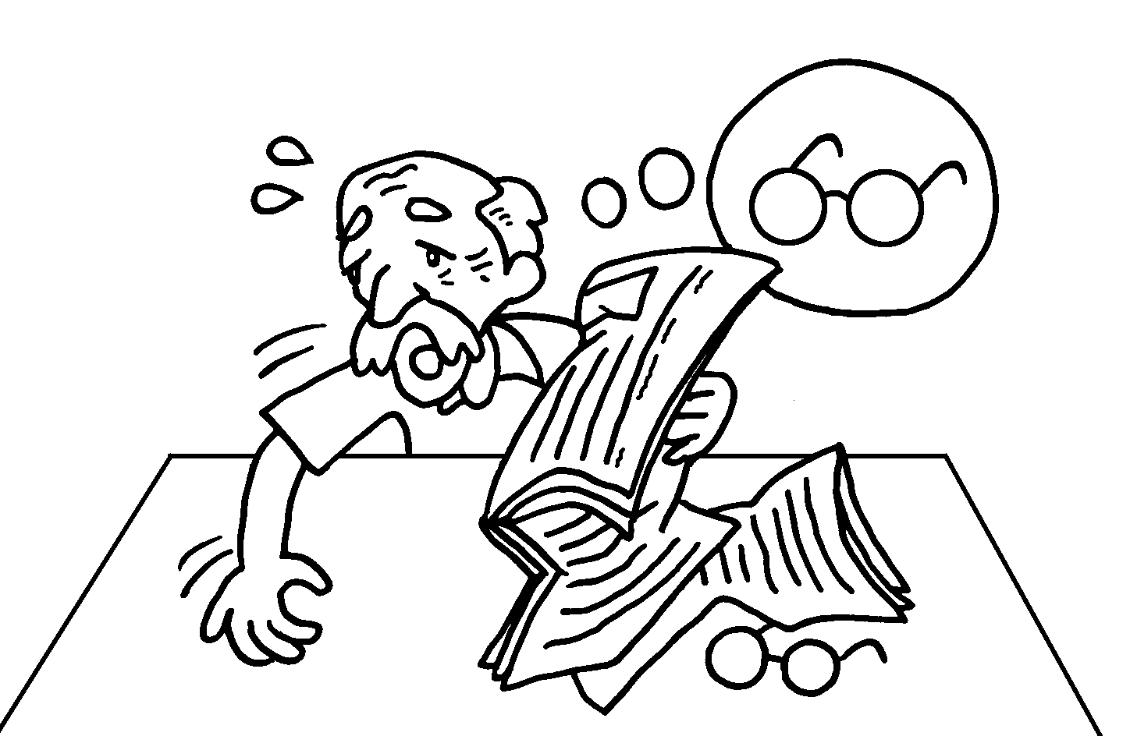 | Grandpa is ( looking / making ) ( into / for ) his glasses.
2 | 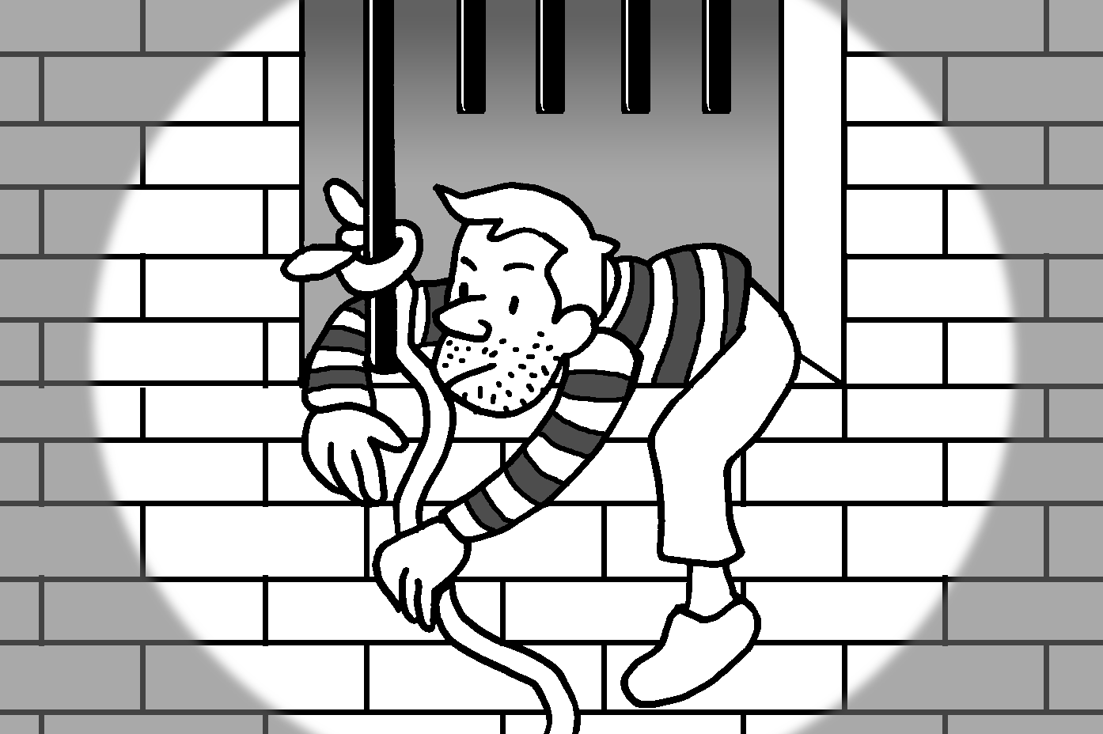 | The thief ( turned / got ) ( up / away ) last night.
3 | 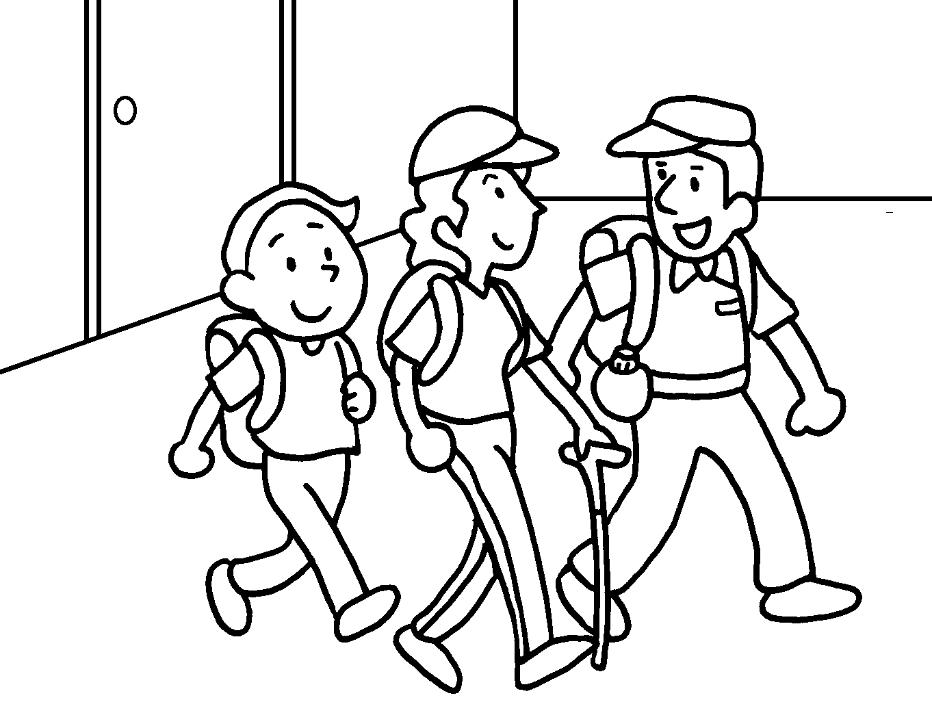 | We ( made / set ) ( off / out ) for Tai Mo Shan at eight o’clock this morning.
4 | 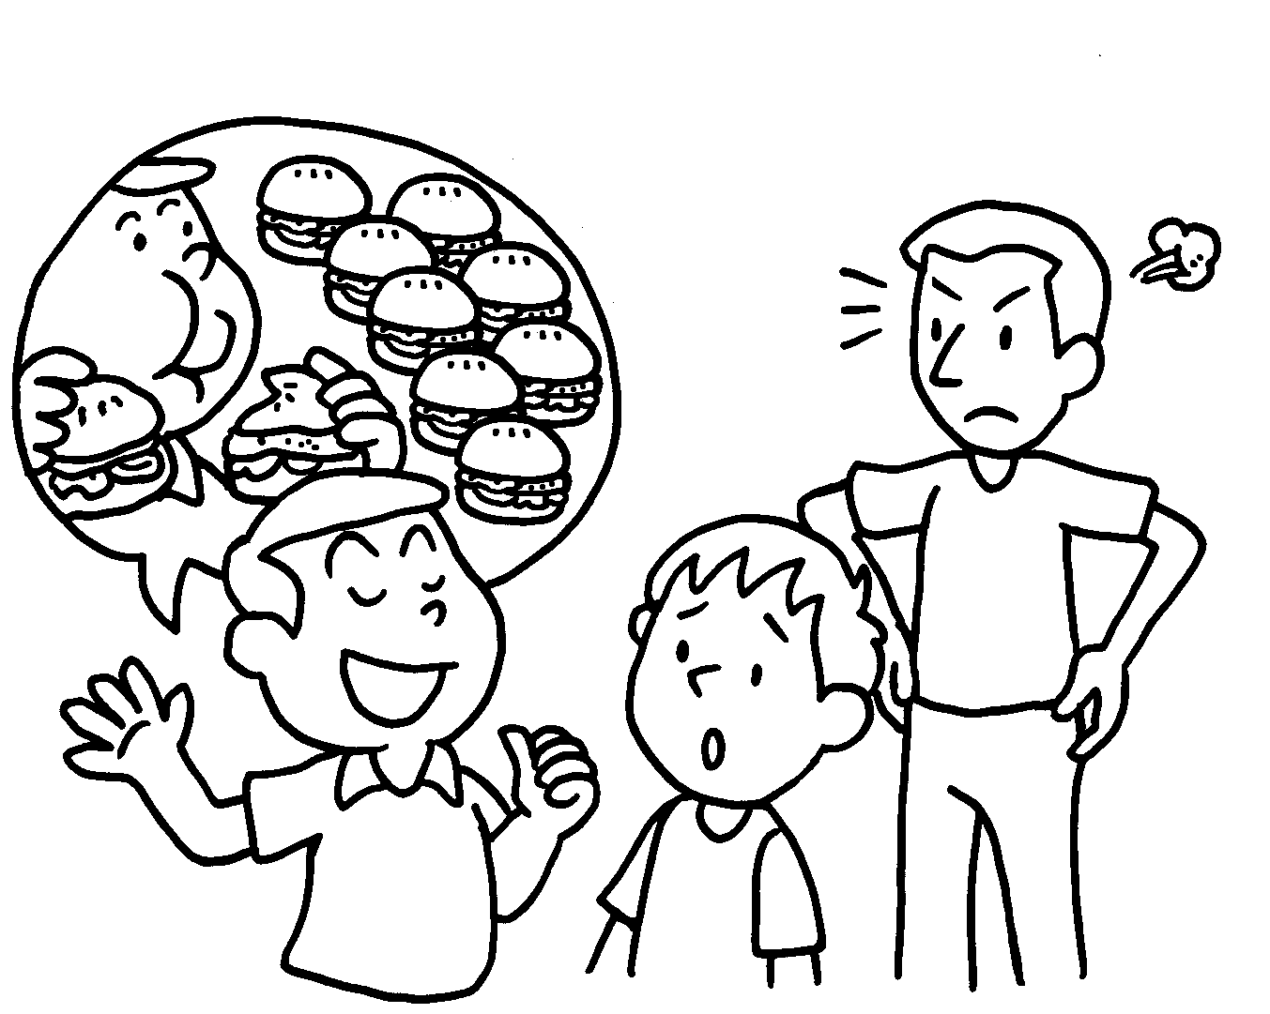 | Ricky always ( makes / finds ) ( up / into ) stories. Don’t believe him.
5 |  | Lily wants to ( find / get ) ( off / out ) about charity work in Hong Kong.
6 | 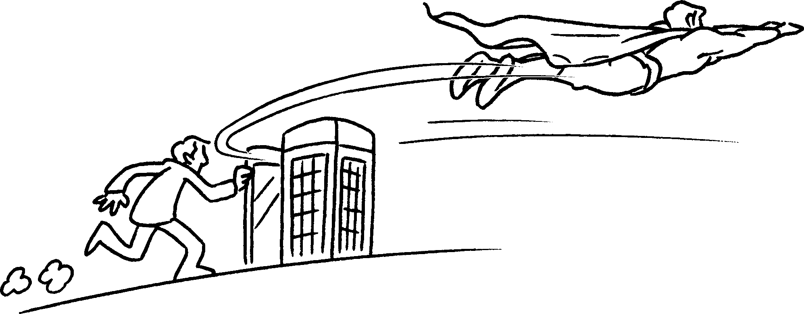 | The man ( gives / turns ) ( into / for ) Superman and saves a lot of people in the film.
7 | 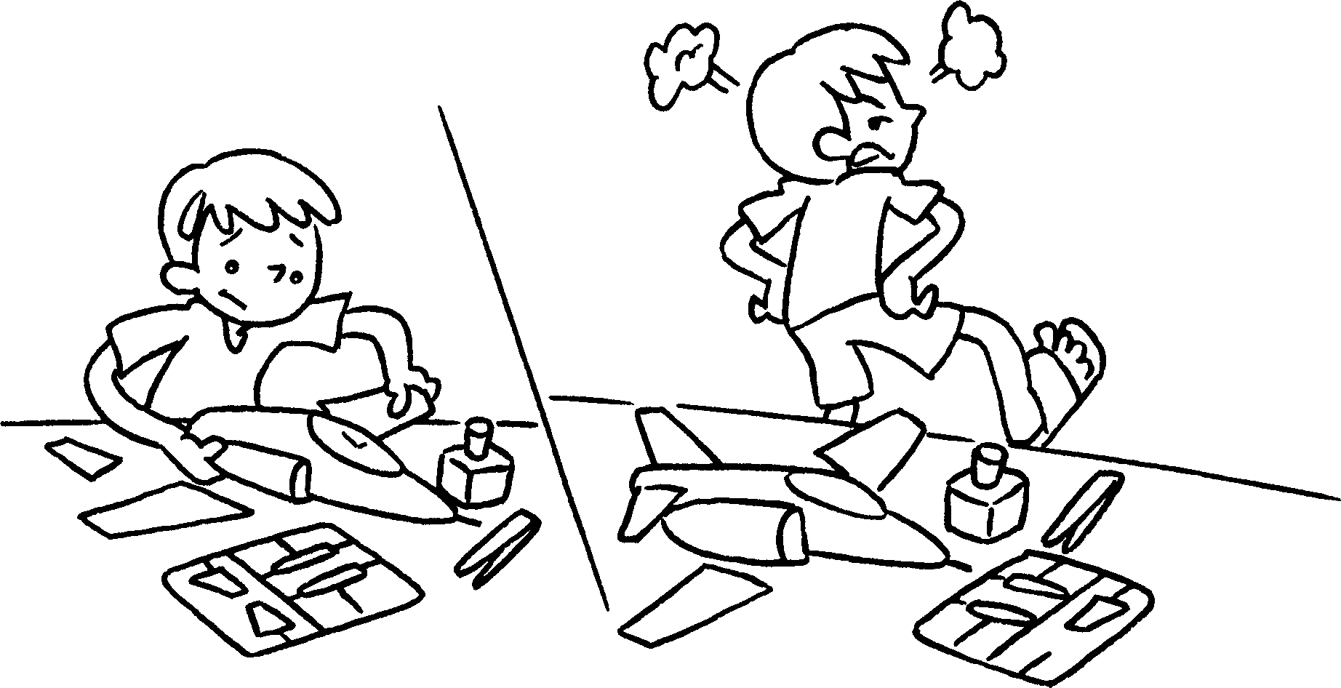 | Tom ( got / gave ) ( out / up ) and did not finish the model.


Book 6A Chapter 5 Graded Worksheets
Worksheet 2⬇
- ( looking / making ) ( into / for )
- ( turned / got ) ( up / away )
- ( made / set ) ( off / out )
- ( makes / finds ) ( up / into )
- ( find / get ) ( off / out )
- ( gives / turns ) ( into / for )
- ( got / gave ) ( out / up )

