Fill in the blanks with the correct phrasal verbs. Use the correct form of the verbs.

1 | 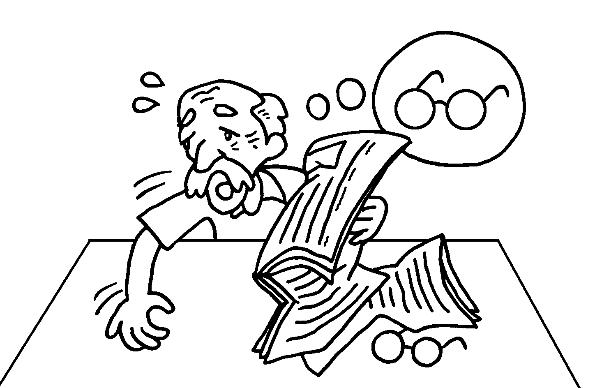 | Grandpa is _________________________ his glasses.
2 | 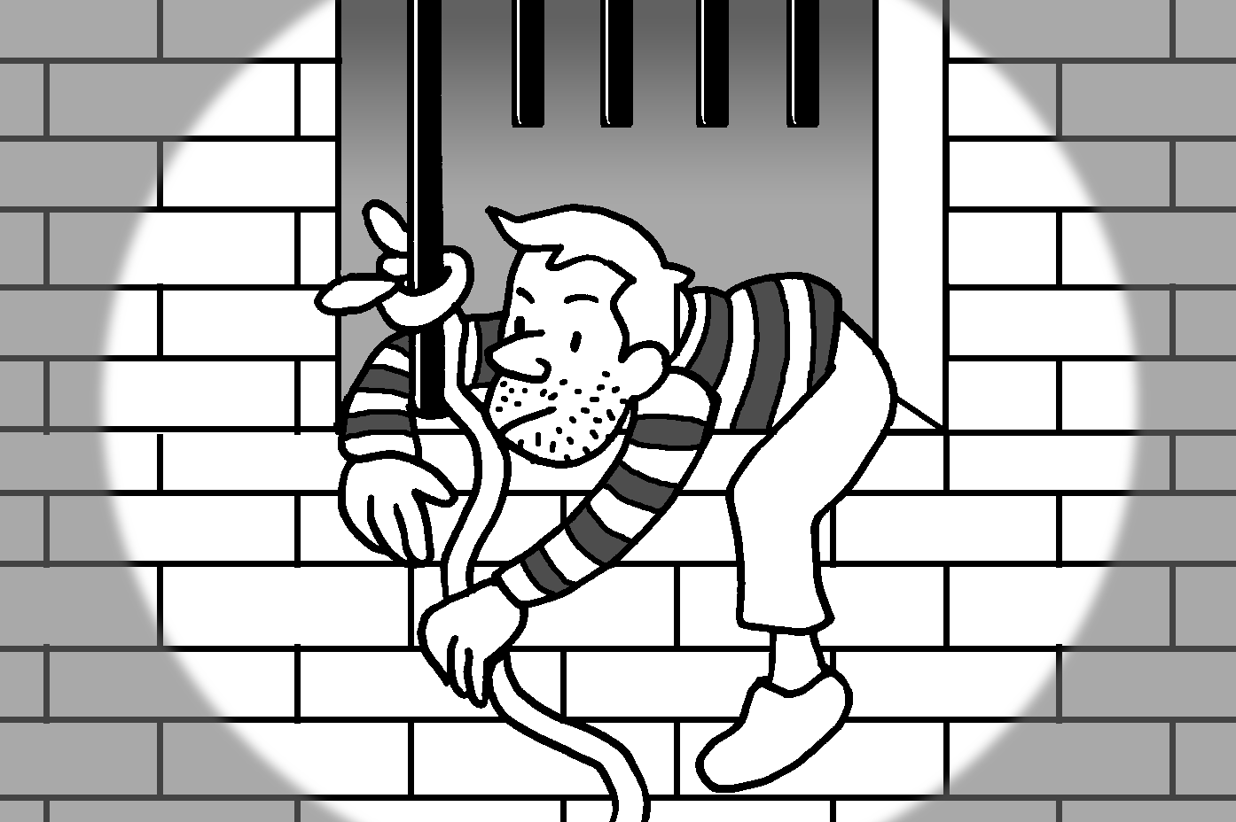 | The thief _________________________ last night.
3 | 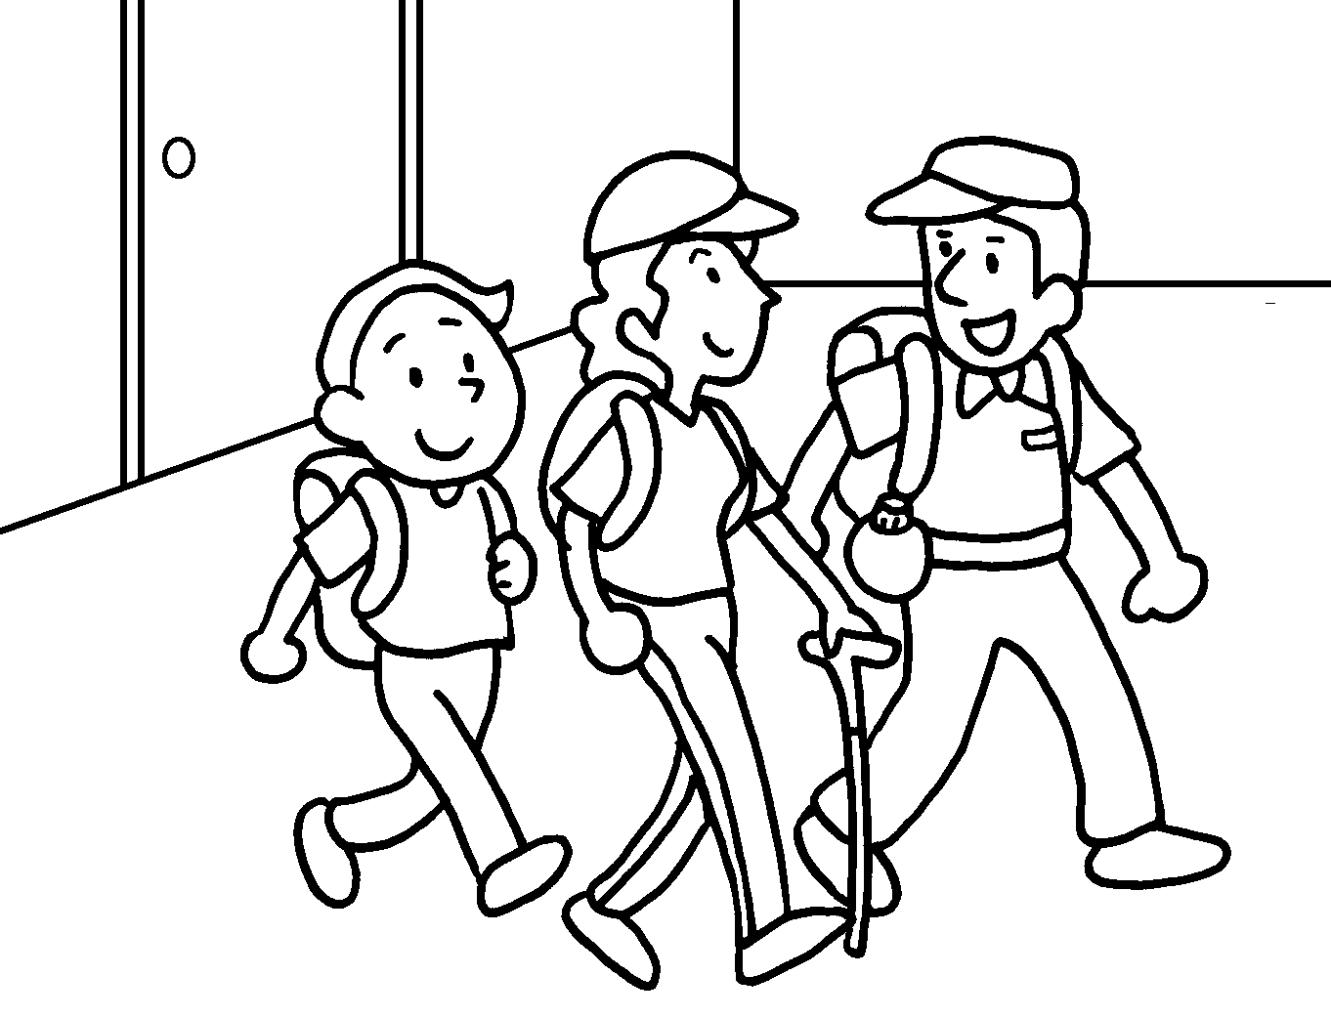 | We _________________________ for Tai Mo Shan at eight o’clock this morning.
4 | 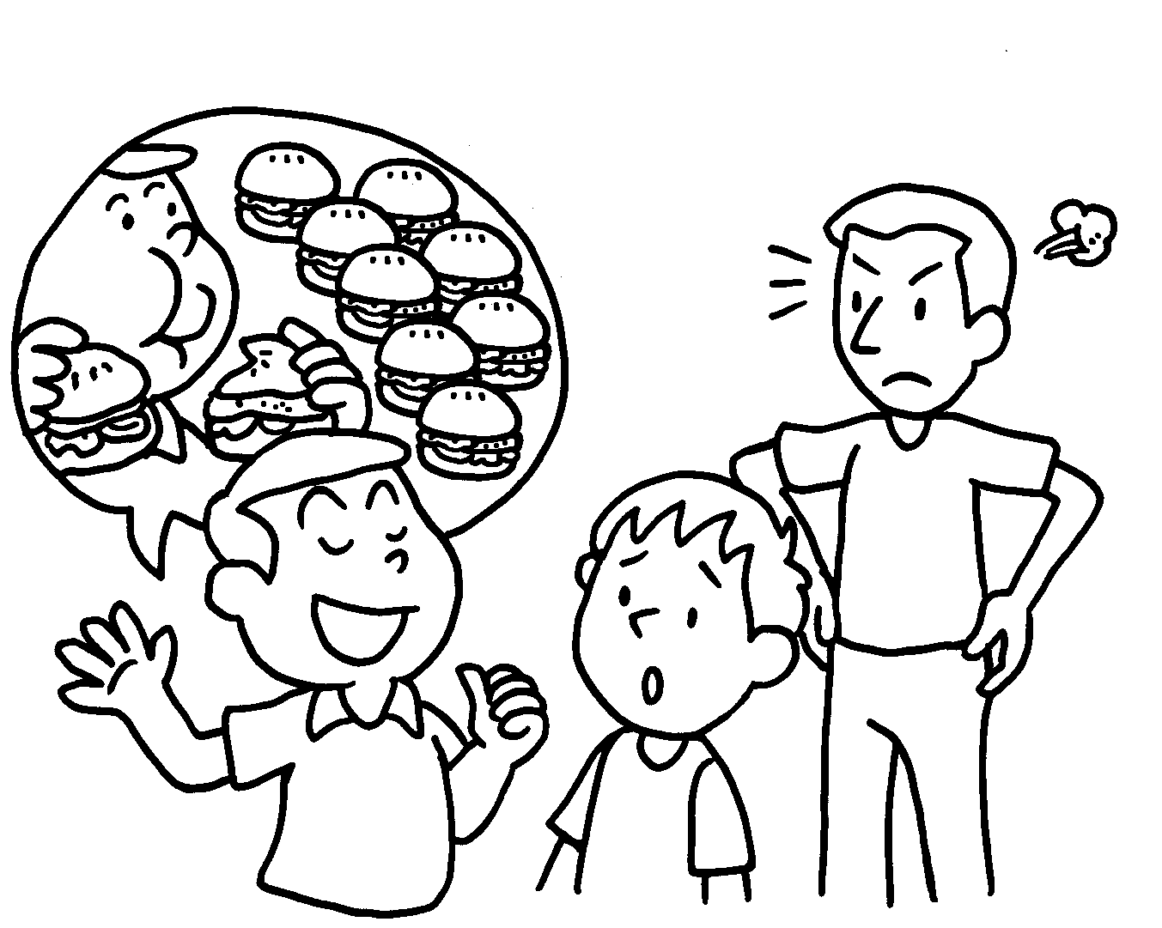 | Ricky always _________________________ stories. Don’t believe him.
5 |  | Lily wants to _________________________ about charity work in Hong Kong.
6 | 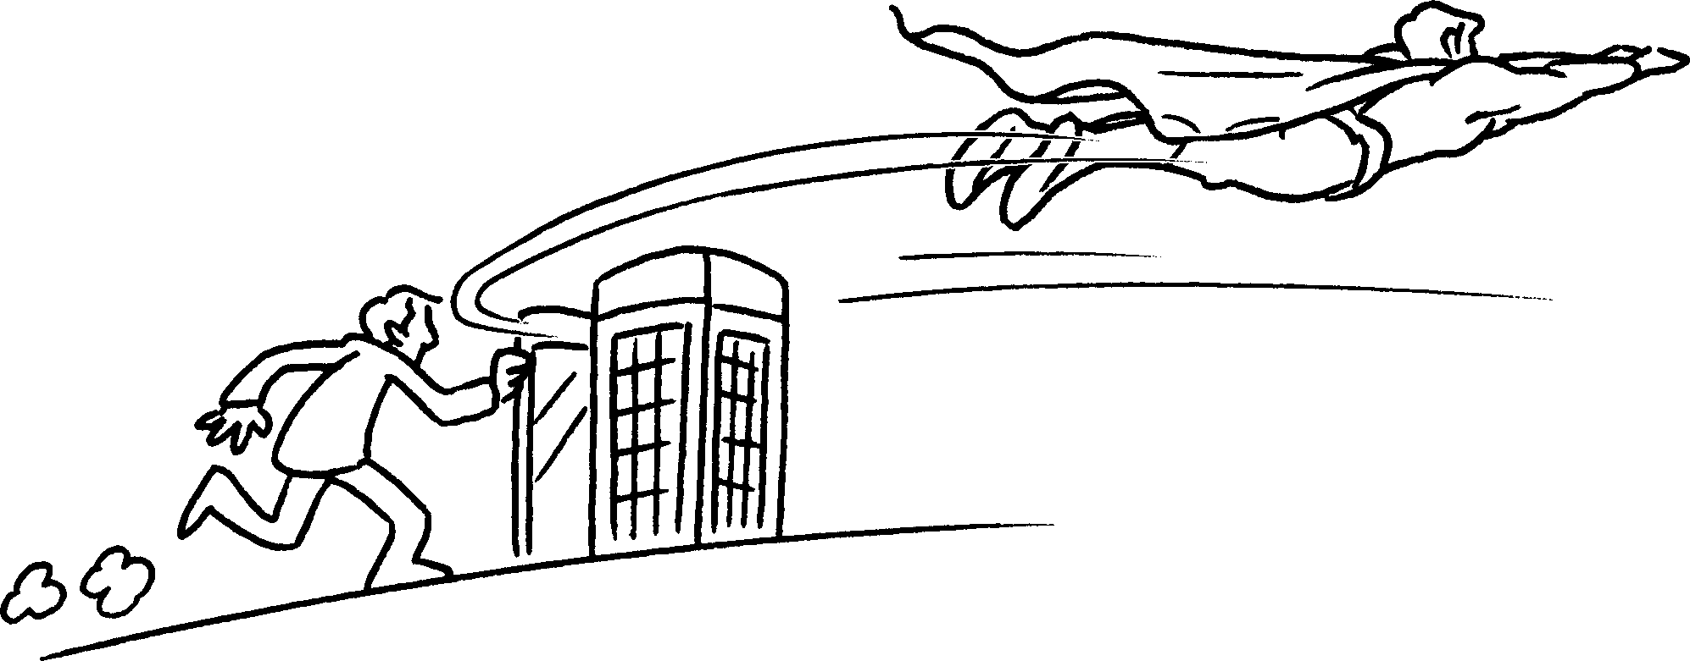 | The man _________________________ Superman and saves a lot of people in the film.
7 | 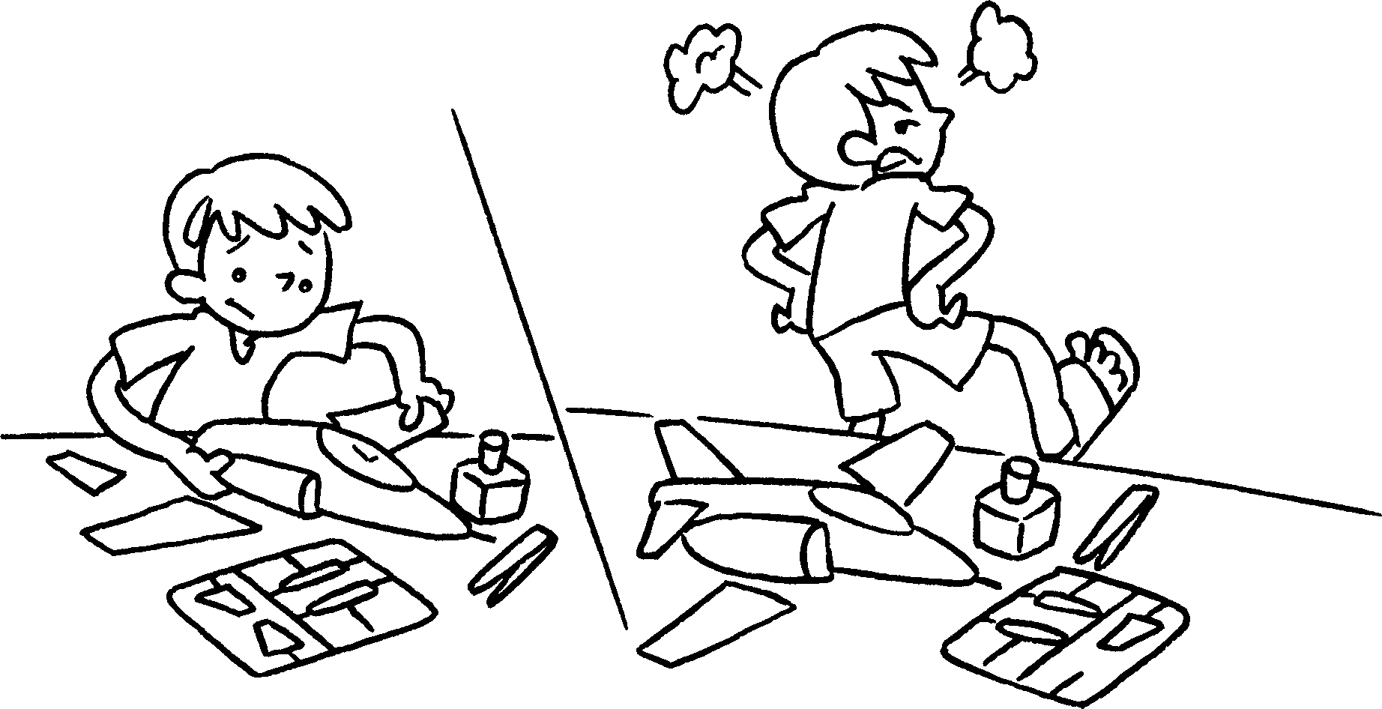 | Tom _________________________ and did not finish the model.


Book 6A Chapter 5 Graded Worksheets
Worksheet 2⬇⬇⬇
- looking for
- got away
- set off
- makes up
- find out
- turns into
- gave up

