Circle the correct answers.

1 | 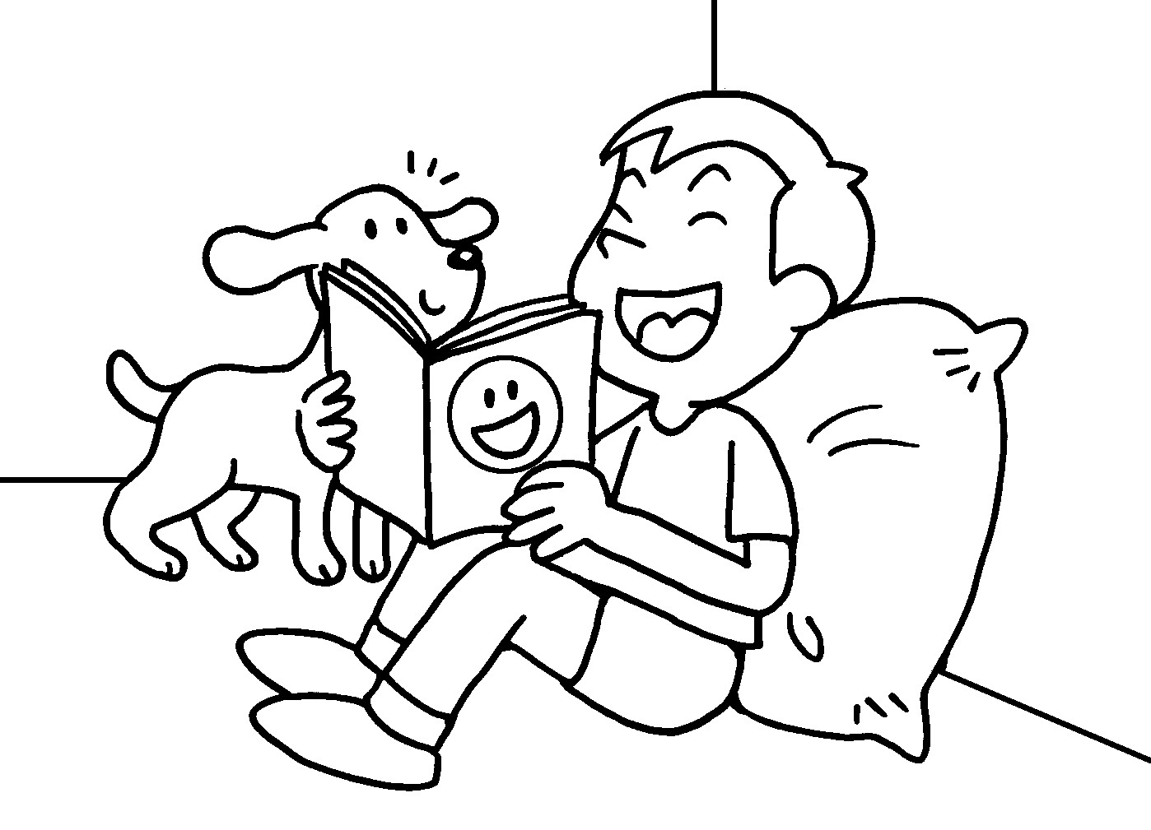  I was ( amused / disappointed ).  The story was ( amusing / disappointed ). |  | 
2 | John’s result was ( disappointing /  exciting ).  I was ( excited / disappointed ).  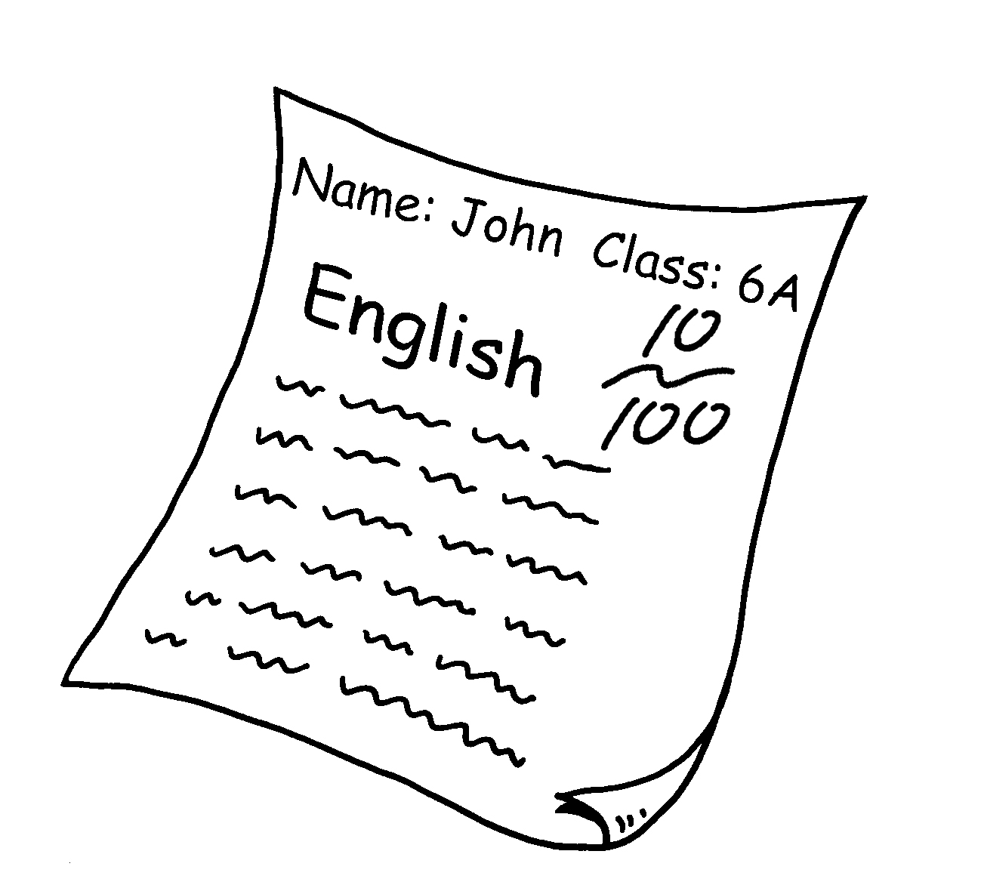 |  | 
3 | I was ( amazed / amazing ).  The performance was ( amazed / amazing ).  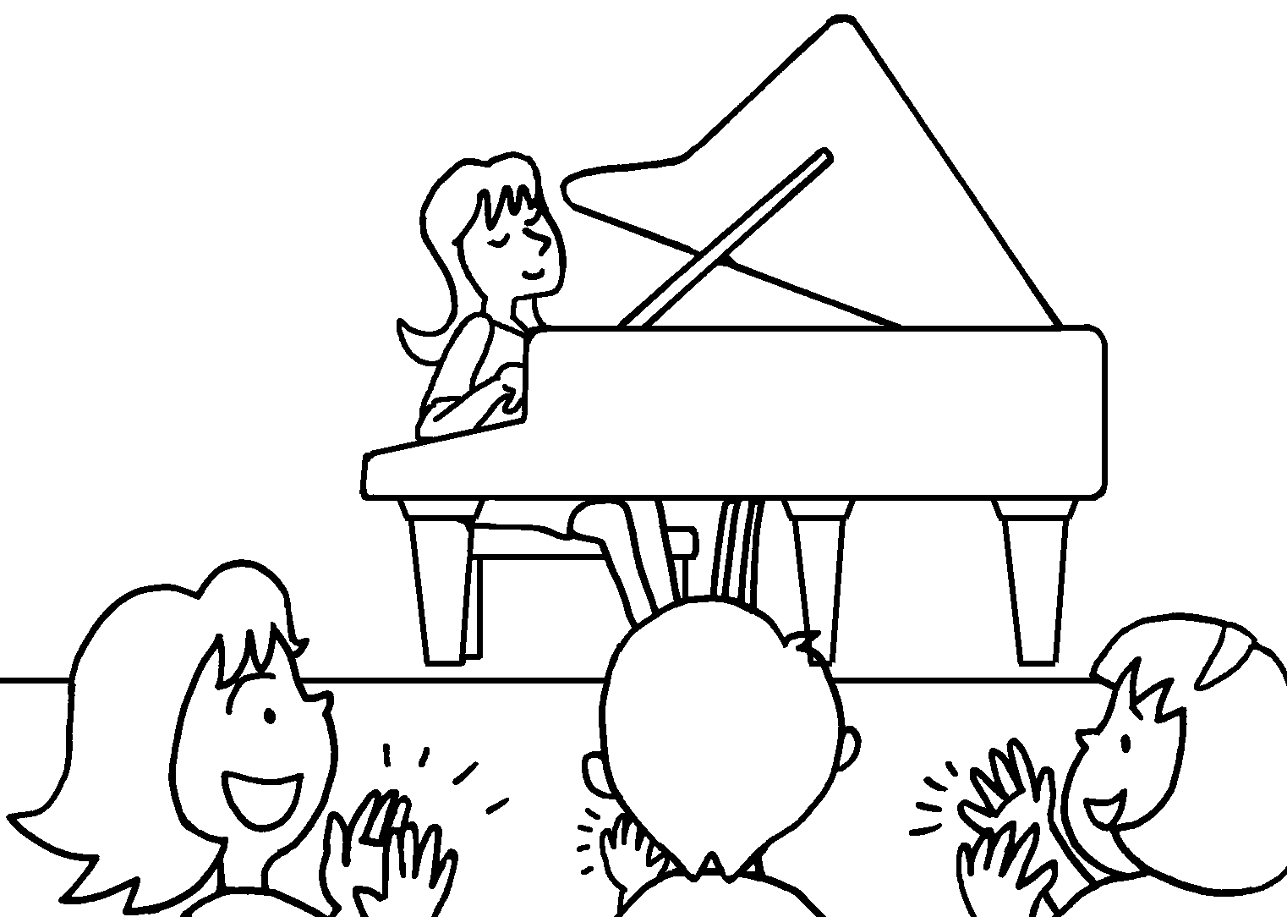 |  | 
4 | 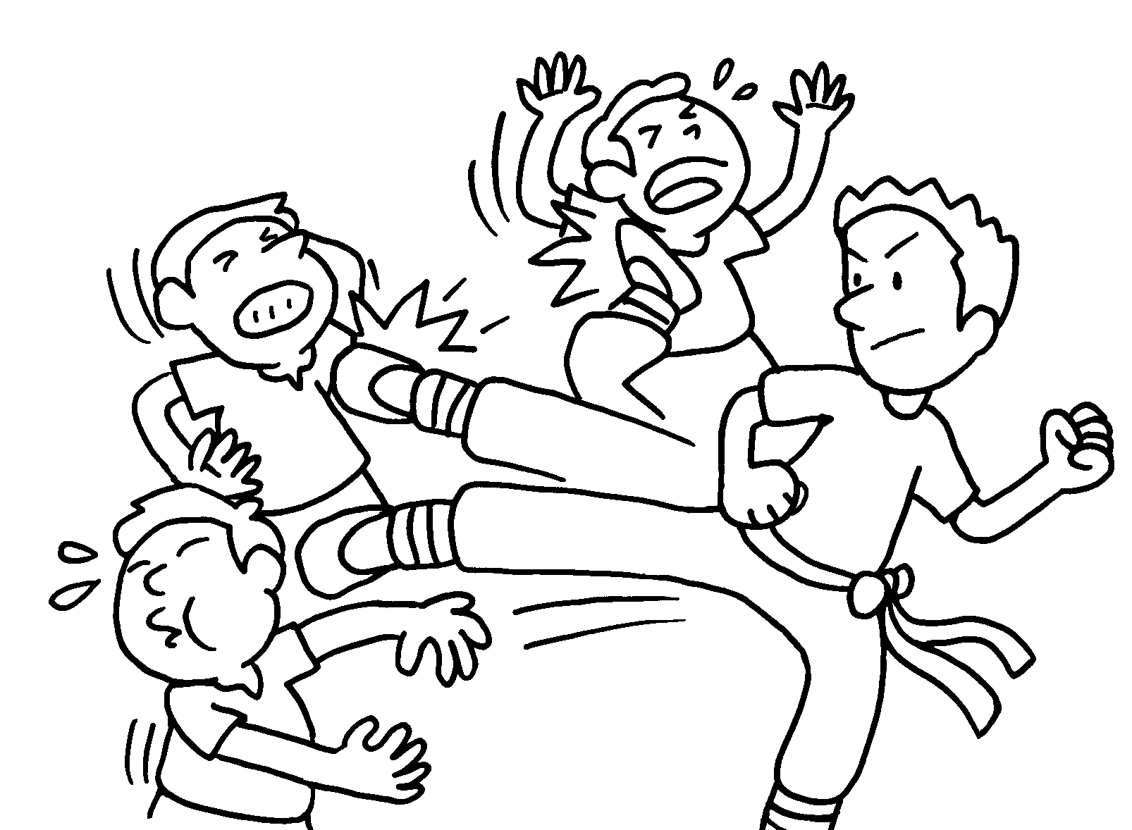  The film was ( excited / exciting ).  I was ( excited / exciting ). |  | 



Book 6A Chapter 5 Graded Worksheets
Worksheet 3⬇
- ( amused / disappointed )
( amusing / disappointing )
- ( disappointing / exciting )
( excited / disappointed )
- ( amazed / amazing )
( amazed / amazing )
- ( excited / exciting )
( excited / exciting )

