Choose and write.

amazed | amused | disappointed | excited
amazing | amusing | disappointing | exciting

1 | 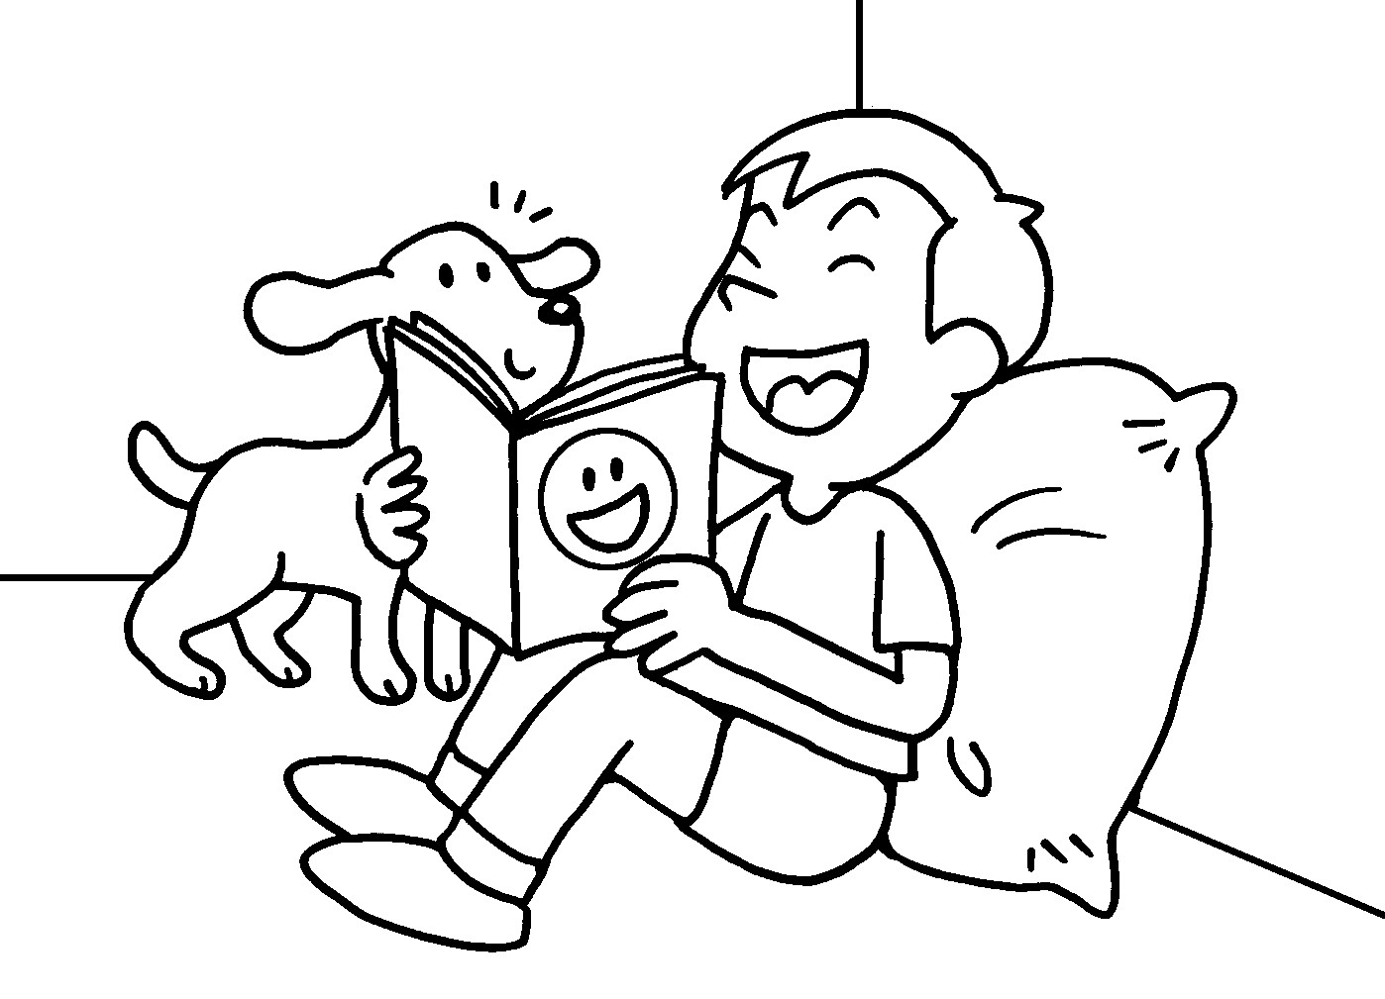 | I was .  The story was . | 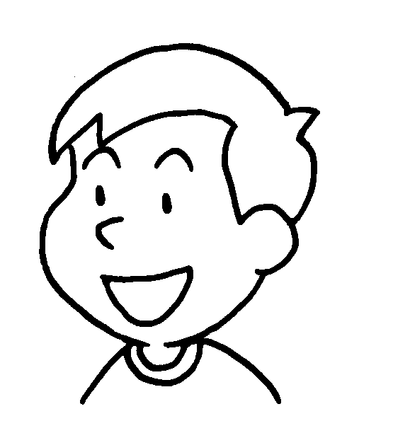
2 | 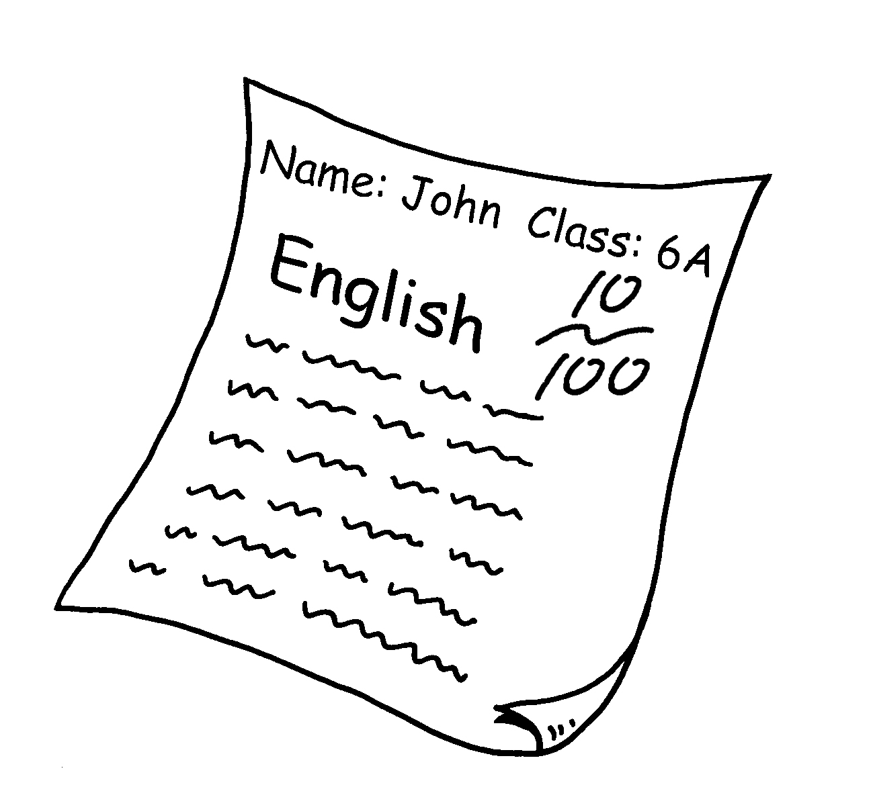 | John’s result was  .  I was . | 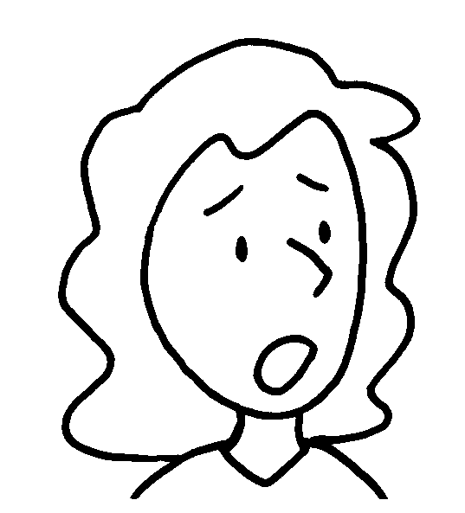
3 | 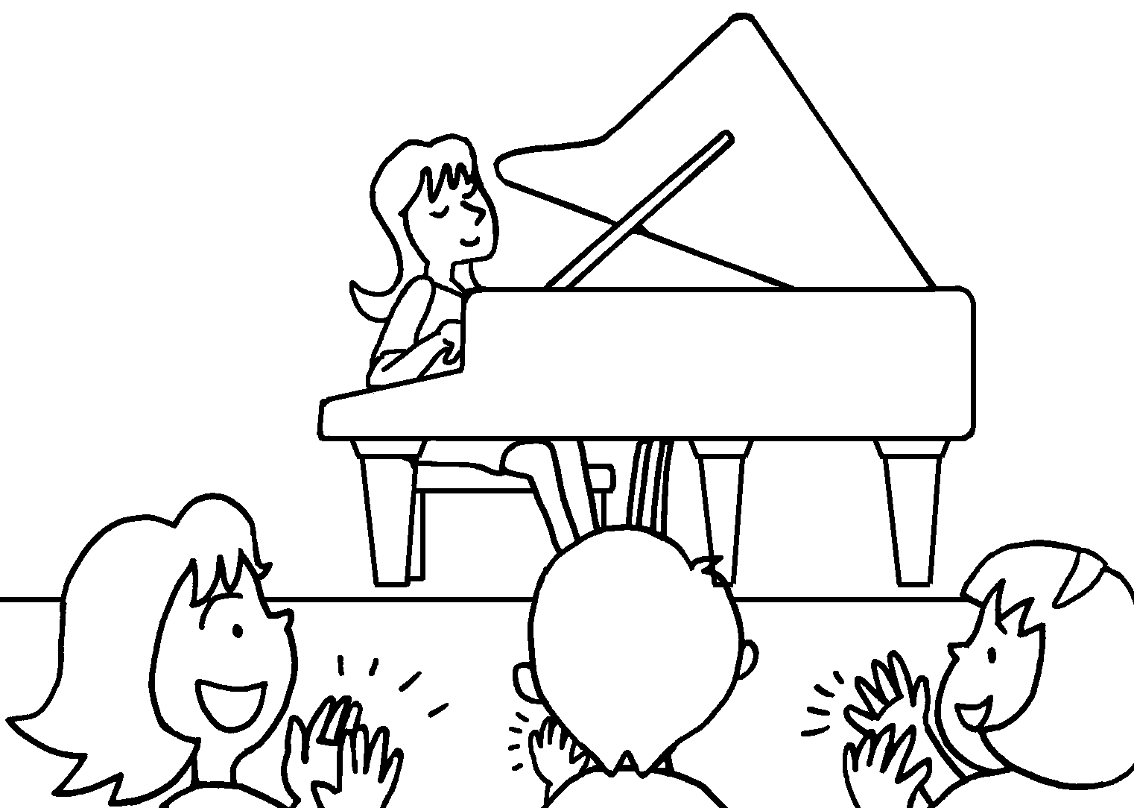 | I was .  The performance was  . | 
4 | 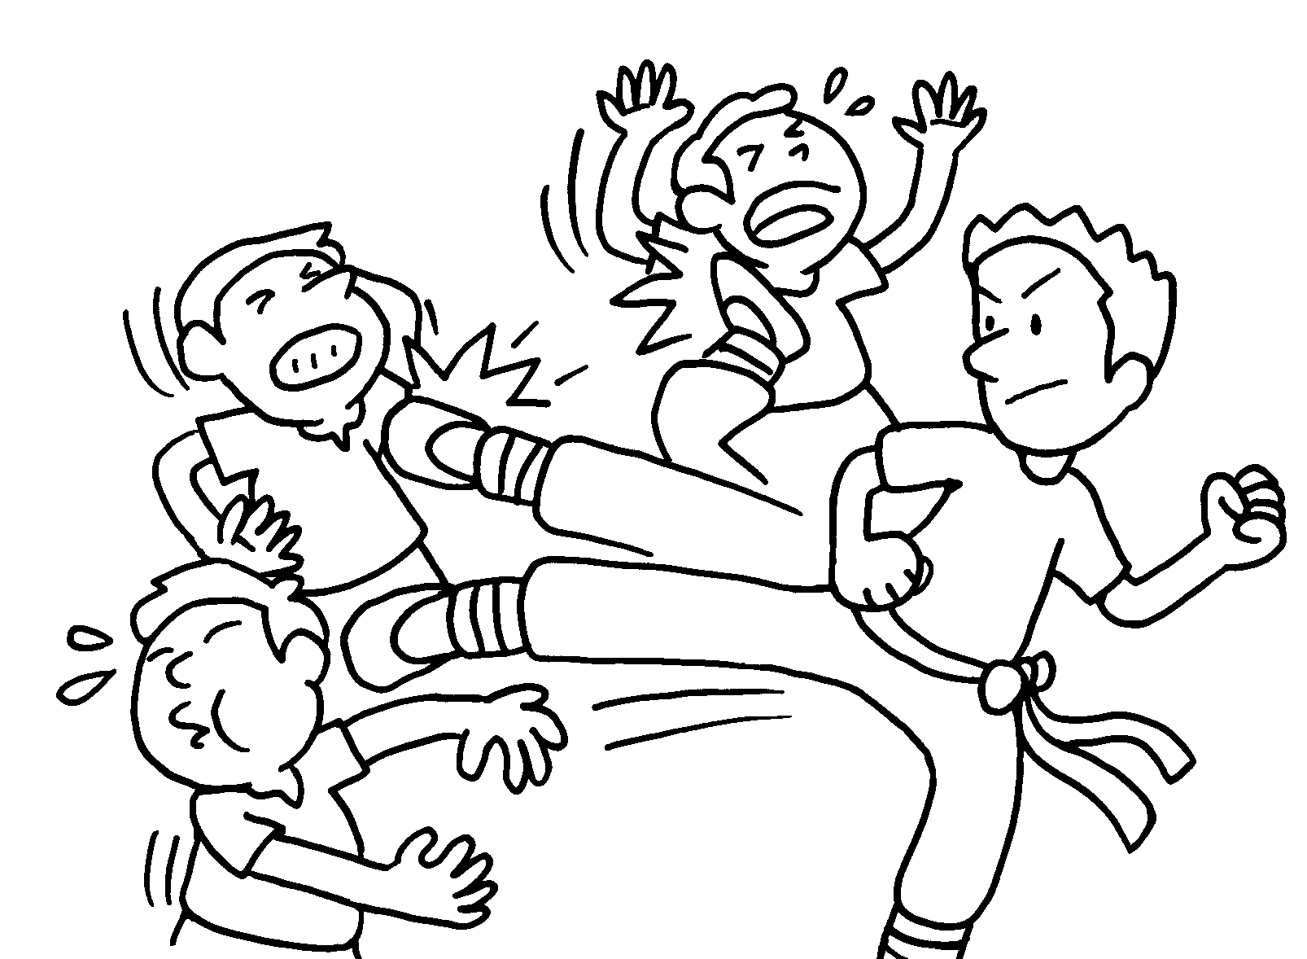 | The film was .  I was . | 


Book 6A Chapter 5 Graded Worksheets
Worksheet 3⬇⬇
- amused
amusing
- disappointing
disappointed
- amazed
amazing
- exciting
excited

