Fill in each blank with an ‘-ed’ or ‘-ing’ adjective.

1 | 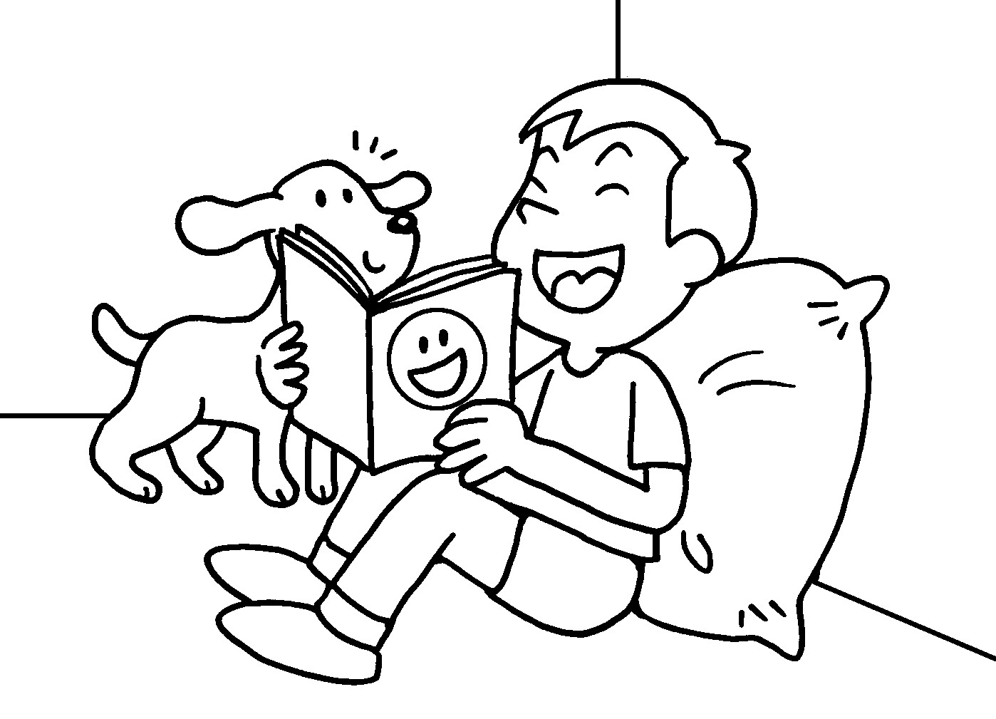 | I was a .  The story was a . | 

2 | 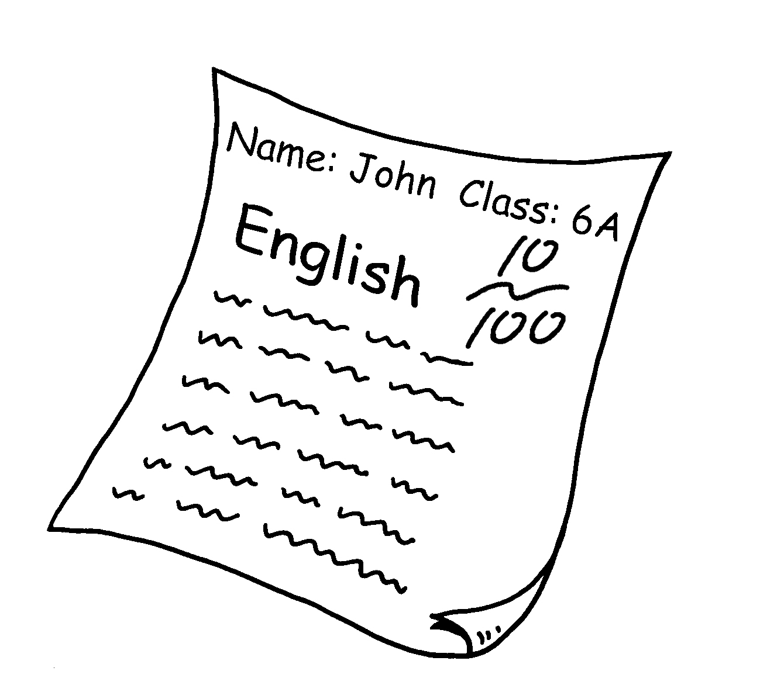 | John’s result was  d .  I was d . | 

3 | 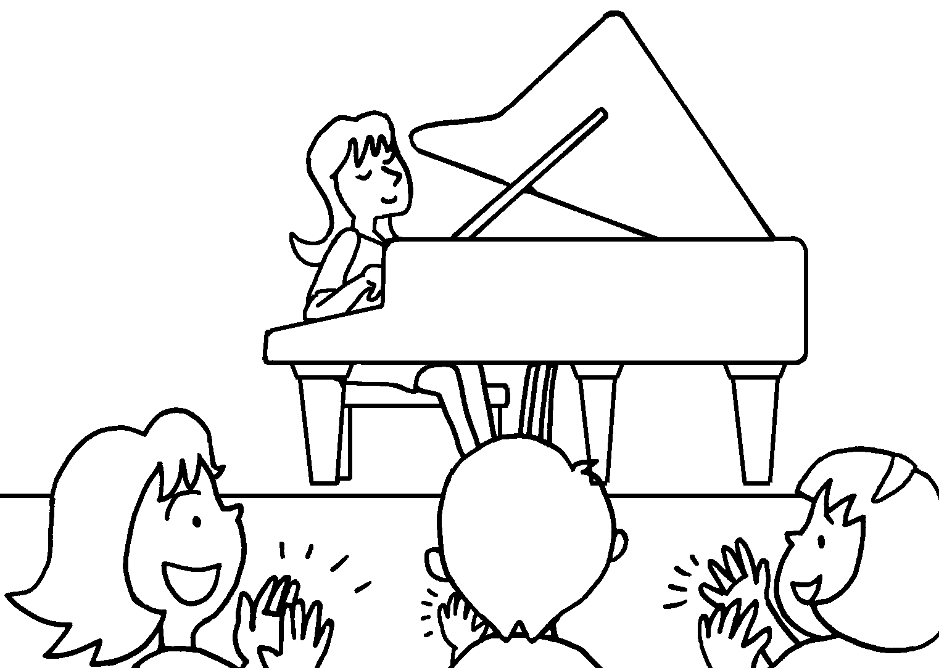 | I was a .  The performance was  a . | 

4 | 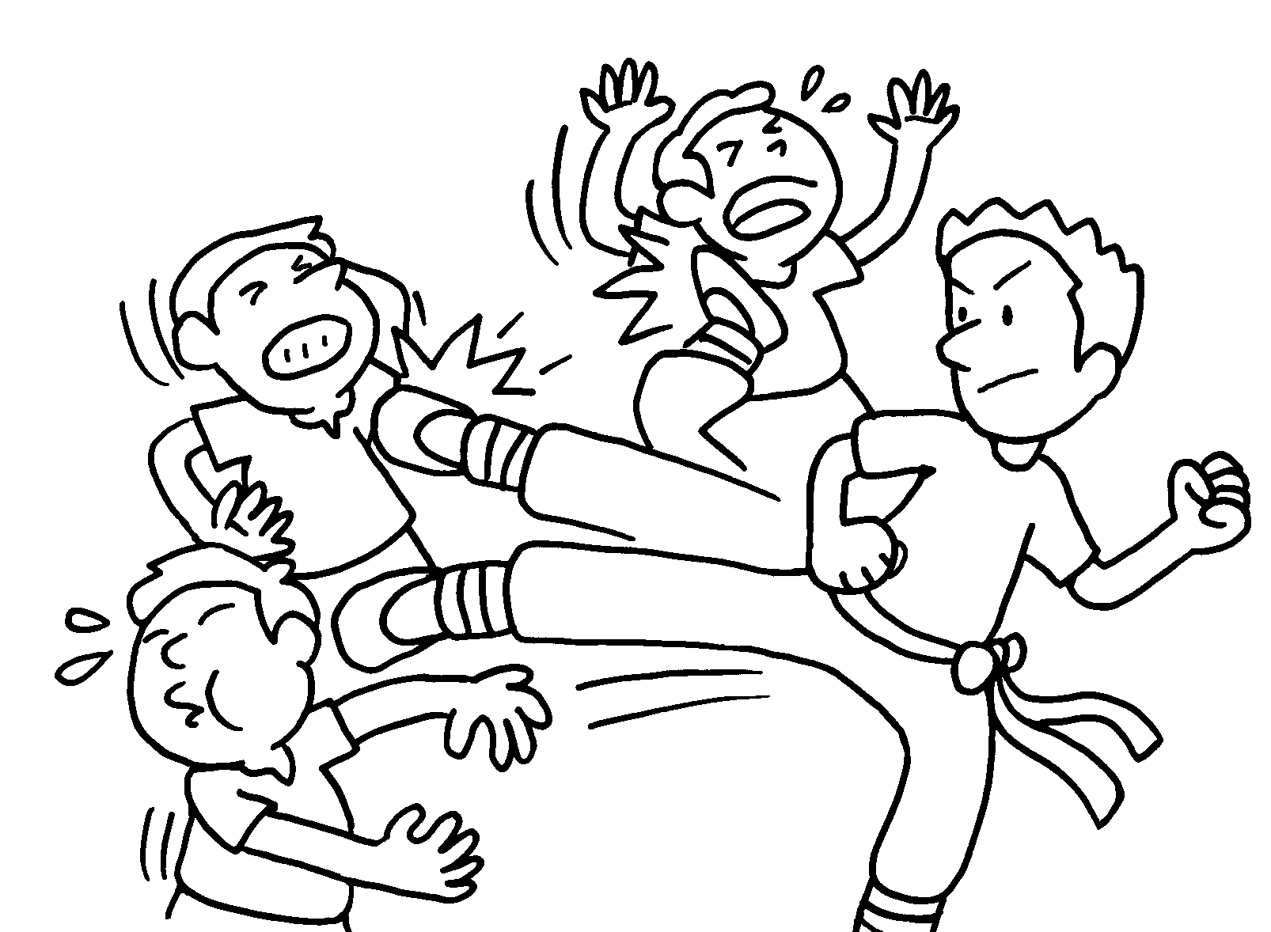 | The film was e .  I was e . | 


Book 6A Chapter 5 Graded Worksheets
Worksheet 3⬇⬇⬇
- amused
amusing
- disappointing
disappointed
- amazed
amazing
- exciting
excited

