- Our favourite films
Have you seen any of these films? Which ones? Did you like them? Read these film reviews and see if you agree with them.
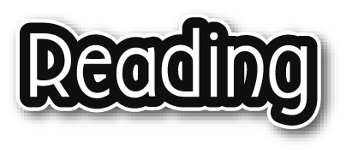
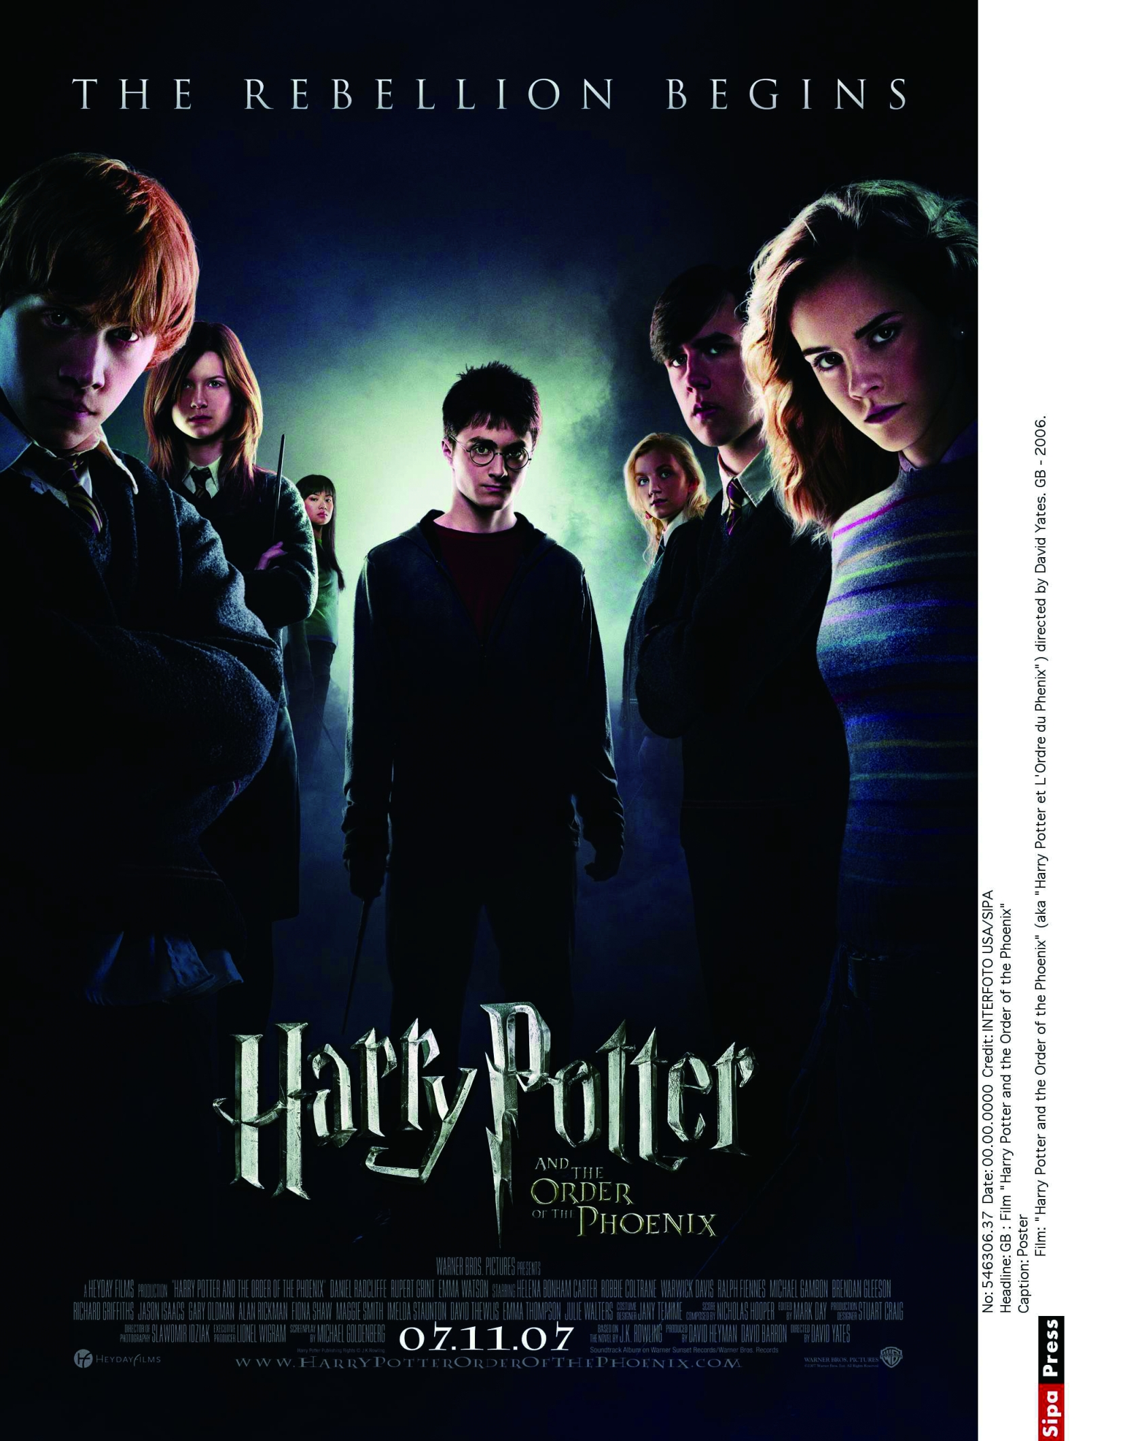
Harry Potter and the Order of the Phoenix
In the fifth Harry Potter film, Harry finds out that evil Lord Voldemort is back. Harry and his friends fight against Voldemort. At the same time, Harry falls in love with one of the girls, Cho Chang.
I was amazed because the special effects were better than those in the other Harry Potter films. I also thought Daniel Radcliffe was a fantastic actor in this film. Mary Kwan, 10 years old

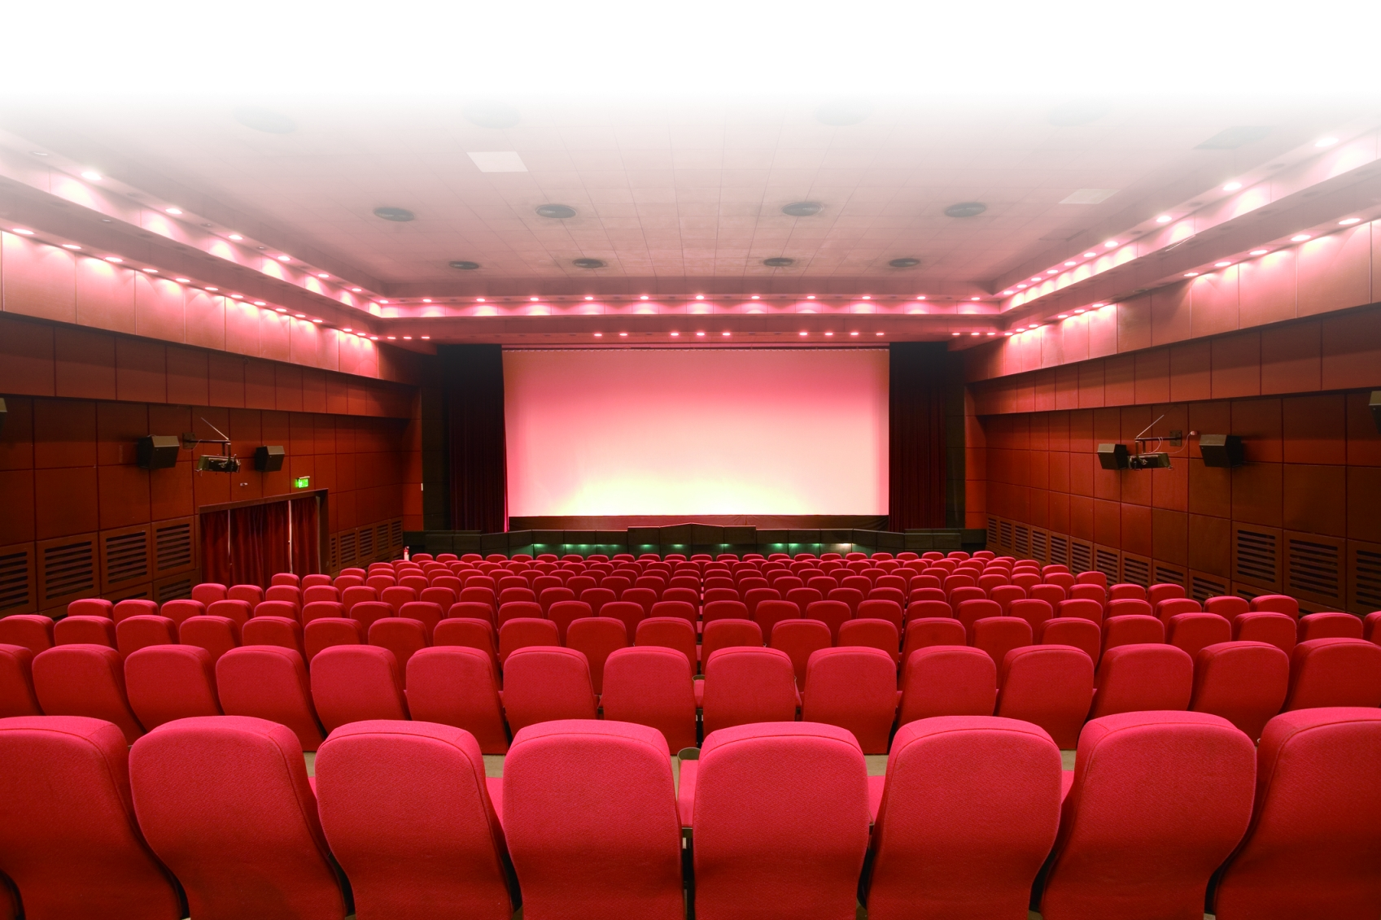

The Incredibles
Mr Parr used to be Mr Incredible, one of the greatest superheroes. Now he lives a normal life but he wants to be a superhero again. One day, an evil man makes up a story and invites Mr Parr to a faraway island to get rid of him. Mr Parr turns into Mr Incredible and goes to the island. He soon gets into trouble. Luckily, his family find out and they come to look for him.
I was never bored because the plot was so exciting and amusing. I loved the animation too. Alan Lau, 11 years old

Meet the Superheroes!

THE INCREDIBLES
www.incredibles.com

Summary of the plot
Shrek

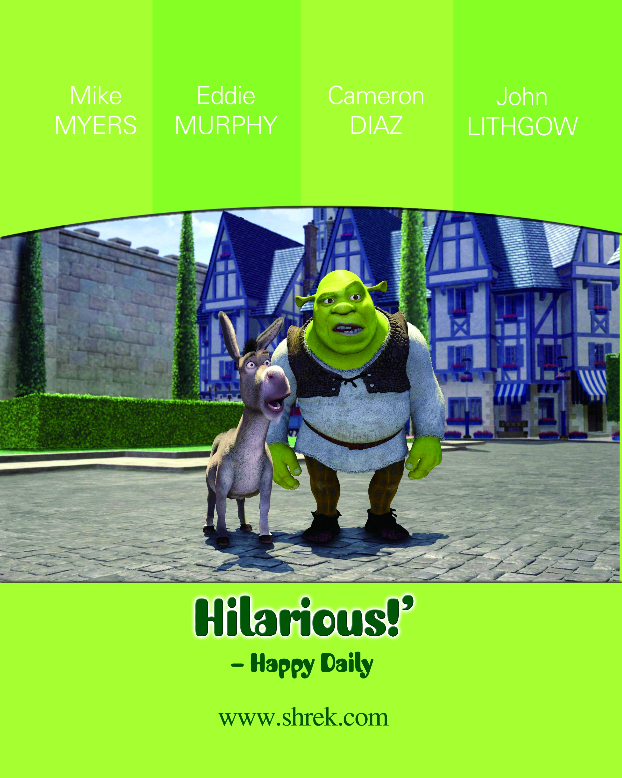

Shrek is a smelly green ogre. Evil Lord Farquaad tells Shrek Princess Fiona from a castle and bring her to him. Shrek sets off to find Fiona with his talkative friend Donkey. They are successful but they do not know that Fiona has a secret ― when the sun goes down, she turns into something.
I really enjoyed Shrek. Donkey was hilarious ― he made me laugh so much. I was also moved because the film was a love story.
Joe Lam, 11 years old


Comments – how we feel about the plot, the actors or the special effects

