Charts

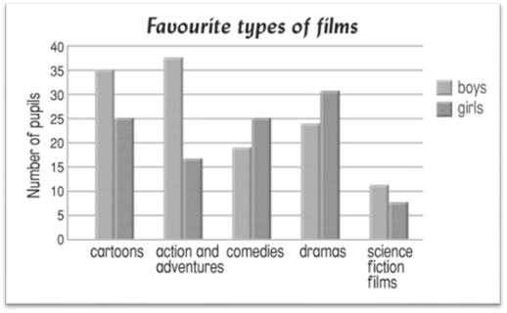

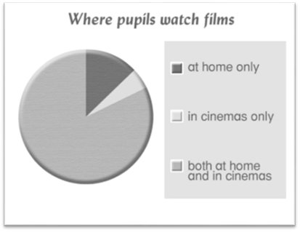
Write the answers and blacken  the circles.

1 What is the most popular type of film for boys?

2 Which types of films are more popular with girls than with boys?

3 Are there any pupils who never go to the cinema?

4 Not many pupils . (You can choose more than one answer.)
 A. go to the cinema 2 to 5 times a year
 B. go to the cinema once a year
 C. watch films in cinemas only
 D. watch films both at home and in cinemas

5 What do the charts tell us? (You can choose more than one answer.)
 A. the pupils’ favourite types of films
 B. the places where pupils watch films
 C. the reasons for watching the latest films
 D. the number of times pupils go to the cinema each month

6 Which sentence is true? (You can choose more than one answer.)
 A. Most pupils go to the cinema because they can see the latest films.
 B. More girls than boys like science fiction films.
 C. Most pupils watch films at home only.
 D. The number of girls who like cartoons and the number of girls who
like comedies are the same.

Answers: (Accept any reasonable answers.)
1 Action and adventures. 2 Comedies and dramas. 3 Yes, there are.
4 B, C 5 A, B 6 A, D

