Choose and write.

cruel | dishonest | greedy | proud
selfish | silly | ugly | wicked

1 | 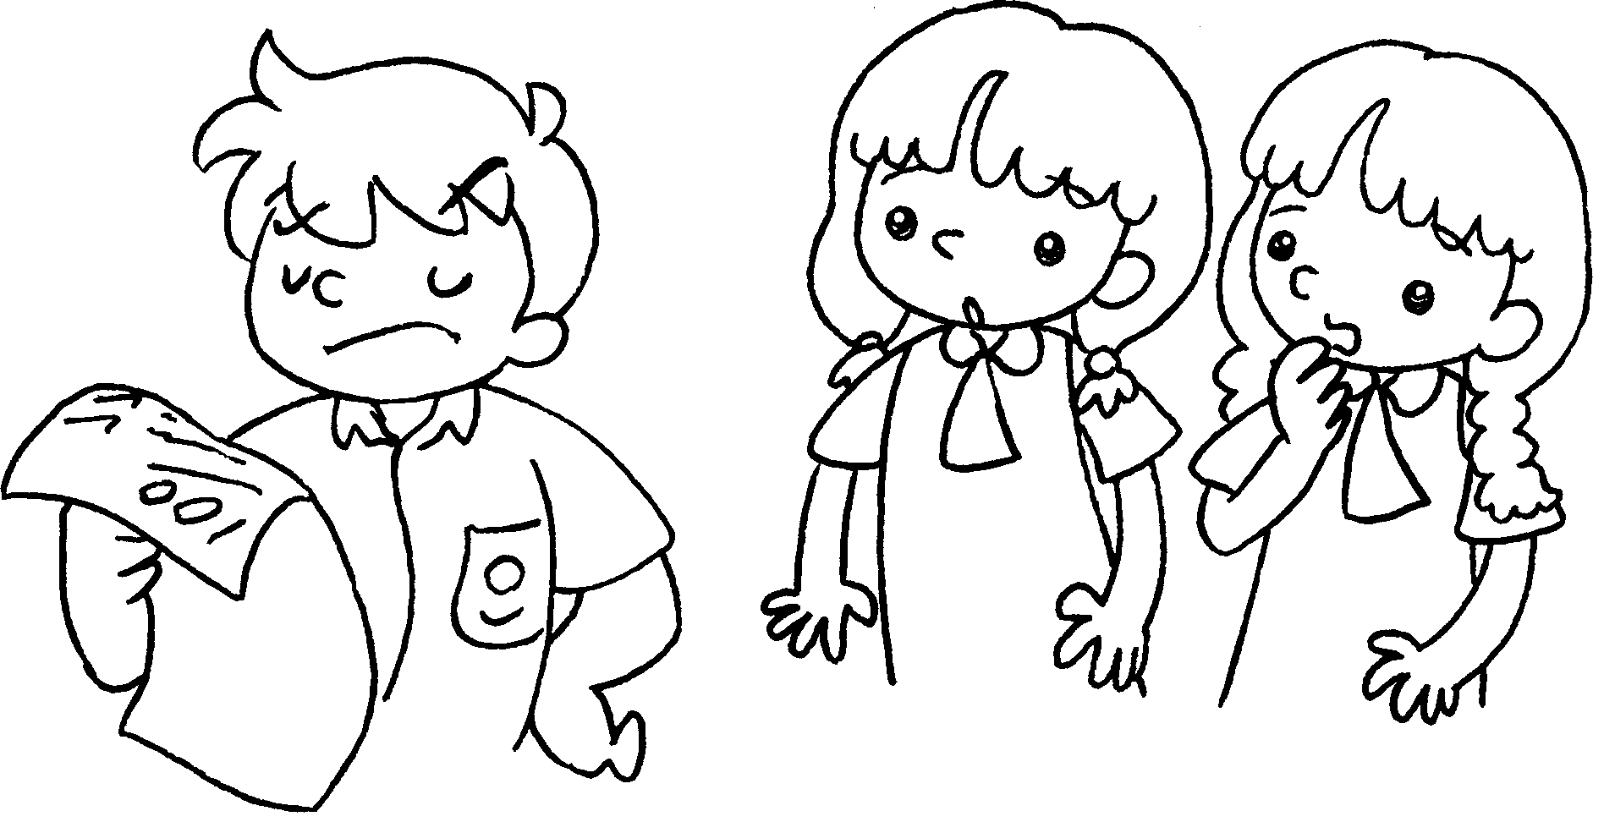 |  | 2 | 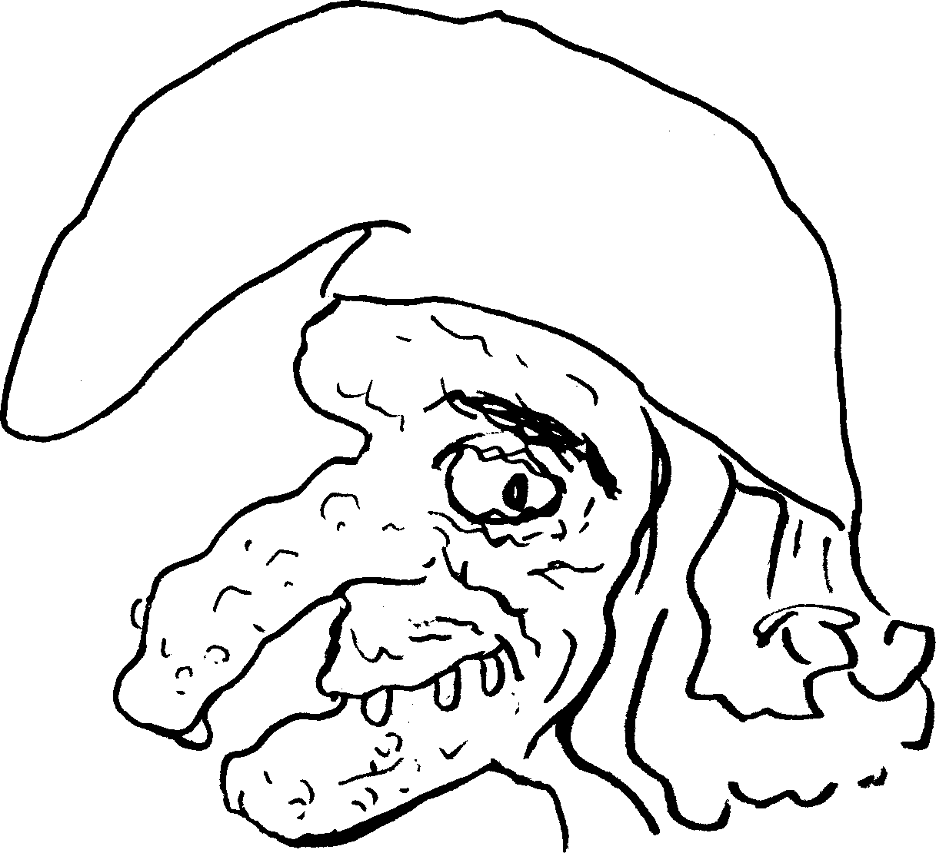
3 | 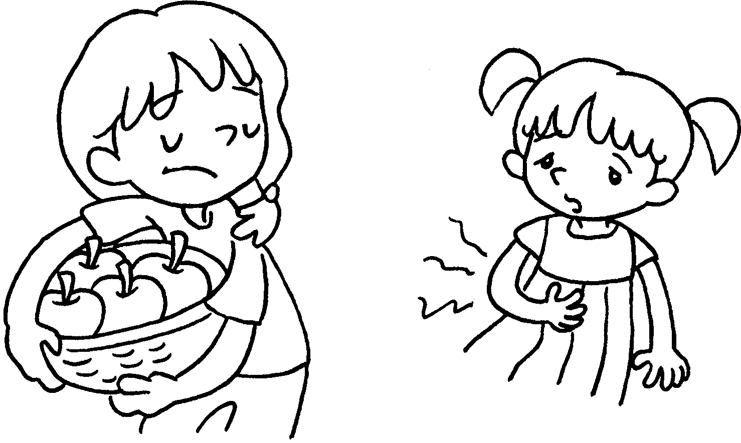 |  | 4 | 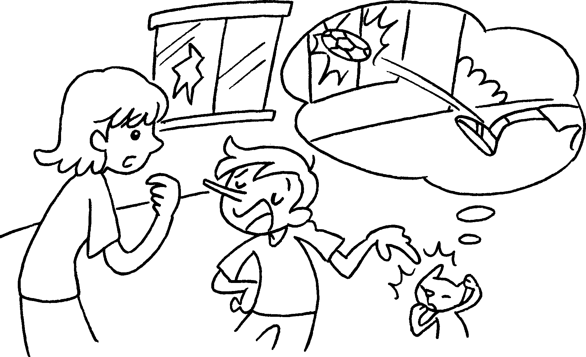
5 | 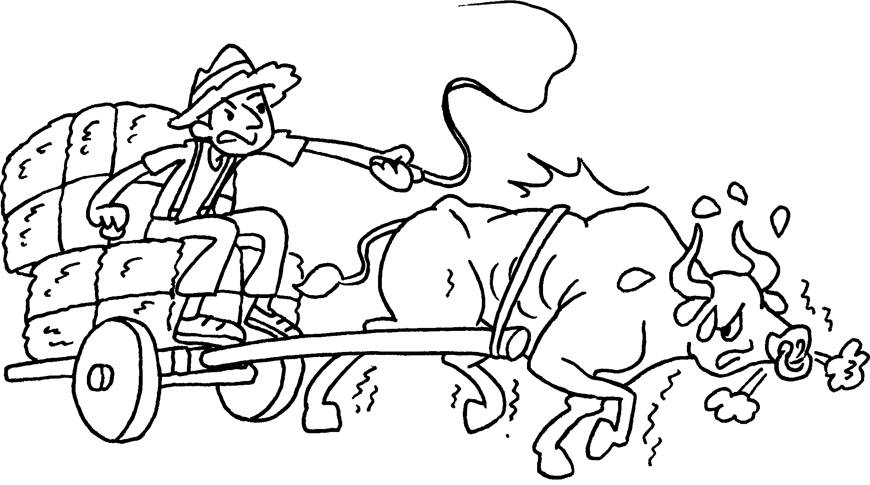 |  | 6 | 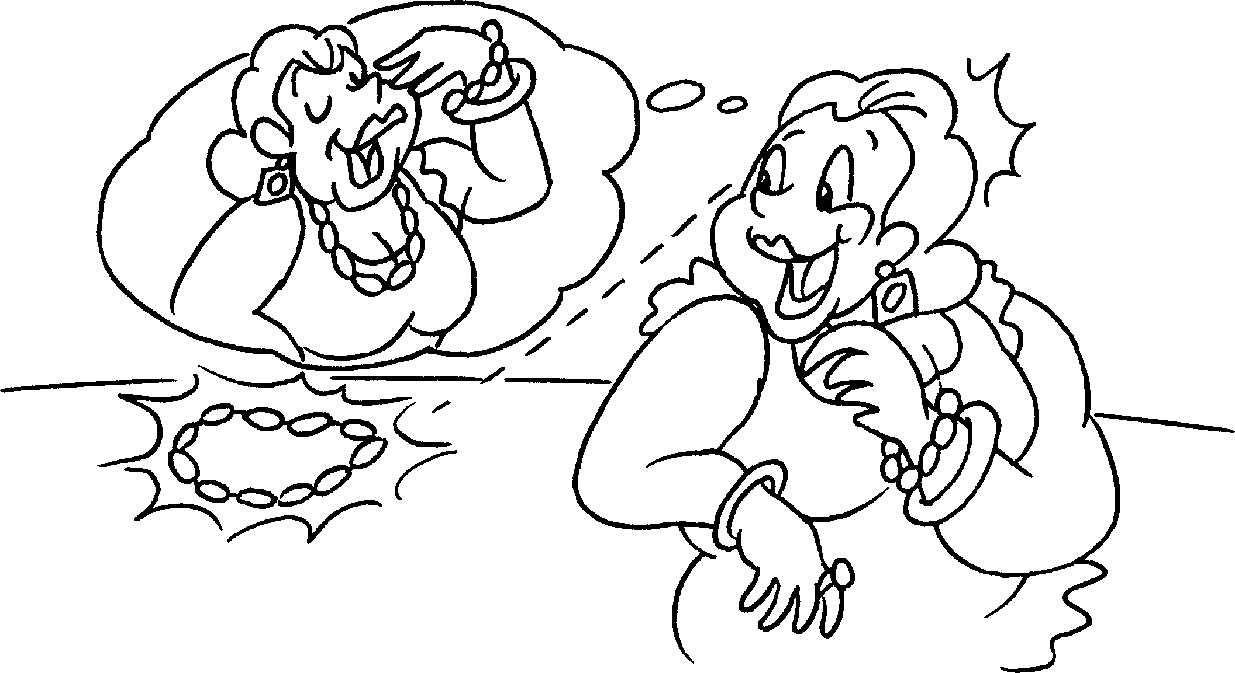
7 | 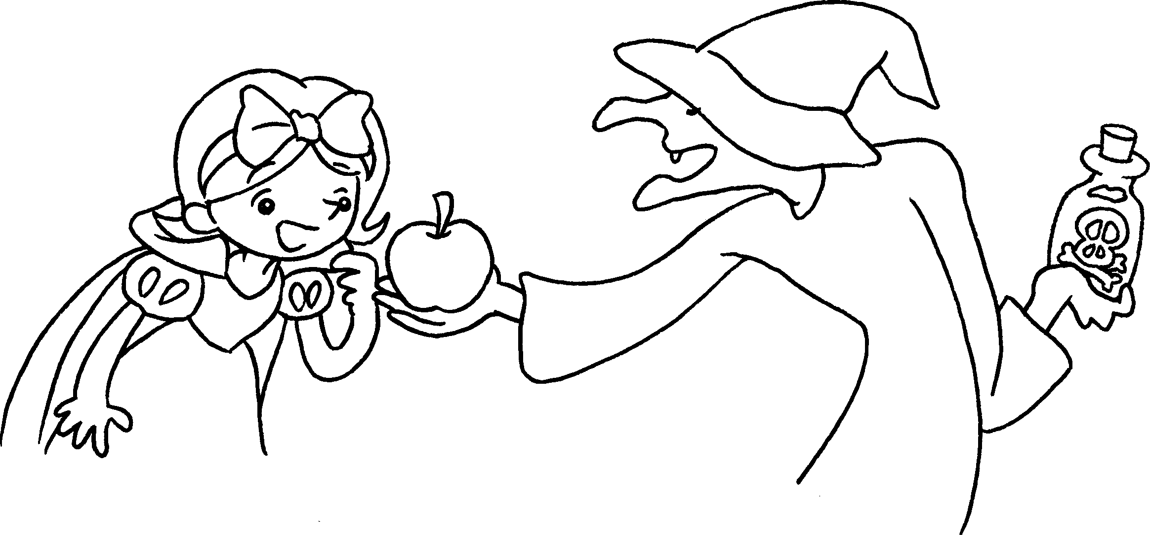 |  | 8 | 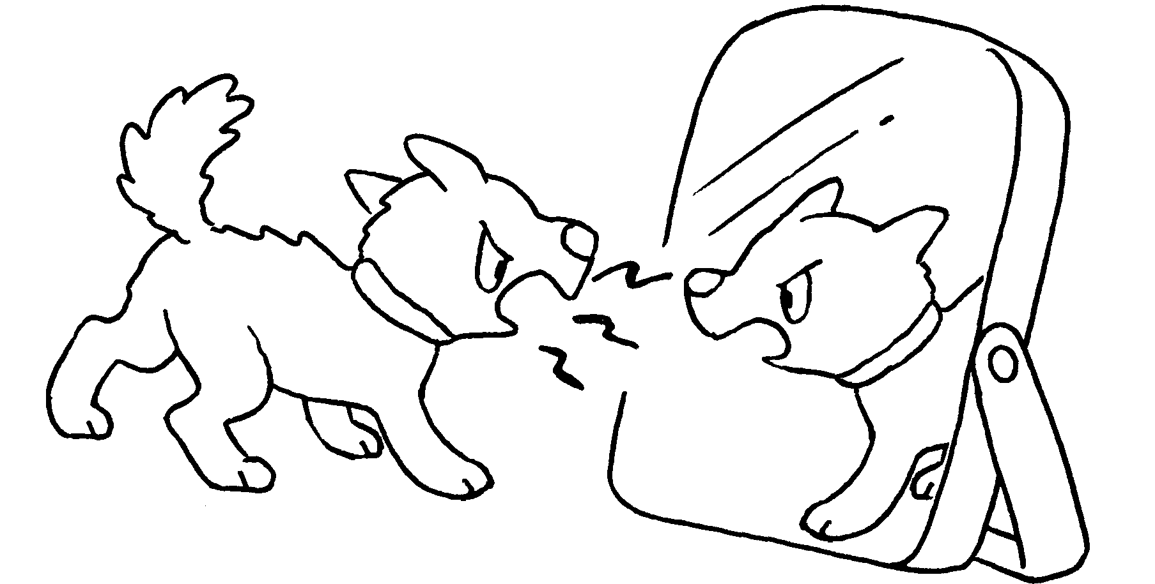


Book 6A Chapter 6 Graded Worksheets
Worksheet 1⬇
- proud 2 ugly
3 selfish 4 dishonest
5 cruel 6 greedy
7 wicked 8 silly

