How would you describe the people / dog? Fill in the missing letters.

1 | 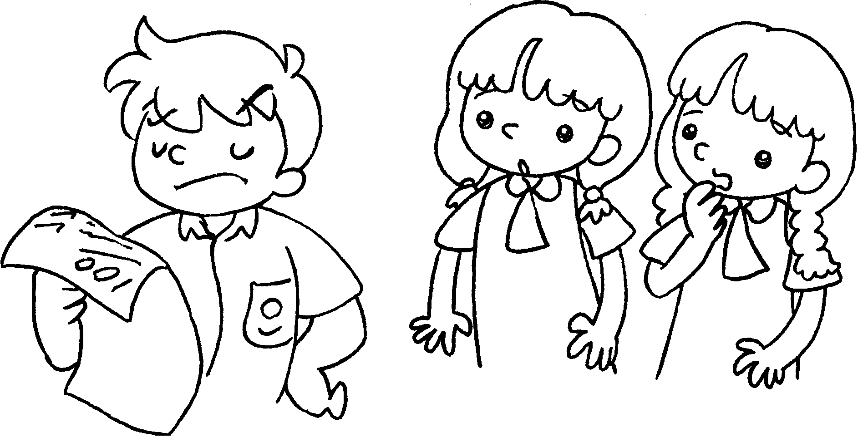 |  | 2 | 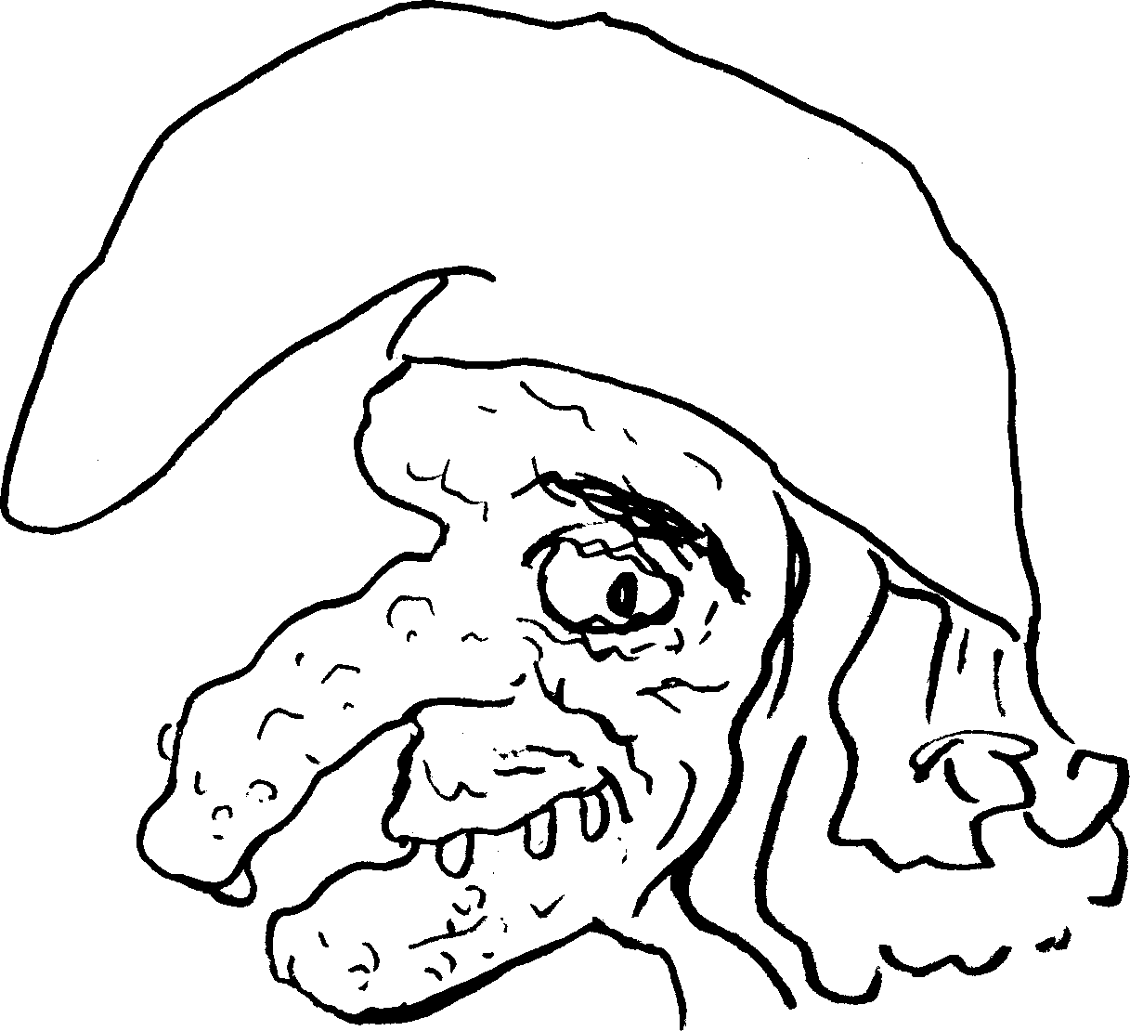
 | p __ __ __ __ |  |  | u __ __ __

3 | 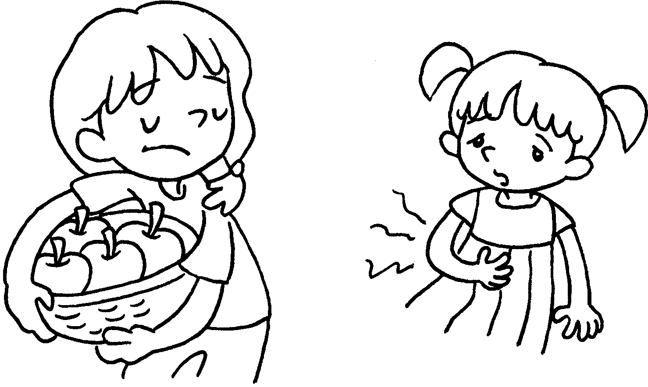 |  | 4 | 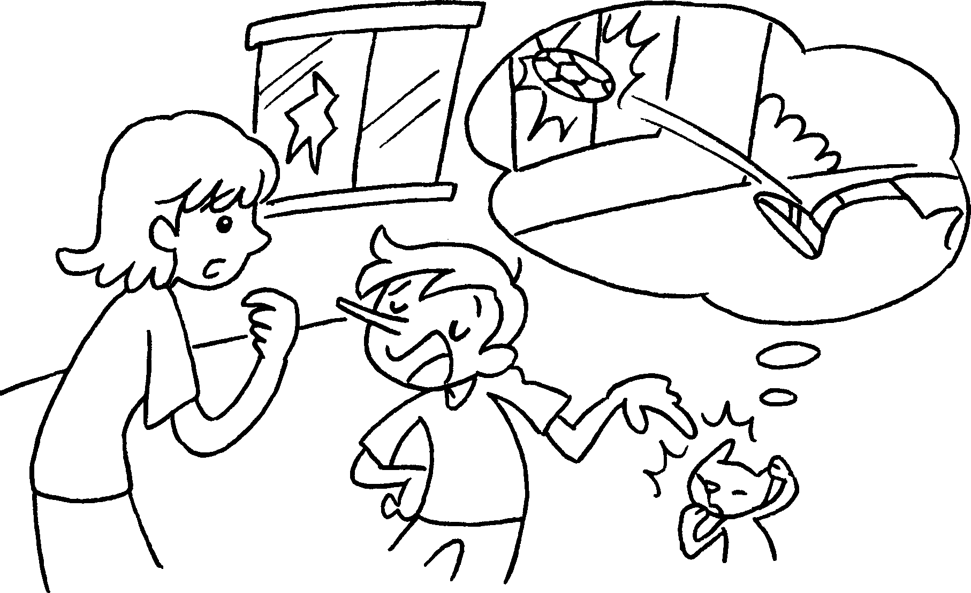
 | s __ __ __ __ __ __ |  |  | d __ __ __ __ __ __ __ __

5 | 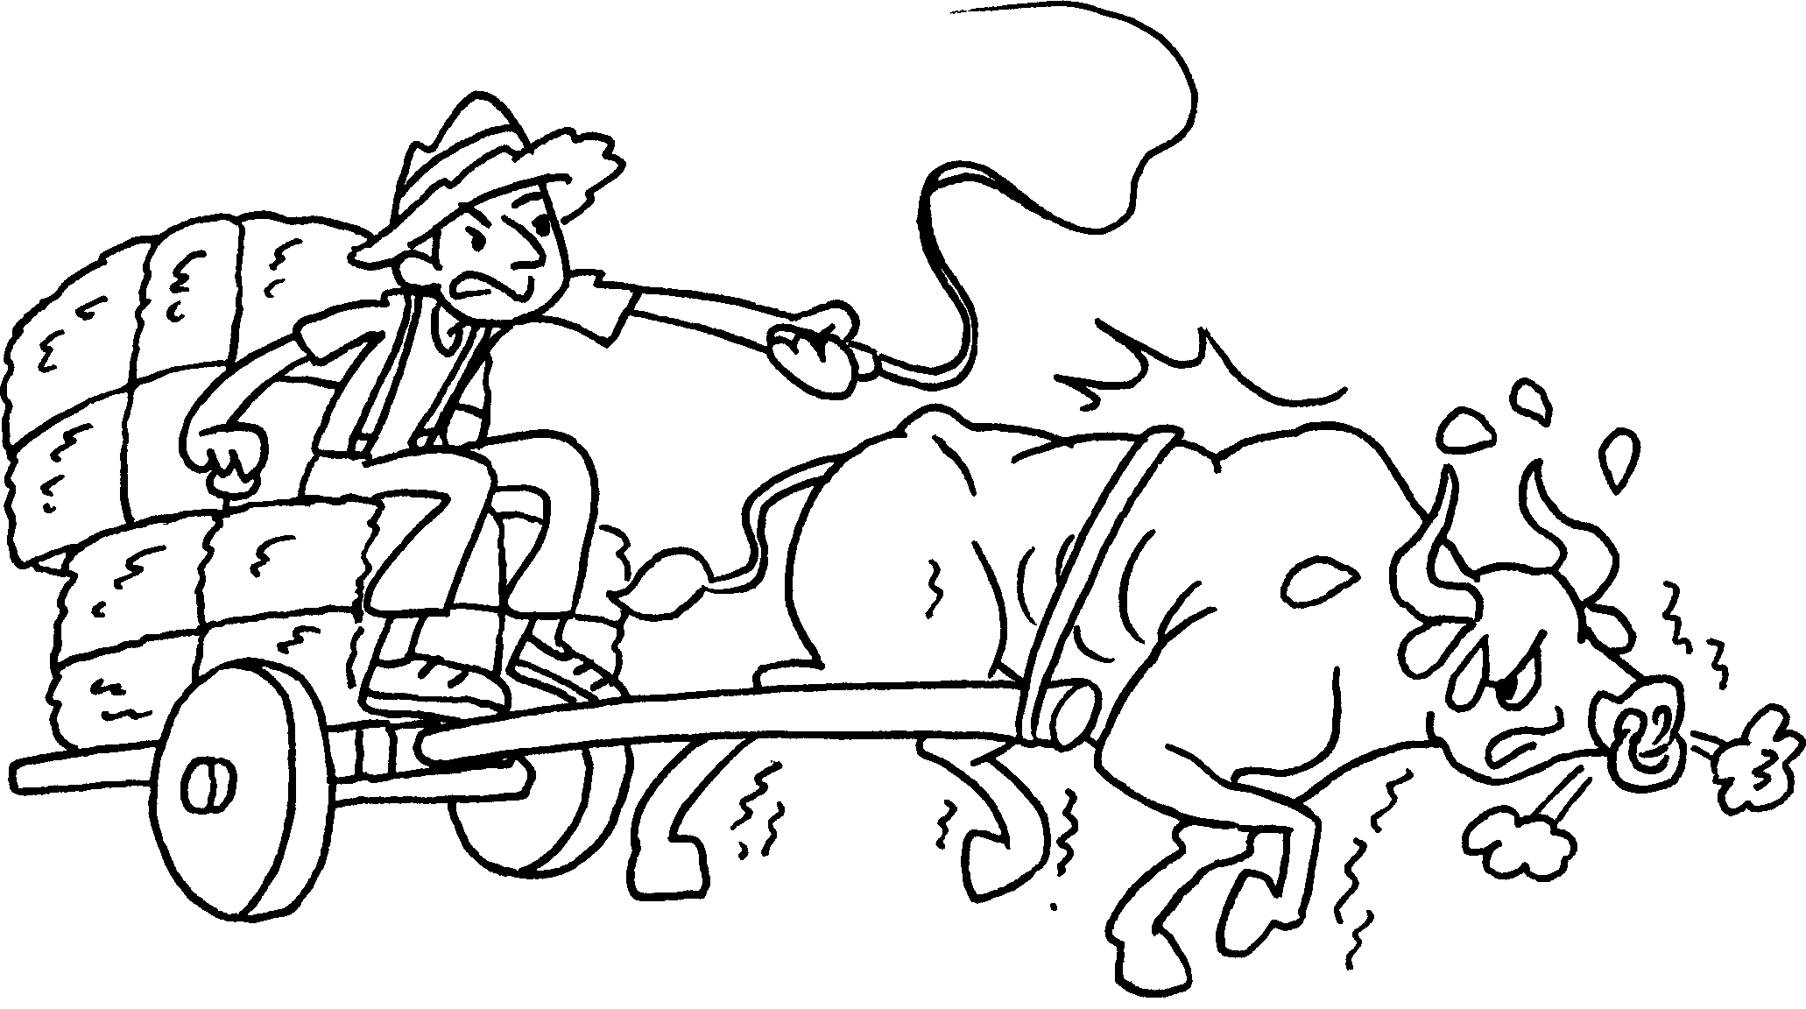 |  | 6 | 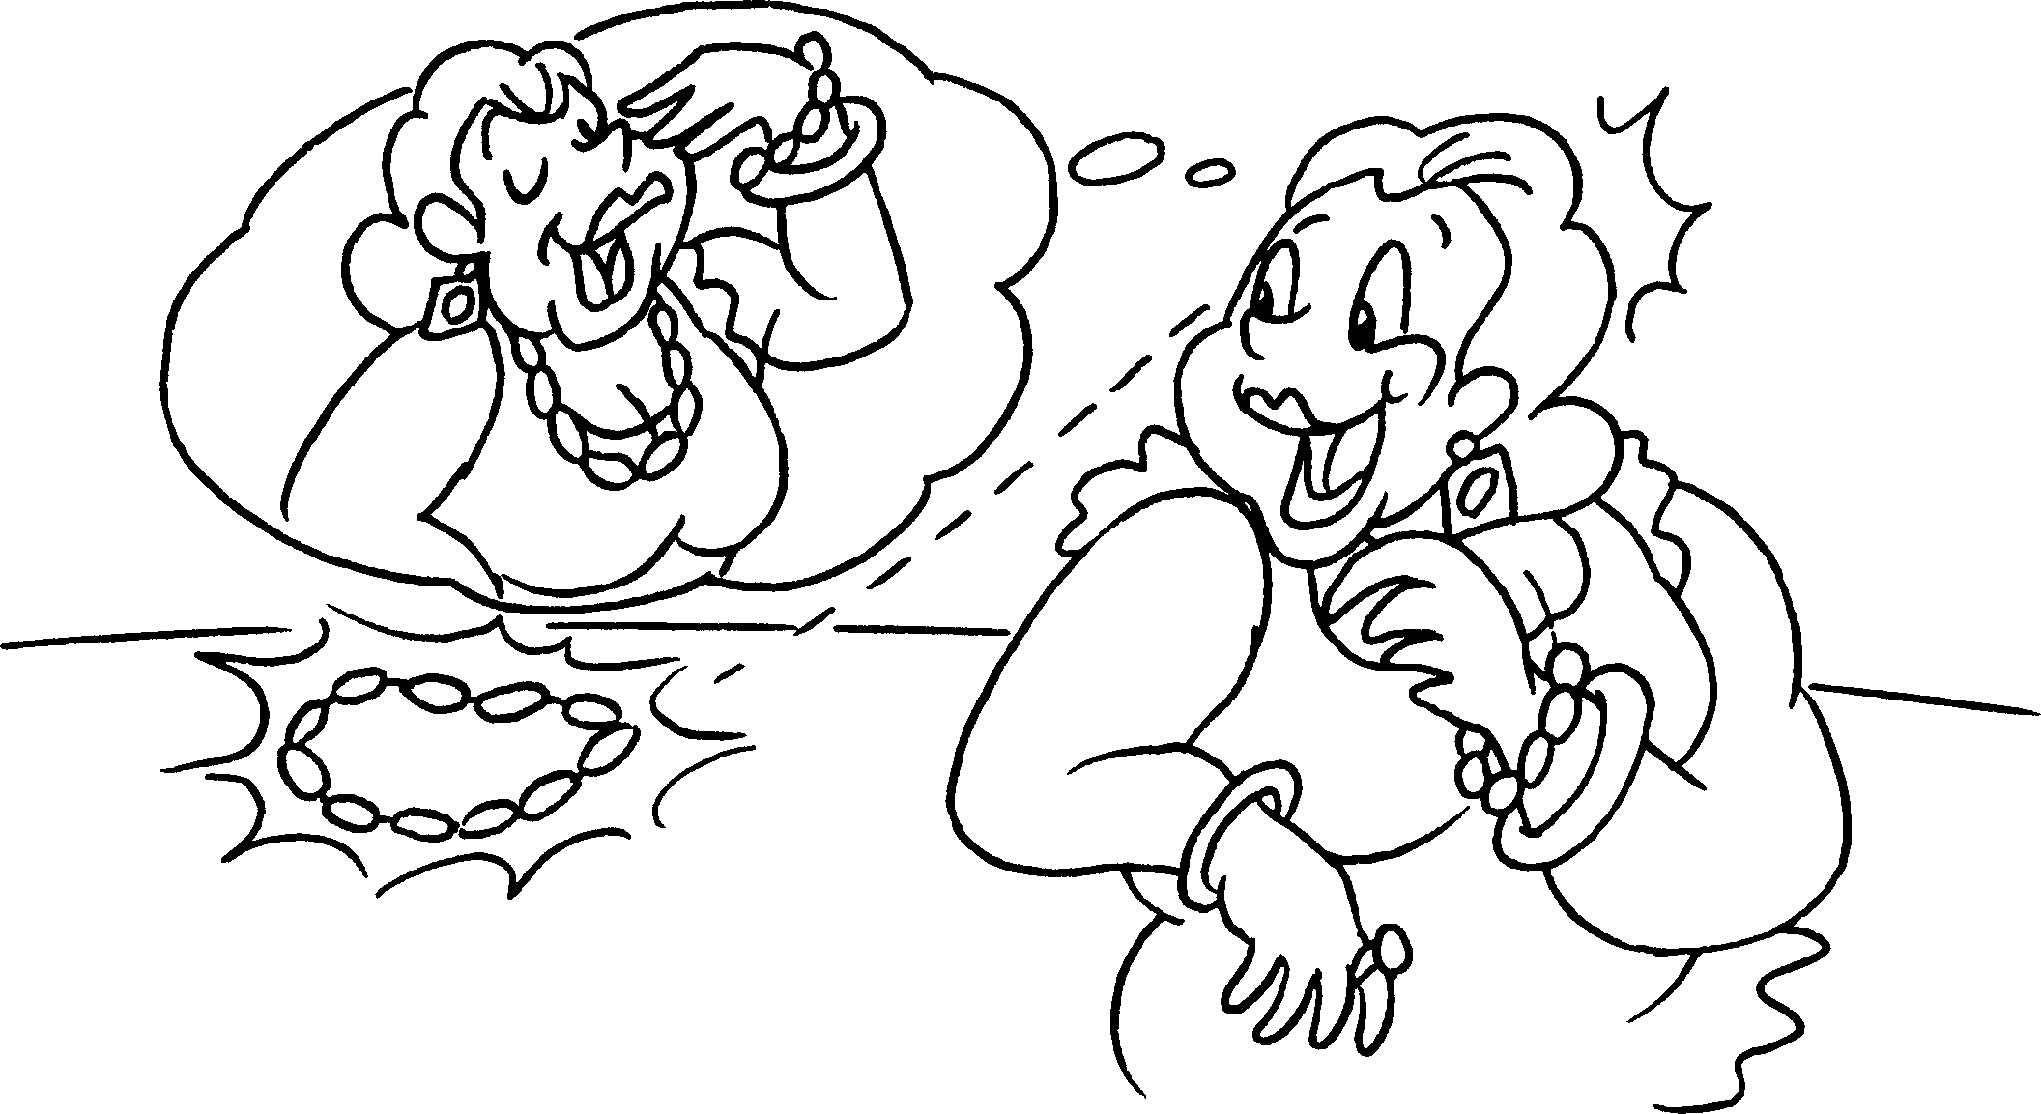
 | c __ __ __ __ |  |  | g __ __ __ __ __

7 | 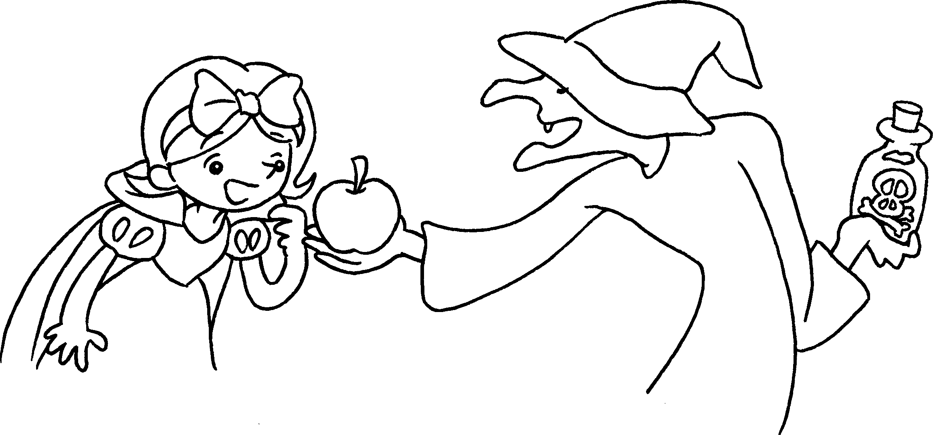 |  | 8 | 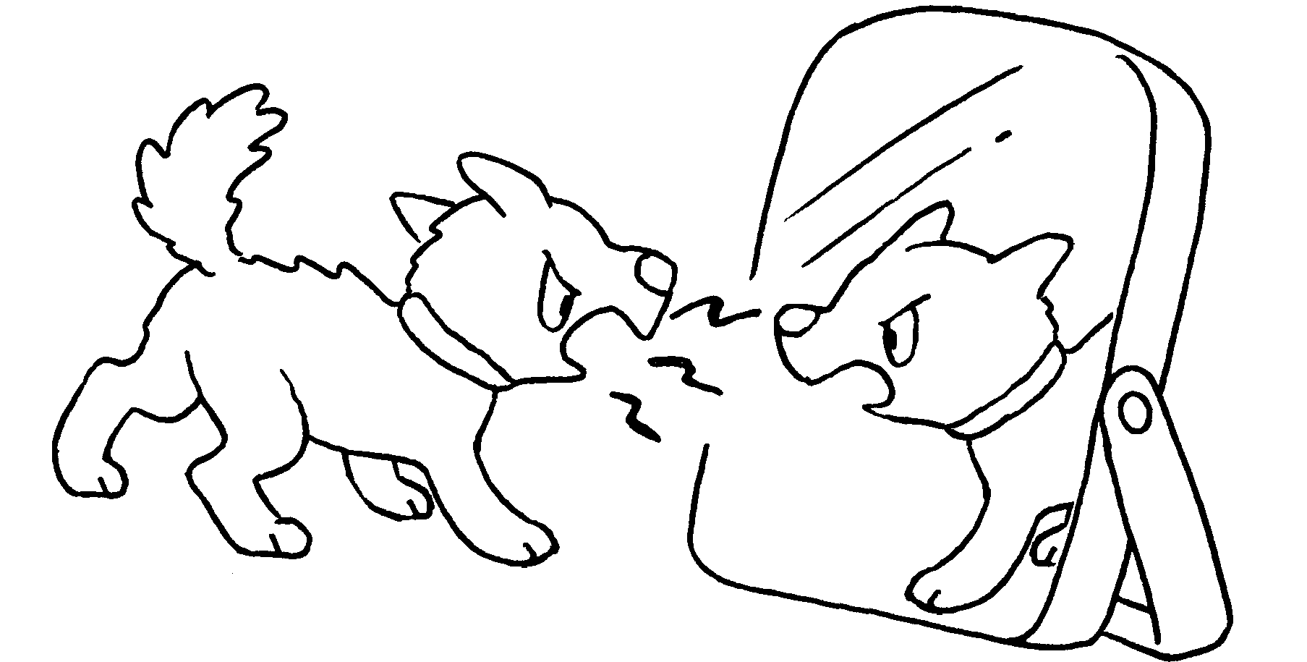
 | w __ __ __ __ __ |  |  | s __ __ __ __


Book 6A Chapter 6 Graded Worksheets
Worksheet 1⬇⬇
- p r o u d 2 u g l y
3 s e l f i s h 4 d i s h o n e s t
5 c r u e l 6 g r e e d y
7 w i c k e d 8 s i l l y

