Link the sentences using ‘who’.

1 | The film is about a boy.  The boy likes cats very much.  The film is about a boy likes cats very much. | 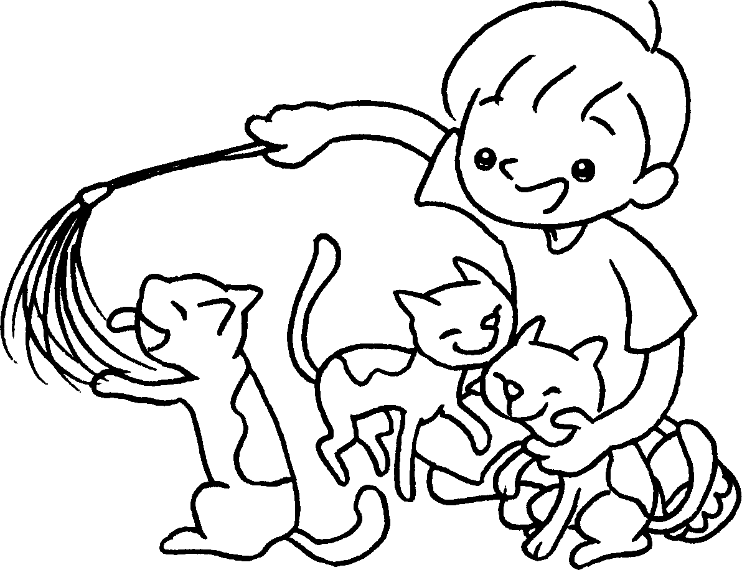
2 | I know the girl.  The girl is good at playing the piano.  I know the girl  . | 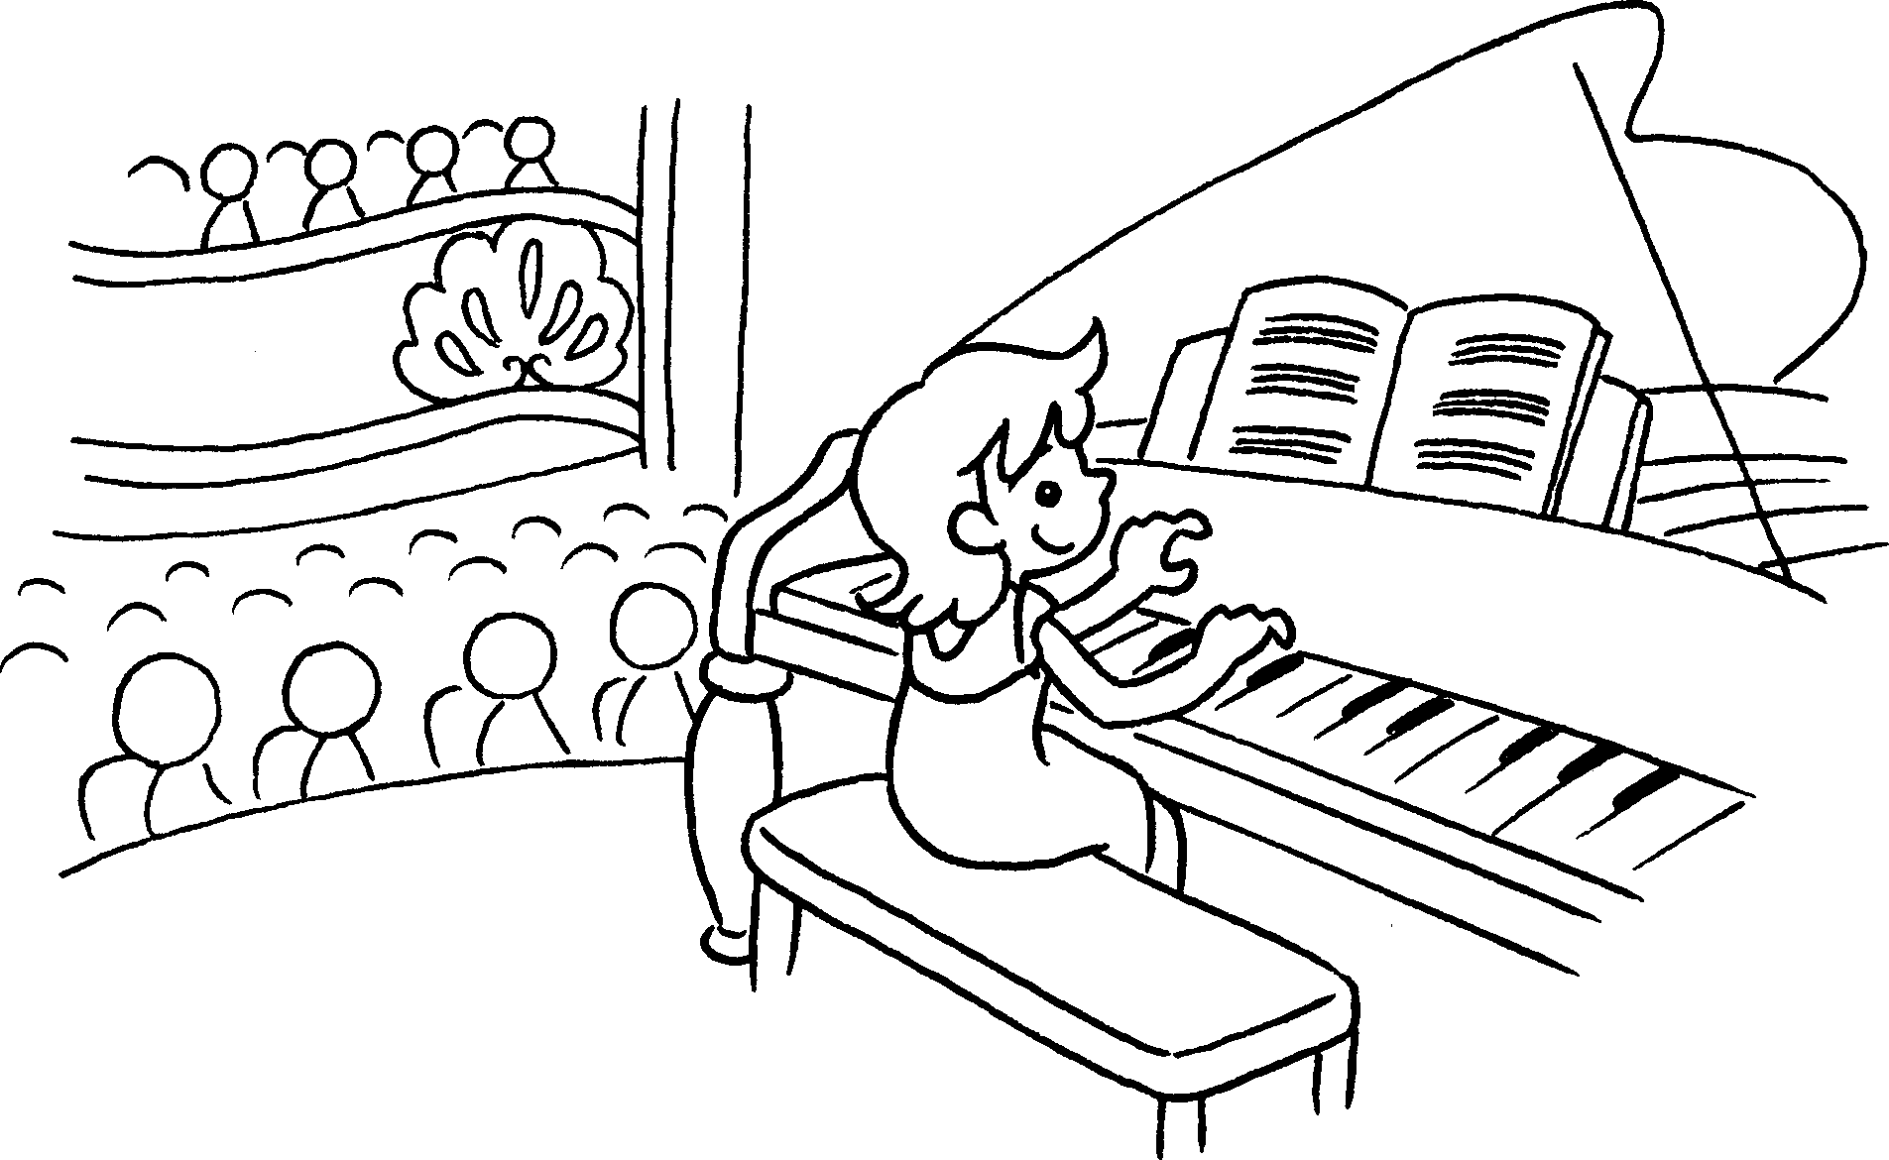
3 | The book is about a man.  The man travels around the world helping poor people.  The book is about a man  . | 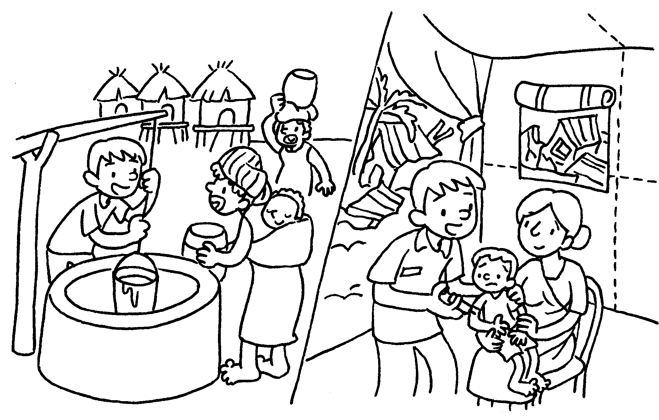
4 | This story is about a creative girl.  The girl works very hard to become a fashion designer.  This story is about | 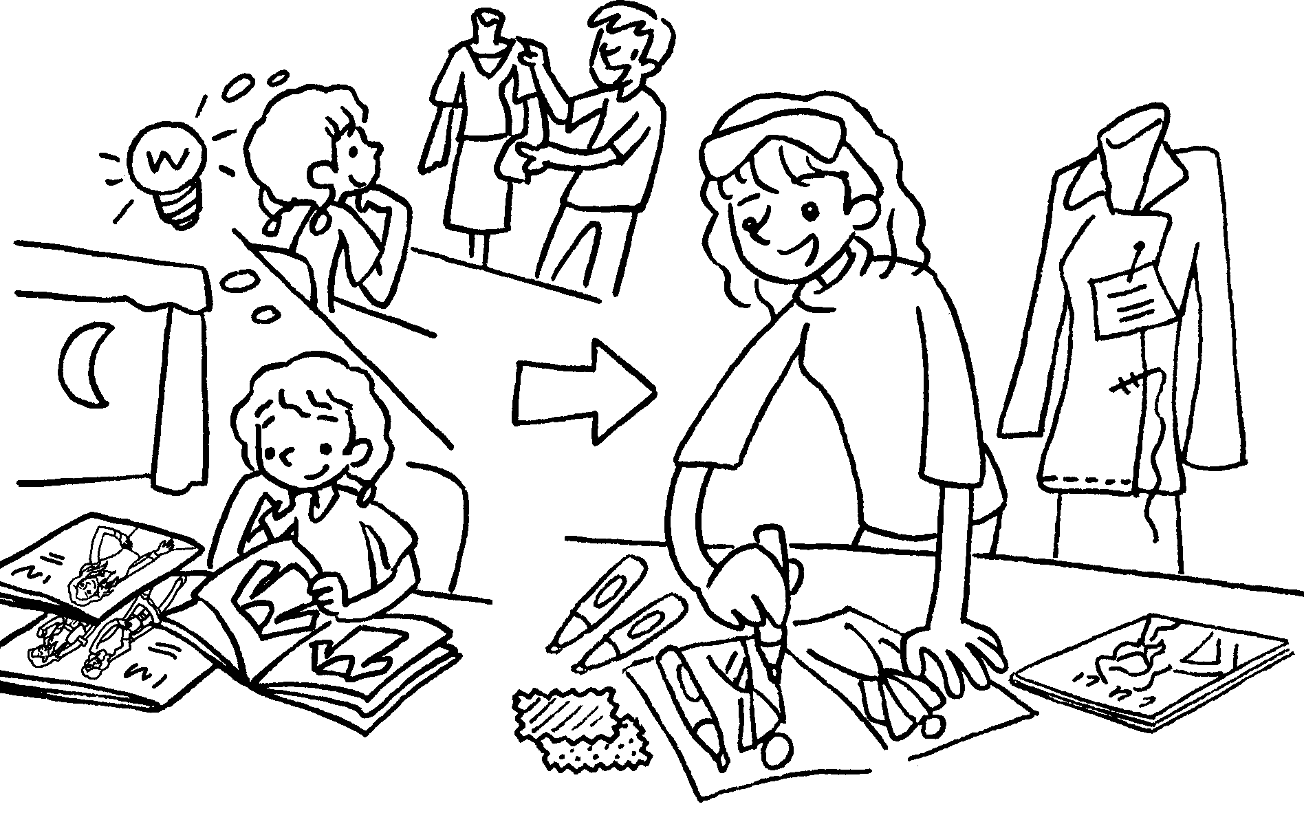



Book 6A Chapter 6 Graded Worksheets
Worksheet 2⬇
- who
- who is good at playing the piano
- who travels around the world helping poor people
- a creative girl who works very hard to become a fashion designer.

