Link the sentences using ‘who’.

1 | The film is about a boy.  The boy likes cats very much.  The film is about a boy  . | 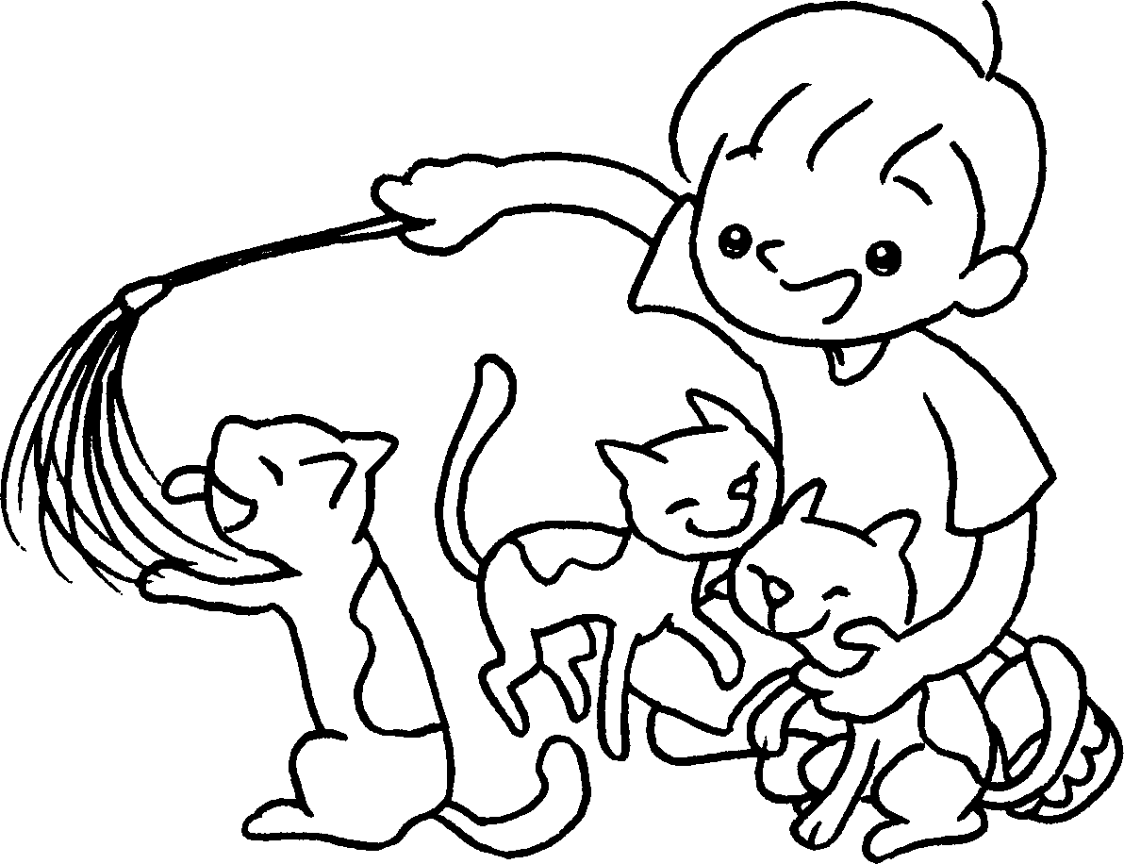
2 | I know the girl.  The girl is good at playing the piano.  I know the girl  . | 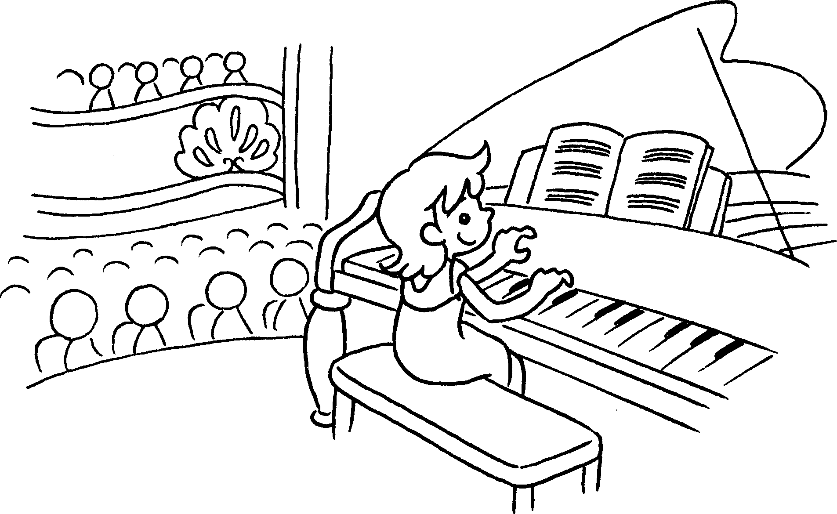
3 | The book is about a man.  The man travels around the world helping poor people. | 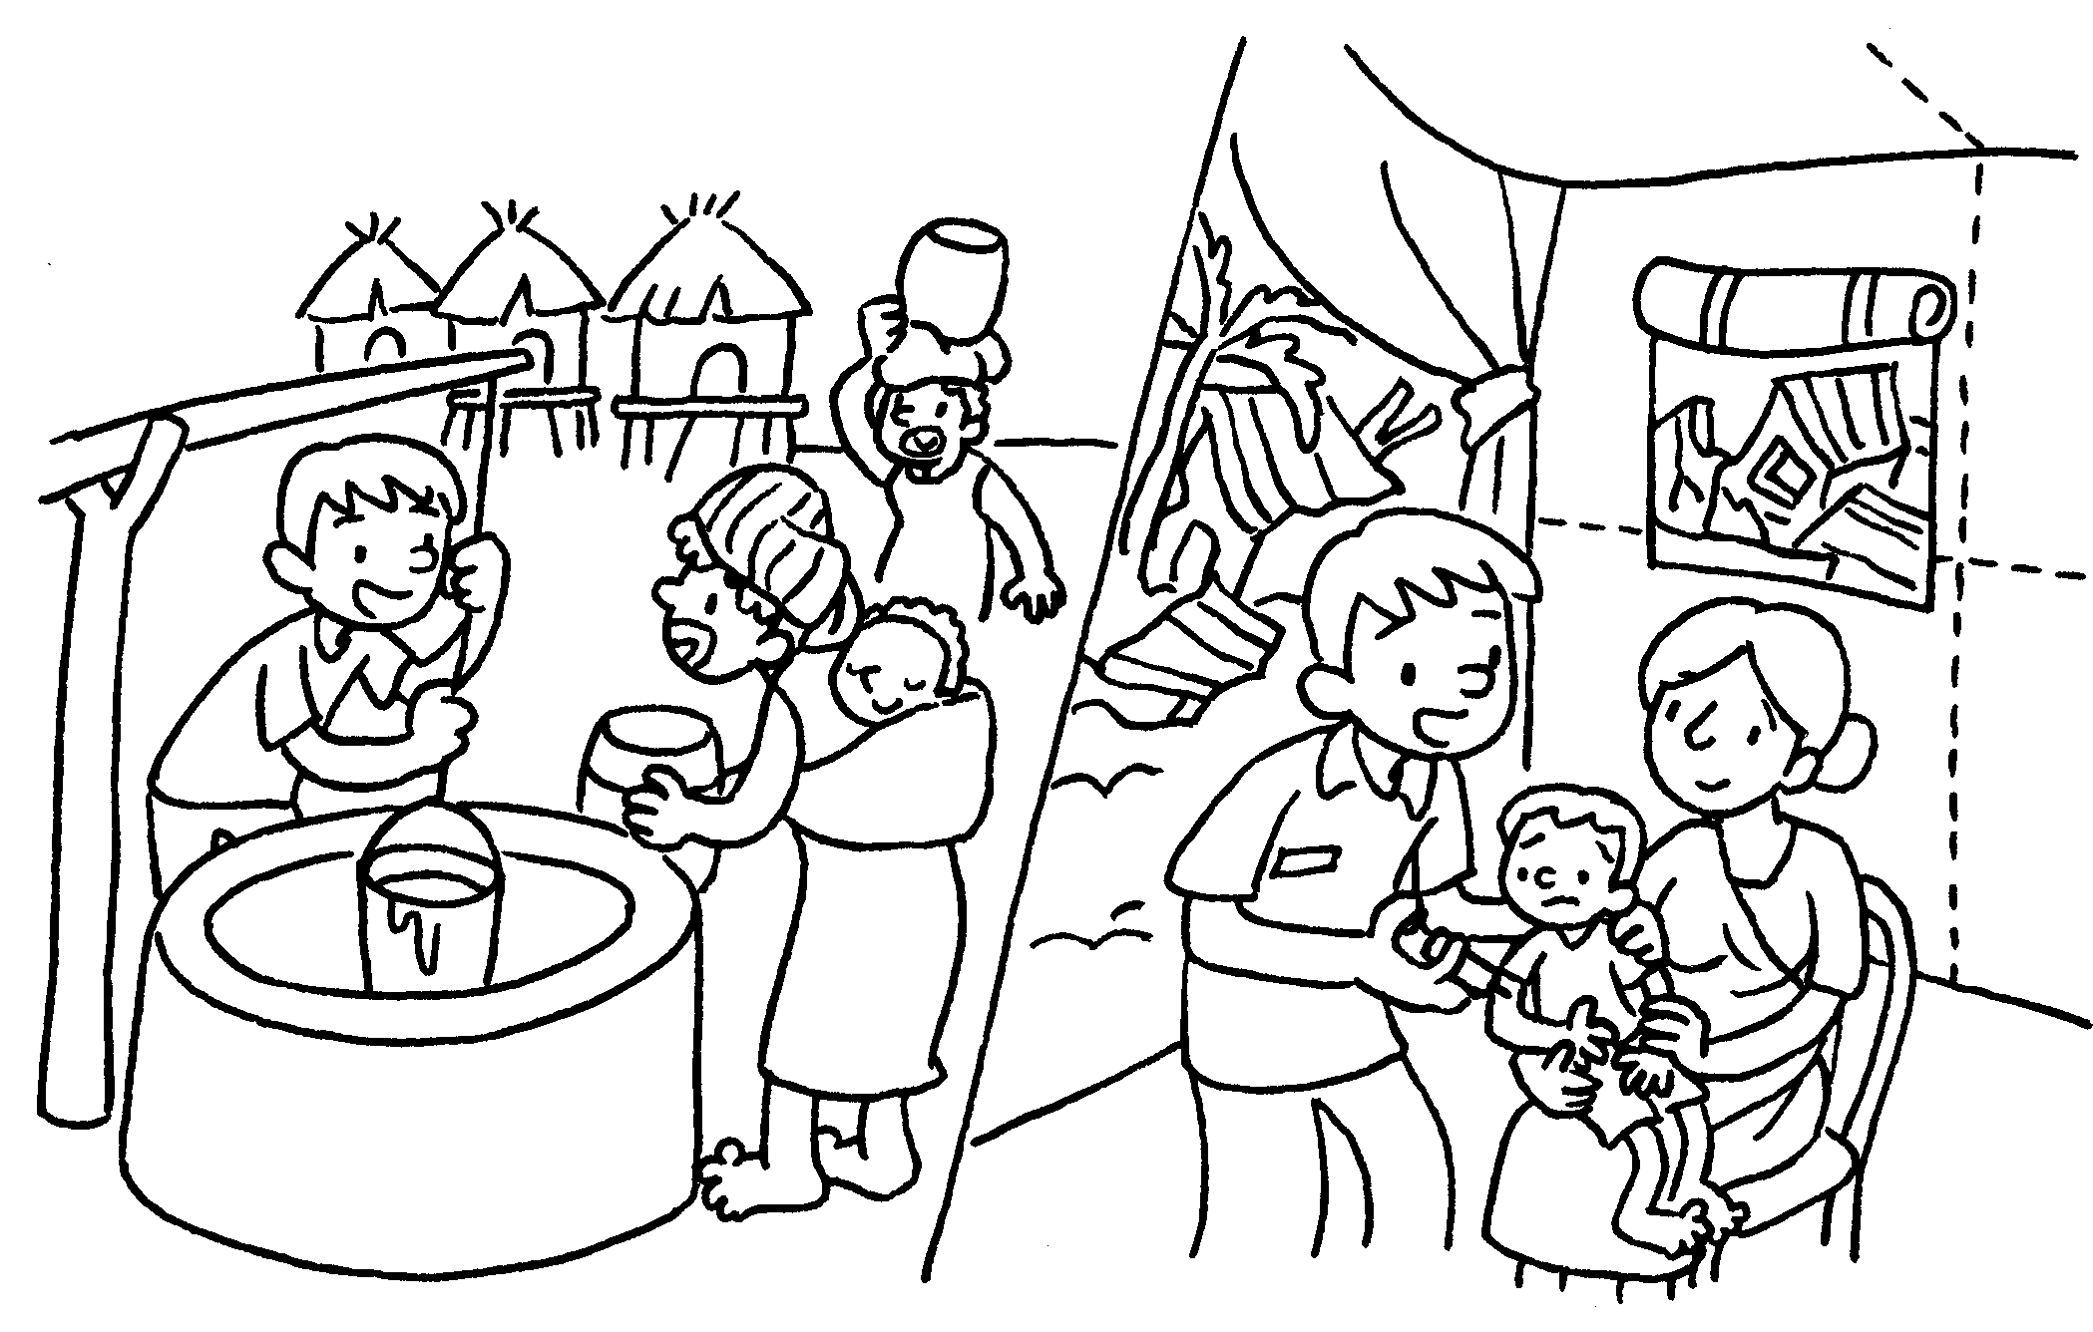
4 | This story is about a creative girl.  The girl works very hard to become a fashion designer. | 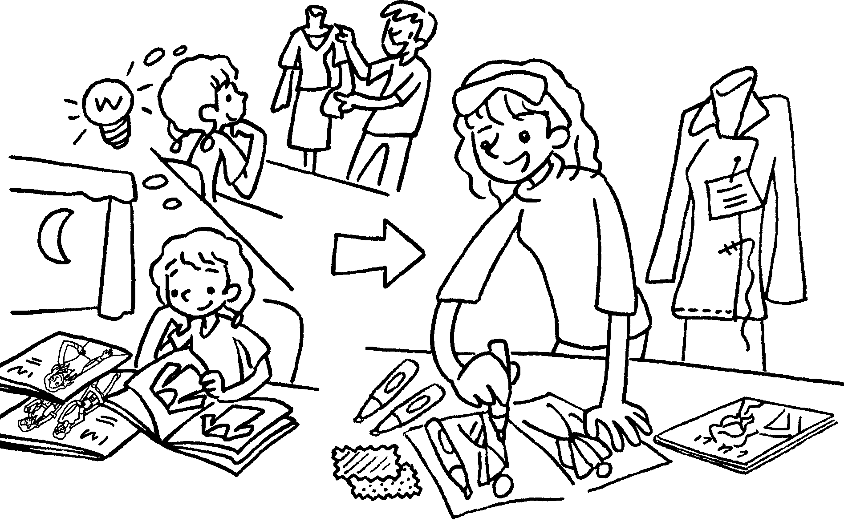


Book 6A Chapter 6 Graded Worksheets
Worksheet 2⬇⬇
- who likes cats very much
- who is good at playing the piano
- The book is about a man who travels around the world helping poor people.
- This story is about a creative girl who works very hard to become a fashion designer.

